Biology: Concepts and Connections, 6e (Campbell)
Chapter 2
The Chemical Basis of Life

Multiple-Choice Questions

1) What phrase best describes the connection between the ants' use of formic acid and the theme of Chapter 2?
A) Ants are important for the survival of trees.
B) Ants use the trees as a home.
C) Other tree species could benefit from the ants.
D) Chemicals are part of the hierarchical structure of life.
E) Ants and trees can form symbiotic relationships.

Answer: D
Topic: Opening Essay
Skill: Conceptual Understanding

2) The four most common elements in living organisms are
A) C, H, O, Fe.
B) C, H, O, Na.
C) C, H, O, N.
D) C, N, O, Na.
E) Fe, N, O, Ca.

Answer: C
Topic: 2.1
Skill: Factual Recall

3) Which of the following is a trace element in the human body?
A) carbon
B) nitrogen
C) zinc
D) oxygen
E) hydrogen

Answer: C
Topic: 2.1
Skill: Factual Recall

4) Which of the following statements regarding matter is false?
A) All life is composed of matter.
B) Matter occupies space.
C) Matter has mass.
D) Matter is composed of elements.
E) Matter can be created and destroyed.

Answer: E
Topic: 2.1
Skill: Factual Recall

5) Which of the following trace elements is commonly added to table salt to prevent the formation of goiters?
A) iodine
B) iron
C) calcium
D) magnesium
E) fluoride

Answer: A
Topic: 2.2
Skill: Factual Recall

6) Which of the following trace elements may be added to bottled water in an effort to prevent tooth decay?
A) nitrogen
B) sodium
C) chlorine
D) potassium
E) fluoride

Answer: E
Topic: 2.2
Skill: Factual Recall

7) Which of the following statements best describes a compound?
A) A compound is a pure element.
B) A compound is less common than a pure element.
C) A compound contains two or more different elements in a fixed ratio.
D) A compound is exemplified by sodium.
E) A compound is a solution.

Answer: C
Topic: 2.3
Skill: Factual Recall

8) In the equation 2 H2 + O2 → 2 H2O,
A) H2, O2, and H2O are all compounds.
B) H2, O2, and H2O are all elements.
C) only H2O is a compound.
D) only H2 and O2 are compounds.
E) H2, O2, and H2O are all trace elements.

Answer: C
Topic: 2.3
Skill: Conceptual Understanding
9) Which of the following particles is found in the nucleus of an atom?
A) protons and neutrons
B) protons and electrons
C) only neutrons
D) only protons
E) only electrons

Answer: A
Topic: 2.4
Skill: Factual Recall

10) Electrons move about the nucleus of an atom in the same way that
A) insects fly around a bright lamp at night.
B) cars are parked along the sides of a street.
C) boats cross a lake.
D) people pass each other along a sidewalk.
E) birds migrate to a new winter home.

Answer: A
Topic: 2.4
Skill: Conceptual Understanding

11) What is the atomic mass of an atom that has 6 protons, 6 neutrons, and 6 electrons?
A) 6
B) 8
C) +1
D) 12
E) 18

Answer: D
Topic: 2.4
Skill: Factual Recall

12) An uncharged atom of boron has an atomic number of 5 and an atomic mass of 11. How many electrons does boron have?
A) 11
B) 15
C) 0
D) 5
E) 2

Answer: D
Topic: 2.4
Skill: Application

13) Which of the following is another term used for atomic mass?
A) roberts
B) darwin
C) mendel
D) dalton
E) calvin

Answer: D
Topic: 2.4
Skill: Factual Recall

14) The sodium atom contains 11 electrons, 11 protons, and 12 neutrons. What is the mass number of sodium?
A) 0
B) 11
C) 22
D) 23
E) 34

Answer: D
Topic: 2.4
Skill: Conceptual Understanding

15) Which of the following best describes the atomic number of an atom?
A) the number of protons in the atom
B) the number of electrons in the atom
C) the number of neutrons in the atom
D) the number of protons, electrons, and neutrons in the atom
E) the net electrical charge of the atom

Answer: A
Topic: 2.4
Skill: Factual Recall

16) Typically, nitrogen atoms are composed of electrons, protons, and neutrons. An isotope of nitrogen could
A) be positively charged.
B) be negatively charged.
C) have more than electrons and more than protons.
D) have more than protons.
E) have more than neutrons.

Answer: E
Topic: 2.4
Skill: Factual Recall

17) A radioactive isotope is an isotope that
A) is stable.
B) decays.
C) has more protons than the common variant of the element.
D) has more electrons than the common variant of the element.
E) has the same atomic mass, but a different atomic number than the common variant of the element.

Answer: B
Topic: 2.4
Skill: Factual Recall

18) If you found a fossilized dinosaur bone, what method could be used to determine the age of the fossil?
A) electrophoresis
B) DNA fingerprinting
C) isotope analysis
D) radial immunodiffusion
E) high-pressure liquid chromatography

Answer: C
Topic: 2.4
Skill: Application

19) Which of the following statements about radioactive isotopes is true?
A) The nuclei of radioactive isotopes are unusually stable, but the atoms tend to lose electrons.
B) When given a choice between radioactive and nonradioactive isotopes of the same atom, living cells are more likely to
incorporate the radioactive isotopes into their structures.
C) The tracers typically used for diagnosing medical problems remain radioactive in the body for a number of years, but
give off very low levels of radioactive energy.
D) The energy emitted by radioactive isotopes can break chemical bonds and cause molecular damage in cells.
E) Radioactive elements are natural and therefore not harmful.

Answer: D
Topic: 2.5
Skill: Factual Recall

20) Based on your understanding of radioactive isotopes and Alzheimer's disease, what might occur with the use of radioactive isotopes when diagnosing this brain disease?
A) It would not be very accurate.
B) It could cause more cellular damage, worsening the condition.
C) It only works on diseased brains.
D) It would only work if the isotope was stable.
E) Naturally occurring radioactive isotopes will provide accurate results.

Answer: B
Topic: 2.5
Skill: Conceptual Understanding

21) Radioactive isotopes
A) are frequently added to foods as nutritional supplements.
B) can be used in conjunction with PET scans to diagnose diseases.
C) have no effect on living tissue.
D) do not occur naturally.
E) are never incorporated into organic compounds.

Answer: B
Topic: 2.5
Skill: Factual Recall

22) When full, the innermost electron shell of argon contains ________ electrons, and the outermost shell contains ________ electrons.
A) 2 . . . 2
B) 2 . . . 8
C) 4 . . . 8
D) 8 . . . 2
E) 8 . . . 8

Answer: B
Topic: 2.6
Skill: Factual Recall

23) What happens to an atom if the electrons in the outer shell are altered?
A) The atom becomes radioactive.
B) The atom will disintegrate.
C) The properties of the atom will change.
D) The atom will remain the same.
E) The atom's characteristics change and it becomes a different element.

Answer: C
Topic: 2.6
Skill: Factual Recall

24) Which particles increase by one as we move from left to right in the elements on the periodic table?
A) neutrons only
B) neutrons and protons
C) electrons only
D) electrons and protons
E) electrons and neutrons

Answer: D
Topic: 2.6
Skill: Factual Recall

25) Table salt is formed when
A) chlorine gives an electron to sodium.
B) a hydrogen bond forms between sodium and chlorine.
C) sodium and chlorine share electrons to form a bond.
D) sodium crystals combine with chlorine crystals.
E) sodium donates its single outer electron to chlorine

Answer: E
Topic: 2.7
Skill: Factual Recall

26) The body uses atoms in different ways to accomplish different tasks. For example, one portion of the body's calcium supply strengthens bones, whereas another portion combines with proteins to stimulate blood clotting after tissue injury. Which of the statements below provides the most logical chemical explanation of calcium's ability to perform such different functions?
A) The bone contains calcium salts, which are less reactive than the calcium ions found in the blood.
B) The calcium in blood is a more reactive form of the atom and therefore has fewer protons than the calcium in bone.
C) There are many different isotopes of calcium, and the most reactive isotope is found in the bone.
D) The calcium in blood has a lighter atomic mass than the calcium in bone and is in a more reactive form.
E) The calcium in blood has fewer protons, is a more reactive form of the atom, and has a lighter atomic mass than the
calcium in bone.

Answer: A
Topic: 2.7
Skill: Application

27) Medicines are often administered in pill form. In many cases, the active ingredient of the pill (the drug) is joined to another substance by ________. This forms a(n) ________, which is stable in the dry environment of a pill bottle but dissociates under the wet conditions of the digestive system to release the drug to the body.
A) ionic bonds . . . salt
B) hydrogen bonds . . . base
C) ionic bonds . . . acid
D) covalent bonds . . . salt
E) polar covalent bonds . . . acid or base (depending on the drug)

Answer: A
Topic: 2.7
Skill: Application

28) A(n) ________ forms when two atoms share electrons.
A) ion
B) element
C) covalent bond
D) ionic bond
E) hydrogen bond

Answer: C
Topic: 2.8
Skill: Factual Recall

29) A hydrogen atom has one electron. How many covalent bonds can hydrogen form?
A) one covalent bond
B) four covalent bonds
C) four covalent bonds
D) two ionic bonds
E) two isotonic bonds

Answer: A
Topic: 2.8
Skill: Application

30) What is the fundamental difference between covalent and ionic bonding?
A) In a covalent bond, the partners have identical electronegativity; in an ionic bond, one of them is more electronegative.
B) In a covalent bond, the partners share a pair of electrons; in an ionic bond, one partner accepts electrons from the other.
C) In covalent bonding, both partners end up with filled outer electron shells; in ionic bonding, one partner does and the
other does not.
D) Covalent bonding involves only the outermost electron shell; ionic bonding also involves the next electron shell inside
the outermost shell.
E) Covalent bonds form between atoms of the same element; ionic bonds form between atoms of different elements.

Answer: B
Topic: 2.8
Skill: Conceptual Understanding

31) Which of the following statements regarding the oxygen atom of a water molecule is true?
A) Oxygen is more positively charged than the hydrogen atoms.
B) Oxygen attracts electrons less strongly than the hydrogen atoms.
C) Oxygen is more electronegative than the hydrogen atoms.
D) Oxygen is electrically neutral.
E) Oxygen is attracted to the negatively charged atoms of other molecules.

Answer: C
Topic: 2.9
Skill: Conceptual Understanding

32) In a water molecule, hydrogen and oxygen are held together by a(n) ________ bond.
A) double covalent
B) ionic
C) nonpolar covalent
D) hydrogen
E) polar covalent

Answer: E
Topic: 2.9
Skill: Factual Recall

33) A person shakes up vinegar and oil dressing before pouring it on salads. What is the chemical reason for doing this?
A) Vinegar contains charged water molecules, while oil is neutral and repels water.
B) Vinegar and oil must be mixed to decease the viscosity.
C) Vinegar and oil are oppositely charged, and opposites attract.
D) Oil is composed of fatty acids, which are too large to dissolve in water.
E) Vinegar has a basic pH and is neutralized when mixed with oil.

Answer: A
Topic: 2.9
Skill: Application

34) A water molecule (HOH) is held together by
A) an ionic bond.
B) a single covalent bond.
C) a double covalent bond.
D) two polar covalent bonds.
E) hydrogen bonds.
Answer: D
Topic: 2.9
Skill: Factual Recall

35) The hydrogen atoms of a water molecule are bonded to the oxygen atom by ________ bonds, whereas neighboring water molecules are held together by ________ bonds.
A) hydrogen . . . ionic
B) hydrogen . . . polar covalent
C) polar covalent . . . hydrogen
D) ionic . . . covalent
E) polar covalent . . . ionic

Answer: C
Topic: 2.9, 2.10
Skill: Factual Recall

36) ________ are weak bonds that are not strong enough to hold atoms together to form molecules but are strong enough to form bonds within and around large molecules.
A) Ionic bonds
B) Covalent bonds
C) Polar covalent bonds
D) Hydrogen bonds
E) Anionic bonds

Answer: D
Topic: 2.10
Skill: Factual Recall

37) Water molecules stick to other water molecules because
A) water molecules are neutral, and neutral molecules are attracted to each other.
B) hydrogen bonds form between the hydrogen atoms of one water molecule and the oxygen atoms of other water
molecules.
C) covalent bonds form between the hydrogen atoms of one water molecule and the oxygen atoms of other water
molecules.
D) the hydrogen atoms of adjacent water molecules are attracted to one another.
E) the oxygen atoms of adjacent water molecules are attracted to one another.

Answer: B
Topic: 2.10
Skill: Conceptual Understanding

38) The tendency of water molecules to stick together is referred to as
A) adhesion.
B) polarity.
C) cohesion.
D) transpiration.
E) evaporation.

Answer: C
Topic: 2.11
Skill: Factual Recall

39) Which of the following is dependent on the ability of water molecules to form hydrogen bonds with other molecules besides water?
A) the evaporative cooling of skin surfaces
B) the movement of water from the roots of a tree to its leaves
C) the milder temperatures of coastal regions compared to inland areas
D) the ability of certain insects to walk on the surface of water
E) the universality of water as a solvent

Answer: E
Topic: 2.11, 2.12
Skill: Conceptual Understanding

40) Water's surface tension and heat storage capacity is accounted for by its
A) orbitals.
B) weight.
C) hydrogen bonds.
D) mass.
E) size.

Answer: C
Topic: 2.11, 2.12
Skill: Conceptual Understanding

41) As ice melts,
A) hydrogen bonds are broken.
B) water molecules become less tightly packed.
C) the water becomes less dense.
D) covalent bonds form.
E) heat is released.

Answer: A
Topic: 2.12, 2.13
Skill: Conceptual Understanding

42) Which of the following will contain more heat but has a lower temperature?
A) a gas-powered lawnmower engine after it has been used for an hour
B) an Olympic-sized heated indoor swimming pool
C) the water used in a dishwasher
D) the boiling water in a pot for noodles
E) a hot air balloon

Answer: B
Topic: 2.12
Skill: Conceptual Understanding

43) The temperature of evaporation is much higher for water than for alcohol. Without knowing more about the chemistry of alcohol, which of the following is the most logical chemical explanation for this phenomenon?
A) Ionic bonds form between alcohol molecules. These are the weakest type of bond and are easier to break than the
hydrogen bonds between water molecules.
B) Alcohol has a higher surface tension than water. This means that alcohol molecules can easily break away from other
alcohol molecules and evaporate at a lower temperature.
C) Alcohol molecules are more cohesive than water molecules. This means that as alcohol molecules evaporate, they pull
other alcohol molecules into the air along with them.
D) Fewer hydrogen bonds form between alcohol molecules. As a result, less heat is needed for alcohol molecules to break
away from solution and enter the air.
E) Water is a better solvent than alcohol. Therefore, alcohol can break covalent bonds easily and will not be restricted
from evaporating from its solute.

Answer: D
Topic: 2.12, 2.13
Skill: Application

44) Which of the following statements about water is false?
A) Ice is less dense than liquid water.
B) The hydrogen bonds in ice are less stable than the hydrogen bonds in liquid water.
C) Water naturally exists in all three physical states on Earth.
D) Floating ice on a pond insulates the liquid water below, slowing its rate of freezing.
E) If ice sank, the oceans would eventually freeze solid.

Answer: B
Topic: 2.13
Skill: Factual Recall

45) You've made a hot drink by dissolving a teaspoon of instant coffee and a teaspoon of sugar in a cup of hot water. Which of the following statements is true?
A) You've just prepared an aqueous solution.
B) The water is the solute portion of the drink.
C) The instant coffee and sugar are solvents.
D) The instant coffee and sugar dissolve because they have no charged regions to repel the partial positive and partial
negative regions of the water molecules.
E) The coffee and sugar would not dissolve in cold water.

Answer: A
Topic: 2.14
Skill: Application

46) Clot formation in our blood can lead to a heart attack or stroke. What was altered in the proteins that made the clot?
A) The proteins became more polar.
B) The blood was saturated with proteins.
C) The proteins were no longer soluble in the blood.
D) A different solvent other than water was used.
E) The proteins became more soluble in the blood.

Answer: C
Topic: 2.14
Skill: Conceptual Understanding
47) A pharmaceutical company hires a chemist to analyze the purity of the water being used in its drug preparations. If the water is pure, the chemist would expect to find
A) only molecules of H2O.
B) H2O molecules and H+ ions.
C) H2O molecules and OH- ions.
D) H2O molecules, H+ ions, and OH- ions.
E) only H+ ions and OH- ions.

Answer: D
Topic: 2.15
Skill: Conceptual Understanding

48) A solution with a pH of 7 is
A) strongly acidic.
B) weakly acidic.
C) neutral.
D) weakly basic.
E) strongly basic.

Answer: C
Topic: 2.15
Skill: Factual Recall

49) Compared to a solution of pH 3, a solution of pH 1 is
A) 100 times more acidic.
B) 10 times more acidic.
C) neutral.
D) 10 times more basic.
E) 100 times more basic.

Answer: A
Topic: 2.15
Skill: Factual Recall

50) Which of the following statements about pH is true?
A) The pH scale is a measure of oxygen ion concentration.
B) A single unit change on the pH scale is equivalent to a 1% change in hydrogen ion concentration.
C) An increase in hydrogen ion concentration means a decrease in pH scale units.
D) Basic pH levels are less than 7.
E) The pH of solutions inside most cells is close to 9.0.

Answer: C
Topic: 2.15
Skill: Factual Recall

51) Household ammonia has a pH of 12; household bleach has a pH of 13. Which of the following statements about them is true?
A) Both of these substances are strong acids.
B) The ammonia has 10 times as many OH- ions as the bleach.
C) The ammonia has 10 times as many H+ ions as the bleach.
D) A solution that could buffer the bleach and ammonia would remove excess OH- ions.
E) The ammonia has 10 times as many OH- ions as the bleach, and a solution that could buffer the bleach and ammonia
would remove excess OH- ions.

Answer: C
Topic: 2.15
Skill: Conceptual Understanding

52) A buffer
A) is an acid that is used to offset overly basic conditions in the body.
B) is a base that is used to offset overly acidic conditions in the body.
C) donates OH- ions when conditions become too acidic and accepts OH- ions when conditions become too basic.
D) donates H+ ions when conditions become too basic and accepts H+ ions when conditions become too acidic.
E) donates OH- ions when conditions become too basic and accepts OH- ions when conditions become too acidic.

Answer: D
Topic: 2.15
Skill: Factual Recall

53) A diabetic, who does not utilize insulin properly, will metabolize fats instead of glucose. A condition called diabetic ketoacidosis is a common result of excessive fat metabolism, causing blood pH values of 7.1 or less (normal range = 7.35 — 7.45). What has happened to the blood pH and why?
A) The pH is above normal (basic) because the ketones are too basic.
B) The pH is below normal (acidic) because the buffering capacity was exceeded.
C) The pH is above normal (basic) because the glucose is polar.
D) The pH is not affected because the blood buffers can absorb the excess H+.
E) The pH is below normal because buffers can donate OH+.

Answer: B
Topic: 2.15
Skill: Application

54) Which of the following statements about acid precipitation is false?
A) Acid precipitation can occur with rain, snow, or fog.
B) Acid precipitation is defined as having a pH below 5.6.
C) Acid precipitation damages natural wilderness areas.
D) Acid precipitation is primarily the result of burning fossil fuels.
E) Acid precipitation has little or no effect on soil chemistry.

Answer: E
Topic: 2.16
Skill: Factual Recall

55) The emission of ________ and ________ are primarily responsible for acid precipitation.
A) carbon dioxide . . . methane
B) CFCs . . . bromides
C) nitrogen oxides . . . sulfur oxides
D) halones . . . CFCs
E) carbon dioxide . . . ozone

Answer: C
Topic: 2.16
Skill: Factual Recall

56) Which of the following would be considered an effective way to decrease the production of acid precipitation?
A) Drive more full-size SUVs.
B) Build more coal-generated electricity power plants.
C) Discourage the use of alternative energy resources such as solar, wind, and geothermal energy.
D) Whenever possible, walk or ride a bicycle instead of driving a car.
E) Consume only organically grown foods.

Answer: D
Topic: 2.16
Skill: Application

57) What is likely to happen to wild salmon prices if the burning of fossil fuels continues at the current rate?
A) Prices will drop to pre-fossil fuel burning levels.
B) Prices will increase due to decreased salmon harvests.
C) Prices will stay the same because fossil fuel has nothing to do with salmon.
D) Prices will fluctuate wildly due to illogical fear in the marketplace.
E) Prices will initially decline and then stabilize.

Answer: B
Topic: 2.16
Skill: Conceptual Understanding

58) Which of the following statements regarding chemical reactions is false?
A) Chemical reactions involve the making and breaking of chemical bonds.
B) Some chemical reactions create electrons; others destroy them.
C) The atoms of the reactants are exactly the same as the atoms of the products.
D) The reactants contain the same number of atoms as the products.
E) Although the atoms of a reaction's reactants and products are identical to each other, their molecular formulae differ.

Answer: B
Topic: 2.17
Skill: Factual Recall

59) Which of the following hypotheses would be supported if liquid water were found on Mars and contained evidence of bacteria-like organisms?
A) Life must evolve in the presence of oxygen.
B) The chemical evolution of life is possible.
C) Life on Earth must have originated on Mars.
D) Life is guided by intelligent design.
E) Life spontaneously arises from the decaying flesh of organisms.

Answer: B
Topic: 2.17-Evolution Connection
Skill: Conceptual Understanding

60) In the equation 2 H2 + O2 → 2 H2O, the H2 molecules are ________ and the H2O molecules are ________.
A) reactants . . . products
B) products . . . reactants
C) created . . . destroyed
D) used . . . stored
E) destroyed . . . created

Answer: A
Topic: 2.18
Skill: Factual Recall

61) Photosynthesis requires many steps to make glucose. As a result of the synthesis process,
A) all the carbons from the six carbon dioxide atoms are found in glucose.
B) more atoms are present at the beginning than at the end.
C) more carbon dioxide is released from the plant than is absorbed.
D) water is synthesized by the plant from H2 and O2.
E) more water is released from the leaves than is absorbed through the roots.

Answer: A
Topic: 2.18
Skill: Conceptual Understanding

Art Questions

1)
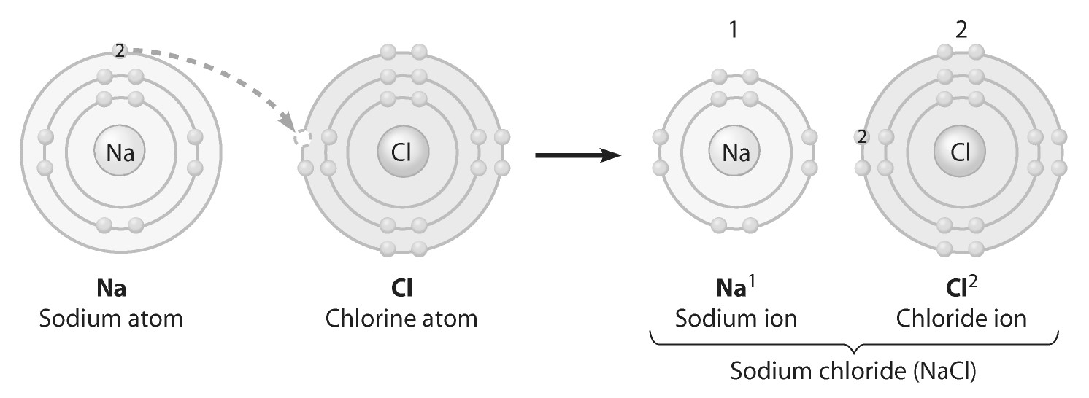
What change is occurring in this figure?
A) Sodium is gaining an electron.
B) Chlorine is losing an electron.
C) Sodium is becoming negatively charged.
D) Sodium is filling its third electron shell.
E) Chlorine is filling its third electron shell.

Answer: E
Topic: 2.6, 2.7
Skill: Conceptual Understanding
2)
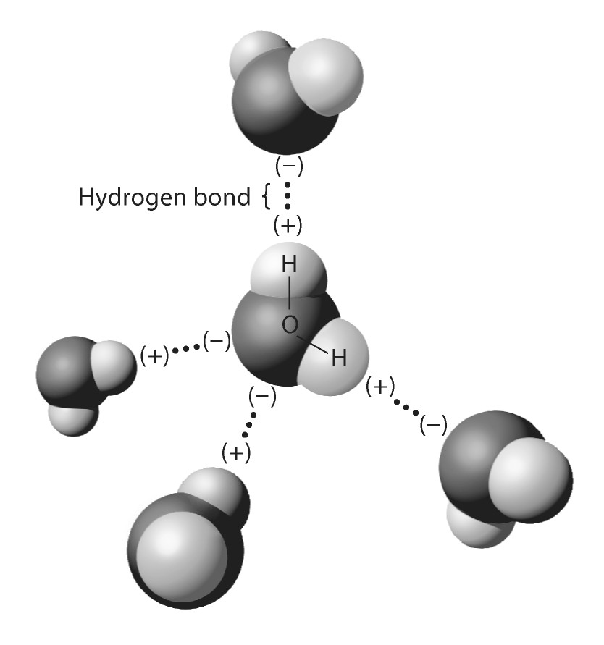
The hydrogen bonds shown in this figure are each
A) between two hydrogen atoms.
B) between two oxygen atoms.
C) between an oxygen and a hydrogen atom of the same water molecule.
D) between an oxygen and a hydrogen atom of different water molecules.
E) between two atoms with the same charge.

Answer: D
Topic: 2.10
Skill: Application

Scenario Questions

After reading the following paragraph, answer the question(s) below.

You've been experiencing acid indigestion lately, and you'd like a quick fix for the problem. You do a little research on the Internet and discover that your problem is caused by excess stomach acid. In the pharmacy aisles, however, you're having a little trouble deciding what to purchase to address the problem. At the pharmacy counter, the clerk recommends that you purchase Pepcid-AC® or Alka-Seltzer® tablets.

1) If you could check the pH of the recommended tablets, you would expect it to be
A) higher than 7.
B) lower than 7.
C) exactly 7.
D) pH neutral.
E) either C or D.

Answer: A
Topic: 2.15
Skill: Conceptual Understanding

2) If you were able to chemically analyze your stomach fluids 30 minutes after taking two tablets, you would find
A) more hydrogen ions.
B) fewer hydrogen ions.
C) the same number of hydrogen ions.
D) that the pH in your stomach has decreased.
E) a greater number of covalent bonds.

Answer: B
Topic: 2.15
Skill: Application

