Comparable Companies Analysis

- Using the information provided for Gasparro Corp., complete the questions regarding fully diluted shares outstanding
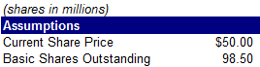
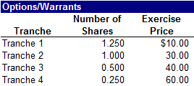

  - Calculate Gasparro Corp.’s in-the-money options/warrants

_______________________________________________________________

  - Calculate proceeds from in-the-money options/warrants

_______________________________________________________________

  - Calculate net new shares from the options/warrants

_______________________________________________________________

  - Calculate fully diluted shares outstanding

_______________________________________________________________

- Using the prior answers and information, as well as the balance sheet data below, calculate Gasparro’s equity value and enterprise value

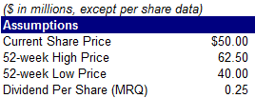

  - Calculate equity value

_______________________________________________________________

  - Calculate enterprise value

_______________________________________________________________

- Using the information provided for Gasparro, complete the questions regarding non-recurring items

  - Calculate adjusted LTM gross profit for Gasparro, assuming the $30.0 million inventory charge is added back to COGS

_______________________________________________________________

  - Calculate adjusted LTM EBIT

_______________________________________________________________

  - Calculate adjusted LTM EBITDA

_______________________________________________________________

  - Calculate adjusted LTM net income

_______________________________________________________________

- Using the prior answers and information, complete the questions regarding Gasparro’s LTM return on investment ratios

  - Calculate return on average invested capital

_______________________________________________________________

  - Calculate return on average equity

_______________________________________________________________

  - Calculate return on average assets

_______________________________________________________________

  - Calculate implied annual dividend per share

_______________________________________________________________

- Using the prior answers and information, complete the questions regarding Gasparro’s LTM credit statistics

  - Calculate debt-to-total capitalization

_______________________________________________________________

  - Calculate total debt-to-EBITDA

_______________________________________________________________

  - Calculate net debt-to-EBITDA

_______________________________________________________________

  - Calculate EBITDA-to-interest expense

_______________________________________________________________

  - Calculate (EBITDA – capex)-to-interest expense

_______________________________________________________________

  - Calculate EBIT-to-interest expense

_______________________________________________________________

- Using the prior answers and information, calculate Gasparro’s trading multiples

  - Calculate Gasparro Corp.’s LTM enterprise value-to-sales

_______________________________________________________________

  - Calculate 2019E enterprise value-to-EBITDA

_______________________________________________________________

  - Calculate 2020E enterprise value-to-EBIT

_______________________________________________________________

  - Calculate 2021E P/E

_______________________________________________________________

  - Calculate 2021E FCF yield

_______________________________________________________________

- Using the prior answers and information, calculate Gasparro’s growth rates

  - Calculate Gasparro’s historical one-year sales growth

_______________________________________________________________

  - Calculate historical two-year EBITDA compounded annual growth rate

_______________________________________________________________

  - Calculate estimated one-year FCF growth

_______________________________________________________________

  - Calculate estimated two-year EPS CAGR

_______________________________________________________________

- Using the information provided for ValueCo’s peers, complete the questions regarding LTM profitability margins

  - Calculate BuyerCo’s gross profit margin

_______________________________________________________________

  - Calculate Sherman Co.’s EBITDA margin

_______________________________________________________________

  - Calculate Pearl Corp.’s EBIT margin

_______________________________________________________________

  - Calculate Kumra Inc.’s net income margin

_______________________________________________________________

  - Calculate the mean EBITDA margin

_______________________________________________________________

  - Calculate the median EBIT margin

_______________________________________________________________

- Using the information below, calculate the LTM leverage and coverage ratios for ValueCo’s peers
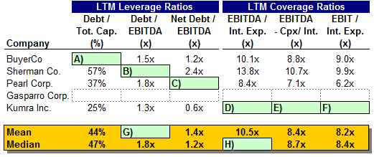

  - Calculate BuyerCo’s debt-to-total capitalization

_______________________________________________________________

  - Calculate Sherman Co.’s debt-to-EBITDA ratio

_______________________________________________________________

  - Calculate Pearl Corp.’s net debt-to-EBITDA ratio

_______________________________________________________________

  - Calculate Kumra Inc.’s EBITDA-to-interest expense ratio

_______________________________________________________________

  - Calculate Kumra Inc.’s (EBITDA – Capex)-to-interest expense ratio

_______________________________________________________________

  - Calculate Kumra Inc.’s EBIT-to-interest expense ratio

_______________________________________________________________

  - Calculate the mean debt-to-EBITDA leverage ratio

_______________________________________________________________

  - Calculate the median EBITDA-to-interest expense ratio

_______________________________________________________________

- Using the information below, calculate the LTM valuation multiples for ValueCo’s peers

  - Calculate BuyerCo’s enterprise value-to-sales multiple

_______________________________________________________________

  - Calculate Sherman Co.’s enterprise value-to-EBITDA multiple

_______________________________________________________________

  - Calculate Pearl Corp.’s enterprise value-to-EBIT multiple

_______________________________________________________________

  - Calculate Kumra Inc.’s P/E multiple

_______________________________________________________________

  - Calculate the mean enterprise value-to-EBITDA multiple

_______________________________________________________________

  - Calculate the median P/E ratio

_______________________________________________________________

- Using the information below, calculate ValueCo’s implied valuation ranges using the company’s LTM EBITDA

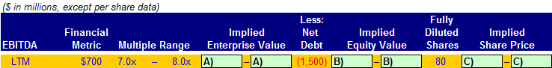

  - Calculate ValueCo’s implied enterprise value range

_____________________________________________________________

  - Calculate ValueCo’s implied equity value range

_____________________________________________________________
  - Calculate ValueCo’s implied share price range

_____________________________________________________________

- Using the information below, calculate ValueCo’s implied valuation ranges using the company’s LTM net income

  - Calculate ValueCo’s implied equity value range

_____________________________________________________________

  - Calculate ValueCo’s implied share price range

_____________________________________________________________

- Which of the following is the correct order of steps to complete comparable companies analysis?

- Locate the Necessary Financial Information
- Select the Universe of Comparable Companies
- Spread Key Statistics, Ratios, and Trading Multiples
- Determine Valuation
- Benchmark the Comparable Companies

    - II, I, III, V, IV
    - I, II, III, IV, V
    - II, I, III, IV, V
    - III, I, IV, V, IV

- All of the following are business characteristics that can be used to select comparable companies EXCEPT

- Products and Services
- Distribution Channels
- Return on Investment
- Sector

- All of the following are financial characteristics that can be used to select comparable companies EXCEPT

- Credit Profile
- Growth Profile
- Profitability
- Geography

- Which of the following are key business characteristics to examine when screening for comparable companies?

- Sector
- Return on investment
- End markets
- Distribution channels
- Return on assets

- I and III
- II and IV
- I, III, and IV
- I, II, III, IV, and V

- Which of the following are key financial characteristics to examine when screening for comparable companies?

- Customers
- Profitability
- Growth profile
- Credit profile
- End markets

- II and III
- II, III, and IV
- I, II, and IV
- II, III, and V

- End markets refer to the

- Market into which a company sells its products and services
- Medium through which a company sells its products and services to the end user
- End users of a product or service
- Stores that distribute a company’s product or service

- Distribution channels refer to the

- Market into which a company sells its products and services
- Medium through which a company sells its products and services to the end user
- End users of a product or service
- Stores that distribute a company’s product or service

- Which of the following is NOT a financial statistic to measure the profitability of a company?

- Gross profit
- EBITDA margin
- EBIT margin
- Equity value

- Which of the following is NOT a source for locating financial information for comparable companies?

- 10-K
- 13-D
- Investor Presentations
- Equity Research

- Which of the following is the correct calculation for fully diluted shares outstanding when used in trading comps?

- “Out-of-the money” options and warrants + “in-the-money” convertible securities
- Basic shares outstanding + “in-the-money” options and warrants + “in-the-money” convertible securities
- “In-the-money” options and warrants + “in-the-money” convertible securities
- Basic shares outstanding + “out-of-the money” options and warrants

- Which methodology is used to determine additional shares from “in-the-money” options and warrants when determining fully diluted shares?

- Treasury Stock Method
- “If-Converted Method”
- Net Share Settlement Method
- “In-the-Money” Method

- Calculate the company’s equity and enterprise value, respectively, using the information below

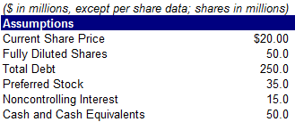

- $1,000.0 million; $1,250.0 million
- $1,000.0 million; $1,350.0 million
- $1,700.0 million; $1,915.0 million
- $1,700.0 million; $1,350.0 million

- Calculate fully diluted shares using the information below

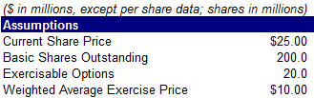

- 150.4 million
- 200.5 million
- 212.0 million
- 220.0 million

- Calculate fully diluted shares using the information below

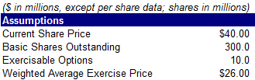

- 295.4 million
- 300.0 million
- 303.5 million
- 310.0 million

- If a company has an enterprise value of $1,000 million and equity value of $1,150 million, what is the company’s net debt?

- $250 million
- ($250) million
- $150 million
- ($150) million

- What is the most conservative (most dilutive scenario) way to treat options and warrants when calculating fully diluted shares outstanding?

- Use all outstanding “in-the-money” options and warrants
- Use all exercisable “in-the-money” options and warrants
- Ignore all “in-the-money” options and warrants
- Ignore all outstanding “in-the-money” options and warrants

- Which type of “in-the-money” options may be excluded from the calculation of fully-diluted shares outstanding in comparable companies analysis?

- Exercisable
- Net share settled
- Outstanding, but not exercisable
- If-Converted

- Calculate fully diluted outstanding shares using the information below

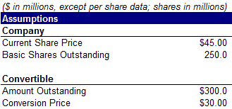

- 200.5 million
- 253.8 million
- 260.0 million
- 265.5 million

- Calculate fully diluted shares using the information below

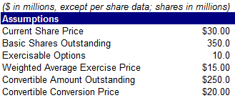

- 325.0 million
- 355.3 million
- 363.5 million
- 367.5 million

Use the information below to answer the next two questions

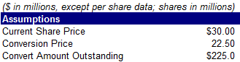

- Using the if-converted method, calculate net new shares

- 2.5
- 5.0
- 10.0
- 12.5

- Using the net share settlement method, calculate net new shares

- 2.5
- 5.0
- 10.0
- 12.5

- What is the formula for calculating enterprise value?

- Equity value + total debt
- Equity value + total debt + preferred stock + noncontrolling interest – cash
- Equity value + total debt – preferred stock – noncontrolling interest – cash
- Equity value + total debt + preferred stock + noncontrolling interest + cash

- All else being constant, how does enterprise value change if a company raises equity and uses the entire amount to repay debt?

- Stays constant
- Increases
- Decreases
- Not enough information to answer the question

- Show the necessary adjustments and pro forma amounts if a company issues $200.0 million of equity and uses the proceeds to repay debt (excluding fees and expenses).

- Which company below has a higher gross profit margin?

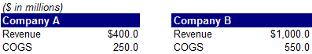

- Company A
- Company B
- Same margin for both companies
- Not enough information to answer the question

- Using the information below, calculate the CAGRs for the 2016 – 2018 and 2018 – 2020 periods

- 15.5% and 10.6%
- (13.4%) and (9.3%)
- 13.4% and 9.3%
- 13.0% and 9.0%

- Which of the following is NOT a metric used to measure a company’s growth?

- Long-term EPS growth rate
- Historical EPS CAGRs
- EBITDA margins
- y/y sales growth rates

- Calculate the company’s return on invested capital (ROIC)?

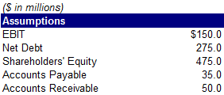

- 19.1%
- 20.0%
- 24.7%
- 30.0%

- Calculate the company’s return on equity (ROE)?

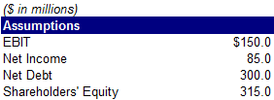

- 10.0%
- 10.4%
- 27.0%
- 29.1%

- Calculate the company’s return on assets (ROA)?

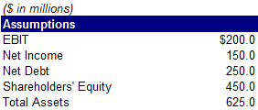

- 19.4%
- 22.4%
- 24.0%
- 25.2%

- Calculate the company’s debt-to-total capitalization

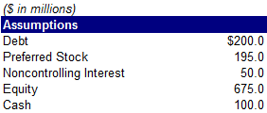

- 17.9%
- 19.7%
- 20.5%
- 23.0%

- When calculating an interest coverage ratio, which of the following is NOT used in the numerator?

- Net income
- EBIT
- EBITDA
- (EBITDA – capex)

- Ratings of Aaa, Aa1, and Aa2 belong to which ratings agency?

- S&P
- Moody’s
- Fitch
- SEC

- Which of the following ratings is investment grade?

- Ba1
- BB+
- BB-
- BBB-

- What is the Moody’s equivalent of B+?

- B1
- B2
- Ba1
- Baa1

- Calculate LTM 9/30/2019 sales given the information below

- $1,900.7 million
- $2,000.5 million
- $2,100.0 million
- $2,400.0 million

- Calculate LTM 12/31/2018 sales given the information below

- $2,500.0 million
- $4,250.0 million
- $4,000.0 million
- $4,500.0 million

- Calendarize the 4/30/2018 sales figure so it can be used alongside companies reporting on a calendar year basis

- $1,050.5 million
- $1,550.0 million
- $1,600.0 million
- $1,655.5 million

- Calculate adjusted net income, EBITDA, and EPS, respectively, assuming $50 million of D&A, and adjusting for the $10.0 million restructuring charge as well as an inventory write-down of $5 million

- $75.0 million, $185.0 million, $2.88
- $86.3 million, $200.0 million, $2.88
- $88.8 million, $200.0 million, $2.50
- $88.8 million, $100.0 million, $2.50

- The P/E ratio is equivalent to

- Equity value/net income
- Enterprise value/net income
- Enterprise value/EBITDA
- Share price/free cash flow

- Which of the following is not an appropriate valuation multiple?

- Enterprise value/EBITDA
- Enterprise value/EBIT
- Enterprise value/net income
- Enterprise value/sales

- Which of the following is not an appropriate valuation multiple?

- Equity value/EBITDA
- Enterprise value/EBITDAR
- Equity value/book value
- Enterprise value/resources

- If a company has noncontrolling interest, which statement contains the data needed to calculate enterprise value?

- Income statement
- Balance sheet
- Cash flow statement
- Management discussion & analysis

- The two most generic and widely used valuation multiples are

- Enterprise value/EBITDA
- EBITDA/interest expense
- Total debt/EBITDA
- P/E

- I and III
- I and IV
- II and III
- II and IV

- What is the premise behind comparable companies analysis?

_______________________________________________________________

_______________________________________________________________

_______________________________________________________________

_______________________________________________________________

- Two companies are very similar in terms of business characteristics, but they are currently trading at substantially different multiples. What discrepancies in financial characteristics could explain this situation?

_______________________________________________________________

_______________________________________________________________

_______________________________________________________________

_______________________________________________________________

- All else being equal, which company would be expected to trade at a higher multiple—a heavily leveraged company or one with moderate to low leverage? Why?

_______________________________________________________________

_______________________________________________________________

_______________________________________________________________

_______________________________________________________________

- Why are comparable companies sometimes tiered into different groups?

_______________________________________________________________

_______________________________________________________________

_______________________________________________________________

_______________________________________________________________

- Match the SEC forms with their formal name

10-K | Proxy statement
10-Q | Annual report
8-K | Current report
DEF14A | Quarterly report

- Match the valuation multiples with the sector that employs them

Enterprise value/reserves | Retail
Enterprise value/EBITDAR | Financial Institutions
Enterprise value/subscriber | Metals & mining
Price/Book | Media

- What are some of the benefits of using comparable companies analysis?

_______________________________________________________________

_______________________________________________________________

_______________________________________________________________

_______________________________________________________________

- What are some of the considerations when using comparable companies analysis?

_______________________________________________________________

_______________________________________________________________

_______________________________________________________________

_______________________________________________________________

