Fundamentals of Investing, 11e (Gitman/Joehnk/Smart)
Chapter 1 The Investment Environment

1.1 Learning Goal 1

1) Since 1900, the average annual return on savings accounts has been higher than the return on stocks.
Answer: FALSE
Question Status: New Question
Learning Goal: Learning Goal 1

2) Land and buildings are examples of real property investments.
Answer: TRUE
Question Status: New Question
Learning Goal: Learning Goal 1

3) Almost half of Americans own stock or stock mutual funds.
Answer: TRUE
Question Status: Previous Edition
Learning Goal: Learning Goal 1

4) A Unites States Savings Bond is an example of an investment as defined in the text.
Answer: TRUE
Question Status: Previous Edition
Learning Goal: Learning Goal 1

5) An example of a direct investment is the purchase of mutual fund shares.
Answer: FALSE
Question Status: Previous Edition
Learning Goal: Learning Goal 1

6) Which of the following is an investment as defined in the text.
A) Automobile insurance
B) A new automobile
C) A United States Saving Bond
D) All of the above
Answer: C
Question Status: Previous Edition
Learning Goal: Learning Goal 1

7) Stocks are a(n) ________ investment representing ________ of a business.
A) direct; ownership
B) direct; debt
C) indirect; ownership
D) indirect; debt
Answer: A
Question Status: Previous Edition
Learning Goal: Learning Goal 1
8) Which of the following is an indirect investment?
A) Stocks in foreign companies
B) U.S. savings bonds
C) Mutual funds
D) Real estate
Answer: C
Question Status: New Question
Learning Goal: Learning Goal 1

9) Debt represents funds loaned in exchange for
A) dividend income and the repayment of the loan principal.
B) dividend income and an ownership interest in the firm.
C) interest income and a partial ownership interest in the firm.
D) interest income and the repayment of the loan principal.
Answer: D
Question Status: Previous Edition
Learning Goal: Learning Goal 1

1.2 Learning Goal 2

1) Institutional investors manage money for businesses and nonprofit organizations, but not for individuals.
Answer: FALSE
Question Status: New Question
Learning Goal: Learning Goal 2

2) Institutional investors are individuals who invest indirectly through financial institutions.
Answer: FALSE
Question Status: New Question
Learning Goal: Learning Goal 2

3) Banks and insurance companies are examples of institutional investors.
Answer: TRUE
Question Status: New Question
Learning Goal: Learning Goal 2

4) In the financial markets, individuals are net suppliers of funds.
Answer: TRUE
Question Status: Revised
Learning Goal: Learning Goal 2

5) The government is generally
A) not involved in the financial markets.
B) the owner of the financial market.
C) a supplier of funds to the financial market.
D) a demander of funds in the financial market.
Answer: D
Question Status: Previous Edition
Learning Goal: Learning Goal 2
6) On a net basis, funds in the financial markets are generally supplied by
A) individuals.
B) both individuals and business firms.
C) business firms.
D) the government.
Answer: A
Question Status: Previous Edition
Learning Goal: Learning Goal 2

7) A forum in which suppliers and demanders of funds make financial transactions is called a financial
A) institution.
B) bank.
C) instrument.
D) market.
Answer: D
Question Status: Previous Edition
Learning Goal: Learning Goal 2

8) Which of the following are true concerning institutional investors?
I. Institutional investors are professionals who manage money for other people.
II. Banks, insurance companies and mutual funds are all institutional investors.
III. Institutional investors are individuals who invest indirectly through financial institutions.
IV. Institutional investors invest large sums of money.
A) I and II only
B) I, II and IV only
C) II, III and IV only
D) I, II, III and IV
Answer: B
Question Status: Revised
Learning Goal: Learning Goal 2

9) Investment in a professionally managed pool of assets such as a mutual fund is an example of
A) direct investment.
B) indirect investment.
C) derivative investment.
D) speculative investment.
Answer: B
Question Status: New Question
Learning Goal: Learning Goal 2

10) Explain the differences between stocks, bonds, and options.
Answer: Stocks are equity securities and represent ownership of a business. Bonds are debt securities and represent a liability of a business. Options are derivative securities and represent neither ownership nor debt of a business. While stocks are issued by corporations, and bonds are issued by corporations and governmental units, options are issued by individual investors.
Question Status: Previous Edition
Learning Goal: Learning Goal 2
1.3 Learning Goal 3

1) Common stock is a type of debt instrument.
Answer: FALSE
Question Status: Previous Edition
Learning Goal: Learning Goal 3

2) A collection of securities designed to meet an investment goal is called a portfolio.
Answer: TRUE
Question Status: Previous Edition
Learning Goal: Learning Goal 3

3) The value of a derivative security is based on the value of an underlying security.
Answer: TRUE
Question Status: Previous Edition
Learning Goal: Learning Goal 3

4) An option to purchase common stock is a type of equity security.
Answer: FALSE
Question Status: Revised
Learning Goal: Learning Goal 3

5) Bonds represent a lower level of risk than do stocks in the same company.
Answer: TRUE
Question Status: Previous Edition
Learning Goal: Learning Goal 3

6) Speculation refers to high-risk investments which offer highly uncertain returns and future value.
Answer: TRUE
Question Status: Previous Edition
Learning Goal: Learning Goal 3

7) Mutual funds invest in diversified portfolios of securities.
Answer: TRUE
Question Status: New Question
Learning Goal: Learning Goal 3

8) Bond prices rise as interest rates decline.
Answer: TRUE
Question Status: Revised
Learning Goal: Learning Goal 3

9) The periodic payments that a corporation pays to its shareholders from net earnings are called a dividends.
Answer: TRUE
Question Status: Revised
Learning Goal: Learning Goal 3
10) Which of the following is an example of a tangible asset.
A) Bonds
B) mutual funds
C) real estate
D) stocks
Answer: C
Question Status: New Question
Learning Goal: Learning Goal 3

11) Which one of the following would be the most liquid investment?
A) stock
B) Series EE bond
C) money market mutual fund
D) real estate
Answer: C
Question Status: Revised
Learning Goal: Learning Goal 3

12) Which of the following investments represents partial ownership of a corporation?
A) bonds
B) mutual funds
C) commercial paper
D) common stock
Answer: D
Question Status: New Question
Learning Goal: Learning Goal 3

13) Sarah purchased a stock one year ago at a price of $32 a share. In the past year, she has received four quarterly dividends of $0.75 each. Today she sold the stock for $38 a share. Her capital gain per share is
A) $3.00.
B) $6.00.
C) $(6.00).
D) $9.00.
Answer: B
Question Status: Previous Edition
Learning Goal: Learning Goal 3

14) Investors seeking a diversified, professionally managed portfolio of securities can purchase shares of
A) preferred stock.
B) convertible securities.
C) insurance policies.
D) mutual funds.
Answer: D
Question Status: New Question
Learning Goal: Learning Goal 3
15) Advantages of investing in real estate potentially include
I. rental income.
II. liquidity.
III. tax write offs.
IV. capital gains.
A) I and IV only
B) II and IV only
C) I, II and IV only
D) I, II, III and IV
Answer: C
Question Status: New Question
Learning Goal: Learning Goal 3

1.4 Learning Goal 4

1) Earning a high rate of return with little or no risk is a realistic investment goal.
Answer: FALSE
Question Status: Previous Edition
Learning Goal: Learning Goal 4

2) Under current tax laws, most taxpayers will pay the same rate on dividends and capital gains.
Answer: TRUE
Question Status: New Question
Learning Goal: Learning Goal 4

3) Investors can postpone or avoid income taxes by investing through Individual Retirement Accounts.
Answer: TRUE
Question Status: Previous Edition
Learning Goal: Learning Goal 4

4) Short-term capital gains are taxed at the taxpayer's marginal tax rate.
Answer: TRUE
Question Status: Previous Edition
Learning Goal: Learning Goal 4

5) To qualify for long-term capital gains rates, a stock must be held for at least 90 days.
Answer: FALSE
Question Status: New Question
Learning Goal: Learning Goal 4

6) Retirement plans, such as a 401(k), allow employees to defer taxes on the plan contributions until such time as the funds are withdrawn from the retirement plan.
Answer: TRUE
Question Status: Previous Edition
Learning Goal: Learning Goal 4

7) You should spend money on housing, clothing and basic insurance before investing.
Answer: TRUE
Question Status: Previous Edition
Learning Goal: Learning Goal 4
8) Which of the following represent investment goals?
I. setting aside enough money to meet emergencies and basic needs
II. sheltering income from taxes
III. increasing current income
IV. saving funds for retirement
A) I and IV only
B) I, III and IV only
C) III and IV only
D) II, III and IV
Answer: D
Question Status: Revised
Learning Goal: Learning Goal 4

9) In selecting investments consistent with your goals, you should consider
A) rates of return and taxes only.
B) the pre-tax rate of return only.
C) annual dividends and taxes only.
D) risks, returns, and taxes.
Answer: D
Question Status: Previous Edition
Learning Goal: Learning Goal 4

10) Monitoring and restructuring your investments is called
A) diversification.
B) valuation.
C) portfolio management.
D) financial planning.
Answer: C
Question Status: Previous Edition
Learning Goal: Learning Goal 4

11) Wages, tips, pension income and alimony are examples of
A) portfolio income.
B) active income.
C) non-taxable income.
D) passive income.
Answer: B
Question Status: Previous Edition
Learning Goal: Learning Goal 4
Table 1.4
Use the following tax rates and income brackets to answer the following question(s).

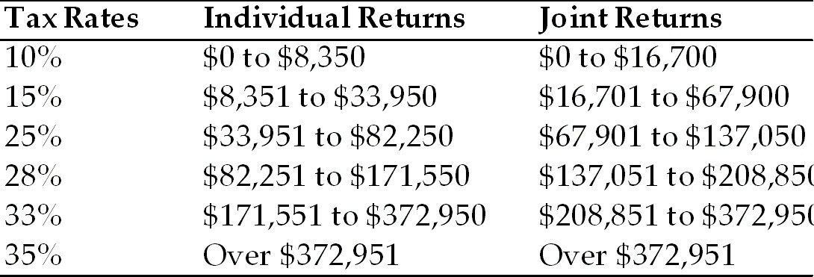

12) John and Nicole earn a combined taxable income of $148,800 from employment and file a joint tax return. If they earn$1,000 in short-term capital gains, how much will they owe on those gains?
A) $100
B) $150
C) $250
D) $280
Answer: D
Question Status: Revised
Learning Goal: Learning Goal 4

13) Josh earned $89,700 in taxable income and files an individual tax return. What is the amount of Josh's taxes for the year?
A) $16,750
B) $18,836
C) $22,425
D) $25,116
Answer: B
Question Status: Revised
Learning Goal: Learning Goal 4

14) For a taxpayer in the 25% marginal tax bracket, a long-term capital gain will be taxed at
A) 5%.
B) 10%.
C) 15%.
D) 25%.
Answer: C
Question Status: Previous Edition
Learning Goal: Learning Goal 4

15) Andrew and Jennifer are in the 25% marginal tax bracket. Three years ago they purchased 100 shares of stock at $20 a share. Today they sold the 100 shares for $29 a share. What is the amount of federal income tax they owe as a result of this sale?
A) $135
B) $165
C) $225
D) $435
Answer: A
Question Status: Revised
Learning Goal: Learning Goal 4
16) Danielle and Jonathan are in the 28% marginal tax bracket. They bought 200 shares of DJN stock at $35 per share and sold them 4 years later at $12 per share? How much did their loss reduce their taxes in the year when they sold the stock?
A) $0
B) $450
C) $840
D) $1,288
Answer: C
Question Status: New Question
Learning Goal: Learning Goal 4

17) Under current tax law, dividend income is taxed at the same rate as
A) ordinary income.
B) short-term capital gains.
C) long-term capital gains.
D) interest income.
Answer: C
Question Status: Previous Edition
Learning Goal: Learning Goal 4

18) Tax planning
A) guides investment activities to maximize after-tax returns over the long term for an acceptable level of risk.
B) ignores the source of income and concentrates solely on the amount of income.
C) is primarily done by individuals with incomes below $200,000.
D) is limited to reviewing income for the current year and determining how to minimize current taxes.
Answer: A
Question Status: Previous Edition
Learning Goal: Learning Goal 4

19) Speculative and growth oriented investments are least appropriate for
A) young investors.
B) middle-aged investors.
C) retired investors.
D) high income investors.
Answer: C
Question Status: Revised
Learning Goal: Learning Goal 4

20) Investors seeking to increase their wealth as quickly as possible would invest in
A) corporate bonds and preferred stock.
B) large company stocks with high dividends.
C) smaller companies pursuing rapid growth.
D) government bonds and low-risk income stocks.
Answer: C
Question Status: Previous Edition
Learning Goal: Learning Goal 4
21) Which one of the following statements about the economy is correct?
A) It is difficult to accurately predict movements in the stock market when the economy is at a peak.
B) A strong economy is associated with a declining business cycle.
C) Stocks tend to perform well in a weak economy.
D) The economic cycle has little effect on stocks.
Answer: A
Question Status: Previous Edition
Learning Goal: Learning Goal 4

22) Which of the following economic conditions is most difficult to identify:
A) recovery
B) expansion
C) recession
D) change in direction
Answer: D
Question Status: Previous Edition
Learning Goal: Learning Goal 4

23) Discuss the relationship between stock prices and investors' beliefs about the business cycle.
Answer: Stock prices tend to anticipate the economic conditions that investors expect in the future. When they believe that economic conditions will deteriorate and profits will decline, stock prices fall. When they expect an improving economy and higher corporate profits, stock prices rise.
Question Status: New Question
Learning Goal: Learning Goal 4

24) Discuss the general investment philosophy and the types of investments preferred by investors in each phase of the life cycle.
Answer:
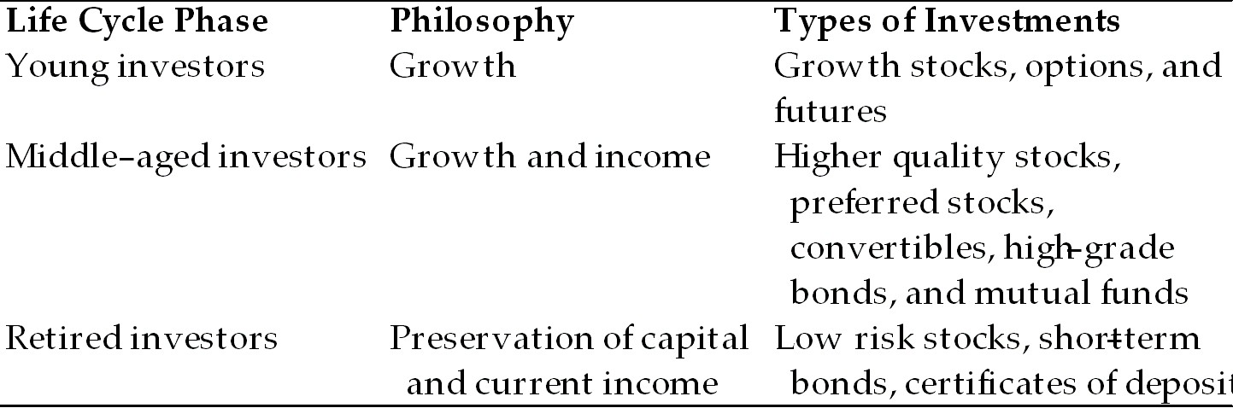

Question Status: Previous Edition
Learning Goal: Learning Goal 4

1.5 Learning Goal 5

1) U. S. Treasury Bills mature in 1 year or less.
Answer: TRUE
Question Status: New Question
Learning Goal: Learning Goal 5
2) Liquidity is the ability to convert an investment into cash quickly with little or no loss of value.
Answer: TRUE
Question Status: Previous Edition
Learning Goal: Learning Goal 5

3) Short-term investments generally provide liquidity, safety, and a high rate of return.
Answer: FALSE
Question Status: Previous Edition
Learning Goal: Learning Goal 5

4) Money market accounts, certificates of deposit, bonds and commercial paper are all forms of short-term investment vehicles.
Answer: FALSE
Question Status: Previous Edition
Learning Goal: Learning Goal 5

5) The primary risk associated with a short-term investment is
A) purchasing power risk.
B) default risk.
C) interest rate risk.
D) economic risk.
Answer: A
Question Status: Previous Edition
Learning Goal: Learning Goal 5

6) Short-term investments
I. provide liquidity.
II. fill an important part of most investment programs.
III. provide a high rate of return with low risk.
IV. provide resources for emergencies.
A) I and IV only
B) II and IV only
C) I, II and IV only
D) I, II, III and IV
Answer: C
Question Status: Previous Edition
Learning Goal: Learning Goal 5

7) Federal insurance protects passbook savings accounts and money market deposit accounts (MMDAs) up to
A) $100,000.
B) $150,000.
C) $250,000.
D) $1,000,000.
Answer: C
Question Status: New Question
Learning Goal: Learning Goal 5
8) Which of the following typically offers the highest rate of return?
A) Certificates of deposit
B) Passbook savings accounts
C) Now accounts
D) Money market deposit accounts
Answer: A
Question Status: New Question
Learning Goal: Learning Goal 5

9) Which one of the following has the lowest level of risk?
A) commercial paper
B) money market mutual fund account
C) banker's acceptance
D) U.S. Treasury bill
Answer: D
Question Status: Previous Edition
Learning Goal: Learning Goal 5

1.6 Learning Goal 6

1) Commercial bankers work with corporate and institutional clients, but not with individuals.
Answer: FALSE
Question Status: New Question
Learning Goal: Learning Goal 6

2) A major goal of corporate financial management is to increase the value of the firm to investors.
Answer: TRUE
Question Status: New Question
Learning Goal: Learning Goal 6

3) Insurance companies invest the premiums and fees collected from customers in order to neutralize the risks assumed from their clients.
Answer: TRUE
Question Status: New Question
Learning Goal: Learning Goal 6

4) Chartered Financial Analyst (CFA) is a degree offered by several prestigious business schools.
Answer: FALSE
Question Status: New Question
Learning Goal: Learning Goal 6
5) Typical responsibilities of financial professionals in a corporate setting include
I. managing cash and short-term investments.
II. evaluating investment opportunities.
III. working one on one with individuals to formulate plans for reaching their financial goals.
IV. interacting with financial markets to find sources of external financing such as debt and equity.
A) I and IV only
B) I, II and IV only
C) II, III and IV only
D) I, II, III and IV
Answer: B
Question Status: New Question
Learning Goal: Learning Goal 6

6) Jobs in which of the following fields require an understanding of the investment environment?
I. Commercial banking.
II. Corporate finance.
III. Financial planning.
IV. Insurance.
A) I and IV only
B) I, II and IV only
C) II, III and IV only
D) I, II, III and IV
Answer: D
Question Status: New Question
Learning Goal: Learning Goal 6

7) A major function of investment banking firms is
A) providing loans to investors.
B) providing financial planning services to wealthy individuals.
C) assisting businesses when they issue stocks and bonds.
D) developing investment strategies to neutralize risk.
Answer: C
Question Status: New Question
Learning Goal: Learning Goal 6

8) In the U. S., the most prestigious designation for financial planners is
A) CFP.
B) CPA.
C) ING.
D) SIPC.
Answer: A
Question Status: New Question
Learning Goal: Learning Goal 6
9) Briefly describe three different career paths that require a strong background in investments.
Answer: Students may discuss any of the following career paths. Answers will vary.
Responsibilities of commercial bankers may include portfolio management, managing short-term securities, and advising individuals as personal bankers.
Corporate financial managers must raise external funds through the debt and equity markets, manage short-term investments, and understand investor expectations for their business.
Financial planners assist individuals in choosing the investments that will help them meet their short and long term goals.
The insurance industry employs professionals to invest and manage the large sums collected from premiums.
Within the investment management industry, professionals may work as securities analysts, fund managers, or retail brokers.
Question Status: New Question
Learning Goal: Learning Goal 6

