CHAPTER  **1** | Economics: Foundations and Models

SOLUTIONS TO END-OF-CHAPTER EXERCISES

|  |  |
| --- | --- |
| **1.1** | Three Key Economic Ideas |
| Learning Objective: Explain these three key economic ideas: People are rational; people respond to incentives; and optimal decisions are made at the margin. |

Review Questions

1.1 “People are rational” is the assumption that decision makers explicitly or implicitly weigh the benefits and costs of each action and then choose an action only if the benefits are expected to outweigh the costs. “People respond to incentives” means that consumers and firms consistently respond to economic incentives. “Optimal decisions are made at the margin” means that most decisions are not “all or nothing” but involve doing a little more or a little less of an activity. Therefore, the optimal decision is to continue any activity up to the point where the marginal benefit equals the marginal cost.

1.2 Scarcity is the situation in which unlimited wants exceed the limited resources available to fulfill those wants. Economics is the study of the choices consumers, business managers, and government officials make to attain their goals. Scarcity is central to the study of economics because scarcity requires people to make choices about how to use their resources to best fulfill their wants.

Problems and Applications

1.3 As noted in the chapter, the economic incentive to banks is clear—it is less costly to put up with bank robberies than to take these additional security measures. The marginal cost of adding the additional security is greater than the expected marginal benefit.

**1.4 a**. Students face scarcity of time, like everyone else, and respond to the incentives of the teacher’s grading system. Students have more incentive to direct their efforts into the parts of the course that have the most weight in the grading system.

**b**. Too little weight on outside readings or the like gives students little incentive to read and master the material. Students will put less effort into the parts of the course that have little effect on their grades.

**c.** Quizzes over assigned readings would give students an incentive to come to class having read the upcoming material. Some teachers give preparation assignments where students have to read and answer questions about the upcoming material, and over the course of the semester students have to successfully complete a certain percentage of the preparation assignments to qualify for an A, or B, or other grade in the course.

**1.5** The carbon price and the subsequent increase in the price of gasoline (and other carbon-intensive products) will encourage people to use less gasoline. If people respond to the negative incentive of higher gas prices by using less gas, maybe by taking the bus or buying a more fuel-efficient car, we will emit fewer greenhouse gases and do less damage to the environment.

**1.6 a.** In deciding whether or not to go to the gym on a specific day, most people aren’t comparing the benefits of an active lifestyle and the cost of the gym membership. They’re comparing what they stand to miss out on and the relatively small benefit any single workout will have on their overall health. By implementing a simple payment system, the researchers increase the benefit of a small number of trips to the gym. Further thought: The benefits of going to the gym tend to materialize over a long time after the decision to go to the gym is made. Some of those benefits will  
be received years into the future. By offering cash payments in the relatively near term, the researchers offer a benefit that can be received in the same time frame as the costs of going to  
the gym are paid.

**b.** Those who do not respond to the monetary incentive to go to the gym clearly value their other options more than the health benefits and monetary reward received by going to the gym. Consider a student who is working to pay for their education. The payment received by going to the gym is likely less than the payment received by going to work. In short, the incentive isn’t big enough.

1.7 Jill is correct. The difference between the grade before and after watching an extra episode is exactly the same as knowing the change in the grade.

1.8 Your friend is failing to think at the margin. It doesn’t matter how much time your friend has already spent studying psychology. What matters is the marginal benefit to be received from studying psychology relative to the marginal cost, where cost is measured as the opportunity cost of lower grades in other subjects. If the course is required to graduate, that may raise the marginal benefit associated with completing the course.

|  |  |
| --- | --- |
| **1.2** | The Economic Problems All Societies Must Solve |
| Learning Objective: Discuss how a society answers these three key economic questions: What goods and services will be produced? How will the goods and services be produced? Who will receive the goods and services produced? |

Review Questions

**2.1** Scarcity implies that every society and every individual faces trade-offs because wants are unlimited, but the ability to satisfy those wants is limited. Societies and individuals cannot have everything they want, so they have to make choices about what to have and what not to have.

2.2 The three economic questions that every society must answer are: (1) What goods and services will be produced? (2) How will the goods and services be produced? (3) Who will receive the goods and services produced? In a centrally planned economy, the government makes most of these decisions. In a pure market economy, almost all these decisions are made by the decentralized interaction of households and firms in markets. In a mixed economy, most economic decisions result from the interaction of buyers and sellers in markets, but the government plays a significant role in the allocation of resources.

**2.3** Productive efficiency occurs when a good or service is produced at the lowest possible cost. Allocative efficiency means that what is produced reflects consumer preferences—every good or service is produced up to the point at which the last unit provides a marginal benefit to consumers equal to the marginal cost of producing it.

**2.4** Efficiency is concerned with producing the goods and services that people want at the lowest cost. Equity is “fairness,” a concept that can differ from person to person. Government policymakers often want to make economic outcomes “fairer,” but doing so usually involves redistributing income from one group to another. Redistributing income usually (but not always) hampers efficiency because it reduces incentives to produce and drives up production costs.

Problems and Applications

**2.5** Yes, even Bill Gates faces scarcity because his wants exceed his resources. First, Gates has established a foundation with billions of dollars to spend on worthy causes like eradicating malaria and reducing homelessness. However, there are an unlimited number of worthy causes that Gates can fund, so even he faces scarcity. Second, even Gates has only 24 hours in a day, so he must make choices about how to spend his scarce time. Everyone faces scarcity, because human desires are virtually unlimited. Because the world’s resources are limited, the only way not to face scarcity would be to reduce your wants to be fewer than what your resources can accomplish.

2.6 a. It is doubtful that centrally planned economies have been less efficient purely by chance. The underlying reason seems to be that centrally planned economies don’t provide as strong incentives for hard work and innovation as market economies do. In addition, the people running centrally planned economies cannot make the most efficient decisions because they don’t have the information that is in the minds of all the decentralized decision makers in a market economy.

b. You might still prefer having a centrally planned economy if you considered it to be more equitable. (Also, you might prefer a centrally planned economy if you were in charge.)

2.7 A complete explanation for the connection between majoring in economics and succeeding in business or government leadership would involve many factors. But we can say that economics teaches us how to look at the trade-offs involved in every decision we make. Those who cannot understand the costs of an action and weigh them against its benefits are unlikely to make good decisions. Climbing the corporate or governmental ladder requires making a wider and wider array of such decisions.

**2.8 a.** The groups of students most likely to try to get the tickets will be those for whom the expected marginal benefit of going to the athletic department’s office on Monday morning is greater than the expected marginal cost. These would include students who have a relatively low opportunity cost of their time, such as those who have no Monday-morning classes. Other students who are likely to stand in line are those who would have a large benefit from getting the tickets: those who love hockey and those who hope to sell their tickets (“scalpers”).

**b.** The major opportunity cost of distributing the tickets this way is the cost to those students who attempt to get the tickets: the costs of missing out on the activities that cannot be done while standing in line, and the costs to those people who try to get tickets but don’t arrive soon enough to do so. There’s also the cost of the lost revenue to the college from giving away the tickets instead of selling them.

**c.** This isn’t an efficient way to distribute the tickets because it wastes a lot of time. It would be more efficient to sell the tickets to those willing to pay the highest prices.

**d.** Equity is hard to define. Some people will see this way of distributing tickets as equitable because students with low incomes can still get tickets, provided they are willing to pay the opportunity cost of waiting in line. Some people will see this way of distributing the tickets as equitable because only those with the greatest desire to watch the game in person will put up with the hassle of getting the tickets. Some people might argue that this system is equitable because students  
are more deserving than non-student recipients of the tickets. Others may disagree, saying that people with a strong desire to obtain the tickets, but who are unable to be at the athletic department’s office at the designated time, would have no chance to get the tickets. Still others could argue that the system is not equitable because no revenue is received for the tickets—revenue that could be used to cover some of the costs of administering the university’s athletic programs.

|  |  |
| --- | --- |
| **1.3** | Economic Models |
| Learning Objective: Understand what economic models are and aren’t, and why they are a good idea. |

Review Questions

**3.1** Economists use models for the same reason that any other scientist (and indeed everyone else) does—to make a complicated world simple enough that it can be understood and analyzed, so that questions about it can be usefully answered. Useful models will generate testable predictions. If these predictions are consistent with economic data, then the model isn’t rejected and can be used to understand the economy. Testing models with data can be very difficult, however, because the economy is always changing, and it is difficult to conduct controlled economic experiments.

**3.2** In arriving at a useful economic model, these five steps are followed: (1) decide the assumptions to be used; (2) formulate a testable hypothesis; (3) use economic data to test the hypothesis; (4) revise the model if it fails to explain the economic data; and (5) retain the revised model to help answer similar economic questions in the future.

**3.3** Positive economic analysis concerns what is; that is, it deals with how the economy actually behaves. Normative economic analysis concerns what ought to be. Economics is mainly concerned with positive analysis—conceptualizing and measuring the costs and benefits of different courses of action. Decision makers (including voters and government officials) can use the trade-offs and costs and benefits identified by positive economic analysis in normatively deciding what course of action should be taken.

Problems and Applications

**3.4** The economist should revise the model in light of its failure to explain or predict real-world events.

**3.5** The problem with Dr. Strangelove’s theory is that it cannot be tested unless we can devise a way to measure the emission of these subatomic particles, which seems to be impossible because they don’t exist in our universe. Because we cannot test the model’s predictions, it is not very useful to us; even though it might be true, we have no way of knowing.

**3.6** The positive elements of debate would be the costs of the policy (people who were harmed and how much they were harmed) and the benefits of the policy (people who were made better off and how much better off they were). The economic data that would be most useful would be to identify those who are unemployed due (largely) to the increase in the minimum wage and to identify those who are able to enjoy the improved income resulting from increased wages. Understanding the number and nature of those who lose and those who gain can help us understand the positive side of the issue. Unfortunately, this data will not resolve the normative side of the data debate, as the normative side of the debate requires people to make an assessment of which group is more important.

**3.7 a.** Tim Hortons and other coffee shops will likely respond to the reduction in the amount of coffee available by increasing the price they charge their customers.

**b.** Centrally planned economies tend to deal with shortages in two different ways. First, when goods are scarce in centrally planned economies, the central planning committee rations the scarce resource by either issuing a small share to each person or restricting the amount any one person is allowed to buy at a time. Second, consumers are often required to wait in long lines to get the scarce goods. By requiring that someone wait in line for hours in order to receive their ration of coffee, central planners are effectively raising the cost of coffee to consumers—some consumers will choose to give up their coffee rather than wait in line.

**3.8.** a. and c. are positive statements; b. and d. are normative statements.

|  |  |
| --- | --- |
| **1.4** | Microeconomics and Macroeconomics |
| Learning Objective: Distinguish between microeconomics and macroeconomics. |

Review Questions

**4.1** Microeconomics is the study of how households and firms make choices, how they interact in specific markets, and how the government influences their choices. *Micro* means small, and microeconomics deals with individual decision makers. Macroeconomics is the study of the economy as a whole. *Macro* means large, and macroeconomics deals with economy-wide outcomes, such as the inflation rate, the unemployment rate, and the economic growth rate.

**4.2** No, because many economic situations have both a microeconomic and a macroeconomic aspect. For example, the level of total consumption spending by households helps to determine how fast the economy grows—which is a macroeconomic issue. But to understand the amount of consumption spending by households, we have to analyze the incentives and constraints individual households face—which is a microeconomic issue.

Problems and Applications

**4.3** a. and d. are microeconomic issues; b. and c. are macroeconomic issues.

**4.4** You should disagree with the assertion. Microeconomics deals with individual decision makers, while macroeconomics deals with economy-wide outcomes. Because the unemployment rate in any one city would be an issue for the economy of the entire city and not an individual, it is a macroeconomic issue rather than a microeconomic issue. The effect of an increase in the taxes on alcohol on underage drinking concerns underage individuals who drink alcohol, so it is a microeconomic issue rather than a macroeconomic issue.

Suggestions for *Critical Thinking Exercises*

**CT1.1** Clearly, answers to this question will vary substantially and will depend on the background of the student. The main point is not correctness but to help students connect the chapter to their prior knowledge. This is difficult for an instructor to evaluate. By connecting to their prior knowledge, students should be able to learn this topic more deeply.

**CT1.2** The key here is what incentive(s) you need to put in place to encourage yourself and your team to train harder or more often. Also, keep in mind that this article suggests that the training is already in progress, so it is also about additional training, or marginal analysis. Simply put, what can you do to make sure you train for an *extra* hour or session, or to make sure you work a little bit harder in your next previously scheduled training session?

SOLUTIONS TO CHAPTER 1 APPENDIX

|  |  |
| --- | --- |
| **A-1** | Using Graphs and Formulas |
| Learning Objective: Review the use of graphs and formulas |

Problems and Applications

**1A.1** **a.** The relationship is negative because as price decreases, the quantity of pies purchased increases.

**b.**

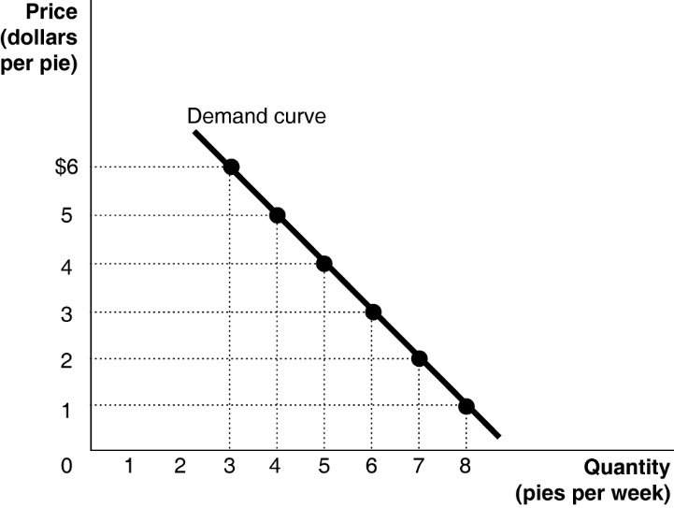

**c.** The slope = ∆*y*/∆*x* = rise/run = −1/1 = –1.

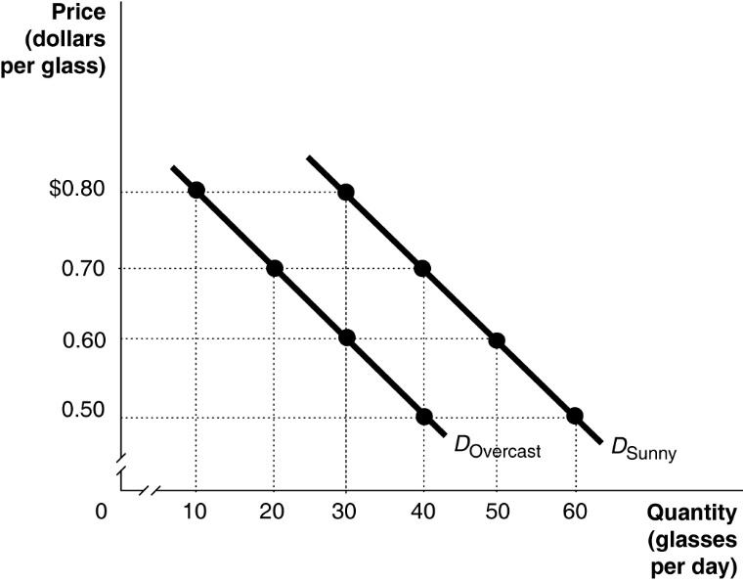**1A.2**

**1A.3** Answers will vary somewhat depending on the values determined from the time-series graph. The calculations below use Ford sales rounded to the nearest million as shown in the table below.

|  |  |
| --- | --- |
| Year | Ford’s Auto Sales (in millions of dollars) |
| 2005 | 6.8 |
| 2006 | 6.6 |
| 2007 | 6.6 |
| 2008 | 5.4 |
| 2009 | 4.9 |
| 2010 | 5.5 |
| 2011 | 5.7 |
| 2012 | 5.7 |
| 2013 | 6.3 |
| 2014 | 6.3 |
| 2015 | 6.6 |
| 2016 | 6.7 |

**Year Percentage Change**

2006 [(6.6 – 6.8)/6.8] × 100 = −2.9%

2007 [(6.6 – 6.6)/6.6] × 100 = 0.0%

2008 [(5.4 – 6.6)/6.6] × 100 = −18.2%

2009 [(4.9 – 5.4)/5.4] × 100 = −9.3%

2010 [(5.5 – 4.9)/4.9] × 100 = 12.2%

2011 [(5.7 – 5.5)/5.5] × 100 = 3.6%

2012 [(5.7 – 5.7)/5.7] × 100 = 0.0%

2013 [(6.3 – 5.7)/5.7] × 100 = 10.5%

2014 [(6.3 – 6.3)/6.3] × 100 = 0.0%

2015 [(6.6 – 6.3)/6.3] × 100 = 4.8%

2016 [(6.7 – 6.6)/6.6] × 100 = 1.5%

We can conclude that sales fell at the highest rate in 2008.

**1A.4** Percentage change in real GDP:

[($16 397 billion − $15 982 billion)/$15 982 billion] × 100 = 2.6%

The percentage change in real GDP from one year to the next is the economy’s growth rate.

**1A.5**

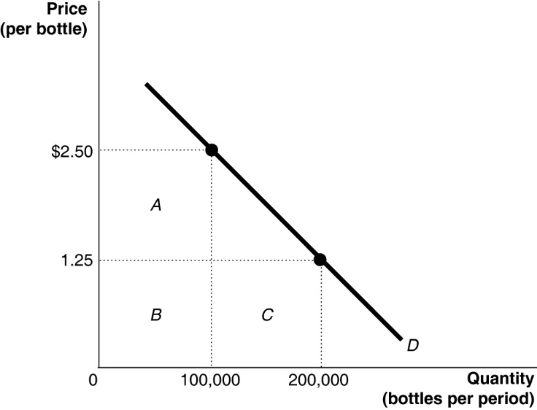 **a.**

**b.** At $2.50 per bottle, the total revenue equals rectangles *A* + *B* = $250 000 (because $2.50 × 100 000 = $250 000). At $1.25 per bottle, the total revenue equals rectangles *B* + *C* = $250 000 (because $1.25 × 200 000 = $250 000).

**1A.6** The triangle’s area = 0.5 × 60 000 × $0.75 = $22 500.

**1A.7** The slope is calculated using the formula:



At point *A*: rise = 300 − 175 = 125, run = 7 − 5 = 2. Therefore, the slope = 125/2 = 62.5.

At point *B*: rise = 900 − 700 = 200, run = 14 – 12 = 2. Therefore, the slope = 200/2 = 100.