Earth Science, 15e (Tarbuck)
Chapter 1 Introduction to Earth Science

1) What are the basic differences between the disciplines of physical and historical geology?
A) Physical geology is the study of fossils and sequences of rock strata; historical geology is the study of how rocks and minerals were used in the past.
B) Historical geology involves the study of rock strata, fossils, and geologic events, utilizing the geologic time scale as a reference; physical geology includes the study of how rocks form and of how erosion shapes the land surface.
C) Physical geology involves the study of rock strata, fossils, and deposition in relation to plate movements in the geologic past; historical geology charts how and where the plates were moving in the past.
D) None of the above-physical geology and historical geology are essentially the same.
Answer: B
Diff: 1
Topic: 1.1 What Is Earth Science?
Bloom's Taxonomy: Remembering/Understanding

2) The study of Earth's atmosphere is known as ________.
A) astronomy
B) oceanography
C) meteorology
D) cosmology
Answer: C
Diff: 1
Topic: 1.1 What Is Earth Science?
Bloom's Taxonomy: Remembering/Understanding

3) Which discipline is not used within the Earth sciences?
A) Chemistry
B) Physics
C) Biology
D) Mathematics
E) None of the above; Earth Science makes use of all of these sciences.
Answer: E
Diff: 2
Topic: 1.1 What Is Earth Science?
Bloom's Taxonomy: Applying/Analyzing

4) Oceanography is the study of the oceans and geology is the study of Earth, so what is meteorology?
A) the study of meteors
B) the study of the Sun's impact on the upper atmosphere
C) the study of the atmosphere
D) the study of how to be a TV newscaster
Answer: C
Diff: 1
Topic: 1.1 What Is Earth Science?
Bloom's Taxonomy: Remembering/Understanding
5) Sedimentary rocks with marine fossils are exposed at the top of Mt. Everest. Which scientists would make most use of this observation in their study?
A) meteorologists, because they could use the fossils as a guide to ancient climates
B) geologists, because their elevation is related to physical geology and fossils are related to Earth history
C) oceanographers, because the fossils can tell us about periods when Earth was covered with water to the height of Mt. Everest
D) astronomers, because they can study how life came from outer space to Earth
Answer: B
Diff: 1
Topic: 1.1 What Is Earth Science?
Bloom's Taxonomy: Remembering/Understanding

6) Hurricanes and tornados are natural disasters. What branch of the Earth sciences studies the origin of these phenomena?
A) meteorology
B) geology
C) oceanography
D) astronomy
Answer: A
Diff: 1
Topic: 1.1 What Is Earth Science?
Bloom's Taxonomy: Remembering/Understanding

7) Earthquakes are natural disasters. Which branch of the Earth sciences studies the impact of this phenomenon on coastal environments?
A) meteorology
B) geology
C) oceanography
D) astronomy
Answer: B
Diff: 1
Topic: 1.1 What Is Earth Science?
Bloom's Taxonomy: Remembering/Understanding

8) Haley's Comet visits Earth's atmosphere once every 76 years. What branch of the Earth sciences is the main group that studies these phenomena?
A) meteorology
B) geology
C) oceanography
D) astronomy
Answer: D
Diff: 1
Topic: 1.1 What Is Earth Science?
Bloom's Taxonomy: Remembering/Understanding
9) If you want to buy a house in an area and you are worried there may be an earthquake hazard, who would be the best person to ask for advice on this hazard?
A) a civil engineer
B) a geologist
C) a physicist
D) an astrologer
Answer: B
Diff: 1
Topic: 1.1 What Is Earth Science?
Bloom's Taxonomy: Applying/Analyzing

10) Earth is estimated to be approximately 4.6 billion years old. Life appeared early in the history of Earth, but metazoans (multicelled organisms) did not appear until about 600 million years ago. If the history of Earth were compressed into a single year, about when would metazoans appear?
A) late September
B) late November
C) mid-December
D) late January
Answer: B
Diff: 2
Topic: 1.1 What Is Earth Science?
Bloom's Taxonomy: Applying/Analyzing

11) Which of the following would not typically be considered an Earth Science study?
A) studies of volcanic eruptions
B) studies of impact craters on the moon
C) studies of acid mine waters and the bacteria that live in those waters
D) chemical refining of petroleum
Answer: D
Diff: 1
Topic: 1.1 What Is Earth Science?
Bloom's Taxonomy: Remembering/Understanding

12) Climate change is a well-known human created problem but there remains resistance to addressing the issue despite widespread scientific agreement on the issue. Although most scientists are familiar with the issues, if you were a congressman and wanted an informed analysis of the problem, which of the following would be most likely to give you the most complete analysis?
A) an astronomer
B) a meteorologist with knowledge of oceanography
C) a geologist with knowledge of astronomy
D) a physicist
Answer: B
Diff: 1
Topic: 1.1 What Is Earth Science?
Bloom's Taxonomy: Remembering/Understanding
13) Geologists primarily would study which phenomenon?
A) clouds and precipitation
B) marine life and ocean currents
C) rocks and minerals
D) stars and galaxies
Answer: C
Diff: 1
Topic: 1.1 What Is Earth Science?
Bloom's Taxonomy: Remembering/Understanding

14) Oceanography includes a study of ________.
A) the ocean floor
B) ocean animals
C) chemistry of sea water
D) the effect of oceans on climate
E) all of the above
Answer: E
Diff: 1
Topic: 1.1 What Is Earth Science?
Bloom's Taxonomy: Remembering/Understanding

15) A ________ is a well-tested and widely accepted view that best explains certain scientific observations.
A) hypothesis
B) generalization
C) law
D) theory
Answer: D
Diff: 1
Topic: 1.2 The Nature of Scientific Inquiry
Bloom's Taxonomy: Remembering/Understanding

16) The primary goal of Earth Science is ________.
A) to develop things that will benefit mankind
B) to identify the patterns in nature and use that information to predict the future
C) to locate resources
D) to protect the environment
Answer: B
Diff: 1
Topic: 1.2 The Nature of Scientific Inquiry
Bloom's Taxonomy: Remembering/Understanding

17) All of the following are possible steps of scientific investigation except for ________.
A) the collection of scientific facts through observation and measurement
B) assumption of conclusions without prior experimentation or observation
C) the development of one or more working hypotheses or models to explain facts
D) development of observations and experiments to test the hypotheses
Answer: B
Diff: 2
Topic: 1.2 The Nature of Scientific Inquiry
Bloom's Taxonomy: Applying/Analyzing
18) Which of the following is not necessary for a hypothesis to be accepted by the scientific community?
A) It must be testable.
B) It must predict something other than the observations it was based on.
C) There must be alternative hypotheses proposed.
D) It must be based on observations or facts.
Answer: C
Diff: 1
Topic: 1.2 The Nature of Scientific Inquiry
Bloom's Taxonomy: Remembering/Understanding

19) If someone says that an idea is "only a theory" and implies that this means it can be dismissed, is this a valid viewpoint?
A) The viewpoint is accurate because a theory is essentially just a guess.
B) The viewpoint is accurate because since science is based on interpretation it is not really trustworthy.
C) The viewpoint is incorrect because for an idea to become a theory it has withstood robust testing and is currently accepted.
D) The viewpoint is incorrect because once an idea becomes a theory it can never be disproven.
Answer: C
Diff: 2
Topic: 1.2 The Nature of Scientific Inquiry
Bloom's Taxonomy: Applying/Analyzing

20) The ________ explains how our solar system probably formed from a giant cloud of gases and dispersed solid particles.
A) protogalactic theory
B) nebular theory
C) extrastellar solar hypothesis
D) planetary compression theory
Answer: B
Diff: 1
Topic: 1.3 Early Evolution of Earth
Bloom's Taxonomy: Remembering/Understanding

21) Which of the following is not a planet?
A) Europa
B) Venus
C) Saturn
D) Neptune
Answer: A
Diff: 1
Topic: 1.3 Early Evolution of Earth
Bloom's Taxonomy: Remembering/Understanding
22) In the television series "Cosmos" the astronomer Carl Sagan used to say, "We are all made of star stuff." What did he mean by that?
A) All of the chemical elements were formed during the big bang when the universe began, so we are like the stars.
B) We all have to potential to be stars.
C) All of the chemical elements in our solar system were forged in an ancient star that went supernova.
D) The earth has incorporated large amounts of chemical material from the solar wind, so our bodies carry this material.
Answer: C
Diff: 2
Topic: 1.3 Early Evolution of Earth
Bloom's Taxonomy: Applying/Analyzing

23) In the proto-solar system nebula, gravity pulled matter together to form larger bodies. As they collided, what happened to these bodies?
A) Oblique collisions caused individual bodies to spin.
B) The objects broke apart to form asteroids, much like a neutron colliding with a heavy atom produces fission.
C) The objects temporarily broke apart and then reformed into large objects, cooling rapidly during the breakup period.
D) Immense heat was released within the colliding bodies as gravitational potential energy was converted to heat.
Answer: D
Diff: 1
Topic: 1.3 Early Evolution of Earth
Bloom's Taxonomy: Remembering/Understanding

24) Light elements like hydrogen and helium form a large percentage of the outer planets and Sun is made up primarily of hydrogen. Why are these elements nearly absent from the inner planets?
A) The Sun captured all of the hydrogen during its formation.
B) These light elements are blown away from the inner planets by the solar wind.
C) It is a mystery that has never been solved by science.
D) Hydrogen and helium have all been bound up by chemical reactions on the inner planets and are held in rock.
Answer: B
Diff: 1
Topic: 1.3 Early Evolution of Earth
Bloom's Taxonomy: Remembering/Understanding

25) Comets are made up primarily of ________.
A) iron-nickel alloys
B) silicate minerals, like rocks on Earth
C) frozen hydrogen
D) frozen water, carbon dioxide, and methane
Answer: D
Diff: 1
Topic: 1.3 Early Evolution of Earth
Bloom's Taxonomy: Remembering/Understanding
26) The Oort cloud is ________.
A) an unusual type of cloud formed when meteorites strike Earth
B) another name for the inner solar system, just before the Sun became hot enough for nuclear fusion
C) the outer solar system where planetesimals, rocky debris and comets orbit outside beyond the outer planets but cross into the inner solar system at times
D) the asteroid belt
Answer: C
Diff: 1
Topic: 1.3 Early Evolution of Earth
Bloom's Taxonomy: Remembering/Understanding

27) The circumference of Earth is about ________ km.
A) 10,000
B) 20,000
C) 30,000
D) 40,000
Answer: D
Diff: 1
Topic: 1.3 Early Evolution of Earth
Bloom's Taxonomy: Remembering/Understanding

28) The ________ refers to the sum total of all life on Earth.
A) hydrosphere
B) atmosphere
C) biosphere
D) geosphere
Answer: C
Diff: 1
Topic: 1.4 Earth as a System
Bloom's Taxonomy: Remembering/Understanding

29) The ________ refers to the water-dominated parts of Earth.
A) hydrosphere
B) atmosphere
C) biosphere
D) geosphere
Answer: A
Diff: 1
Topic: 1.4 Earth as a System
Bloom's Taxonomy: Remembering/Understanding

30) The largest of Earth's spheres is the ________.
A) hydrosphere
B) atmosphere
C) geosphere
D) biosphere
Answer: C
Diff: 1
Topic: 1.4 Earth as a System
Bloom's Taxonomy: Remembering/Understanding
31) Soil belongs to the ________.
A) hydrosphere
B) atmosphere
C) geosphere
D) biosphere
E) All of the above
Answer: E
Diff: 1
Topic: 1.4 Earth as a System
Bloom's Taxonomy: Remembering/Understanding

32) The exchange of energy between the surface of Earth, the atmosphere, and space causes ________.
A) topography
B) temperature
C) weather
D) glaciers
Answer: C
Diff: 1
Topic: 1.4 Earth as a System
Bloom's Taxonomy: Remembering/Understanding

33) Ocean surf wearing away rocks is an example of the interaction of which two of Earth's spheres?
A) atmosphere and hydrosphere
B) biosphere and atmosphere
C) biosphere and geosphere
D) hydrosphere and geosphere
Answer: D
Diff: 2
Topic: 1.4 Earth as a System
Bloom's Taxonomy: Applying/Analyzing

34) In correct order from the center outward, Earth includes which units?
A) core, inner mantle, outer mantle, crust
B) inner core, outer core, mantle, crust
C) inner core, crust, mantle, hydrosphere
D) core, crust, mantle, hydrosphere
Answer: B
Diff: 1
Topic: 1.4 Earth as a System
Bloom's Taxonomy: Remembering/Understanding

35) The composition of Earth's inner core is thought to be ________.
A) basalt
B) granite
C) peridotite
D) solid iron-nickel alloy
Answer: D
Diff: 1
Topic: 1.4 Earth as a System
Bloom's Taxonomy: Remembering/Understanding
36) The asthenosphere is part of the ________ of Earth.
A) outer core
B) crust
C) inner core
D) mantle
Answer: D
Diff: 1
Topic: 1.4 Earth as a System
Bloom's Taxonomy: Remembering/Understanding

37) The ________ is thought to be a liquid, metallic region in Earth's interior.
A) inner core
B) lithosphere
C) mantle
D) outer core
Answer: D
Diff: 1
Topic: 1.4 Earth as a System
Bloom's Taxonomy: Remembering/Understanding

38) The ________ is the thinnest layer of Earth.
A) crust
B) outer core
C) mantle
D) inner core
Answer: A
Diff: 1
Topic: 1.4 Earth as a System
Bloom's Taxonomy: Remembering/Understanding

39) The ________ forms the relatively cool, brittle tectonic plates.
A) asthenosphere
B) lithosphere
C) astrosphere
D) eosphere
Answer: B
Diff: 1
Topic: 1.5 The Face of Earth
Bloom's Taxonomy: Remembering/Understanding

40) Which of the following energy sources is thought to drive the lateral motions of Earth's lithospheric plates?
A) gravitational attractive forces of the Sun and Moon
B) electrical and magnetic fields localized in the inner core
C) heat transfer between Earth's interior and the surface of Earth
D) swirling movements of the molten iron particles in the outer core
Answer: C
Diff: 1
Topic: 1.5 The Face of Earth
Bloom's Taxonomy: Remembering/Understanding
41) Convergent plate boundaries are ________.
A) sites where oceanic plates descend beneath continental plates
B) sites where heat from Earth's interior is vented to the surface as volcanoes
C) areas where two plates slide laterally past one another, generating earthquakes, like the San Andreas fault
D) sites of supervolcanoes like Yellowstone
Answer: A
Diff: 1
Topic: 1.5 The Face of Earth
Bloom's Taxonomy: Remembering/Understanding

42) Oceanic crust is generated at ________.
A) hot spots on the sea floor, like Iceland
B) spreading ridges
C) convergent plate margins
D) transform plate margins
Answer: B
Diff: 1
Topic: 1.5 The Face of Earth
Bloom's Taxonomy: Remembering/Understanding

43) Continental shields and platforms represent ________.
A) sites where continents collide, analogous to warriors clashing shields
B) names given to Paleozoic mountain belts
C) sedimentary basins with inland seas shaped like a shield, like Hudson's bay
D) areas in the interior of continents that have not experienced mountain building for billions of years
Answer: D
Diff: 1
Topic: 1.5 The Face of Earth
Bloom's Taxonomy: Remembering/Understanding

44) Which of the following layers in Earth has the highest density?
A) lithosphere
B) asthenosphere
C) lower mantle
D) outer Core
Answer: D
Diff: 1
Topic: 1.5 The Face of Earth
Bloom's Taxonomy: Remembering/Understanding

45) The Andes Mountains in South America are formed as a result of ________.
A) subduction
B) sea floor spreading
C) back-arc contraction
D) continental collision
Answer: A
Diff: 1
Topic: 1.5 The Face of Earth
Bloom's Taxonomy: Remembering/Understanding
46) The Himalayan Mountains and adjacent Tibet are a mountain system formed by ________.
A) subduction
B) sea floor spreading
C) back-arc contraction
D) continental collision
Answer: D
Diff: 1
Topic: 1.5 The Face of Earth
Bloom's Taxonomy: Remembering/Understanding

47) Which of the following is a reasonable approximation of the rate that plates move?
A) the rate of growth of human hair or fingernails
B) the speed a turtle walks
C) the speed of a mountain glacier
D) the speed of deep ocean currents
Answer: A
Diff: 2
Topic: 1.5 The Face of Earth
Bloom's Taxonomy: Remembering/Understanding

48) What two chemical elements are most abundant in the deep interior of Earth?
A) iron and magnesium
B) magnesium and oxygen
C) hydrogen and helium
D) silicon and oxygen
Answer: A
Diff: 1
Topic: 1.5 The Face of Earth
Bloom's Taxonomy: Remembering/Understanding

49) A major cause of the differences in elevation between ocean basins and continents is ________.
A) viscosity
B) temperature
C) density
D) mass
Answer: C
Diff: 1
Topic: 1.5 The Face of Earth
Bloom's Taxonomy: Remembering/Understanding

50) Ocean floor averages about ________ km depth below sea level.
A) 2
B) 4
C) 6
D) 8
Answer: B
Diff: 1
Topic: 1.5 The Face of Earth
Bloom's Taxonomy: Remembering/Understanding
51) Ocean crust is denser than continental crust because ocean crust is ________.
A) composed primarily of basalt
B) composed primarily of granite
C) thicker than continental crust
D) thinner than continental crust
Answer: A
Diff: 1
Topic: 1.5 The Face of Earth
Bloom's Taxonomy: Remembering/Understanding

52) Flat, stable areas of continental crust tend to be located ________.
A) along coastlines
B) near desert regions
C) in the interior of continents
D) in areas that receive large amounts of rainfall
Answer: C
Diff: 1
Topic: 1.5 The Face of Earth
Bloom's Taxonomy: Remembering/Understanding

53) Major mountain belts on Earth are ________.
A) older than smaller mountain belts because they have had enough time to grow large
B) located around the Pacific Ocean
C) over 10 km high
D) made of granite because it is low density and allows for maximum growth
Answer: B
Diff: 1
Topic: 1.5 The Face of Earth
Bloom's Taxonomy: Remembering/Understanding

54) Shield areas in continental interiors are characterized by ________.
A) linear chains of mountains less than 100 million years old
B) flat areas that include rocks older than 1 billion years old
C) flat river valleys that cut through older mountain ranges
D) ancient coastal regions that have become abandoned and eroded
Answer: B
Diff: 1
Topic: 1.5 The Face of Earth
Bloom's Taxonomy: Remembering/Understanding

55) Which of the following is not considered to be part of a typical ocean basin?
A) a linear chain of volcanoes
B) large expanses of flat plains
C) granitic intrusions
D) deep canyons
Answer: C
Diff: 1
Topic: 1.5 The Face of Earth
Bloom's Taxonomy: Remembering/Understanding
56) Deep ocean trenches typically are not located adjacent to ________.
A) transform plate boundaries
B) volcanic island arc chains
C) young continental mountains
D) abyssal plains
Answer: A
Diff: 1
Topic: 1.5 The Face of Earth
Bloom's Taxonomy: Remembering/Understanding

57) Long oceanic mountain chains typically are characterized by ________.
A) highly deformed sedimentary rocks
B) granitic plutons and batholiths
C) layers of igneous rocks
D) rocks older than 1 billion years old
Answer: C
Diff: 1
Topic: 1.5 The Face of Earth
Bloom's Taxonomy: Remembering/Understanding

58) Active mountain belts are most likely to be found ________.
A) along the margins of continents
B) in the interior regions of continents
C) scattered throughout continents
D) along only the eastern margins of continents
Answer: A
Diff: 1
Topic: 1.5 The Face of Earth
Bloom's Taxonomy: Remembering/Understanding

59) The continental shelf is located ________.
A) between the continental slope and continental rise
B) between the continental rise and the abyssal plains
C) seaward of the continental slope
D) landward of the continental slope
Answer: D
Diff: 1
Topic: 1.5 The Face of Earth
Bloom's Taxonomy: Remembering/Understanding

60) The most prominent features on the ocean floor are the ________.
A) deep-ocean trenches
B) oceanic ridges
C) seamounts
D) lava plateaus
Answer: B
Diff: 1
Topic: 1.5 The Face of Earth
Bloom's Taxonomy: Remembering/Understanding
61) Below is a picture of Mt. St. Helens volcano

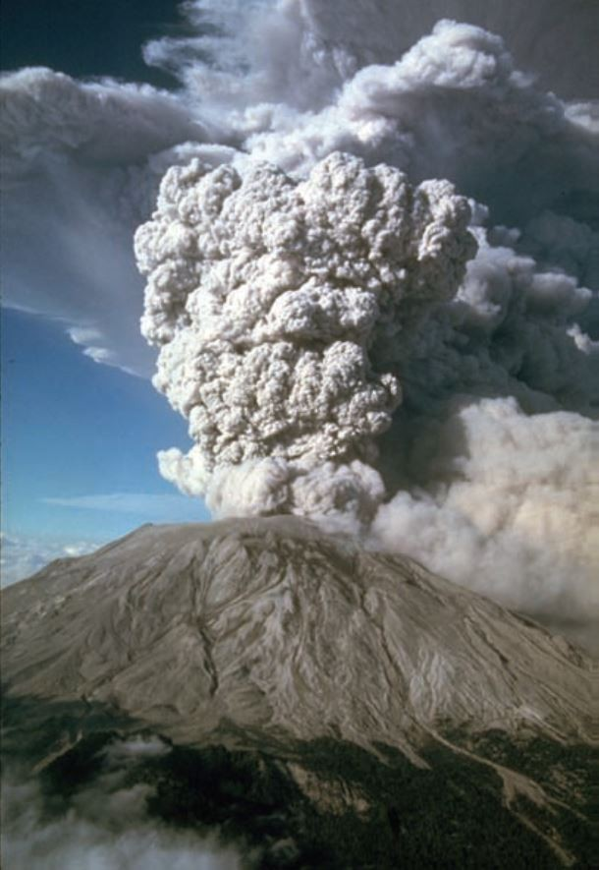

What is the usual cause for such events?
A) earthquakes
B) interaction of the hydrosphere and the atmosphere
C) location near a plate boundary
D) location in earth's interior
Answer: B
Diff: 2
Topic: 1.5 The Face of Earth
Bloom's Taxonomy: Applying/Analyzing
62) Below is a picture of an Appalachian mountain ridge and Himalayan mountain peaks (left and right, respectively). Why are the Appalachians so much smoother and lower than the Himalayan Mountains?

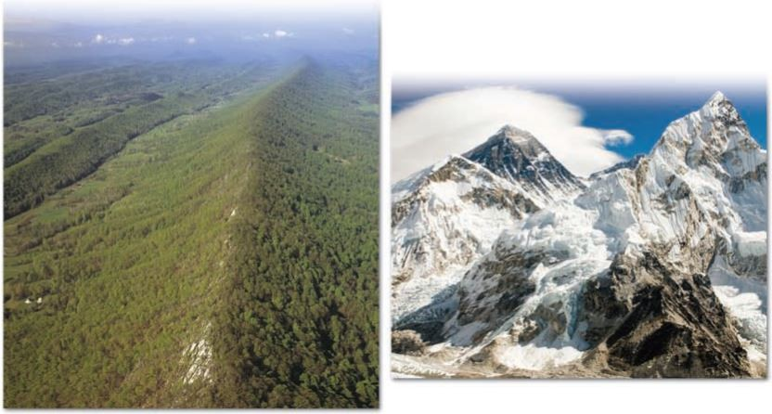

A) The Appalachian Mountains are younger and have not yet built up to being jagged.
B) The Appalachian Mountains are younger and younger mountains tend to be more weathered.
C) The Appalachian Mountains are older and thus have become more worn down.
D) The Appalachian Mountains are older and thus have softer rocks.
Answer: C
Diff: 2
Topic: 1.5 The Face of Earth
Bloom's Taxonomy: Applying/Analyzing

63) A(n) ________ system is one in which energy moves freely in and out, but no matter enters or leaves the system.
A) closed
B) open
C) feedback
D) equilibrated
Answer: A
Diff: 1
Topic: 1.4 Earth as a System
Bloom's Taxonomy: Remembering/Understanding

64) Mechanisms that enhance or drive change are known as ________.
A) negative feedback mechanisms
B) positive feedback mechanisms
C) closed feedback mechanisms
D) open feedback mechanisms
Answer: B
Diff: 1
Topic: 1.4 Earth as a System
Bloom's Taxonomy: Remembering/Understanding
65) What is the source of the energy that powers the Earth system?
A) the Sun
B) heat from Earth's interior
C) both A and B
D) none of the above
Answer: C
Diff: 1
Topic: 1.4 Earth as a System
Bloom's Taxonomy: Remembering/Understanding

66) Which of the following is not a system?
A) the biosphere
B) soil, plants, rock, soil organisms, and animals
C) the study of minerals
D) the Pacific Ocean and the west coast of North America
Answer: C
Diff: 2
Topic: 1.4 Earth as a System
Bloom's Taxonomy: Applying/Analyzing

67) A mineralogist studies minerals and their origins. A mineralogist studying the Earth system would ________.
A) do the same thing, studying minerals and their origins, as any other mineralogist
B) study how minerals form rocks
C) study how minerals influence organisms living on them, how they react with water to produce soil forming minerals, or study how wind transports minerals as dust and influences climate
D) Minerals can never be used to study the Earth system.
Answer: C
Diff: 2
Topic: 1.4 Earth as a System
Bloom's Taxonomy: Applying/Analyzing

68) Examine the words and/or phrases below and determine the relationship among the majority of words/phrases. Choose the option that does not fit the pattern.
A) hypothesis
B) theory
C) fact
D) observation
Answer: C
Diff: 2
Topic: 1.2 The Nature of Scientific Inquiry
Bloom's Taxonomy: Applying/Analyzing
69) Examine the words and/or phrases below and determine the relationship among the majority of words/phrases. Choose the option that does not fit the pattern.
A) Oort cloud
B) planetesimals
C) meteorites
D) comets
Answer: A
Diff: 2
Topic: 1.3 Early Evolution of Earth
Bloom's Taxonomy: Applying/Analyzing

70) Examine the words and/or phrases below and determine the relationship among the majority of words/phrases. Choose the option that does not fit the pattern.
A) hydrosphere
B) biosphere
C) atmosphere
D) solid Earth
Answer: A
Diff: 2
Topic: 1.4 Earth as a System
Bloom's Taxonomy: Applying/Analyzing

71) Examine the words and/or phrases below and determine the relationship among the majority of words/phrases. Choose the option that does not fit the pattern.
A) crust
B) mantle
C) lithosphere
D) core
Answer: C
Diff: 2
Topic: 1.5 The Face of Earth
Bloom's Taxonomy: Applying/Analyzing

72) Examine the words and/or phrases below and determine the relationship among the majority of words/phrases. Choose the option that does not fit the pattern.
A) mountain belt
B) shield
C) continental interior
D) stable platform
Answer: A
Diff: 2
Topic: 1.5 The Face of Earth
Bloom's Taxonomy: Applying/Analyzing
73) Examine the words and/or phrases below and determine the relationship among the majority of words/phrases. Choose the option that does not fit the pattern.
A) abyssal plain
B) seamount
C) oceanic ridge
D) continental crust
Answer: D
Diff: 2
Topic: 1.5 The Face of Earth
Bloom's Taxonomy: Applying/Analyzing

74) Examine the words and/or phrases below and determine the relationship among the majority of words/phrases. Choose the option that does not fit the pattern.
A) astronomy
B) geology
C) meteorology
D) oceanography
E) psychology
Answer: E
Diff: 1
Topic: 1.1 What Is Earth Science?
Bloom's Taxonomy: Remembering/Understanding

75) The vast majority of Earth scientists are involved in ________.
A) either extraction of mineral resources or energy
B) exploring the features and process of Earth
C) lobbying for alternative energy for profit
D) focusing on only one earth science discipline with few connections to other Earth science disciplines.
Answer: A
Diff: 1
Topic: 1.1 What Is Earth Science?
Bloom's Taxonomy: Remembering/Understanding

76) Earth Science uses ________.
A) mathematics
B) chemistry
C) biology
D) All of the above
Answer: D
Diff: 1
Topic: 1.1 What Is Earth Science?
Bloom's Taxonomy: Remembering/Understanding

77) Environmental science primarily focuses on any of the following except ________.
A) water use
B) air pollution
C) sustainable development
D) mineral classification
Answer: D
Diff: 1
Topic: 1.1 What Is Earth Science?
Bloom's Taxonomy: Remembering/Understanding
78) Science is based on the assumption that nature behaves in a ________ and ________ manner.
A) consistent; predictable
B) consistent; unpredictable
C) inconsistent; predictable
D) inconsistent; unpredictable
Answer: A
Diff: 1
Topic: 1.2 The Nature of Scientific Inquiry
Bloom's Taxonomy: Remembering/Understanding

79) A scientific ________ is a tentative or untested explanation that is proposed to explain scientific observations.
A) hypothesis
B) law
C) observation
D) theory
Answer: D
Diff: 1
Topic: 1.2 The Nature of Scientific Inquiry
Bloom's Taxonomy: Remembering/Understanding

80) A scientific theory is the ________ step in developing an idea. It is ________ well tested.
A) first; not very
B) first; very
C) last; not very
D) last; very
Answer: D
Diff: 1
Topic: 1.2 The Nature of Scientific Inquiry
Bloom's Taxonomy: Remembering/Understanding

81) The "Big Bang" is an example of a ________.
A) hypothesis
B) law
C) observation
D) theory
Answer: D
Diff: 1
Topic: 1.2 The Nature of Scientific Inquiry and 1.3 Early Evolution of Earth
Bloom's Taxonomy: Remembering/Understanding

82) The formation of the solar system from a huge cloud of gases and dispersed particles is known as the ________.
A) Big Bang theory
B) harmony of the heavens
C) origin of species
D) solar galactic hypothesis
Answer: D
Diff: 1
Topic: 1.3 Early Evolution of Earth
Bloom's Taxonomy: Remembering/Understanding
83) According to the nebular theory, all of the bodies in the universe evolved from a rotating cloud of gases and dust about ________ billion years ago.
A) 2
B) 3
C) 5
D) 12
Answer: C
Diff: 1
Topic: 1.3 Early Evolution of Earth
Bloom's Taxonomy: Remembering/Understanding

84) There are places on the deepest parts of the ocean where no ________ penetrates that support colonies of life.
A) energy
B) light
C) sound
D) water
Answer: B
Diff: 1
Topic: 1.4 Earth as a System
Bloom's Taxonomy: Remembering/Understanding

85) Oceans cover about ________ of Earth's surface.
A) 30
B) 70
C) 90
D) 97
Answer: B
Diff: 1
Topic: 1.4 Earth as a System
Bloom's Taxonomy: Remembering/Understanding

86) The lithosphere and asthenosphere are layers of Earth defined by their ________.
A) biology
B) composition
C) heat
D) strength
Answer: D
Diff: 1
Topic: 1.4 Earth as a System
Bloom's Taxonomy: Remembering/Understanding

87) The earth is sometimes called "The Blue Planet" because the ________ appear(s) blue in sunlight.
A) atmosphere
B) lakes
C) overall surface of earth from space
D) rivers
Answer: C
Diff: 1
Topic: 1.4 Earth as a System
Bloom's Taxonomy: Remembering/Understanding
88) Internally, Earth consists of ________ shells with different compositions and densities.
A) circular
B) hollow
C) rectangular
D) square
Answer: A
Diff: 1
Topic: 1.5 The Face of Earth
Bloom's Taxonomy: Remembering/Understanding

89) The asthenosphere is the ________ layer in the upper mantle that the plates move on.
A) all liquid
B) all solid
C) gaseous
D) partially melted
Answer: D
Diff: 1
Topic: 1.5 The Face of Earth
Bloom's Taxonomy: Remembering/Understanding

90) Subduction zones are where ________ are descending.
A) collisional mountain chairs
B) transform faults
C) magmas
D) oceanic plates
Answer: D
Diff: 1
Topic: 1.5 The Face of Earth
Bloom's Taxonomy: Remembering/Understanding

91) Earth's core is largely molten ________ and ________ and convection of this molten mass generates Earth's magnetic field.
A) nickel, iron
B) nickel, silicon
C) oxygen, iron
D) silicon, iron
Answer: A
Diff: 1
Topic: 1.5 The Face of Earth
Bloom's Taxonomy: Remembering/Understanding

92) Subduction zones are regions of convergence and the overlying plate is made of ________ lithosphere.
A) continental
B) liquid
C) oceanic
D) sedimentary
Answer: A
Diff: 1
Topic: 1.5 The Face of Earth
Bloom's Taxonomy: Remembering/Understanding
93) During the history of Earth there have been periods when all the continents were together in a supercontinent known as ________.
A) Gaia
B) Laurentia
C) Pangaea
D) Tethys
Answer: C
Diff: 1
Topic: 1.5 The Face of Earth
Bloom's Taxonomy: Remembering/Understanding

94) The asthenosphere is a relatively ________ and rigid shell that ________ the lithosphere.
A) cool; overlies
B) cool; underlies
C) warm; overlies
D) warm; underlies
Answer: D
Diff: 1
Topic: 1.5 The Face of Earth
Bloom's Taxonomy: Remembering/Understanding

95) Continents are, on average, about 2 km higher than sea level.
Answer: FALSE
Diff: 1
Topic: 1.5 The Face of Earth
Bloom's Taxonomy: Remembering/Understanding

96) The waterline where the ocean meets the land is the boundary between ________.
A) continental crust and oceanic crust
B) dry land and submerged land
C) mid-ocean ridge and subduction zone
D) all of the above
Answer: B
Diff: 1
Topic: 1.5 The Face of Earth
Bloom's Taxonomy: Remembering/Understanding
97) Shields and stable platforms are typically found in the ________ regions of a continent.
A) atmospheric
B) exterior
C) interior
D) subsurface
Answer: C
Diff: 1
Topic: 1.5 The Face of Earth
Bloom's Taxonomy: Remembering/Understanding
98) Humans are ________ the Earth System ________ Earth's environment in a major way.
A) not part of; but affect
B) not part of; and do not affect
C) part of; and affect
D) part of; but do not affect
Answer: C
Diff: 2
Topic: 1.4 Earth as a System
Bloom's Taxonomy: Applying/Analyzing

99) In an open system energy and matter flow ________ of the system.
A) into but not out
B) into and out
C) not into but out
D) not into and not out
Answer: B
Diff: 1
Topic: 1.4 Earth as a System
Bloom's Taxonomy: Remembering/Understanding

100) The two broad, traditional subject areas of geologic study are ________.
A) mineralogy and igneous petrology
B) physical and historical geology
C) structural geology and sedimentology
D) None of the above
Answer: B
Diff: 1
Topic: 1.1 What Is Earth Science?
Bloom's Taxonomy: Remembering/Understanding

101) The thin, outer layer of Earth, from 7 to 40 km in thickness, is called the ________.
A) core
B) crust
C) lithosphere
D) mantle
Answer: B
Diff: 1
Topic: 1.4 Earth as a System
Bloom's Taxonomy: Remembering/Understanding

102) The ________ is the relatively rigid zone above the asthenosphere that includes the crust and upper mantle.
A) core
B) crust
C) lithosphere
D) mantle
Answer: C
Diff: 1
Topic: 1.5 The Face of Earth
Bloom's Taxonomy: Remembering/Understanding
103) The ________ is the solid, rocky shell between the crust and outer core.
A) core
B) crust
C) lithosphere
D) mantle
Answer: D
Diff: 1
Topic: 1.5 The Face of Earth
Bloom's Taxonomy: Remembering/Understanding

104) The convective flow of liquid, metallic iron in the ________ is thought to generate Earth's magnetic field.
A) asthenosphere
B) inner core
C) lithosphere
D) outer core
Answer: D
Diff: 1
Topic: 1.5 The Face of Earth
Bloom's Taxonomy: Remembering/Understanding

105) Moving from the shoreline towards the deep-ocean basin, the first part of the continental margin you would encounter would be the continental ________.
A) rise
B) shelf
C) slope
D) trench
Answer: B
Diff: 1
Topic: 1.5 The Face of Earth
Bloom's Taxonomy: Remembering/Understanding

106) The ________ are the most prominent feature on the ocean floor.
A) abyssal mounds
B) mid-ocean ridges
C) seamounts
D) sediment cores
Answer: B
Diff: 1
Topic: 1.5 The Face of Earth
Bloom's Taxonomy: Remembering/Understanding
107) Earth's physical environment is traditionally divided in the hydrosphere, atmosphere, and the solid Earth. Remembering the scientific method, why do you think that scientists tend to categorize and classify various features, phenomena, and characteristics of the natural world into groups or subdivisions? Also, are there potential pitfalls or problems if we only consider the natural world as individual groups or categories rather than as a whole?
Answer: Categorizing and classifying is a way of cataloging the differences and similarities between things. We put items that are mostly similar into the same broad groups and separate items that are mostly different. From this system, we can begin to study why things are similar and what is the significance of the differences and that helps us to get to the basic processes that are of scientific interest. The pitfalls or problems are that we may not recognize similarities in objects that have been classified as different and vice versa. Also, we are likely to miss the interactions between different groups and the processes that cause those interactions when we focus on classifying things.
Diff: 3
Topic: 1.4 Earth as a System
Bloom's Taxonomy: Synthesis/Evaluation

108) What is the relationship of the dense oceanic crust that is produced at a divergent plate boundary to the convergence or collision of an oceanic plate and a continental plate, such as the western margin of South America in the diagram below?

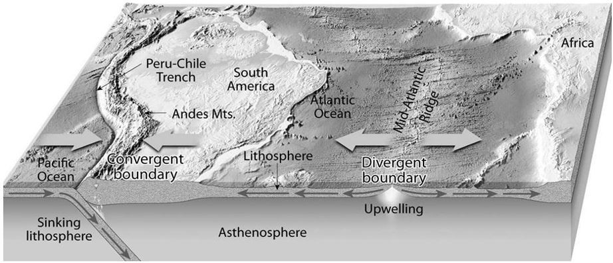
Answer: The dense oceanic crust sinks underneath the more buoyant continental crust at this type of convergent plate boundary.
Diff: 2
Topic: 1.5 The Face of Earth
Bloom's Taxonomy: Applying/Analyzing
109) Below is a picture of water striking rocks at a coastline.

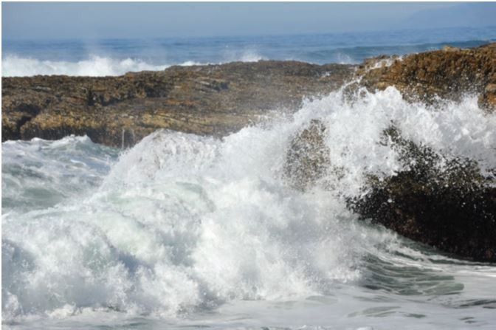

Describe which of Earth's "spheres" are interacting here, and some of the effects that may be caused by this interaction.
Answer: Student may say that the hydrosphere (surf) and geosphere (rocks) are interacting. They may also involve the atmosphere, as its energy is driving the force of the waves. Less commonly they may invoke the biosphere, nothing that the rocks may be made from the shells of organisms. In terms of the effects, they could note that the surf energy will diminish when it hits the land, but erosion may occur as a result of the surf hitting land.
Diff: 2
Topic: 1.4 Earth as a System
Bloom's Taxonomy: Applying/Analyzing

