Microeconomics: Canada in Global Environment, 11e (Parkin/Bade)
Chapter 1 What Is Economics?

1.1 Definition of Economics

1) In a world characterized by scarcity
A) all goods are free.
B) opportunity cost is zero.
C) we are not limited by time.
D) individuals need not work to obtain goods.
E) people must make choices among alternatives.
Answer: E
Diff: 1 Type: MC
Topic: Definition of Economics

2) Which of the following is the best definition of economics?
A) the study of how a provincial government allocates tax dollars
B) the study of how consumers spend their income
C) the study of how producers decide what inputs to hire and what outputs to produce
D) the study of how individuals, businesses, governments, and entire societies make choices as they cope with scarcity and the incentives that influence and reconcile those choices
E) the study of how consumers and producers meet each other in the market
Answer: D
Diff: 1 Type: MC
Topic: Definition of Economics

3) Which of the following is a microeconomic topic?
A) the reasons why a consumer buys less honey
B) the reasons why the average price level in a country falls
C) the cause of increasing unemployment
D) the effect of the government budget deficit on inflation
E) the reasons why the labour force in a country decreases
Answer: A
Diff: 1 Type: MC
Topic: Definition of Economics

4) The study of how wages are set for New Brunswick teachers is classified as
A) a macroeconomic topic.
B) a microeconomic topic.
C) economics of social interest.
D) economics of private interest.
E) normative economics.
Answer: B
Diff: 1 Type: MC
Topic: Definition of Economics

5) Which of the following newspaper headlines concerns a macroeconomic issue?
A) Why are people buying more SUVs and fewer minivans?
B) How would a tax on e-commerce affect chapters.indigo.ca?
C) How would an unexpected freeze in Oxford, Nova Scotia change the price of blueberries in the Maritimes?
D) Why is the U.S. economy experiencing slow growth?
E) Why do grain producers purchase less pesticides?
Answer: D
Diff: 1 Type: MC
Topic: Definition of Economics

6) The branch of economics that studies the choices of individuals and businesses is
A) macroeconomics.
B) microeconomics.
C) positive economics.
D) normative economics.
E) social economics.
Answer: B
Diff: 1 Type: MC
Topic: Definition of Economics

7) Each of the following would be considered a macroeconomic topic except
A) the reasons for a decrease in the unemployment rate.
B) the cause of recessions.
C) the effect of the government budget deficit on inflation.
D) the determination of aggregate income.
E) the selection of production techniques.
Answer: E
Diff: 2 Type: MC
Topic: Definition of Economics

8) Complete the following sentence. Macroeconomics
A) is primarily concerned with the operation of individual markets in the economy.
B) deals mainly with the economic behaviour of households.
C) is the only part of economics to deal with government decisions.
D) is primarily concerned with the behaviour of the stock market.
E) is the study of the performance of the national economy and the global economy.
Answer: E
Diff: 2 Type: MC
Topic: Definition of Economics

9) The determination of prices in individual markets is primarily a concern of
A) positive economics.
B) negative economics.
C) macroeconomics.
D) microeconomics.
E) descriptive economics.
Answer: D
Diff: 2 Type: MC
Topic: Definition of Economics

10) Which one of the following topics does macroeconomics study?
A) decisions of individual firms
B) effects of government safety regulations on the price of cars
C) the performance of the global economy
D) prices of individual goods and services
E) effects of taxes on the price of gasoline
Answer: C
Diff: 2 Type: MC
Topic: Definition of Economics

11) Which one of the following topics does microeconomics study?
A) reasons for a fall in the price of orange juice
B) the effect of a rise in the Canadian dollar on Canada's exports
C) effect of interest rates on national economic growth
D) effect of the government budget deficit on employment
E) determination of total production in a country
Answer: A
Diff: 2 Type: MC
Topic: Definition of Economics

12) Complete the following sentence. Microeconomics is
A) not concerned with factors of production.
B) concerned with normative issues only.
C) concerned with the size of the total amount of income earned by all households in an economy.
D) the branch of economics that studies the choices of individuals and businesses.
E) concerned exclusively with the role of the government in the economy.
Answer: D
Diff: 2 Type: MC
Topic: Definition of Economics

13) Which of the following would be considered a microeconomic topic?
A) the severity of a recession
B) the cause of unemployment in the economy
C) the effect of the government budget deficit on inflation
D) the determination of aggregate income
E) the study of how wages are set for childcare workers
Answer: E
Diff: 2 Type: MC
Topic: Definition of Economics

14) The branch of economics that studies the performance of the national economy and the global economy is
A) macroeconomics.
B) microeconomics.
C) Keynesian economics.
D) positive economics.
E) normative economics.
Answer: A
Diff: 1 Type: MC
Topic: Definition of Economics

15) The fact that human wants cannot be fully satisfied with available resources is called the problem of
A) opportunity cost.
B) scarcity.
C) normative economics.
D) marginal cost.
E) the big tradeoff.
Answer: B
Diff: 1 Type: MC
Topic: Definition of Economics

16) The problem of scarcity exists
A) only in economies that lack incentives.
B) only in economies that have incentives.
C) in all economies.
D) only when people are unemployed.
E) now but will be eliminated with economic growth.
Answer: C
Diff: 2 Type: MC
Topic: Definition of Economics

17) The inescapable economic fact is that
A) there are unlimited wants and limited resources.
B) there are unlimited resources, and we have to decide how to allocate them.
C) resources cannot be allocated without government intervention.
D) resources cost too much.
E) there are limited wants and limited resources.
Answer: A
Diff: 2 Type: MC
Topic: Definition of Economics

18) An incentive
A) could be a reward but could not be a penalty.
B) could be a penalty but could not be a reward.
C) could be either a reward or a penalty.
D) is the opposite of a tradeoff.
E) occurs in the macroeconomy but not in the microeconomy.
Answer: C
Diff: 1 Type: MC
Topic: Definition of Economics

19) Scarcity confronts
A) neither the poor nor the rich.
B) the rich but not the poor.
C) the poor but not the rich.
D) the rich and the poor.
E) only families with incomes less than $25,000 a year.
Answer: D
Diff: 1 Type: MC
Topic: Definition of Economics

20) The problem of scarcity applies
A) to all countries, regardless of their level of development.
B) only to industrially developed countries because they create pollution.
C) only to developing countries because resources are scarce in these countries.
D) only to countries that are over-populated.
E) only to countries that use natural resources in most of their production processes.
Answer: A
Diff: 1 Type: MC
Topic: Definition of Economics

21) Operators of private dog parks in your city decide to eliminate their fees and allow dog owners to exercise their dogs in the parks at no charge.
This statement means that the incentive to exercise dogs at the dog park ________. The operators' decision is a ________.
A) remains the same; macroeconomic decision
B) changes; microeconomic decision
C) remains the same; microeconomic decision
D) changes; macroeconomic decision
E) changes; decision in the self-interest but not in the social interest
Answer: B
Diff: 2 Type: MC
Topic: Definition of Economics

22) Choose the statement about incentives that is incorrect.
A) An incentive can be a penalty that discourages an action.
B) Incentives create scarcity.
C) With stiffer penalties for fraud, company directors have an incentive to play by the rules.
D) If the price of a bus ride falls, Jill has less incentive to drive herself to school.
E) An incentive can be a reward that encourages an action.
Answer: B
Diff: 1 Type: MC
Topic: Definition of Economics

1.2 Two Big Economic Questions

1) The two big economic questions
A) involve self-interest only.
B) involve only social interest.
C) involve neither self-interest nor social interest.
D) do not arise from scarcity.
E) involve both self-interest and social interest.
Answer: E
Diff: 1 Type: MC
Topic: Two Big Economic Questions

2) The two big economic questions
A) summarize the scope of economics.
B) are "what goods and services are produced?" and "how are goods and services produced?"
C) are "why are goods and services produced?" and "when are goods and services produced?"
D) deal with macroeconomics but not microeconomics.
E) are "where are goods and services produced?" and "what goods and services are produced?"
Answer: A
Diff: 1 Type: MC
Topic: Two Big Economic Questions

3) The two big economic questions include all of the following except
A) what to produce.
B) why to produce.
C) how to produce.
D) for whom to produce.
E) a determination of whether the pursuit of self-interest also promotes the social interest.
Answer: B
Diff: 2 Type: MC
Topic: Two Big Economic Questions

4) When a firm decides to produce more hybrid cars and fewer gas guzzlers, it is answering the ________ question.
A) "how"
B) "what"
C) "who"
D) "where"
E) "when"
Answer: B
Diff: 2 Type: MC
Topic: Two Big Economic Questions

5) When a textile firm decides to produce more silk fabric and less cotton fabric, it is answering the ________ question.
A) "who"
B) "how"
C) "what"
D) "where"
E) "when"
Answer: C
Diff: 2 Type: MC
Topic: Two Big Economic Questions

6) When a farmer decides to harvest tomatoes using machines instead of migrant workers, the farmer is answering the ________ question.
A) "what"
B) "how"
C) "who"
D) "where"
E) "when"
Answer: B
Diff: 2 Type: MC
Topic: Two Big Economic Questions

7) What is capital? Capital is
A) money in the bank.
B) the knowledge and skill that people obtain from education, on-the-job training, and work experience.
C) the tools, instruments, machines, buildings, and other constructions that businesses use to produce goods and services.
D) composed of financial investment and commodities such as gold and silver.
E) traded in stock markets and bond markets.
Answer: C
Diff: 1 Type: MC
Topic: Two Big Economic Questions

8) When a firm decides to produce computers using robots instead of people, it is answering the ________ question.
A) "what"
B) "where"
C) "how"
D) "who"
E) "when"
Answer: C
Diff: 2 Type: MC
Topic: Two Big Economic Questions

9) To meet increased demand for its good, a firm decides to hire a few high-skilled workers, rather than hire many low-skilled workers. The firm is answering the ________ question.
A) "when"
B) "what"
C) "who"
D) "where"
E) "how"
Answer: E
Diff: 2 Type: MC
Topic: Two Big Economic Questions

10) An art museum decides to offer audio tour downloads rather than have tour guides. The museum is answering the ________ question.
A) "what"
B) "who"
C) "how"
D) "where"
E) "when"
Answer: C
Diff: 2 Type: MC
Topic: Two Big Economic Questions

11) To earn income, people sell the services of the factors of production they own. Land earns ________ and labour earns ________.
A) profit; wages
B) wages; interest
C) rent; wages
D) profit; interest
E) rent; minimum wage
Answer: C
Diff: 2 Type: MC
Topic: Two Big Economic Questions

12) Some people can afford to live in beautiful homes and others are homeless. This is an example of an economy answering the ________ question.
A) "what"
B) "how"
C) "for whom"
D) "where"
E) "when"
Answer: C
Diff: 2 Type: MC
Topic: Two Big Economic Questions

13) A hockey player earns $10 million a year and a teacher earns $75,000 a year. This is an example of an economy answering the ________ question.
A) "what"
B) "how"
C) "where"
D) "for whom"
E) "when"
Answer: D
Diff: 2 Type: MC
Topic: Two Big Economic Questions

14) What is entrepreneurship? Entrepreneurship is
A) a form of money.
B) traded on the stock market.
C) categorized as capital.
D) the human resource that organizes labour, land and capital.
E) categorized as the factor of production labour.
Answer: D
Diff: 2 Type: MC
Topic: Two Big Economic Questions

15) Sue, who has a law degree, earns $200,000 a year, while Chris, a high-school dropout, earns $15.00 an hour. This is an example of an economy answering the ________ question.
A) "what"
B) "how"
C) "for whom"
D) "where"
E) "when"
Answer: C
Diff: 2 Type: MC
Topic: Two Big Economic Questions

16) A star athlete owns many cars while other people who cannot afford a car use a city bus for transportation. This is an example of an economy answering the ________ question.
A) "what"
B) "how"
C) "for whom"
D) "where"
E) "when"
Answer: C
Diff: 2 Type: MC
Topic: Two Big Economic Questions

17) What is financial capital? Financial capital is
A) one of the "gifts of nature."
B) a factor of production.
C) money, stocks, and bonds.
D) not subject to scarcity.
E) a service.
Answer: C
Diff: 1 Type: MC
Topic: Two Big Economic Questions

18) Which factor of production earns the most income?
A) capital
B) land
C) labour
D) entrepreneurship
E) the stock market
Answer: C
Diff: 2 Type: MC
Topic: Two Big Economic Questions

19) A choice is in the social interest when it is
A) best for the poorest citizens.
B) influenced by lobbyists.
C) best for society as a whole.
D) made by majority vote.
E) made by well-meaning citizens.
Answer: C
Diff: 1 Type: MC
Topic: Two Big Economic Questions

20) Choices in the self-interest are
A) choices which are best for the person making them.
B) never in the social interest.
C) always in the social interest.
D) choices that are best for all residents of a region.
E) choices that are agreed to by majority vote.
Answer: A
Diff: 3 Type: MC
Topic: Two Big Economic Questions

21) The expansion of international trade, borrowing and lending, and investment is
A) the big tradeoff.
B) not in the best interests of most countries.
C) a corporate revolution.
D) globalization.
E) antiglobalization.
Answer: D
Diff: 3 Type: MC
Topic: Two Big Economic Questions

22) Which statement about incomes earned by factors of production is correct?
A) Land earns interest.
B) Land earns rent.
C) Labour earns rent.
D) Capital earns profit.
E) Entrepreneurship earns rent.
Answer: B
Diff: 1 Type: MC
Topic: Two Big Economic Questions

23) Which statement about incomes earned by factors of production is false?
A) Land earns rent.
B) Natural resources earn rent.
C) Labour earns wages.
D) Capital earns profit.
E) Entrepreneurship earns profit.
Answer: D
Diff: 1 Type: MC
Topic: Two Big Economic Questions

24) A tractor is an example of which of the following factors of production?
A) capital
B) labour
C) land
D) entrepreneurship
E) energy
Answer: A
Diff: 1 Type: MC
Topic: Two Big Economic Questions

25) Which one of the following is an example of capital as a factor of production?
A) money
B) a Bell Canada bond
C) an automobile factory owned by Ford
D) a high school teacher
E) natural gas
Answer: C
Diff: 1 Type: MC
Topic: Two Big Economic Questions

26) Which of the following would an economist classify as capital?
A) natural resources
B) a deposit of silver
C) entrepreneurship
D) a computer
E) land
Answer: D
Diff: 1 Type: MC
Topic: Two Big Economic Questions

27) Which one of the following is labour?
A) money
B) a carpenter's hammer
C) a shoe factory
D) a bread-slicing machine
E) a singer's voice
Answer: E
Diff: 1 Type: MC
Topic: Two Big Economic Questions

28) Which one of the following would economists classify as land?
A) an automotive plant in British Columbia
B) rich agricultural soil in Saskatchewan
C) an oil rig in the Atlantic Ocean
D) an elementary school in Nova Scotia
E) automobiles parked in a parking lot in Manitoba
Answer: B
Diff: 2 Type: MC
Topic: Two Big Economic Questions

29) Which one of the following is an example of a factor of production?
A) an insurance policy
B) a donut
C) the skills of a welder
D) an IBM stock certificate
E) a computer game
Answer: C
Diff: 1 Type: MC
Topic: Two Big Economic Questions

30) Which one of the following is an example of capital?
A) money
B) a carpenter
C) pasture
D) a bread-slicing machine
E) a university professor
Answer: D
Diff: 1 Type: MC
Topic: Two Big Economic Questions

31) The creation of a successful movie can influence the main questions that economics seeks to answer. Choose the statement that is false.
A) The movie influences the how question because the movie can create new production techniques, which can be used in subsequent films.
B) The movie influences the for whom question because the people who earn higher incomes through the movie production buy more goods and services.
C) The movie influences the when question because movie crews work on many different films and must be available for the entire production.
D) The movie influences the what question because it can lead to spinoff goods or a new movie genre, which can result in the production of similar films.
E) The movie influences the how question because it can use unknown actors or Academy Award winners.
Answer: C
Diff: 1 Type: MC
Topic: Two Big Economic Questions

32) Choose the correct statement.
A) Canada produces more services than goods.
B) In Canada today, manufacturing accounts for 50 percent of total production.
C) In Canada today, agriculture accounts for 30 percent of total production.
D) China's production of services is a greater percentage of its total production than Canada's.
E) Canada's production of manufacturing is a greater percentage of its total production than China's.
Answer: A
Diff: 1 Type: MC
Topic: Two Big Economic Questions

33) In Canada approximately ________ percent of the adult population have completed high school and approximately ________ percent have a college or university degree.
A) 25; 95
B) 95; 55
C) 95; 25
D) 100; 55
E) 55; 25
Answer: C
Diff: 2 Type: MC
Topic: Two Big Economic Questions

34) Which of the following is not a factor of production?
A) the water used to cool a nuclear power plant
B) the effort of farmers raising cattle
C) the wages paid to workers
D) the management skill of a small business owner
E) the land used by a farmer to grow wheat
Answer: C
Diff: 1 Type: MC
Topic: Two Big Economic Questions

35) Which factor of production includes the "gifts of nature"?
A) labour
B) capital
C) human capital
D) entrepreneurship
E) land
Answer: E
Diff: 1 Type: MC
Topic: Two Big Economic Questions

36) Which of the following is not a factor of production?
A) Tim who is developing a production schedule for a new product
B) 175 shares of Microsoft stock
C) vans used by a bakery company for deliveries
D) wilderness areas that have yet to be developed
E) national parks
Answer: B
Diff: 1 Type: MC
Topic: Two Big Economic Questions

37) An outcome is considered efficient if
A) it is the best available choice for an individual.
B) as many people as possible are happy about the outcome.
C) it is not possible to make someone better off without making anyone else worse off.
D) everyone makes the same income.
E) there is the smallest difference possible between the highest income earned and the lowest income earned.
Answer: C
Diff: 2 Type: MC
Topic: Two Big Economic Questions

38) According to Adam Smith
A) government intervention in markets is not desirable because an invisible hand leads decisions made in pursuit of self-interest to unintentionally promote the social interest.
B) in a market transaction buyers can either get what they want for less than they would be willing to pay or sellers can make a profit, but both buyers and sellers can't gain simultaneously.
C) politicians are well-equipped to regulate corporations and intervene in markets to improve market outcomes.
D) when big corporations pursue their self-interest of maximum profit, they will inevitably conflict with social interest.
E) the self-interest and the social interest never conflict.
Answer: A
Diff: 2 Type: MC
Topic: Two Big Economic Questions

39) Which one of the following news headlines definitely concerns the social interest?
A) McDonald's Moves into Salads
B) Starbucks Expands in China
C) E Coli Test Results Must be Posted on Beaches
D) Pumpkin Spice Lattes Available Now!
E) The Maple Leafs Win the Stanley Cup
Answer: C
Diff: 2 Type: MC
Topic: Two Big Economic Questions

40) Which of the following statements is correct?
A) Canada produces more manufactured goods than services.
B) Canada produces more agricultural goods than services.
C) Canada produces more services than goods.
D) Agriculture accounts for 10 percent of total Canadian production.
E) Canada produces more agricultural goods than manufactured goods.
Answer: C
Diff: 1 Type: MC
Topic: Two Big Economic Questions

41) Martin contacts 10 high school students who don't have summer jobs and hires them to work during the summer in his convenience store. He pays 5 of the students $12 an hour and he pays 5 of the students $15 an hour. Is the outcome efficient?
A) The outcome is inefficient because not all students receive the same wage rate.
B) The outcome is efficient because all the students are better off.
C) The outcome is efficient because the students no longer face scarcity.
D) The outcome is inefficient if the students are paid more than minimum wage.
E) The outcome is efficient if the students that Martin hired are hard workers.
Answer: B
Diff: 2 Type: MC
Topic: Two Big Economic Questions

1.3 The Economic Way of Thinking

1) Opportunity cost is
A) the value of your favourite activity.
B) your value of leisure.
C) the money you spend on food, shelter, and clothing.
D) the marginal benefit of an activity.
E) the highest-valued alternative that we give up to get something.
Answer: E
Diff: 2 Type: MC
Topic: The Economic Way of Thinking

2) During the next hour John can choose one of the following three activities: playing basketball, watching television, or reading a book. The opportunity cost of reading a book
A) depends on how much the book cost when it was purchased.
B) is the value of playing basketball if John prefers that to watching television.
C) is the value of playing basketball and the value of watching television.
D) depends on how much John enjoys the book.
E) is equal to the marginal benefit of reading the book.
Answer: B
Diff: 3 Type: MC
Topic: The Economic Way of Thinking

3) Sally has to decide whether to study for her economics test or her accounting test. If she chooses to study for accounting, her opportunity cost of studying accounting is
A) studying economics.
B) less than the value of studying economics.
C) not comparable to the value of studying economics.
D) equal to the value of studying economics.
E) the future lost wages that will occur if she fails her accounting exam.
Answer: A
Diff: 2 Type: MC
Topic: The Economic Way of Thinking

4) When the government of Alberta chooses to build more roads, the required resources are no longer available to provide better healthcare facilities. This situation illustrates the concept of
A) marginal benefit.
B) monetary cost.
C) opportunity cost.
D) human capital.
E) entrepreneurship.
Answer: C
Diff: 1 Type: MC
Topic: The Economic Way of Thinking

5) The concept of opportunity cost
A) is used in microeconomics but not macroeconomics.
B) suggests that individuals can achieve all they want.
C) suggests that a major increase in public education spending means reduced expansion in the public healthcare system.
D) is used in macroeconomics but not microeconomics.
E) is relevant only for developing countries.
Answer: C
Diff: 2 Type: MC
Topic: The Economic Way of Thinking

6) To make choices, people must
A) be risk-takers.
B) have unlimited resources.
C) be free from government constraint.
D) have unlimited access to information at no cost.
E) evaluate the values of alternative actions.
Answer: E
Diff: 2 Type: MC
Topic: The Economic Way of Thinking

7) When the government chooses to use resources to build a dam, those resources are no longer available to build a highway. This illustrates the concept of
A) a market.
B) macroeconomics.
C) opportunity cost.
D) a "how" tradeoff.
E) the big tradeoff.
Answer: C
Diff: 2 Type: MC
Topic: The Economic Way of Thinking

8) Marginal benefit is
A) the cost of an increase in an activity.
B) the sum of benefit and cost that arises from an increase in an activity.
C) the cost of a decrease in an activity.
D) the benefit that arises from an increase in an activity.
E) the benefit that arises from a decrease in an activity.
Answer: D
Diff: 2 Type: MC
Topic: The Economic Way of Thinking

9) "There can be too much of a good thing." This statement suggests that
A) choices made in self-interest cannot be applied to many economic decisions.
B) a good may be produced to the point where its marginal cost exceeds its marginal benefit.
C) certain goods and services such as education and health care are inherently desirable and should be produced regardless of costs and benefits.
D) a good may be produced to the point where its marginal benefit exceeds its marginal cost.
E) a good may be produced to the point where its marginal benefit is equal to its marginal cost.
Answer: B
Diff: 2 Type: MC
Topic: The Economic Way of Thinking

10) Which of the following sayings best describes opportunity cost?
A) "Make hay while the sun shines."
B) "Love of money is the root of all evil."
C) "Boldly go where no one has gone before."
D) "There's no such thing as a free lunch."
E) "Baseball has been very good to me."
Answer: D
Diff: 2 Type: MC
Topic: The Economic Way of Thinking

11) If you take an additional class this term, you can graduate earlier. This is an example of
A) opportunity cost.
B) total cost.
C) the pursuit of social interest.
D) marginal benefit.
E) social cost.
Answer: D
Diff: 2 Type: MC
Topic: The Economic Way of Thinking

12) Marginal benefit is the
A) total benefit from an activity.
B) additional benefit from a decrease in an activity.
C) additional benefit from an increase in an activity.
D) opportunity cost of a decrease in an activity.
E) opportunity cost of an increase in an activity.
Answer: C
Diff: 1 Type: MC
Topic: The Economic Way of Thinking

13) What is marginal cost? Marginal cost is
A) the total cost of an activity.
B) the total cost of a decrease in an activity.
C) the opportunity cost of an increase in an activity.
D) the opportunity cost of a decrease in an activity.
E) equal to marginal benefit.
Answer: C
Diff: 1 Type: MC
Topic: The Economic Way of Thinking

14) Monika will choose to eat a seventh pizza slice if
A) the marginal benefit of the seventh slice is greater than its marginal cost.
B) the marginal benefit of the seventh slice is less than its marginal cost.
C) the total benefit of all seven slices is greater than their total cost.
D) the total benefit of all seven slices is less than their total cost.
E) she has enough money to pay for it.
Answer: A
Diff: 2 Type: MC
Topic: The Economic Way of Thinking

15) The night before a history test, you decide to go to the movies instead of reviewing your notes. You get 60 percent on your test compared with the 75 percent that you normally score. You ________ a tradeoff and the opportunity cost of your evening at the movies was ________.
A) faced; the 15 percent fall in your grade
B) did not face; zero
C) did not face; the 15 percent fall in your grade
D) faced; the mark of 60 percent on your test
E) faced; the 75 percent that you normally score
Answer: A
Diff: 1 Type: MC
Topic: The Economic Way of Thinking

16) A university decides to change its late night bus service between the campus and student housing from a fare-based service to a free service. This statement means that the incentive to ride the bus ________ and the opportunity cost of a bus ride ________. The university's decision is a ________ decision.
A) changes; decreases; microeconomic
B) changes; decreases; macroeconomic
C) remains the same; remains the same; macroeconomic
D) remains the same; remains the same; microeconomic
E) changes; increases; microeconomic
Answer: A
Diff: 1 Type: MC
Topic: The Economic Way of Thinking

17) You have the choice of going on vacation to Florida for one week, staying at work for the week, or spending the week doing fix-up projects around your house. If you decide to go to Florida, the opportunity cost of the trip is
A) working and doing fix-up projects.
B) working or doing fix-up projects, depending on which you would have done otherwise.
C) working, because you would be giving up income.
D) nothing because you will enjoy the trip to Florida.
E) variable depending on the weather you leave behind in Canada.
Answer: B
Diff: 1 Type: MC
Topic: The Economic Way of Thinking

18) Laura is a manager for HP. When Laura must decide whether to produce a few additional printers, she is choosing at the margin when she compares
A) the total revenue from sales of printers to the total cost of producing all the printers.
B) the extra revenue from selling a few additional printers to the extra costs of producing the printers.
C) the extra revenue from selling a few additional printers to the average cost of producing the additional printers.
D) the revenue from selling HP's printers as compared to printers from competing companies, such as Lexmark.
E) the cost of producing HP's printers as compared to printers from competing companies, such as Lexmark.
Answer: B
Diff: 1 Type: MC
Topic: The Economic Way of Thinking

19) Which of the following creates an incentive to increase the amount of an activity?
A) an increase in the marginal cost of the activity and a decrease in the marginal benefit of the activity
B) a decrease in the marginal cost of the activity and an increase in the marginal benefit of the activity
C) constant marginal cost and constant marginal benefit of the activity
D) an increase in the marginal cost of the activity and an equal increase in the marginal benefit of the activity
E) a decrease in the marginal cost of the activity and an equal decrease in the marginal benefit of the activity
Answer: B
Diff: 1 Type: MC
Topic: The Economic Way of Thinking

20) You have the choice to go skiing during spring break, staying at the university to study, or spending the week visiting your family. If you decide to go skiing, the opportunity cost of the holiday is
A) staying at the university to study because you need to improve your grades.
B) staying at the university because your parents are paying your tuition.
C) staying at the university or spending the week visiting your family, depending on what you would have done otherwise.
D) nothing because you enjoy skiing.
E) visiting your family because not visiting means that you will feel guilty.
Answer: C
Diff: 1 Type: MC
Topic: The Economic Way of Thinking

21) Chanel has the option of purchasing one of three products: Brand A, Brand B, or Brand C. The price of each product is $10. If Chanel decides to purchase Brand A, the opportunity cost of this decision is
A) $20.
B) Brand B or Brand C, depending on which she considers to be the highest-valued alternative forgone.
C) Brand A.
D) Brand B and Brand C.
E) zero if this is a frivolous purchase with no marginal benefit.
Answer: B
Diff: 2 Type: MC
Topic: The Economic Way of Thinking

22) If Gordon's decision to attend Western University is a rational choice, then
A) most of Gordon's friends must have made the same choice of university.
B) Gordon faced no tradeoff when he made his choice.
C) tuition and living costs at Western University must have been less than at any other university.
D) for Gordon, attending Western University achieved the greatest benefit over cost.
E) Western must be the university that is closest to Gordon's home
Answer: D
Diff: 2 Type: MC
Topic: The Economic Way of Thinking

Use the information below to answer the following questions.

Fact 1.3.1 Costco

When Costco opened a gas bar just off Highway 401, the neighbourhood was swamped with cars as drivers lined up to get a discount of 10 cents a litre.

23) Refer to Fact 1.3.1. The opportunity cost of a litre of gas includes
A) the time that you would have spent doing something other than lining up to buy a litre of gasoline.
B) the amount of money that a consumer saves by buying gasoline at Costco.
C) the 10 cent discount on a litre of gasoline.
D) the pleasure that motorists receive from buying cheaper gasoline.
E) the incentive to purchase a full tank of gas.
Answer: A
Diff: 1 Type: MC
Topic: Economics as Social Science and Policy Tool

24) Refer to Fact 1.3.1. To control the crowd Costco hires traffic police. When Costco hires traffic police, it faces a tradeoff that could include all of the following except
A) hiring more customer service representatives.
B) having a larger inventory of stock.
C) having large seasonal displays.
D) taking business away from gas stations in the area.
E) expansion of the warehouse.
Answer: D
Diff: 2 Type: MC
Topic: Economics as Social Science and Policy Tool

1.4 Economics as Social Science and Policy Tool

1) Statements about "what should be" are called
A) positive statements.
B) normative statements.
C) economic statements.
D) scientific statements.
E) hypotheses.
Answer: B
Diff: 1 Type: MC
Topic: Economics as Social Science and Policy Tool

2) Statements about "what is" are called
A) positive statements.
B) normative statements.
C) economic statements.
D) scientific statements.
E) hypotheses.
Answer: A
Diff: 1 Type: MC
Topic: Economics as Social Science and Policy Tool

3) Which of the following statements is normative?
A) Scientists should not make normative statements.
B) Warts are caused by handling toads.
C) As e-book prices fall, people buy more of them.
D) If income increases, sales of luxury goods fall.
E) There is more caffeine in a cup of tea than in a cup of coffee.
Answer: A
Diff: 2 Type: MC
Topic: Economics as Social Science and Policy Tool

4) A positive statement is
A) always true.
B) always false.
C) about what ought to be.
D) what is currently believed about the way the world operates.
E) an opinion that cannot be verified.
Answer: D
Diff: 1 Type: MC
Topic: Economics as Social Science and Policy Tool

5) A normative statement is
A) about what should be.
B) about what is.
C) always true.
D) always false.
E) capable of evaluation, as true or false, by observation and measurement.
Answer: A
Diff: 1 Type: MC
Topic: Economics as Social Science and Policy Tool

6) "The rich should face higher income tax rates than the poor." This is an example of
A) a normative statement.
B) a positive statement.
C) a negative statement.
D) economic reasoning.
E) neither a normative nor a positive statement.
Answer: A
Diff: 2 Type: MC
Topic: Economics as Social Science and Policy Tool

7) Which of the following is an example of a positive statement?
A) Canada should cut back on its use of carbon-based fuels such as coal and oil.
B) Increasing the minimum wage results in more unemployment.
C) Every Canadian should have equal access to healthcare.
D) The Bank of Canada should cut the interest rate.
E) Canada should have lower tax rates for wealthier Canadians.
Answer: B
Diff: 2 Type: MC
Topic: Economics as Social Science and Policy Tool

8) What is true about economic models? Economic models
A) do not answer questions about the economic world.
B) include most of the details of the economic world.
C) describe some aspect of the economic world, but include only those features needed for the purpose at hand.
D) answer questions that arise from normative statements.
E) were first developed in the 1970s.
Answer: C
Diff: 2 Type: MC
Topic: Economics as Social Science and Policy Tool

9) The scientific purpose of simplifying assumptions in an economic model is to
A) avoid confronting difficult issues.
B) eliminate the need for further testing of the implications of the model.
C) abstract from the complexities of the real world those issues that are not important for the issues under examination.
D) eliminate the possibility of personal bias in the model.
E) add necessary hypotheses to the problem.
Answer: C
Diff: 2 Type: MC
Topic: Economics as Social Science and Policy Tool

10) Model A is superior to Model B if Model A
A) contains more real world detail than Model B.
B) contains fewer unrealistic assumptions than Model B.
C) makes predictions that correspond more closely to the facts than the predictions of Model B.
D) is preferred by a majority of researchers in a public opinion poll.
E) is scientifically more "elegant" than Model B.
Answer: C
Diff: 2 Type: MC
Topic: Economics as Social Science and Policy Tool

11) In choosing among alternative models, economists generally have the strongest preference for models that
A) have assumptions that are close to exact replicas of reality.
B) are detailed and complex, with every available fact and figure included.
C) have few assumptions and are as simple as possible, even if they cannot predict very well.
D) predict better than any other that is available.
E) have assumptions that are complicated.
Answer: D
Diff: 2 Type: MC
Topic: Economics as Social Science and Policy Tool

12) A normative statement is a statement regarding
A) what is usually the case.
B) the assumptions of an economic model.
C) what should be.
D) the predictions of an economic model.
E) what is.
Answer: C
Diff: 1 Type: MC
Topic: Economics as Social Science and Policy Tool

13) An economic model is tested by
A) examining the realism of its assumptions.
B) comparing its predictions with the facts.
C) comparing its complexity to other models that deal with similar issues.
D) the Testing Committee of the Canadian Economic Association.
E) comparing its descriptions and examining the realism of its assumptions.
Answer: B
Diff: 2 Type: MC
Topic: Economics as Social Science and Policy Tool

14) Which of the following is a positive statement?
A) Low rents restrict the supply of housing.
B) Low rents are better for a city than high rents.
C) Housing costs too much.
D) Owners of apartment buildings should be free to charge whatever rent they want.
E) Government should control the rents that apartment owners charge.
Answer: A
Diff: 2 Type: MC
Topic: Economics as Social Science and Policy Tool

15) "The rich face higher income tax rates than the poor, which is not good since it is the rich who provide jobs for the poor." This is an example of
A) a normative statement.
B) a positive statement.
C) a negative statement.
D) a theoretical statement.
E) a descriptive statement.
Answer: A
Diff: 2 Type: MC
Topic: Economics as Social Science and Policy Tool

16) An economic model is
A) tested by examining the realism of its assumptions.
B) useful if it predicts well, even if its assumptions are not realistic.
C) tested by the Testing Committee of the Canadian Economic Association.
D) not useful unless it predicts with 100 percent accuracy.
E) not useful because it simplifies real problems.
Answer: B
Diff: 1 Type: MC
Topic: Economics as Social Science and Policy Tool

17) Select the best statement about economic models.
A) An economic model must always be correct in its predictions or it must be discarded.
B) An economic model is evaluated based on the realism of its assumptions.
C) An economic model should not generate predictions about actual events in the real world, since it discusses only abstract events.
D) An economic model will be discarded if its predictions are often in conflict with the facts.
E) Economic models are all false.
Answer: D
Diff: 2 Type: MC
Topic: Economics as Social Science and Policy Tool

18) Economists test economic models by using
A) the what, how, and for whom questions.
B) positive statements and normative statements.
C) personal economic policy, business economic policy, and government economic policy.
D) natural experiments, statistical investigations, and economic experiments.
E) marginal benefit and marginal cost.
Answer: D
Diff: 2 Type: MC
Topic: Economics as Social Science and Policy Tool

19) Which of the following statements are positive?
1. The federal government should increase taxes on the production of biofuels.
2. Pandemic restrictions reduced passenger air travel.
3. The greatest number of accidents are caused by drunk drivers.
4. We should have a cure for cancer.
A) Statements 1 and 4 are positive.
B) Statements 2 and 3 are positive.
C) Statements 1 and 2 are positive.
D) Statements 3 and 4 are positive.
E) Statements 2 and 4 are positive.
Answer: B
Diff: 2 Type: MC
Topic: Economics as Social Science and Policy Tool

20) Which of the following statements are true regarding "positive" statements?
I. They describe what "should be."
II. They describe what is believed about how the world appears.
III. They can be tested as to their truthfulness.
A) I and II
B) II and III
C) I and III
D) I, II and III
E) None of the statements are true.
Answer: B
Diff: 1 Type: MC
Topic: Economics as Social Science and Policy Tool

21) Which of the following is a normative statement?
A) Next year's inflation rate will be under 2 percent.
B) Consumers will buy more gasoline over the December holiday period than they bought during the summer holiday period even if the price of gas is 10 cents a litre higher than it was during the summer.
C) Government cuts in welfare spending impose an unfair hardship on the poor.
D) A wheat shortage or surplus is always the result of federal government policies.
E) Hurricane Katrina caused more damage in the United States than Hurricane Andrew.
Answer: C
Diff: 1 Type: MC
Topic: Economics as Social Science and Policy Tool

22) When Al makes the statement, "The cost of living has increased 10 percent over the past 10 years," he is
A) making a positive statement.
B) making a negative statement.
C) making a normative statement.
D) testing an economic model.
E) identifying the tradeoff between the standard of living and the cost of living.
Answer: A
Diff: 1 Type: MC
Topic: Economics as Social Science and Policy Tool

23) A good economic model
A) does not include more than two variables.
B) includes only those features of the world that are needed for the purpose at hand.
C) describes all aspects of the economic world.
D) includes only features of the world that can be described numerically.
E) includes more than two variables but less than 10 variables.
Answer: B
Diff: 1 Type: MC
Topic: Economics as Social Science and Policy Tool

24) "The poor pay too much for housing" is ________ statement.
"More low priced housing should be available" is ________ statement.
A) a normative; a normative
B) a normative; a positive
C) a positive; a normative
D) a correct; a correct
E) a political; a political
Answer: A
Diff: 1 Type: MC
Topic: Economics as Social Science and Policy Tool

1.5 Economists in the Economy

1) Of the tasks listed below, an economics major would be best qualified to take a job
A) analyzing balance sheets.
B) determining the amount of tax owed.
C) studying ways of using resources more effectively.
D) litigating.
E) determining ways of minimizing taxable income.
Answer: C
Diff: 1 Type: MC
Topic: Economists in the Economy

2) According to the U.S. Bureau of Labor Statistics, between 2014 and 2024
A) budget analyst jobs are expected to grow by less than overall employment growth because these jobs are easy to replace with artificial intelligence.
B) jobs for those with a Ph.D. in economics are forecasted to grow faster than overall employment growth because government jobs for economists are expected to expand.
C) financial analyst jobs are expected to grow by less than overall employment growth.
D) market research analyst jobs are expected to grow by less than overall employment growth.
E) budget analyst jobs are expected to grow by less than overall employment growth because these jobs will be replaced by people with bookkeeping skills.
Answer: A
Diff: 1 Type: MC
Topic: Economists in the Economy

3) The most important skills needed for an economics job include
A) oral communication skills and qualitative skills.
B) critical-thinking skills and entrepreneurial skills.
C) analytical skills and customer service skills.
D) critical-thinking skills and math skills.
Answer: D
Diff: 1 Type: MC
Topic: Economists in the Economy

4) Choose the correct option regarding the earnings of economics majors.
A) A person who majors in economics, completes a Ph.D., and gets a job as an economist would expect to earn about $250,000 by mid-career.
B) Graduates in economics can generally expect to earn more than graduates in sociology or business.
C) Market research analysts and financial analysts can generally expect to earn more at mid-career than a person with a Ph.D. in economics.
D) The Web resource payscale.com reports that the pay range for economists is between $25,000 and $250,000.
E) Economists who work in finance, insurance, and government jobs earn less than other economists on average.
Answer: B
Diff: 1 Type: MC
Topic: Economists in the Economy

1.6 Appendix: Graphing Data

Use the figure below to answer the following questions.

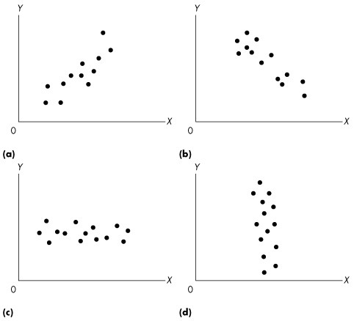

Figure 1A.1.1

1) The graphs in Figure 1A.1.1 are examples of
A) misleading graphs.
B) graphs that show no relationship between x and y.
C) dot diagrams.
D) scatter diagrams.
E) none of the above.
Answer: D
Diff: 1 Type: MC
Topic: Appendix: Graphing Data

Use the figure below to answer the following questions.

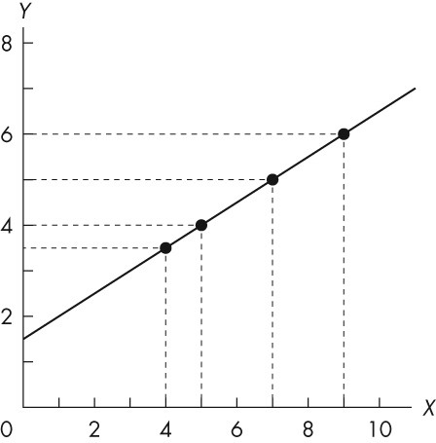

Figure 1A.1.2

2) In Figure 1A.1.2, the value of y is 5 when x is
A) 4.
B) 5.
C) 6.
D) 7.
E) 8.
Answer: D
Diff: 1 Type: MC
Topic: Appendix: Graphing Data

3) Refer to Figure 1A.1.2. If x decreases from 5 to 4, y
A) decreases from 4 to 3.
B) decreases from 4 to 3 1/2.
C) decreases from 4 to 2.
D) increases from 4 to 5.
E) increases from 3 1/2 to 4.
Answer: B
Diff: 1 Type: MC
Topic: Appendix: Graphing Data

4) Refer to Figure 1A.1.2. When y increases from 5 to 6, x
A) increases from 5 to 6.
B) increases from 7 to 8.
C) increases from 7 to 9.
D) decreases from 9 to 7.
E) increases from 7 to 7 1/2.
Answer: C
Diff: 1 Type: MC
Topic: Appendix: Graphing Data

1.7 Appendix: Graphs Used in Economic Models

Use the figure below to answer the following questions.

Figure 1A.2.1

1) Refer to Figure 1A.2.1. Which graph or graphs indicates a positive relationship between x and y?
A) (a)
B) (b)
C) (c)
D) (d)
E) (a) and (d)
Answer: A
Diff: 2 Type: MC
Topic: Appendix: Graphs Used in Economic Models

2) Refer to Figure 1A.2.1. Which graph or graphs indicates a negative relationship between x and y?
A) (a)
B) (b)
C) (c)
D) (d)
E) (b) and (d)
Answer: B
Diff: 2 Type: MC
Topic: Appendix: Graphs Used in Economic Models

3) Refer to Figure 1A.2.1. Which graph or graphs indicates no relationship between x and y?
A) (a)
B) (b)
C) (c)
D) (c) and (d)
E) (a) and (b)
Answer: D
Diff: 3 Type: MC
Topic: Appendix: Graphs Used in Economic Models

4) Consider graph (a) of Figure 1A.2.1. Which one of the following statements is true?
A) The graph shows a negative relationship.
B) x and y are unrelated.
C) The graph shows a positive relationship.
D) x and y move in opposite directions.
E) Both A and D are correct.
Answer: C
Diff: 2 Type: MC
Topic: Appendix: Graphs Used in Economic Models

5) Consider graph (b) of Figure 1A.2.1. Which one of the following statements is true?
A) The graph shows a negative relationship.
B) x and y are unrelated.
C) The graph shows a positive relationship.
D) x and y move in opposite directions.
E) Both A and D are correct.
Answer: E
Diff: 3 Type: MC
Topic: Appendix: Graphs Used in Economic Models

6) Consider graph (d) of Figure 1A.2.1. Which one of the following statements is true?
A) The graph shows a negative relationship.
B) x and y are unrelated.
C) The graph shows a positive relationship.
D) x and y move in opposite directions.
E) Both A and D are correct.
Answer: B
Diff: 3 Type: MC
Topic: Appendix: Graphs Used in Economic Models

7) If variables x and y move in the same direction, they are
A) positively related.
B) negatively related.
C) conversely related.
D) unrelated.
E) trendy.
Answer: A
Diff: 2 Type: MC
Topic: Appendix: Graphs Used in Economic Models

8) Two variables are positively related if
A) increases in one are associated with decreases in the other.
B) increases in one are associated with increases in the other.
C) decreases in one are associated with increases in the other.
D) any change in one causes an increase in the other.
E) any change in one causes a decrease in the other.
Answer: B
Diff: 2 Type: MC
Topic: Appendix: Graphs Used in Economic Models

9) Two variables are negatively related if
A) increases in one are associated with decreases in the other.
B) increases in one are associated with increases in the other.
C) both variables are less than zero.
D) any change in one causes an increase in the other.
E) any change in one causes a decrease in the other.
Answer: A
Diff: 2 Type: MC
Topic: Appendix: Graphs Used in Economic Models

10) The relationship between two variables that are positively related is shown graphically by a line that
A) slopes upward to the right.
B) is horizontal.
C) slopes downward to the right.
D) is vertical.
E) is above the x-axis and to the right of the y-axis.
Answer: A
Diff: 2 Type: MC
Topic: Appendix: Graphs Used in Economic Models

11) The relationship between two variables that are negatively related is shown graphically by a line that
A) slopes upward to the right.
B) is horizontal.
C) slopes downward to the right.
D) is vertical.
E) is below the x-axis and to the left of the y-axis.
Answer: C
Diff: 2 Type: MC
Topic: Appendix: Graphs Used in Economic Models

Use the figure below to answer the following questions.

Figure 1A.2.2

12) Refer to Figure 1A.2.2. The variables x and y
A) are negatively related.
B) have a nonlinear relationship.
C) have a negative linear relationship.
D) are unrelated.
E) are positively related.
Answer: E
Diff: 2 Type: MC
Topic: Appendix: Graphs Used in Economic Models

Use the figure below to answer the following question.

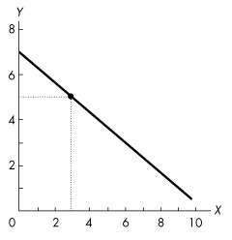

Figure 1A.2.3

13) In Figure 1A.2.3, the variables x and y
A) move in the same direction.
B) have a negative relationship.
C) are always equal.
D) are unrelated
E) have a positive relationship.
Answer: B
Diff: 1 Type: MC
Topic: Appendix: Graphs Used in Economic Models

14) The relationship between two variables that move in opposite directions is shown graphically by a line that is
A) positively sloped.
B) relatively steep.
C) relatively flat.
D) negatively sloped.
E) curved.
Answer: D
Diff: 1 Type: MC
Topic: Appendix: Graphs Used in Economic Models

Use the figure below to answer the following questions.

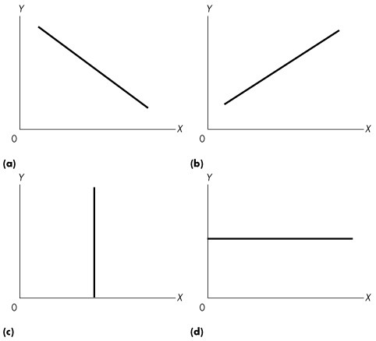

Figure 1A.2.4

15) Refer to Figure 1A.2.4. If economic theory predicts that higher levels of the rate of interest (x) lead to lower levels of sales of houses (y), which graph represents this economic relationship?
A) (a)
B) (b)
C) (c)
D) (d)
E) (a) or (d)
Answer: A
Diff: 2 Type: MC
Topic: Appendix: Graphs Used in Economic Models

16) Refer to Figure 1A.2.4. If theory predicts that a rise in the wage rate (x) leads to a rise in the amount of labour supplied in the economy (y), which graph represents this relationship?
A) (a)
B) (b)
C) (c)
D) (d)
E) (a) or (c)
Answer: B
Diff: 2 Type: MC
Topic: Appendix: Graphs Used in Economic Models

17) Refer to Figure 1A.2.4. Which of the graphs shows a positive relationship between x and y?
A) (a)
B) (b)
C) (c)
D) (d)
E) both (b) and (d)
Answer: B
Diff: 1 Type: MC
Topic: Appendix: Graphs Used in Economic Models

18) Refer to Figure 1A.2.4. Which one of the graphs shows a negative relationship between x and y?
A) (a)
B) (b)
C) (c)
D) (d)
E) both (a) and (d)
Answer: A
Diff: 1 Type: MC
Topic: Appendix: Graphs Used in Economic Models

19) Refer to Figure 1A.2.4. Suppose theory predicted that for low levels of quantity produced (x) a firm's profits (y) were low, for medium levels of output their profits were high, and for high levels of output their profits were low again. Which one of the graphs would represent this relationship?
A) (a)
B) (b)
C) (c)
D) (d)
E) none of the graphs
Answer: E
Diff: 2 Type: MC
Topic: Appendix: Graphs Used in Economic Models

Use the figure below to answer the following questions.

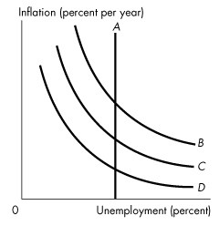
Figure 1A.2.5

20) Which curve or curves in Figure 1A.2.5 shows a positive relationship between unemployment and inflation?
A) A
B) A and B
C) B, C, and D
D) A and C
E) none of the curves.
Answer: E
Diff: 1 Type: MC
Topic: Appendix: Graphs Used in Economic Models

21) Which curve or curves in Figure 1A.2.5 shows no relationship between unemployment and inflation?
A) A
B) A and B
C) B, C, and D
D) A and C
E) B and D
Answer: A
Diff: 1 Type: MC
Topic: Appendix: Graphs Used in Economic Models

22) Which curve or curves in Figure 1A.2.5 shows a negative relationship between unemployment and inflation?
A) A
B) A and B
C) B, C, and D
D) A and D
E) B and C
Answer: C
Diff: 1 Type: MC
Topic: Appendix: Graphs Used in Economic Models

Use the table below to answer the following question.

Table 1A.2.1
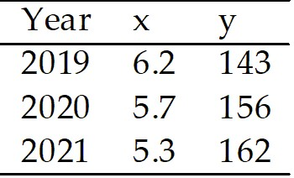

23) The data in Table 1A.2.1 shows that
A) x and y have a negative relationship.
B) x and y have a positive relationship.
C) there is no relationship between x and y.
D) there is first a negative and then a positive relationship between x and y.
E) there is first a positive and then a negative relationship between x and y.
Answer: A
Diff: 2 Type: MC
Topic: Appendix: Graphs Used in Economic Models

Use the figure below to answer the following question.

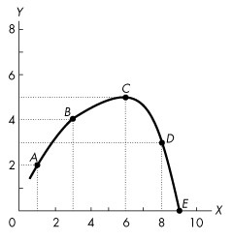

Figure 1A.2.6

24) Refer to Figure 1A.2.6. Which one of the following statements is true?
A) x and y are positively related at all points between A and D.
B) x and y are negatively related at all points between points B and D.
C) y reaches a maximum at point C.
D) y reaches a minimum at point C.
E) x and y are unrelated.
Answer: C
Diff: 1 Type: MC
Topic: Appendix: Graphs Used in Economic Models

Use the table below to answer the following question.

Table 1A.2.2

y | 4 | 6 | 8 | 10 | 12
z | 1 | 2 | 3 | 4 | 5

25) Refer to Table 1A.2.2. What type of relationship exists between y and z?
A) negative
B) positive
C) inverse
D) No consistent relationship exists.
E) first a positive relationship, then a negative one
Answer: B
Diff: 2 Type: MC
Topic: Appendix: Graphs Used in Economic Models

Use the table below to answer the following question.

Table 1A.2.3

w | 2 | 4 | 6 | 8 | 10
u | 15 | 12 | 9 | 6 | 3

26) Refer to Table 1A.2.3. What type of relationship exists between w and u?
A) positive
B) negative
C) direct
D) No consistent relationship exists.
E) first a positive relationship, then a negative one
Answer: B
Diff: 2 Type: MC
Topic: Appendix: Graphs Used in Economic Models

Use the figure below to answer the following question.

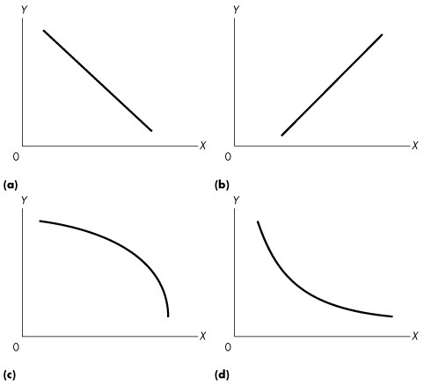

Figure 1A.2.7

27) Refer to Figure 1A.2.7. Consider the values for x and y given in the following table:

x | 2 | 4 | 6 | 8 | 10
y | 12 | 8 | 5 | 3 | 2

Which one of the graphs in Figure 1A.2.7 represents the relationship between x and y?
A) (a)
B) (b)
C) (c)
D) (d)
E) (a) and (b)
Answer: D
Diff: 1 Type: MC
Topic: Appendix: Graphs Used in Economic Models

1.8 Appendix: The Slope of a Relationship

1) The change in the value of the variable measured on the y- axis divided by the change in the value of the variable measured on the x-axis is
A) increasing.
B) equal to the slope.
C) decreasing.
D) constant.
E) a maximum or minimum.
Answer: B
Diff: 1 Type: MC
Topic: Appendix: The Slope of a Relationship

2) The slope of a horizontal line is
A) positive.
B) negative.
C) zero.
D) infinite.
E) initially positive and then negative.
Answer: C
Diff: 1 Type: MC
Topic: Appendix: The Slope of a Relationship

3) The slope of a straight line
A) is the same at every point.
B) increases as the variable on the x-axis increases if the slope is positive.
C) decreases as the variable on the x-axis increases if the slope is negative.
D) is the same at every point only if the line is horizontal.
E) depends on where you measure the slope.
Answer: A
Diff: 1 Type: MC
Topic: Appendix: The Slope of a Relationship

Use the figure below to answer the following questions.

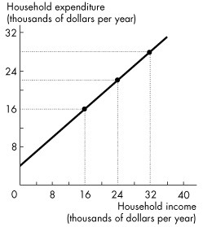

Figure 1A.3.1

4) In Figure 1A.3.1, if household income increases by $1 000, household expenditure will
A) increase by $1,333.
B) decrease by $1,333.
C) remain unchanged.
D) increase by $1,000.
E) increase by $750.
Answer: E
Diff: 2 Type: MC
Topic: Appendix: The Slope of a Relationship

5) The slope of the line in Figure 1A.3.1 is
A) 0.50.
B) 0.75.
C) 1.00
D) 1.25.
E) 1.50.
Answer: B
Diff: 2 Type: MC
Topic: Appendix: The Slope of a Relationship

Use the figure below to answer the following question.

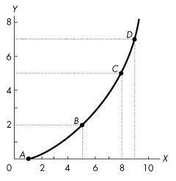

Figure 1A.3.2

6) Refer to Figure 1A.3.2. The slope across the arc between A and B is
A) 1/2.
B) 2/3.
C) 1.
D) 2.
E) 3.
Answer: A
Diff: 2 Type: MC
Topic: Appendix: The Slope of a Relationship

Use the figure below to answer the following questions.

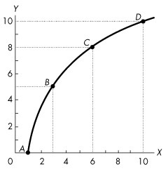

Figure 1A.3.3

7) Figure 1A.3.3 illustrates two variables, x and y, which are
A) negatively related, with a decreasing slope as x increases.
B) negatively related, with an increasing slope as x increases.
C) positively related, with a decreasing slope as x increases.
D) positively related, with an increasing slope as x increases.
E) positively related, with slope first increasing then decreasing.
Answer: C
Diff: 2 Type: MC
Topic: Appendix: The Slope of a Relationship

8) In Figure 1A.3.3, the slope across arc AB is
A) 1/2.
B) 1.
C) 3/2.
D) 5/2.
E) 5/3.
Answer: D
Diff: 2 Type: MC
Topic: Appendix: The Slope of a Relationship

9) In Figure 1A.3.3 the relationship between x and y as x increases is
A) positive with decreasing slope.
B) negative with decreasing slope.
C) negative with increasing slope.
D) positive with increasing slope.
E) positive with slope first increasing then decreasing.
Answer: A
Diff: 3 Type: MC
Topic: Appendix: The Slope of a Relationship

10) What is the slope across the arc between B and C in Figure 1A.3.3?
A) 1/2.
B) 2/3
C) 1
D) 2
E) 3
Answer: C
Diff: 2 Type: MC
Topic: Appendix: The Slope of a Relationship

Use the figure below to answer the following questions.

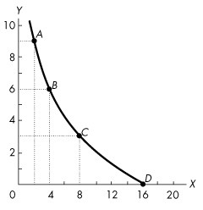

Figure 1A.3.4

11) Figure 1A.3.4 illustrates two variables, x and y, which are
A) negatively related, with slope becoming closer to 0 as x increases from 2 to 16.
B) negatively related, with slope becoming farther from 0 as x increases from 2 to 16.
C) positively related, with slope becoming closer to 0 as x increases from 2 to 16.
D) positively related, with slope becoming farther from 0 as x increases from 2 to 16.
E) positively related, with the slope unchanging as x increases from 2 to 16.
Answer: A
Diff: 2 Type: MC
Topic: Appendix: The Slope of a Relationship

12) In Figure 1A.3.4, the slope across arc AB is
A) 2/3.
B) -1.
C) -3/2.
D) -3.
E) -9/4.
Answer: C
Diff: 2 Type: MC
Topic: Appendix: The Slope of a Relationship

13) In Figure 1A.3.4, the slope across arc BC is
A) -2/3.
B) -3/2.
C) -2.
D) -4/3.
E) -3/4.
Answer: E
Diff: 2 Type: MC
Topic: Appendix: The Slope of a Relationship

14) Refer to Figure 1A.3.4. In Figure 1A.3.4, the slope at point B
A) lies between -2/3 and -1.
B) lies between -3/4 and -3/2.
C) lies between -2/3 and -4/3.
D) lies between 1 and 3/2.
E) is greater than 3/2.
Answer: B
Diff: 2 Type: MC
Topic: Appendix: The Slope of a Relationship

Use the figure below to answer the following questions.

Figure 1A.3.5

15) Refer to Figure 1A.3.5. Which one of the following statements is true?
A) The slope is less between points A and B than between points B and C.
B) The slope is greater between points B and C than between points A and B.
C) The slope at C is 0.
D) The slope at C is 1.
E) The slope at C is negative.
Answer: C
Diff: 2 Type: MC
Topic: Appendix: The Slope of a Relationship

16) Refer to Figure 1A.3.5. In Figure 1A.3.5, the slope across arc BC is
A) 1/3.
B) 1/2.
C) 1.
D) 2.
E) 5/6.
Answer: A
Diff: 2 Type: MC
Topic: Appendix: The Slope of a Relationship

17) Refer to Figure 1A.3.5. In Figure 1A.3.5, the slope across arc CD is
A) 1/2.
B) 1.
C) -1/2.
D) -1.
E) -5/8.
Answer: D
Diff: 2 Type: MC
Topic: Appendix: The Slope of a Relationship

Use the table below to answer the following question.

Table 1A.3.1

y | 4 | 6 | 8 | 10 | 12
z | 1 | 2 | 3 | 4 | 5

18) Refer to Table 1A.3.1. Assuming y is plotted on the vertical axis, the slope of the line is
A) constant at -2.
B) -2 when x is between 1 and 3.
C) -2 when x is between 1 and 3, and then +2 when x is between 4 and 5.
D) -2 when x is between 4 and 5.
E) constant at +2.
Answer: E
Diff: 2 Type: MC
Topic: Appendix: The Slope of a Relationship

Use the table below to answer the following questions.

Table 1A.3.2

w | 2 | 4 | 6 | 8 | 10
u | 15 | 12 | 9 | 6 | 3

19) In Table 1A.3.2, suppose that w is measured along the x-axis. The slope of the line relating w and u is
A) positive with a decreasing slope.
B) negative with a decreasing slope.
C) positive with an increasing slope.
D) negative with a constant slope.
E) positive with a constant slope.
Answer: D
Diff: 2 Type: MC
Topic: Appendix: The Slope of a Relationship

20) Refer to Table 1A.3.2. Suppose that w is measured along the x-axis. The slope of the line relating w and u is
A) +3.
B) -3.
C) -2/3.
D) +3/2.
E) -3/2.
Answer: E
Diff: 2 Type: MC
Topic: Appendix: The Slope of a Relationship

Use the table below to answer the following questions.

Table 1A.3.3

x | 0 | 1 | 2 | 3 | 4 | 5 | 6 | 7 | 8 | 9
y | 10 | 8 | 6 | 4 | 2 | 0 | 2 | 4 | 6 | 8

21) Refer to Table 1A.3.3. If we were to draw a graph of this relationship, when would the slope be positive?
A) never
B) only if x is less than 5
C) only if x equals 5
D) only if x is greater than 5
E) We do not have enough information to tell.
Answer: D
Diff: 3 Type: MC
Topic: Appendix: The Slope of a Relationship

22) Refer to Table 1A.3.3. When x equals 5, the slope is
A) 5.
B) -2.
C) +2.
D) 0.
E) infinite.
Answer: D
Diff: 3 Type: MC
Topic: Appendix: The Slope of a Relationship

23) Refer to Table 1A.3.3. When x equals 5
A) y is at a maximum.
B) y is at a minimum.
C) the slope is positive.
D) the slope is negative.
E) the slope is first positive and then becomes negative.
Answer: B
Diff: 2 Type: MC
Topic: Appendix: The Slope of a Relationship

24) At all points along a straight line, slope is
A) positive.
B) negative.
C) constant.
D) zero.
E) infinity.
Answer: C
Diff: 1 Type: MC
Topic: Appendix: The Slope of a Relationship

Use the figure below to answer the following question.

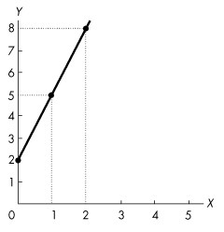

Figure 1A.3.6

25) What is the slope of the line in Figure A1.3.6?
A) 2
B) 1/2.
C) 3
D) 1/3
E) -3
Answer: C
Diff: 1 Type: MC
Topic: Appendix: The Slope of a Relationship

Use the figure below to answer the following question.

Figure 1A.3.7

26) The slope of the line in Figure 1A.3.7 is
A) 1.
B) -1.
C) 1/2.
D) 2.
E) dependent on where you measure it.
Answer: C
Diff: 1 Type: MC
Topic: Appendix: The Slope of a Relationship

Use the figure below to answer the following question.

Figure 1A.3.8

27) The slope of the line in Figure 1A.3.8 is
A) 3/2.
B) 2/3.
C) -3/2.
D) -2/3.
E) none of the above.
Answer: D
Diff: 1 Type: MC
Topic: Appendix: The Slope of a Relationship

Use the figure below to answer the following questions.

Figure 1A.3.9

28) Refer to Figure 1A.3.9. Which one of the graphs shows a line with a zero slope?
A) (a)
B) (b)
C) (c)
D) (d)
E) (a), (b), and (c)
Answer: D
Diff: 1 Type: MC
Topic: Appendix: The Slope of a Relationship

29) Refer to Figure 1A.3.9. Which one of the graphs shows a line with an infinite slope?
A) (a)
B) (b)
C) (c)
D) (d)
E) (b) and (c)
Answer: C
Diff: 1 Type: MC
Topic: Appendix: The Slope of a Relationship

Use the figure below to answer the following questions.

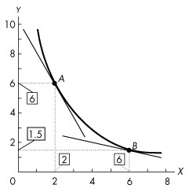

Figure 1A.3.10

30) Refer to Figure 1A.3.10. The figure shows a relationship between two variables, x and y. The slope at point A is
A) 2.
B) -2.
C) 0.25.
D) -0.25.
E) -4.
Answer: B
Diff: 1 Type: MC
Topic: Appendix: The Slope of a Relationship

Use the figure below to answer the following question.

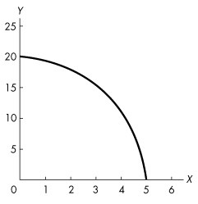

Figure 1A.3.11

31) Refer to Figure 1A.3.11. The graph shows a ________ relationship. The absolute value of the slope of the relationship ________ as the value of x increases.
A) positive; increases
B) positive; decreases
C) negative; decreases
D) negative; increases
E) negative; does not change
Answer: D
Diff: 1 Type: MC
Topic: Appendix: The Slope of a Relationship

1.9 Appendix: Graphing Relationships Among More Than Two Variables

1) To graph a relationship among three variables we
A) hold two variables constant to graph the third variable.
B) hold one variable constant and graph the relationship between the other two variables.
C) graph each of the three variables using a separate set of axes.
D) must be able to draw in three dimensions.
E) must be able to allow all three variables to vary simultaneously in one graph.
Answer: B
Diff: 2 Type: MC
Topic: Appendix: Graphing Relationships Among More Than Two Variables

Use the table below to answer the following questions.

Table 1A.4.1

x | 120 | 100 | 80 | 140 | 120 | 100 | 160 | 140 | 120
y | 10 | 12 | 14 | 10 | 12 | 14 | 10 | 12 | 14
z | 4 | 4 | 4 | 5 | 5 | 5 | 6 | 6 | 6

2) Given the data in Table 1A.4.1, holding z constant, the graph of x and y
A) is a negatively sloped line.
B) is a positively sloped line.
C) reaches a maximum.
D) reaches a minimum.
E) does not have a constant slope.
Answer: A
Diff: 3 Type: MC
Topic: Appendix: Graphing Relationships Among More Than Two Variables

3) Given the data in Table 1A.4.1, holding y constant, the graph of x and z
A) is a negatively sloped line.
B) is a positively sloped line.
C) reaches a maximum.
D) reaches a minimum.
E) shows that x and z are not related.
Answer: B
Diff: 3 Type: MC
Topic: Appendix: Graphing Relationships Among More Than Two Variables

4) Consider the data in Table 1A.4.1. Suppose z increases from 4 to 5. What will happen to the graph of the relationship between x and y?
A) It will shift to the right.
B) It will shift to the left.
C) It will become positively sloped.
D) both A and C
E) both B and C
Answer: A
Diff: 3 Type: MC
Topic: Appendix: Graphing Relationships Among More Than Two Variables

Use the figure below to answer the following question.

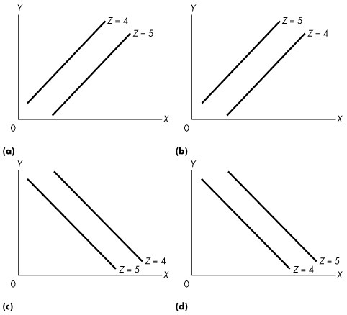

Figure 1A.4.1

5) Given the data in the following table, which one of the graphs in Figure 1A.4.1 correctly represents the relationship among x, y, and z?

x | 120 | 100 | 80 | 140 | 120 | 100 | 160 | 140 | 120
y | 10 | 12 | 14 | 10 | 12 | 14 | 10 | 12 | 14
z | 4 | 4 | 4 | 5 | 5 | 5 | 6 | 6 | 6

A) (a)
B) (b)
C) (c)
D) (d)
E) (b) and (c)
Answer: D
Diff: 3 Type: MC
Topic: Appendix: Graphing Relationships Among More Than Two Variables

Use the figure below to answer the following question.

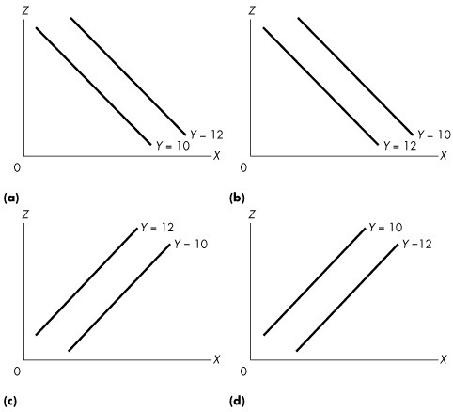

Figure 1A.4.2

6) Given the data in the following table, which one of the graphs in Figure 1A.4.2 correctly represents the relationship among x, y, and z?

x | 120 | 100 | 80 | 140 | 120 | 100 | 160 | 140 | 120
y | 10 | 12 | 14 | 10 | 12 | 14 | 10 | 12 | 14
z | 4 | 4 | 4 | 5 | 5 | 5 | 6 | 6 | 6

A) (a)
B) (b)
C) (c)
D) (d)
E) (a) and (d)
Answer: C
Diff: 3 Type: MC
Topic: Appendix: Graphing Relationships Among More Than Two Variables

Use the table below to answer the following questions.

Table 1A.4.2

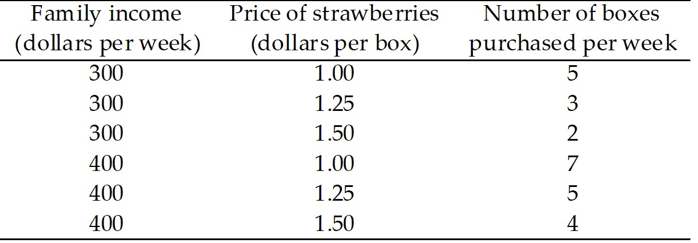

7) Table 1A.4.2 shows that
A) the number of boxes of strawberries purchased is negatively related to the price of strawberries, holding income constant.
B) the number of boxes of strawberries purchased is negatively related to income, holding the price of strawberries constant.
C) the price of strawberries is negatively related to family income, holding purchases of strawberries constant.
D) there is no relationship between the price of strawberries and the number of boxes purchased.
E) there is no relationship between family income and the number of boxes of strawberries purchased.
Answer: A
Diff: 3 Type: MC
Topic: Appendix: Graphing Relationships Among More Than Two Variables

8) Given the data in Table 1A.4.2, holding income constant, the graph relating the price of strawberries, measured on the y-axis and the purchases of strawberries, measured on the x-axis
A) is a vertical line.
B) is a horizontal line.
C) is a positively sloped line.
D) is a negatively sloped line.
E) reaches a minimum.
Answer: D
Diff: 3 Type: MC
Topic: Appendix: Graphing Relationships Among More Than Two Variables

9) Given the data in Table 1A.4.2, suppose family income decreases from $400 to $300 per week. Then the graph relating the price of strawberries, measured on the y-axis and the number of boxes of strawberries purchased, measured on the x-axis will
A) become negatively sloped.
B) become positively sloped.
C) shift rightward.
D) shift leftward.
E) no longer exist.
Answer: D
Diff: 3 Type: MC
Topic: Appendix: Graphing Relationships Among More Than Two Variables

10) Given the data in Table 1A.4.2, holding price constant, the graph of the purchases of strawberries, measured on the x-axis and family income, measured on the y-axis is a
A) vertical line.
B) horizontal line.
C) positively sloped line.
D) negatively sloped line.
E) positively or negatively sloped line, depending on the price that is held constant.
Answer: C
Diff: 3 Type: MC
Topic: Appendix: Graphing Relationships Among More Than Two Variables

Use the figure below to answer the following questions.

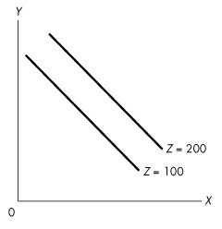
Figure 1A.4.3

11) In Figure 1A.4.3, x is
A) positively related to y and negatively related to z.
B) positively related to both y and z.
C) negatively related to y and positively related to z.
D) negatively related to both y and z.
E) greater than z.
Answer: C
Diff: 3 Type: MC
Topic: Appendix: Graphing Relationships Among More Than Two Variables

12) In Figure 1A.4.3, a decrease in the value of z results in, ceteris paribus
A) a decrease in the value of x.
B) an increase in the value of x.
C) an increase in the value of y.
D) no change in the value of y.
E) no change in the value of x.
Answer: A
Diff: 3 Type: MC
Topic: Appendix: Graphing Relationships Among More Than Two Variables

Use the figure below to answer the following question.

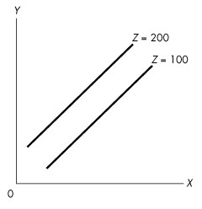
Figure 1A.4.4

13) Complete the following sentence. In Figure 1A.4.4, z is
A) positively related to x and negatively related to y.
B) negatively related to x and positively related to y.
C) positively related to both x and y.
D) negatively related to both x and y.
E) related to y but not related to x.
Answer: B
Diff: 3 Type: MC
Topic: Appendix: Graphing Relationships Among More Than Two Variables

14) Consider the following information on cola sales by number of cases for a typical university residence floor:

Price (dollars per case)
Temp. (°C) | 10.00 | 12.50 | 15.00 | 17.50
15 | 50 | 40 | 30 | 20
20 | 60 | 50 | 40 | 30
25 | 70 | 60 | 50 | 40
30 | 80 | 70 | 60 | 50
35 | 90 | 80 | 70 | 60

Cola sales and cola prices are
A) inversely related.
B) positively related.
C) not affected by the temperature.
D) unrelated.
E) negatively related at low temperatures, but positively related at high temperatures.
Answer: A
Diff: 2 Type: MC
Topic: Appendix: Graphing Relationships Among More Than Two Variables

15) Consider the following information on cola sales by number of cases for a typical university residence floor:

Price (dollars per case)
Temp. (°C) | 10.00 | 12.50 | 15.00 | 17.50
15 | 50 | 40 | 30 | 20
20 | 60 | 50 | 40 | 30
25 | 70 | 60 | 50 | 40
30 | 80 | 70 | 60 | 50
35 | 90 | 80 | 70 | 60

Cola sales and temperature are
A) inversely related.
B) positively related.
C) not affected by the price.
D) unrelated.
E) negatively related at low prices, but positively related at high prices.
Answer: B
Diff: 2 Type: MC
Topic: Appendix: Graphing Relationships Among More Than Two Variables

Use the figure below to answer the following questions.

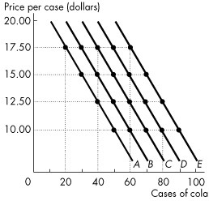

Figure 1A.4.5

16) Consider the following information on cola sales by number of cases for a typical university residence floor:

Price (dollars per case)
Temp. (°C) | 10.00 | 12.50 | 15.00 | 17.50
15 | 50 | 40 | 30 | 20
20 | 60 | 50 | 40 | 30
25 | 70 | 60 | 50 | 40
30 | 80 | 70 | 60 | 50
35 | 90 | 80 | 70 | 60

Refer to Figure 1A.4.5. Which line shows the relationship of cola sales and its price when the temperature is 30°C?
A) A
B) B
C) C
D) D
E) E
Answer: D
Diff: 2 Type: MC
Topic: Appendix: Graphing Relationships Among More Than Two Variables

17) Consider the following information on cola sales by number of cases for a typical university residence floor:

Price (dollars per case)
Temp. (°C) | 10.00 | 12.50 | 15.00 | 17.50
15 | 50 | 40 | 30 | 20
20 | 60 | 50 | 40 | 30
25 | 70 | 60 | 50 | 40
30 | 80 | 70 | 60 | 50
35 | 90 | 80 | 70 | 60

Refer to Figure 1A.4.5. Which line shows the relationship of cola sales and the temperature when the price of a case is $15.00?
A) A
B) B
C) C
D) D
E) none of the above.
Answer: E
Diff: 3 Type: MC
Topic: Appendix: Graphing Relationships Among More Than Two Variables

18) Consider the following information on cola sales by number of cases for a typical university residence floor:

Price (dollars per case)
Temp. (°C) | 10.00 | 12.50 | 15.00 | 17.50
15 | 50 | 40 | 30 | 20
20 | 60 | 50 | 40 | 30
25 | 70 | 60 | 50 | 40
30 | 80 | 70 | 60 | 50
35 | 90 | 80 | 70 | 60

Refer to Figure 1A.4.5. Which one of the following represents what happens when the temperature rises from 20°C to 25°C?
A) The curve shifts from A to B.
B) The curve shifts from C to B.
C) The curve shifts from B to C.
D) The curve shifts along line B.
E) The curve shifts along line C.
Answer: C
Diff: 3 Type: MC
Topic: Appendix: Graphing Relationships Among More Than Two Variables

19) The Latin term ceteris paribus means
A) "Innocent until proven guilty."
B) "Fallacies are composed."
C) "Compositions are fallacious."
D) "The whole is not the sum of the parts."
E) "If all other relevant things remain the same."
Answer: E
Diff: 1 Type: MC
Topic: Appendix: Graphing Relationships Among More Than Two Variables

Use the table below to answer the following question.

Table 1A.4.3

Ice cream consumption
(litres per day)
Price  (dollars per scoop) | 0  degrees | 10  degrees | 20  degrees | 30  degrees
2.00  2.50  3.00  3.50  4.00 | 12  10  7  5  3 | 18  12  10  7  5 | 25  18  13  10  7 | 50  37  27  20  14

20) Refer to Table 1A.4.3. The table shows some data on the quantity of ice cream consumed at different prices and in different weather conditions. To draw a graph of the relationship between the quantity of the ice cream consumed and the price of ice cream, we must
A) decrease the temperature as the price rises.
B) pick the temperature that prevailed when the price was $2.00.
C) increase the temperature as the price rises.
D) hold the temperature constant at any of the four levels shown.
E) hold the price constant at any of the five levels shown.
Answer: D
Diff: 3 Type: MC
Topic: Appendix: Graphing Relationships Among More Than Two Variables

1.10 Mathematical Note: Equations of Straight Lines

Use the figure below to answer the following question.

Figure 1A.5.1

1) The equation of the line in Figure 1A.5.1 is
A) y = 1.5 - 0.5x.
B) y =1.5 + 2x.
C) y = 1.5 + 0.5x.
D) y = -3 + 2x.
E) dependent on where you measure it.
Answer: C
Diff: 1 Type: MC
Topic: Mathematical Note: Equations of Straight Lines

Use the figure below to answer the following question.

Figure 1A.5.2

2) If the line in Figure 1A.5.2 were to continue down to the x-axis, what would the value of x be when y is zero?
A) 0
B) 2
C) 2/3
D) -2/3
E) -3/2
Answer: D
Diff: 2 Type: MC
Topic: Mathematical Note: Equations of Straight Lines

3) If the equation of a straight line is y = 6 + 3x, then the slope is
A) -3 and the y-axis intercept is 6.
B) -3 and the y-axis intercept is -2.
C) 3 and the y-axis intercept is 6.
D) 3 and the y-axis intercept is -2.
E) 3 and the y-axis intercept is -6.
Answer: C
Diff: 1 Type: MC
Topic: Mathematical Note: Equations of Straight Lines

4) If the equation of a straight line is y = 8 - 2x, then the slope is
A) -2 and the x-axis intercept is -4.
B) -2 and the x-axis intercept is 4.
C) -2 and the x-axis intercept is 8.
D) 2 and the x-axis intercept is -4.
E) 2 and the x-axis intercept is 4.
Answer: B
Diff: 1 Type: MC
Topic: Mathematical Note: Equations of Straight Lines

5) The equation of a line is y = 4 + 2x. What is the y-axis intercept of this line?
A) 4
B) -2
C) -1/2
D) 1/4
E) 0
Answer: A
Diff: 1 Type: MC
Topic: Mathematical Note: Equations of Straight Lines

6) The equation of a line is y = 4 + 2x. What is the x-axis intercept of this line?
A) 4
B) -2
C) -1/2
D) 1/4
E) 0
Answer: B
Diff: 2 Type: MC
Topic: Mathematical Note: Equations of Straight Lines

7) The equation of a line is y = 4 + 2x. What is the slope of this line?
A) 4
B) 2
C) 1/2
D) 1/4
E) 0
Answer: B
Diff: 1 Type: MC
Topic: Mathematical Note: Equations of Straight Lines

Use the figure below to answer the following question.

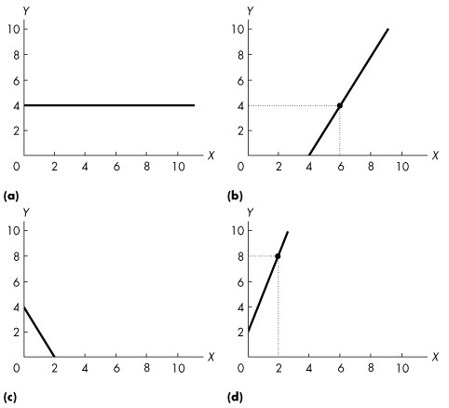

Figure 1A.5.3

8) The equation of a line is y = 4 + 2x. Which one of the graphs in Figure 1A.5.3 represents this line?
A) (a)
B) (b)
C) (c)
D) (d)
E) none of the graphs
Answer: E
Diff: 2 Type: MC
Topic: Mathematical Note: Equations of Straight Lines

Use the figure below to answer the following question.

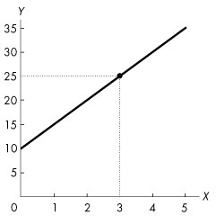
Figure 1A.5.4

9) Refer to Figure 1A.5.4. The graph shows the relationship between two variables, x and y. This relationship is described by the equation
A) y = 5x2 + 10.
B) y = 10x + 5.
C) y = -5x + 10.
D) y = 5x + 10.
E) x = 10 + 5y.
Answer: D
Diff: 2 Type: MC
Topic: Mathematical Note: Equations of Straight Lines

Use the figure below to answer the following question.

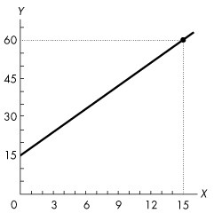
Figure 1A.5.5

10) Refer to Figure 1A.5.5. The graph shows the relationship between two variables, x and y. Which of the following equations describes this relationship?
A) y = 3x + 15
B) y = -3x + 15
C) y = -3x2 + 15
D) y = 15x + 3
E) x = 15y + 3
Answer: A
Diff: 2 Type: MC
Topic: Mathematical Note: Equations of Straight Lines

11) Which of the following equations describes a straight line with a y-axis intercept of -2 and a slope of -5?
A) y = -5 - 2x
B) y = -2
C) y = -2 - 5x
D) y = -5x
E) x = -2 - 5y
Answer: C
Diff: 2 Type: MC
Topic: Mathematical Note: Equations of Straight Lines

