 |  | Appendix: Making and Using Graphs |  |  | Chapter  1
 | ANSWERS TO APPENDIX CHECKPOINT
■ Study Plan Problems
 | A | B | C | D
1 | 1996 | 779 | 17 | 3
2 | 1997 | 753 | 19 | 4
3 | 1998 | 847 | 27 | 7
4 | 1999 | 939 | 20 | 12
5 | 2000 | 943 | 18 | 19
6 | 2001 | 882 | 18 | 31
7 | 2002 | 803 | 15 | 51
8 | 2003 | 746 | 20 | 85
9 | 2004 | 767 | 33 | 139
10 | 2005 | 705 | 34 | 367
11 | 2006 | 620 | 23 | 586
12 | 2007 | 511 | 28 | 810
The spreadsheet provides data on the U.S. economy: Column A is the year; the other columns are quantities sold in millions per year of compact discs (column B), music videos (column C), and singles downloads (column D). Use this spreadsheet to work Problems 1 to 5.
1. Draw a scatter diagram to show the relationship between the quantities sold of compact discs and music videos. Describe the relationship.
Figure A1.1 (on the next page) illustrates the relationship of the data from the spreadsheet between the quantities sold of compact discs and the quantities sold of music videos. Over all the period, there appears to be a negative relationship; that is, when more compact discs are sold, fewer music videos are sold.
2. Draw a scatter diagram to show the relationship between quantities sold of music videos and singles downloads. Describe the relationship.
Figure A1.2 (on the next page) illustrates the relationship of the data from the spreadsheet between the quantities sold of music videos and singles downloads. Over all the period, there appears to be a (weak) positive relationship; that is, when more music videos are sold, more singles are downloaded.

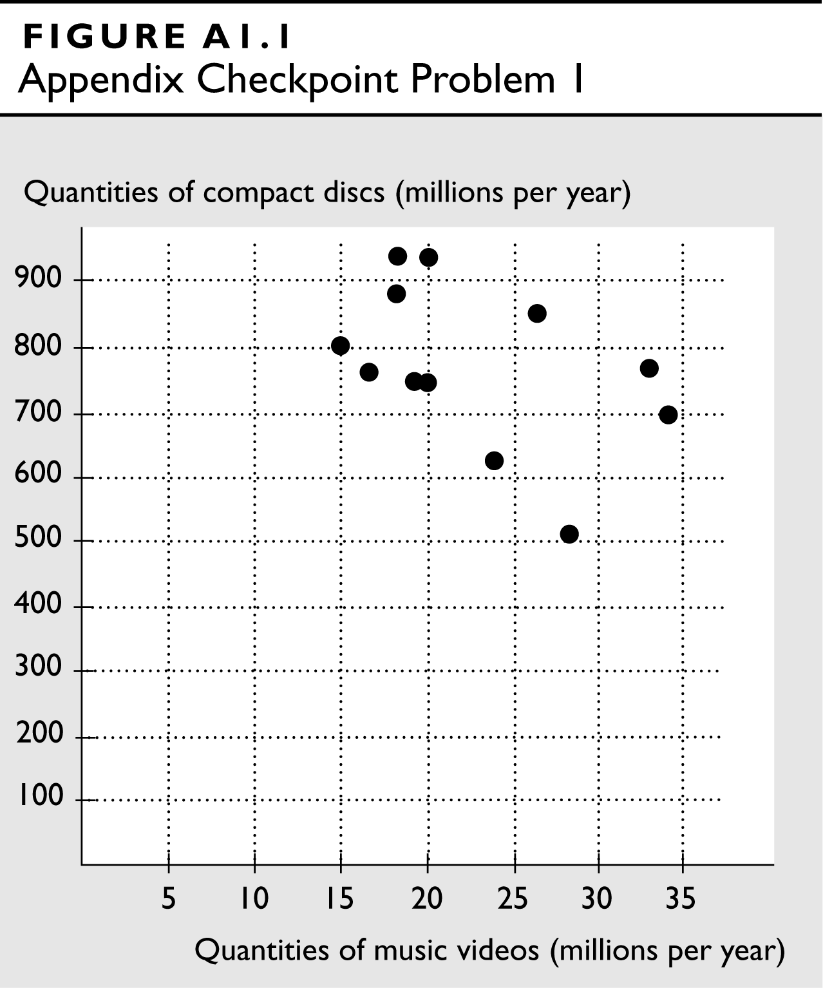 | 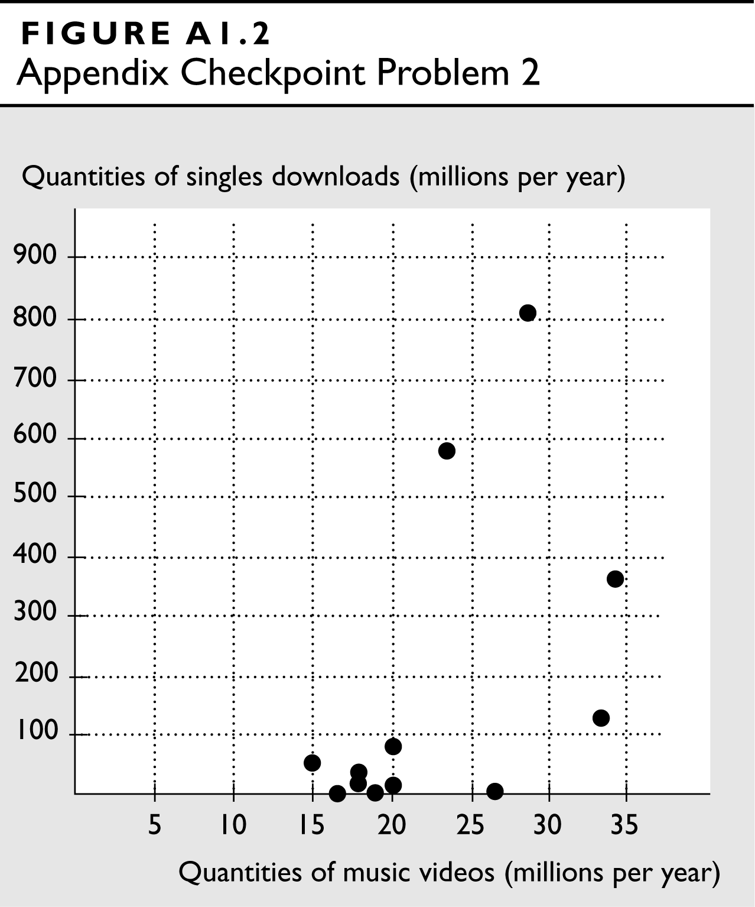
3. Draw a scatter diagram to show the relationship between quantities sold of compact discs and singles downloads. Describe the relationship.
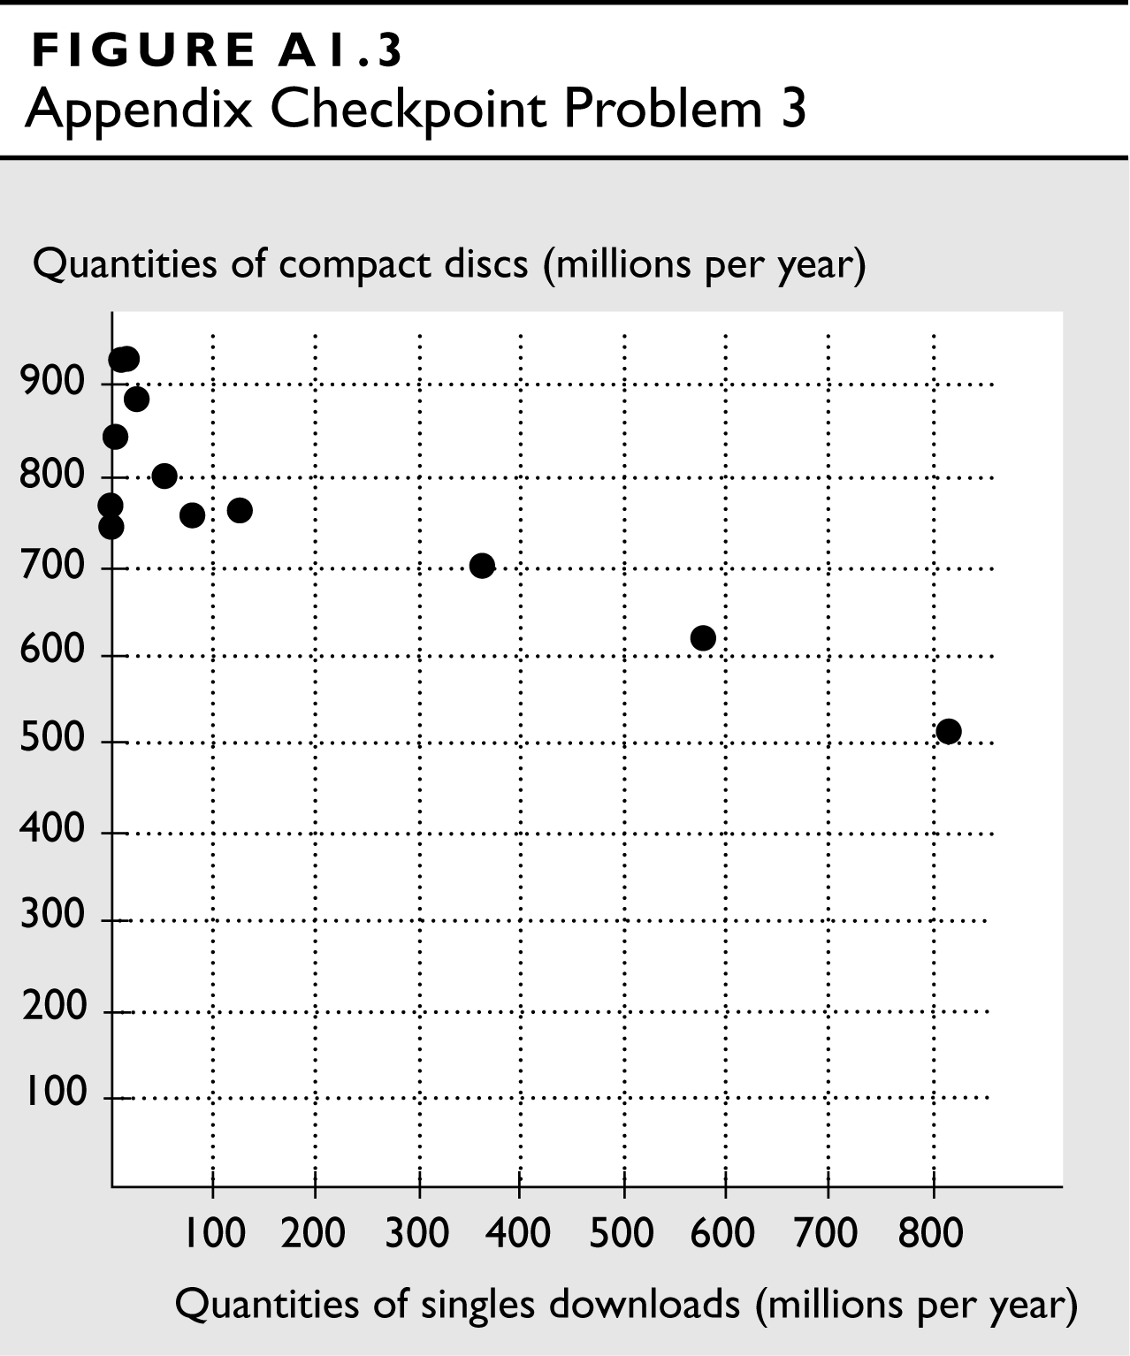
Figure A1.3 illustrates the relationship of the data from the spreadsheet between the quantities sold of compact discs and singles downloads. The relationship is negative. The negative relationship means that decreased quantities of compact discs are sold at the same time that increased quantities of singles are downloaded.

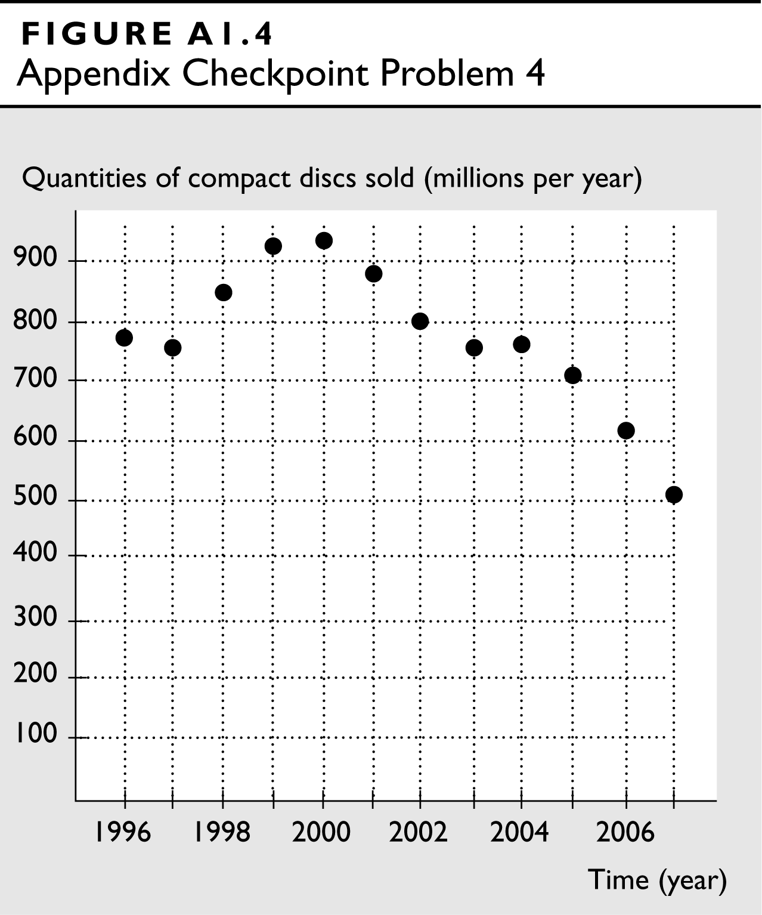
4. Draw a time-series graph of quantity of compact discs sold. Say in which year or years the quantity sold (a) was highest, (b) was lowest, (c) increased the most, and (d) decreased the most. If the data show a trend, describe it.
Figure A1.4 illustrates the time series of the quantity of compact discs sold using the data from the spreadsheet.
a. The quantity sold was the highest in 2000.
b. The quantity sold was the lowest in 2007.
c. The quantity sold increased the most between 1997 and 1998 when it increased by 94 million.
d. The quantity sold decreased the most between 2006 and 2007 when it decreased by 109 million.
Over the entire time period covered in the figure, there is a downward trend in the quantity of compact discs sold. Since 2000, the downward trend has been especially pronounced.
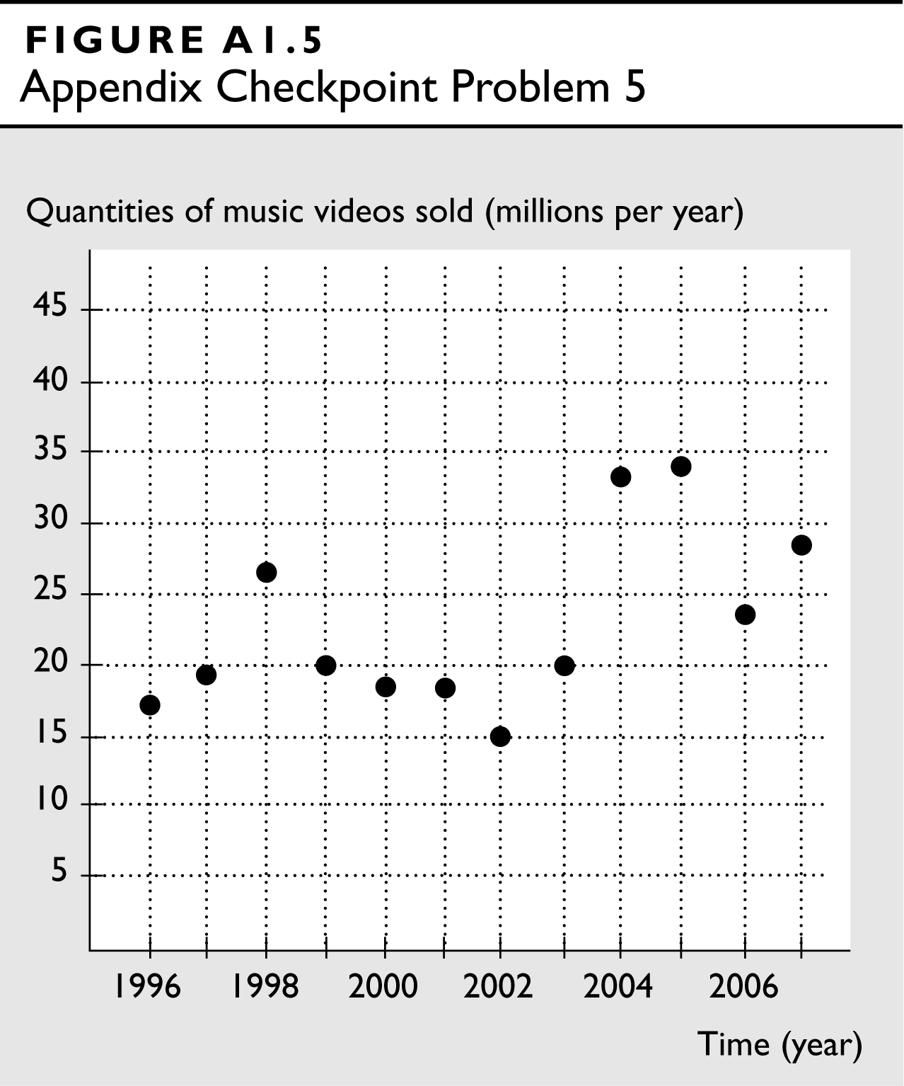
5. Draw a time-series graph of the quantity of music videos sold. Say in which year or years the quantity sold (a) was highest, (b) was lowest, (c) decreased the most, and (d) decreased the least. If the data show a trend, describe it.
Figure A1.5 illustrates the time series of music videos sold using the data from the spreadsheet.
a. The quantity sold was the highest in 2005.
b. The quantity sold was the lowest in 2002.
c. The quantity sold decreased the most between 2005 and 2006.
d. The quantity sold decreased the least between 1999 and 2000.
There is a slight upward trend in the quantity of music videos sold.
■ Instructor Assignable Problems
Use the following information on the relationship between two variables x and y to work Problems 1 and 2.
x | 0 | 1 | 2 | 3 | 4 | 5
y | 0 | 1 | 4 | 9 | 16 | 25
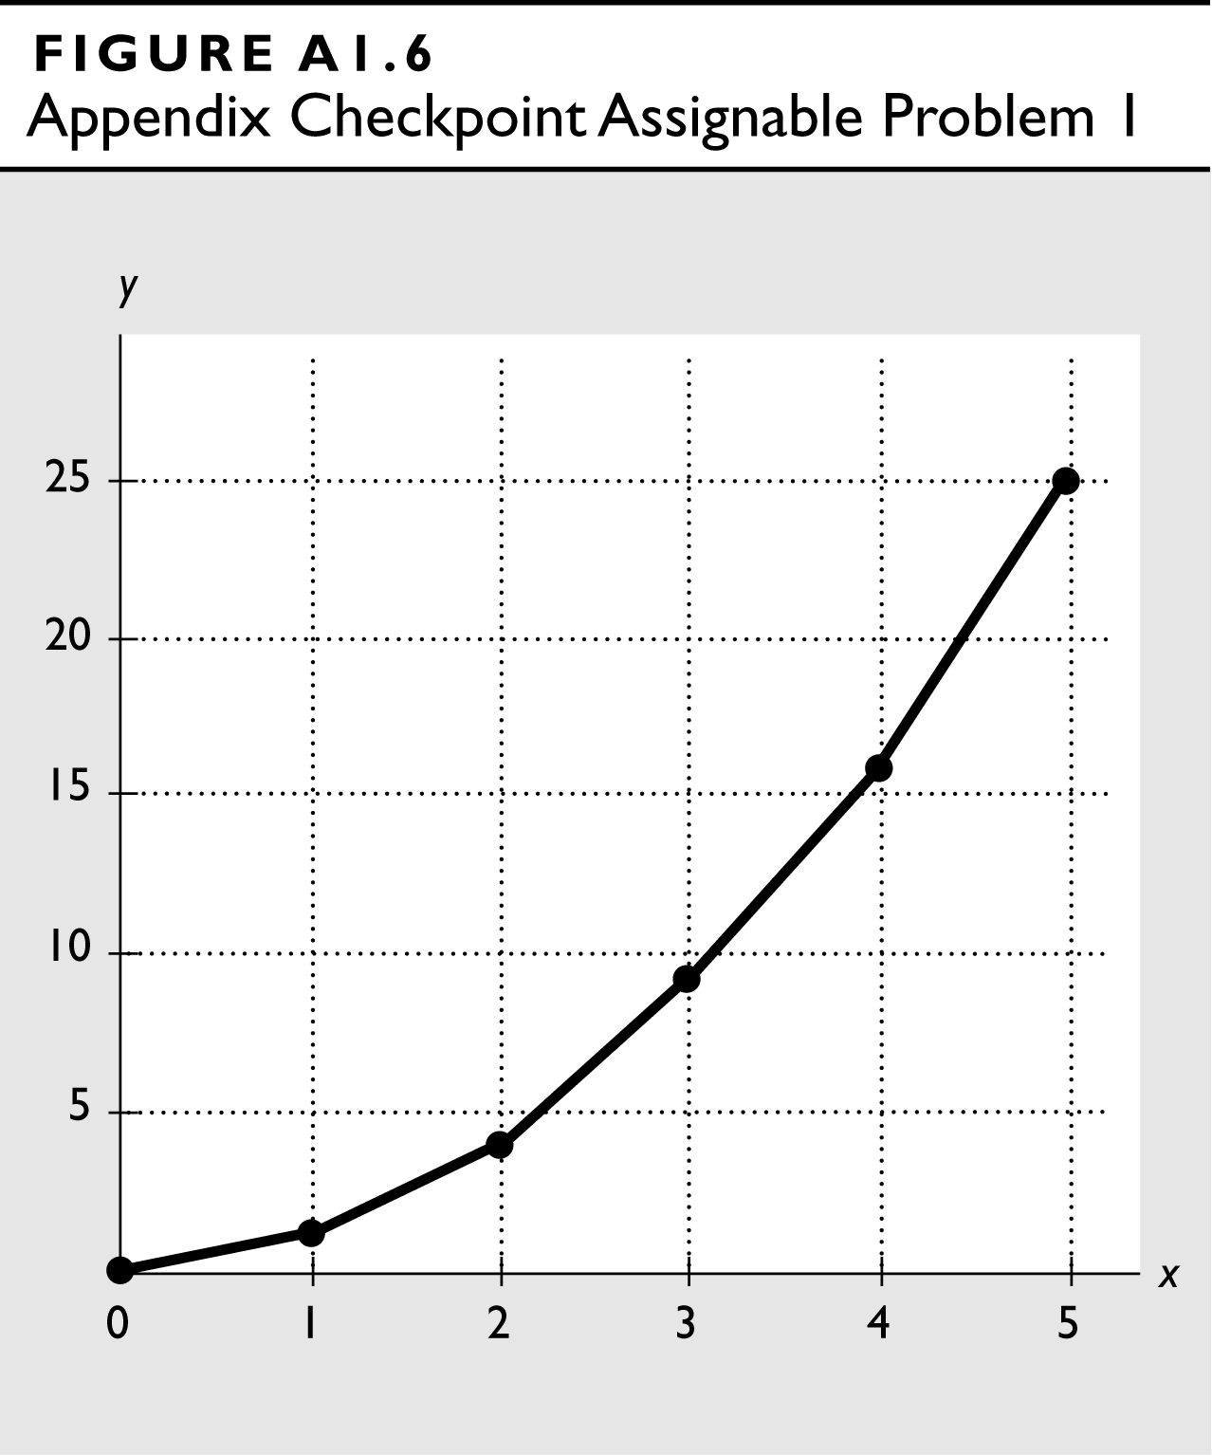
1. Draw a graph to show the relationship between x and y. Is the relationship positive or negative?
Figure A1.6 illustrates the relationship between x and y. The relationship is positive: When x increases, y also increases.
2. Calculate the slope of the relationship between x and y when x equals 2 and when x equals 4. How does the slope change as the value of x increases?
The slope of the relationship equals the change in y divided by the change in x along the tangent line. When x equals 2, the slope of the tangent line equals 4, so the slope of the relationship equals 4. When x equals 4, the slope of the tangent line equals 8, so the slope of the relationship equals 8. The slope of the relationship increases as x increases.
Use the following information on the relationship between two variables x and z to work Problems 3 and 4.
x | 0 | 1 | 2 | 3 | 4 | 5
z | 32 | 31 | 28 | 23 | 16 | 7
3. Is the relationship between x and z positive or negative?
The relationship is negative: When x increases, z decreases.
4. Calculate the slope of the relationship between x and z when x equals 2 and when x equals 4. How does the slope change as the value of x increases?
The slope of the relationship equals the change in z divided by the change in x. When x equals 2, the slope of the tangent line equals –4, so the slope of the relationship equals –4. When x equals 4, the slope of the tangent line equals –8, so the slope of the relationship equals –8. The slope of the relationship increases in magnitude (the line becomes steeper) as x increases.
5. The table provides data on the price of a balloon ride, the temperature, and the number of rides a day. Draw graphs to show the relationship between:
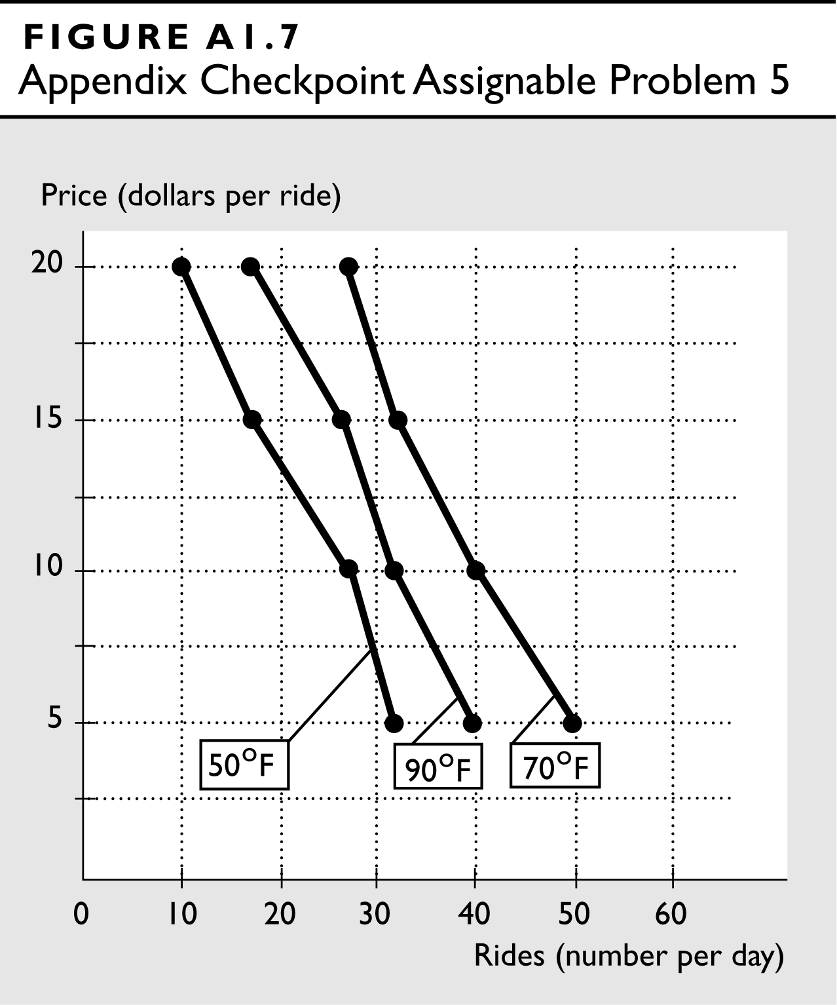
- The price and the number of rides, when the temperature is constant.
Price  (dollars per ride) | Balloon rides  (number per day)
Price  (dollars per ride) | 50°F | 70°F | 90°F
5 | 32 | 50 | 40
10 | 27 | 40 | 32
15 | 18 | 32 | 27
20 | 10 | 27 | 18
Figure A1.7 illustrates the relationship between the price and the number of rides holding constant the temperature. Note that there are three relationships, one for each temperature.

- The number of rides and the temperature, when the price is constant.
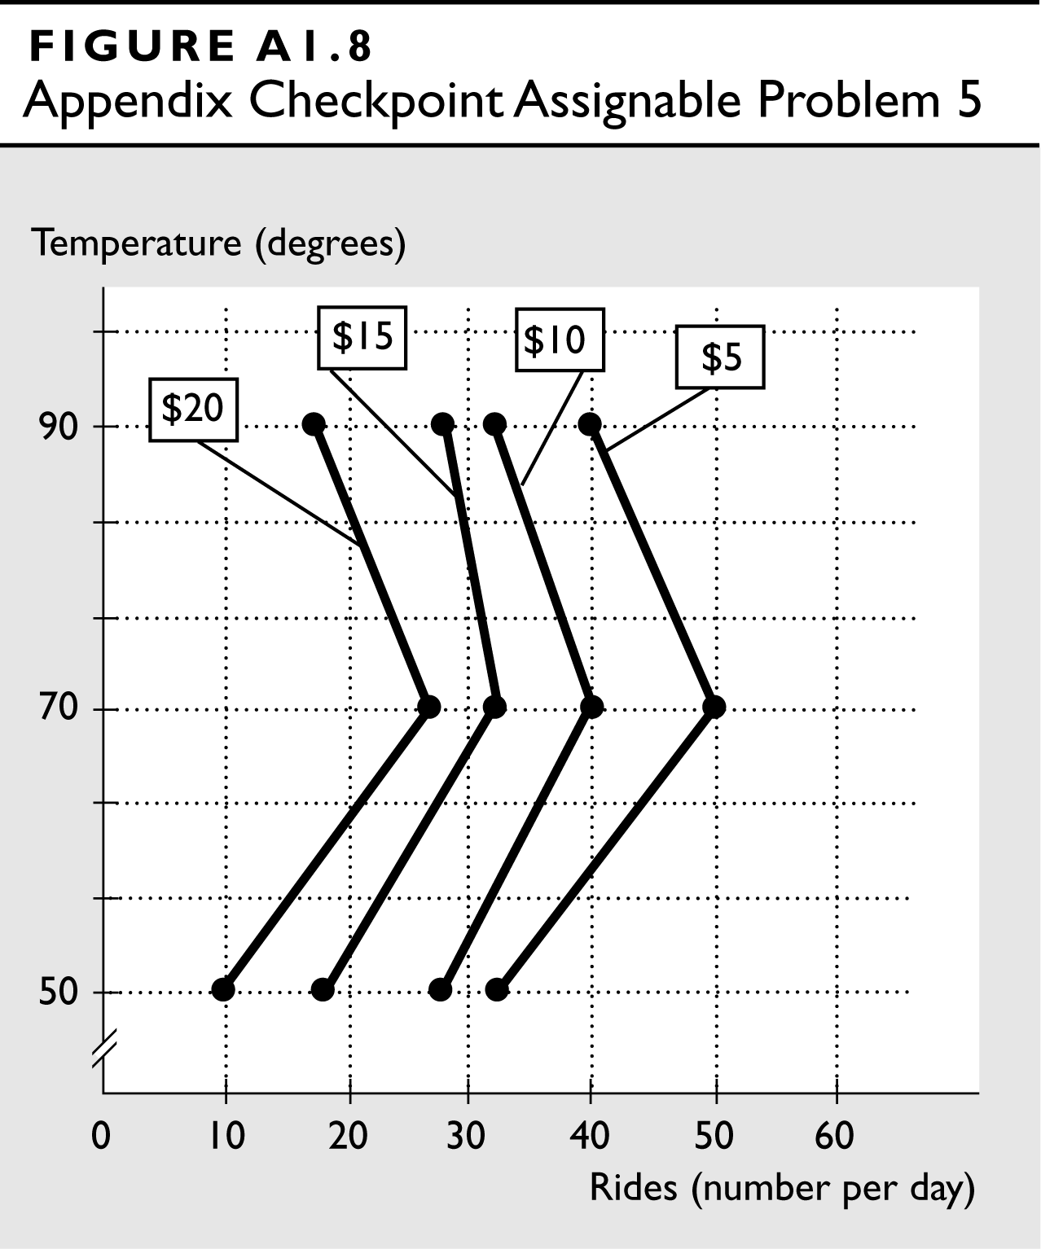
Figure A1.8 illustrates the relationship between the number of rides and the temperature, holding constant the price. Note that there are four relationships, one for each price.

- The temperature and the price, when the number of rides is constant.
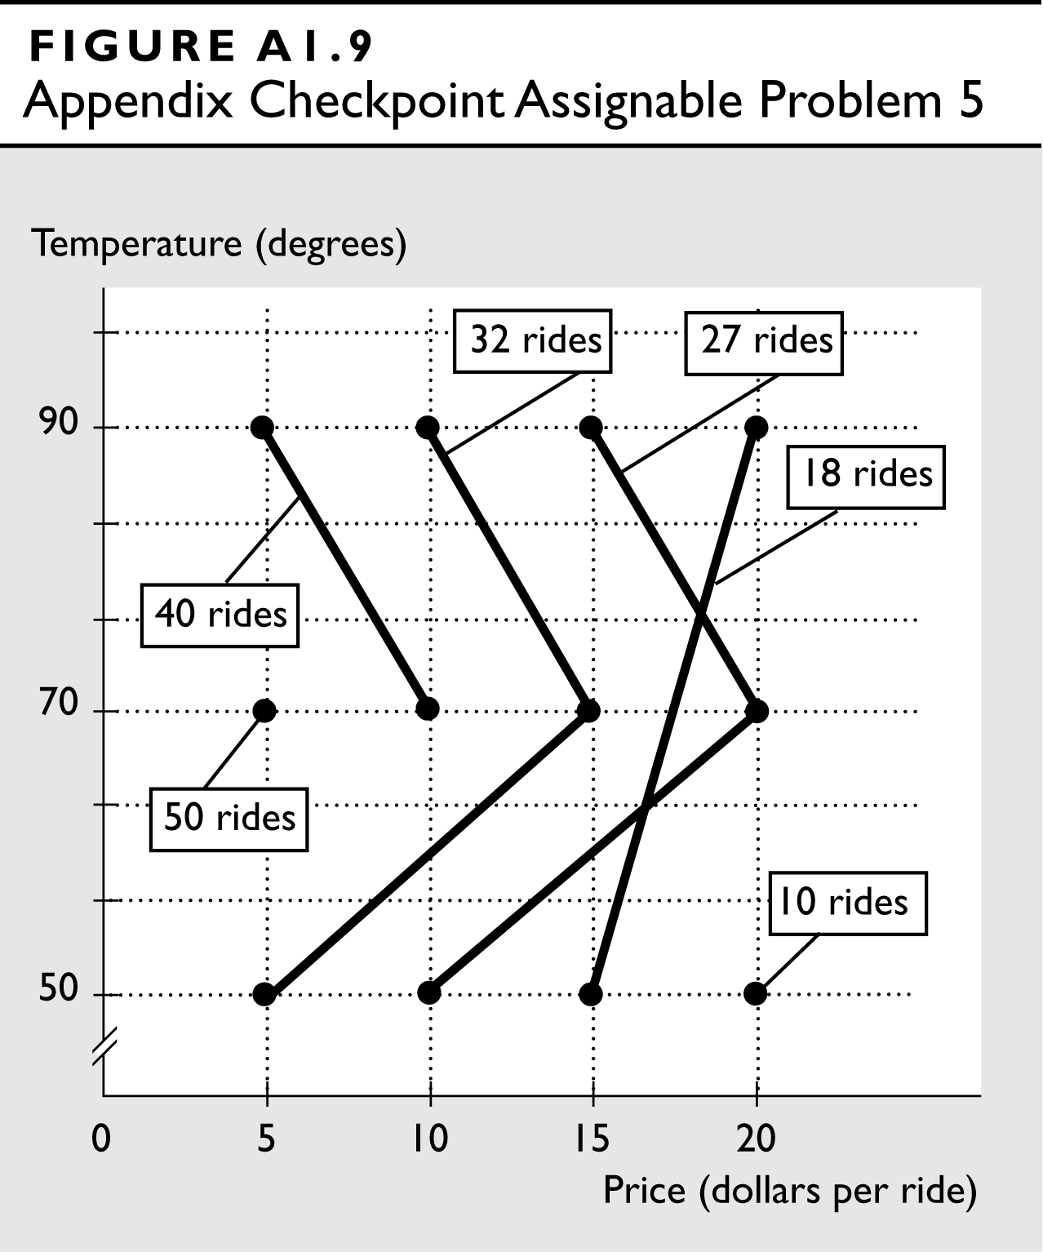
Figure A1.9 illustrates the relationship between the temperature and the price, holding constant the number of rides. Note that there are six relationships, one for each number of rides.

