Chapter 1: The Chemical Basis of Life

1. Choose the correct answer from the list. Not all the answers will be used.
The most abundant chemical element in the human body is
A) | nitrogen.

B) | ΔG.

C) | phylogenetic.

D) | q/T.

E) | ΔH°.

F) | thermophiles.

G) | carbon.

H) | H – TS.

I) | polymers.

J) | equilibrium.

K) | halobacteria.

L) | entropy.

M) | flux.

Ans: G
Difficulty Level: 1-2
Section Ref: Easy

2. Choose the correct answer from the list. Not all the answers will be used.
The term used to indicate the degree of randomness within a system is
A) | ΔH°.

B) | ΔG.

C) | q/T.

D) | halobacteria.

E) | H – TS.

F) | entropy.

G) | flux.

H) | phylogenetic.

I) | carbon.

J) | polymers.

K) | equilibrium.

L) | nitrogen.

M) | thermophiles.

Ans: F
Difficulty Level: Easy
Section Ref: 1-3

3. Choose the correct answer from the list. Not all the answers will be used.
Gibbs free energy is defined as G =
A) | equilibrium.

B) | carbon.

C) | H – TS.

D) | entropy.

E) | phylogenetic.

F) | halobacteria.

G) | ΔH°.

H) | ΔG.

I) | flux.

J) | q/T.

K) | polymers.

L) | thermophiles.

M) | nitrogen.

Ans: C
Difficulty Level: Easy
Section Ref: 1-3

4. The atmosphere of early earth probably contained the following molecules:
A) | H₂O, CO₂, N₂, CH₄, and NH₃.

B) | H₂O, CO₂, CH₄, C₆H₆O₆,and NH₃.

C) | H₂O, CO₂, CH₄, C₆H₆O₆,and COOHCH₂NH₃.

D) | H₂O, CO₂, CH₄, COOHCH₂NH₃, and NH₃.

E) | none of the above

Ans: A
Difficulty Level: Medium
Section Ref: 1-4

5. Which of the following statements about hydrothermal vents is true?
A) | The vents have temperatures as high as 800°C, and emit H₂S and nitrogen sulfides.

B) | The vents have temperatures as high as 600°C, and emit H₂S and metal nitrates.

C) | The vents have temperatures as high as 350°C, and emit H₂S and metal sulfides.

D) | none of the above

E) | all of the above

Ans: C
Difficulty Level: Hard
Section Ref: 1-4

6. The biological classification system categorizes organisms into the domains:
A) | bacteria, eukarya, and vertebrate.

B) | archaea and eukarya.

C) | bacteria, eukarya, and archaea.

D) | eukarya and bacteria.

E) | none of the above

Ans: C
Difficulty Level: Medium
Section Ref: 1-4

7. The second Law of Thermodynamics states that:
A) | spontaneous processes are characterized by the overall conversion of order to disorder.

B) | spontaneous processes are characterized by the conversion of work to force.

C) | nonspontaneous processes are characterized by the conversion of order to disorder.

D) | spontaneous processes are characterized by the conversion heat to pressure.

E) | none of the above

Ans: A
Difficulty Level: Easy
Section Ref: 1-3

8. If gas molecules in an enclosed space are allowed to enter a second chamber, the resulting redistribution of gas molecules represents an increase in
A) | enthalpy.

B) | entropy.

C) | force.

D) | A and C

E) | A, B, and C

Ans: B
Difficulty Level: Medium
Section Ref: 1-3
9. Consider the structure of the coenzyme NADP
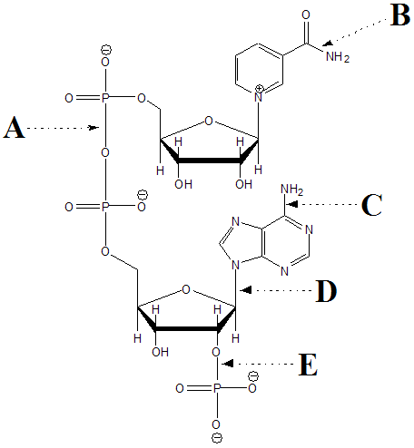

Which arrow points at a phosphate ester bond?
A) | A

B) | B

C) | C

D) | D

E) | E

Ans: E
Difficulty Level: Easy
Section Ref: 1-2

10. Consider the structure of the coenzyme NADP

Which arrow points at an amide bond?
A) | A

B) | B

C) | C

D) | D

E) | E

Ans: B
Difficulty Level: Easy
Section Ref: 1-2

11. Consider the structure of the coenzyme NADP

Which arrow points at an anhydride bond?
A) | A

B) | B

C) | C

D) | D

E) | E

Ans: A
Difficulty Level: Easy
Section Ref: 1-2

12. Which of the following is a similarity between all prokaryotes and all eukaryotes?
A) | Both contain DNA in a nucleus

B) | Both contain certain of the same membrane bound cell organelles (like mitochondria, Golgi complexes etc)

C) | Both have a cytoskeleton

D) | All of the above are similarities between prokaryotes and eukaryotes

E) | None of the above are similarities between prokaryotes and eukaryotes

Ans: E
Difficulty Level: Medium
Section Ref: 1-4

13. Which of the following statements concerning prokaryotes is false?
A) | Prokaryotes are made up of two major groupings: the eubacteria and the archaea, which are as different from each other as from the eukaryotes.

B) | Prokaryotes are generally much smaller than the eukaryotic cells.

C) | Prokaryotes are one branch of the newer, more accurate phylogenic tree made up of prokarya, archaea and eukarya.

D) | Prokaryotes do not have organelles.

E) | None of the above are false

Ans: C
Difficulty Level: Medium
Section Ref: 1-4

14. Which of the following is not true of eukaryotes:
A) | They contain organelles like mitochondria, chloroplasts, ribosomes, and a nucleus

B) | They are usually 10 to 100 microns in diameter

C) | They can be both uni or multicellular

D) | They are also called archaea

E) | All of the above are true of eukaryotes

Ans: D
Difficulty Level: Medium
Section Ref: 1-4

15. A spontaneous process
A) | occurs without the addition of free energy.

B) | has a ΔG<0.

C) | is exergonic.

D) | all of the above

E) | none of the above

Ans: D
Difficulty Level: Easy
Section Ref: 1-3

16. The bulk of aerobic metabolism in eukaryotic cells takes place in
A) | the Golgi apparatus

B) | the mitochondria

C) | the endoplasmic reticulum

D) | the nucleus

E) | peroxisomes

Ans: B
Difficulty Level: Medium
Section Ref: 1-4

17. An increase in disorder
A) | is found in every exergonic process

B) | is characteristic of a system increasing in enthalpy

C) | is required for a process to be spontaneous

D) | results in a decrease in entropy

E) | results in the factor TΔS being positive

Ans: E
Difficulty Level: Medium
Section Ref: 1-3

