Human Physiology, 5e (Silverthorn)
Chapter 1 Introduction to Physiology

1) Physiology is the study of
A) the structure of the body.
B) the tissues and organs of the body at the microscopic level.
C) growth and reproduction.
D) the normal functions of the organ systems.
E) the facial features as an indication of personality.
Answer: D
Skill: Level I: Reviewing Facts and Terms

2) The literal meaning of the term physiology is knowledge of
A) organs.
B) nature.
C) science.
D) chemistry.
E) math.
Answer: B
Skill: Level I: Reviewing Facts and Terms

3) Because anatomy and physiology have different definitions, they are usually considered separately in studies of the body.
A) true
B) false
Answer: B
Skill: Level I: Reviewing Facts and Terms

4) The following is a list of several levels of organization that make up the human body.
1. tissue
2. cell
3. organ
4. molecule
5. organism
6. organ system
The correct order from the smallest to the largest is
A) 2, 4, 1, 3, 6, 5.
B) 4, 2, 1, 6, 3, 5.
C) 4, 2, 1, 3, 6, 5.
D) 4, 2, 3, 1, 6, 5.
E) 6, 4, 5, 2, 3, 1.
Answer: C
Skill: Level I: Reviewing Facts and Terms
5) “Glucose is transported from blood into cells because cells require glucose to meet their energy needs.” This type of explanation is
A) mechanistic.
B) theological.
C) teleological.
D) metalogical.
E) scatological.
Answer: C
Skill: Level I: Reviewing Facts and Terms

6) “Glucose is transported from blood into cells by transporters in response to insulin.” This type of explanation is
A) mechanistic.
B) theological.
C) teleological.
D) metalogical.
E) scatological.
Answer: A
Skill: Level I: Reviewing Facts and Terms

7) Which of the following is a buffer zone between the outside world and most of the cells of the body?
A) blood
B) lumen
C) lymph
D) extracellular fluid
E) all of the above
Answer: D
Skill: Level I: Reviewing Facts and Terms

8) Which of the following is one of Cannon's "internal secretions"?
A) hormones
B) nutrients
C) water
D) inorganic ions
E) none of the above
Answer: A
Skill: Level I: Reviewing Facts and Terms

9) The study of body function in a disease state is
A) necrology.
B) physiology.
C) microbiology.
D) pathophysiology.
E) histology.
Answer: D
Skill: Level I: Reviewing Facts and Terms
10) Homeostasis is the ability of the body to
A) prevent the external environment from changing.
B) prevent the internal environment from changing.
C) quickly restore changed conditions to normal.
D) ignore external stimuli to remain in a state of rest.
E) prevent excessive blood loss.
Answer: C
Skill: Level I: Reviewing Facts and Terms

11) When you are dehydrated, your kidneys alter their function to retain more water than they do when you are normally hydrated. This change in function is an example of a __________ mechanism.
A) compensatory
B) mandatory
C) pathophysiological
D) pathological
E) teleological
Answer: A
Skill: Level I: Reviewing Facts and Terms

12) How genetics influences the body’s response to drugs is called
A) pharmacokinetics.
B) pharmacogenetics.
C) pharmacogenomics.
D) pharmacodynamics.
E) pharmageddon.
Answer: C
Skill: Level I: Reviewing Facts and Terms

13) A physician basing clinical decisions on primary research published in biomedical literature is doing __________ medicine.
A) evidence-based
B) traditional
C) alternative
D) whimsical
E) holistic
Answer: A
Skill: Level I: Reviewing Facts and Terms

14) The Internet database for molecular, cellular, and physiological information is called the __________ Project.
A) Human Genome
B) Physiognomy
C) Physiosome
D) Physiome
E) Manhattan
Answer: D
Skill: Level I: Reviewing Facts and Terms
15) A placebo is
A) any drug being tested in a clinical trial.
B) any drug in a class of drugs commonly used as pain relievers.
C) a drug or treatment that is expected to have no pharmacological effect.
D) a nutritive and respiratory organ in fetal development.
E) a hole in a cavity wall through which an organ protrudes.
Answer: C
Skill: Level I: Reviewing Facts and Terms

16) A technique used to resolve contradictory results in scientific studies is
A) meta-analysis.
B) retrospective analysis.
C) prospective analysis.
D) cross-sectional analysis.
E) longitudinal analysis.
Answer: A
Skill: Level I: Reviewing Facts and Terms

17) A scientifically logical guess is a
A) model.
B) theory.
C) hypothesis.
D) law.
E) variable.
Answer: C
Skill: Level I: Reviewing Facts and Terms

18) If a scientific opinion has been verified repeatedly it becomes a
A) model.
B) theory.
C) hypothesis.
D) law.
E) variable.
Answer: D
Skill: Level I: Reviewing Facts and Terms

19) Place these terms in the typical sequence in which they appear in the scientific process: experimental data, theory, model, observation, hypothesis, replication.
A) experimental data, theory, model, observation, hypothesis, replication
B) replication, hypothesis, experimental data, theory, model, observation
C) theory, observation, experimental data, hypothesis, replication, model
D) observation, replication, model, experimental data, hypothesis, theory
E) observation, hypothesis, experimental data, replication, model, theory
Answer: E
Skill: Level I: Reviewing Facts and Terms
20) You are interested in learning more about Parkinson's disease, a neurological disorder that primarily affects motor function. What is the best source to begin your investigation?
A) Google
B) PubMed
C) public library
D) physiology textbook
E) a physician
Answer: B
Skill: Level I: Reviewing Facts and Terms

For the following questions, match the level of organization with its definition below.

A. a collection of similar cells that carry out similar functions
B. the smallest living unit
C. a collection of different tissues that carry out related functions
D. groups of organs functioning in a coordinated manner

21) cell
Answer: B
Skill: Level I: Reviewing Facts and Terms

22) tissue
Answer: A
Skill: Level I: Reviewing Facts and Terms

23) organs
Answer: C
Skill: Level I: Reviewing Facts and Terms

24) organ systems
Answer: D
Skill: Level I: Reviewing Facts and Terms

25) What is a nocebo effect?
Answer: The phenomenon whereby a patient who has been informed of the side effects of a drug he is taking is more likely to experience some of the side effects than an otherwise similar patient receiving the same drug who has not been so informed.
Skill: Level I: Reviewing Facts and Terms

26) List the key concepts or themes in physiology.
Answer: See Table 1-2 in the chapter.
Skill: Level I: Reviewing Facts and Terms
27) Adaptive significance is an important concept in physiology because it describes
A) the importance of a highly variable external environment.
B) the physiological functions that promote an organism's survival.
C) the ability of an organism to monitor and restore its internal state to normal conditions when necessary.
D) the similarities between ancient and modern marine organisms.
E) the parameters necessary to maintain a constant internal environment.
Answer: B
Skill: Level II: Reviewing Concepts

28) You conduct an experiment on twenty 18-year-old male subjects to see how various intensities of exercise influence heart rate. Which of the following is/are considered an independent variable?
A) age of subjects
B) sex of subjects
C) intensity of exercise
D) heart rate
E) more than one of these
Answer: C
Skill: Level II: Reviewing Concepts

29) You conduct an experiment on twenty 18-year-old male subjects to see how various intensities of exercise influence heart rate. Which of the following is/are considered a dependent variable?
A) age of subjects
B) sex of subjects
C) intensity of exercise
D) heart rate
E) more than one of these
Answer: D
Skill: Level II: Reviewing Concepts

30) Why are physiology and anatomy frequently studied together?
Answer: This is discussed in the "Physiological Systems" section of the chapter.
Skill: Level II: Reviewing Concepts

You want to display data on the finish times of the 10 fastest race horses in a single race at the Kentucky Derby.

31) What type of graph would be best to display this information?
A) bar graph
B) line graph
C) scatter plot
Answer: A
Skill: Level II: Reviewing Concepts

32) What would the labels be for the graph axes?
Answer: The x-axis is horse name or number; the y-axis is finish time in minutes.
Skill: Level II: Reviewing Concepts
A horse runs 10 races, each a mile long, during a 6-month period, and you are interested in determining if the horse's race time changes with experience. You set up a graph to display the race finish times of this horse.

33) What type of graph would be best to display the race finish times of this horse?
A) bar graph
B) line graph
C) scatter plot
Answer: B
Skill: Level II: Reviewing Concepts

34) What would the labels be for the graph axes?
Answer: The x-axis is race number or date; the y-axis is finish time in minutes.
Skill: Level II: Reviewing Concepts

There are 10 cloned horses, born on the same day, with identical chromosomes. They are each subjected to the same physical training regimen, but given daily injections of different concentrations of a particular vitamin. They all run the same race. You set up a graph to explore a relationship between race finish time and vitamin dose.

35) Which type of graph is best to explore a relationship between race finish time and vitamin dose?
A) bar graph
B) line graph
C) scatter plot
Answer: C
Skill: Level II: Reviewing Concepts

36) What are the labels for the graph axes?
Answer: The x-axis is vitamin dose; the y-axis is finish time in minutes.
Skill: Level II: Reviewing Concepts

37) What is the difference between a peer-reviewed article and a review article?
Answer: A peer-reviewed article describes original research by one author (or group of authors working together) that has gone through a screening process in which a panel of qualified scientists evaluate the work. A review article is a summary (usually a collection of published research that was previously peer-reviewed, usually from more than one independent lab) that discusses a particular topic in the field.
Skill: Level II: Reviewing Concepts

38) What is the major problem with the deconstructionist view of biology?
Answer: Return to the topic of function and process. The deconstructionist view of biology predicted that once we uncovered the sequence of the human genome, the inner workings of the human body would be revealed. In reality, it is possible to know how a gene codes for a particular protein without knowing why that protein exists. Our knowledge of the human genome is only a piece of the puzzle.
Skill: Level II: Reviewing Concepts

39) Why is it necessary to label the axes of a graph?
Answer: A graph with no axis labels is meaninglesswithout knowing what trend is being illustrated, there is no communication of scientific information.
Skill: Level II: Reviewing Concepts
40) Why is it necessary to space grid marks on a graph proportionally to the quantity measured (example: each square represents one centimeter)?
Answer: If this is not done, a trend would be obscured or even misrepresented.
Skill: Level II: Reviewing Concepts

41) Explain why the prefix homeo- is used in the term homeostasis. Why do some physiologists prefer the term homeodynamics over homeostasis?
Answer: The prefix homeo-, meaning like or similar, is used to indicate that the body's internal environment is maintained within a range of acceptable values rather than a fixed state. Some physiologists argue that the term homeodynamics better reflects the small but constant changes that continuously take place in the internal environment, as opposed to homeostasis, which erroneously implies lack of change.
Skill: Level II: Reviewing Concepts

42) Explain why animals are used in research. Are there any limitations to the application of animal data to human physiology? Could these limitations be addressed using cell or tissue culture, or computer simulations?
Answer: [Note to instructor: This may be a good question to ask early in the semester, then again toward the end, after the organ systems have been covered.] There is a brief discussion of using humans or animals in research in the chapter. This question is intended to stimulate students to think about how science is done, how data are generated, and how the process is challenged by social issues. Generally, there are limitations to the usefulness of computer simulations and cell/tissue culture systems for the same reason that nonhuman animal data are not 100% applicable to human physiology. How human organ systems perform may be different in very subtle ways from corresponding systems in other species. Cells in culture are in an artificial environment, and while much has been learned from such systems, it has also been noted that the behavior of cells in culture is not identical to cells in a living body. Furthermore, cells cultured from established lines can change over time, becoming less like the original cells from which they were derived, and presumably less like normal cells. Computer simulations are valuable, but are only as good as the data entered, and given that we don't know everything there is to know about physiology, we can't write a perfect computer program. All three approaches are useful, but for different reasons, and therefore one research system does not completely substitute for another, nor is it appropriate to abandon one entirely.
Skill: Level II: Reviewing Concepts

43) You conduct an experiment on twenty 18-year-old male subjects to see how various levels of exercise influence heart rate. Explain why only 18-year-old males were used as subjects.
Answer: An important part of scientific inquiry is to remove sources of variation from among subjects. By choosing subjects of one gender in a particular age group, it is easier to determine that the dependent variable (heart rate, in this case) depends only on the independent variable, level of exercise. This also allows a study to have fewer participants, assuming that subjects were randomly assigned to a level of exercise. If subjects were of random ages and genders, data would have to be collected from many more individuals.
Skill: Level II: Reviewing Concepts
44) Design a concept map on scientific experimental design.
Answer: Variable. It is recommended that the instructor create a map before evaluating the students' maps, and modify the instructor map as necessary.
Skill: Level III: Problem Solving

45) Provide an example of a control system. Be sure to include the three main components: an input signal, a controller, and an output signal.
Answer: Variable. One example is blood glucose concentration. The input signal is a blood glucose concentration outside of the normal range, the controller is the pancreas, and the output signal is release of either insulin or glucagon.
Skill: Level III: Problem Solving

46) Write a teleological explanation for why heart rate increases during exercise. Now write a mechanistic explanation for the same phenomenon.
Answer: Teleological: Heart rate increases because the increased activity of skeletal and cardiac muscles requires increased delivery of blood contents such as oxygen and glucose. Mechanistic: Heart rate increases in response to signals from the brain (pacemaker cells of the heart are stimulated by the nervous system).
Skill: Level III: Problem Solving

47) What is a hypothesis? What are the steps involved in following the scientific method? How does one distinguish the dependent variable from the independent variable in an experiment? How are each of these represented on a graph?
Answer: This is discussed in "The Science of Physiology" section of the chapter, and in Fig. 1-7.
Skill: Level III: Problem Solving

48) You are designing a study to assess the effects of a new treatment for hypertension. What ethical considerations would you employ when monitoring your progress?
Answer: Major considerations should involve assessing the efficacy of the treatment such that the control group patients are not deprived as well as ensuring that the experimental treatment is not less effective than the standard treatments.
Skill: Level III: Problem Solving

49) In your study of a drug’s efficacy in treating hypertension, your subjects are white males, ages 40 to 60 years. Is your study applicable to all people? Explain.
Answer: Possibly but not necessarily. There are gender differences in appropriate therapies because of physiological effects of higher testosterone in males compared to females, for example. Drugs are often not tested in children, and children also have a different hormonal environment than adults (again, sex hormones are a good example, because their levels are low until just before the onset of puberty). There are also racial differences in effectiveness of therapies, and while it is a contentious issue as to whether these represent genetic or socioeconomic influences, they should be considered.
Skill: Level III: Problem Solving

Use the table and graph below to answer the following questions.

Heart rates (bpm) of Sprague-Dawley rats after
administration of various concentrations of epinephrine.

Heart Rates
Epinephrine (mg) | Animal 1 | Animal 2 | Animal 3
50 | 48 | 62 | 55
100 | 58 | 67 | 63
150 | 67 | 70 | 79
200 | 80 | 85 | 93
150 | 67 | 70 | 79

Table 1-1

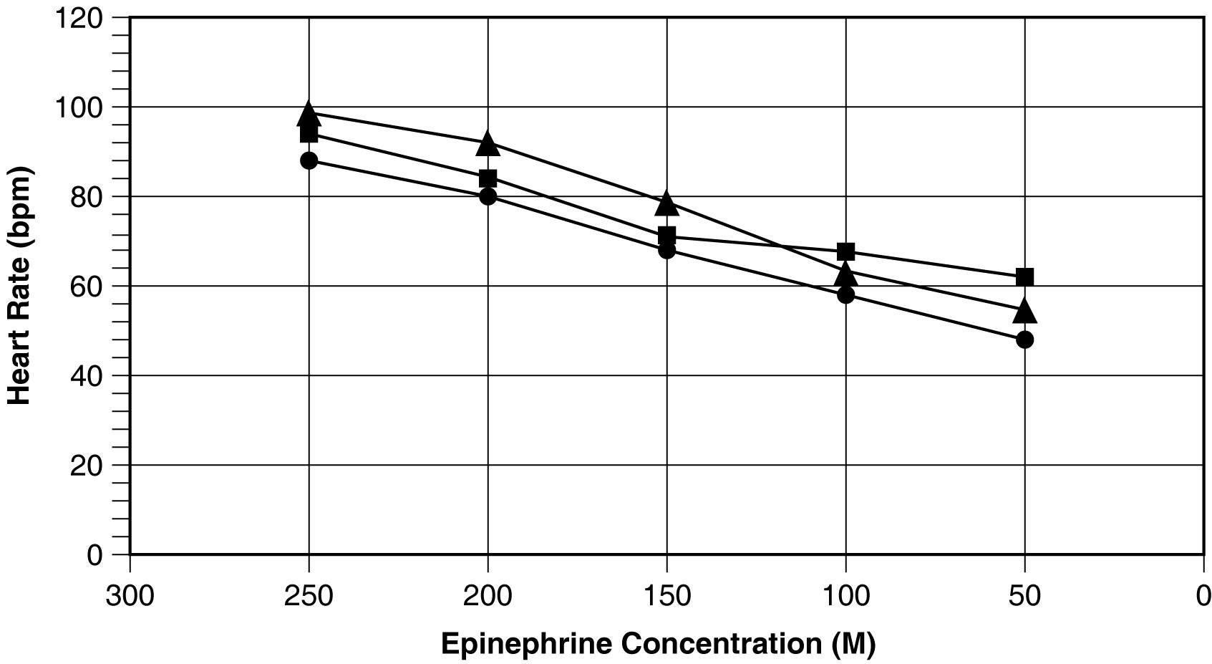
Figure 1-1

50) List all of the errors in Fig. 1-1.
Answer: 1. The units of concentration are labeled as M when they should be mg.
2. The x-axis is in decreasing order of concentration.
3. The graph needs a legend.
4. The data for each concentration of epinephrine should be averaged and plotted as a single trend.
Skill: Level IV: Quantitative Problems

51) How can you determine the control value using Fig. 1-1?
Answer: Extrapolation. The control value is the heart rate that corresponds to an epinephrine dose equal to zero.
Skill: Level IV: Quantitative Problems

52) Use Table 1-1 to graph the data appropriately.
Answer: Graphs should address the errors in Fig. 1-1.
Skill: Level IV: Quantitative Problems

53) What can you CONCLUDE based on the new figure?
Answer: An increase in epinephrine concentration increases the average heart rate of Sprague-Dawley rats.
Skill: Level IV: Quantitative Problems

Use the table and graph below to answer the following questions.

Average systolic blood pressure at
various ages for males (M) and females (F).

Average Blood Pressure
Age | M | F
10 | 115 | 113
20 | 122 | 117
30 | 127 | 120
40 | 130 | 128
50 | 131 | 136
60 | 140 | 144
70 | 145 | 160
80 | 144 | 156
90 | 142 | 150

Table 1-2

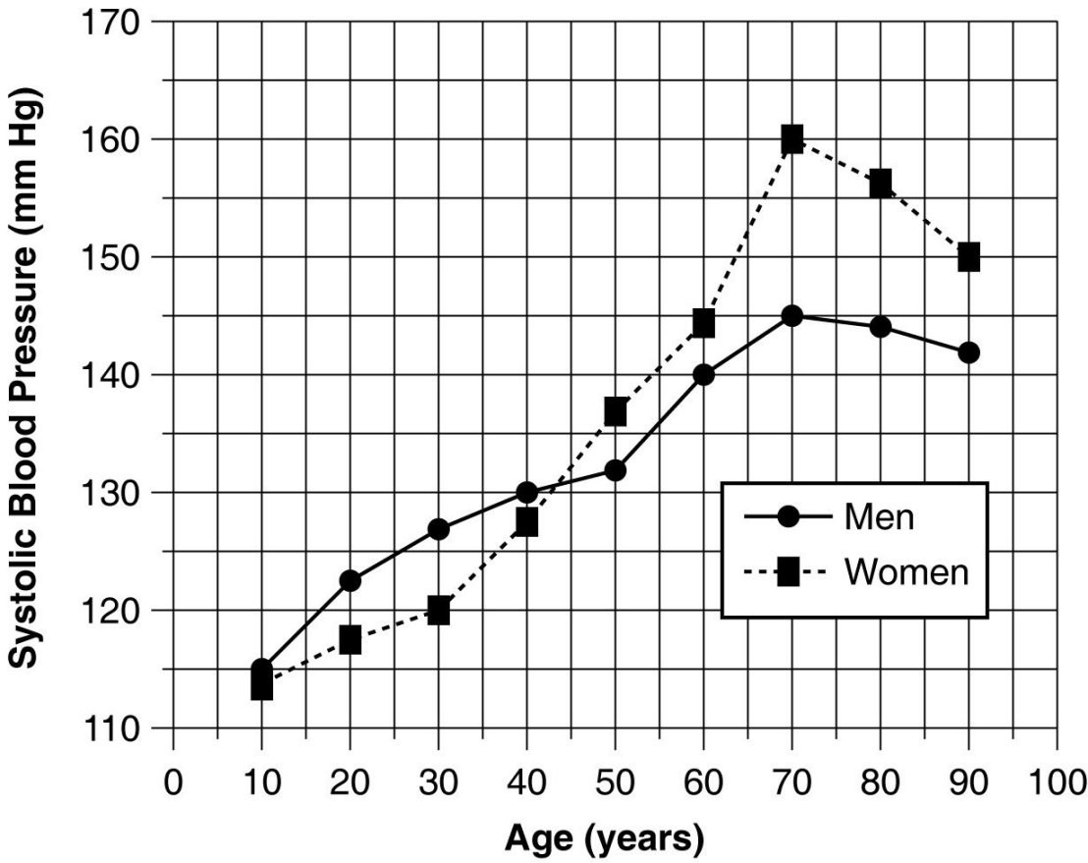
Figure 1-2

54) Summarize the data shown in Fig. 1-2.
Answer: The systolic pressure of both genders increases with age. Under age 40, the systolic pressure of males is higher than that of females. After age 40, the systolic pressure of females is higher than that of males. The greatest rate of increase is from ages 50 to 70 in both genders. Blood pressure declines after age 70.
Skill: Level IV: Quantitative Problems

55) What general trend in systolic blood pressures is seen as both men and women increase in age?
Answer: The systolic pressure of both genders increases with advancing age.
Skill: Level IV: Quantitative Problems

56) At approximately what age do men begin to show higher systolic blood pressures than women? At what age does this trend reverse?
Answer: From age 10 to 40, male pressures are higher; after age 40, female pressures are higher.
Skill: Level IV: Quantitative Problems
57) What is the conclusion from the graph? Discuss the trends and discrepancies, explaining why they may occur.
Answer: Answers will vary, reiterating the results shown above, plus perhaps speculating on why the graph changes directions at various points.
Skill: Level IV: Quantitative Problems

58) You are doing an experiment to determine if caffeine consumption affects reaction time.
A. Which is the dependent variable?
B. Which is the independent variable?
C. Briefly describe some ways you might manipulate the independent variable.
D. Name three stimuli you could use, and how you might measure reaction time for each.
E. Write an appropriate hypothesis for this study.
F. You compute the following average values from your experiment. What would be a logical conclusion for these data?
Average caffeine consumer's reaction time: 400 ms
Average noncaffeine consumer's reaction time: 650 ms
G. Sketch a simple graph to convey these results to your classmates. What kind of graph did you choose? Why? Which variable did you plot on the x-axis? Which one did you plot on the y-axis? Why?
H. Do the results of this experiment support the hypothesis you chose?
Answer: A. Reaction time
B. Caffeine consumption
C. Vary the amounts of caffeine consumed; vary the source, for example, use coffee, pills, cola drinks, and/or chocolate; vary both the amounts and sources.
D. Answers will vary. Example: a computer-based timer could measure the time elapsed between the subject's detecting the appearance of an object on the computer monitor and depressing a key on the keyboard. Auditory or touch stimuli could be used, too.
E. Depending on the answer to C, could choose: "Consumption of caffeine decreases reaction time" or similar statement.
F. Consumption of caffeine improves reaction time by 250 ms, on average.
G. Bar graph; allows comparison of the average of two groups. The x-axis: group, caffeine or none. The y-axis: reaction time in milliseconds.
H. Yes, in case of hypothesis written in D.
Skill: Level IV: Quantitative Problems

Following is a table of data collected from one section of an 8 a.m. physiology lab. There were 20 students present, 10 men and 10 women. Information collected from the students included their height, weight, age, and resting pulse rate. In addition, the students were surveyed to see if they smoked cigarettes, considered themselves "regular exercisers," if they had consumed caffeine the morning of the lab, and if they had eaten breakfast that day. A "y" or "n" (yes or no) was recorded to indicate their answers. Each student did "jumping jacks" for 5 minutes and recorded the time required to regain their resting heart rate, which is listed on the table as "recovery time." Finally, each student participated in an exercise designed to measure their reaction time (in milliseconds) in catching an object dropped by a lab partner according to specified criteria. Use this table to answer the following questions. Ignore statistical problems caused by small sample size, and so on.

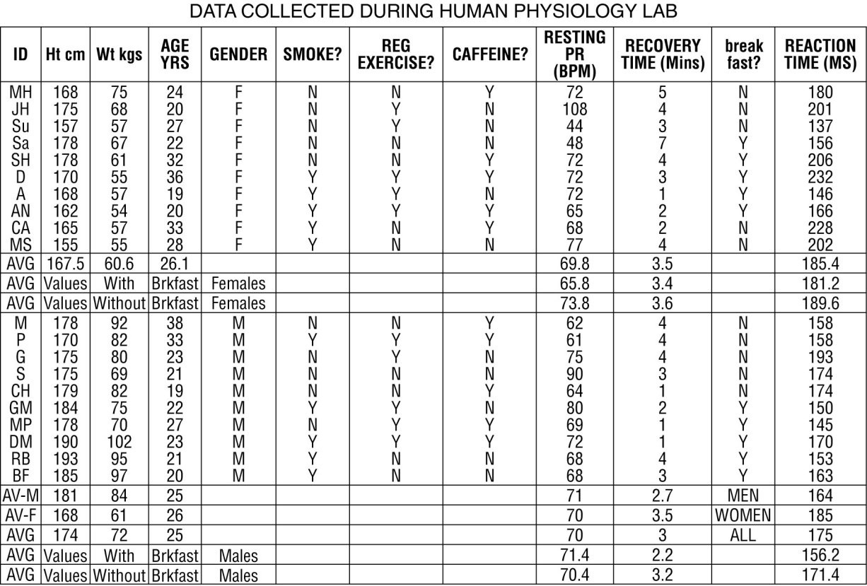
Table 1-3

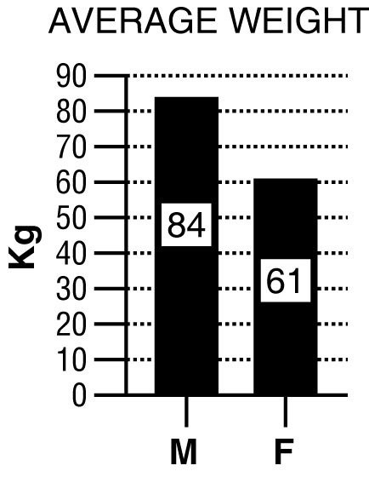

For these questions, the data were separated and analyzed by gender.

59) A. Write a hypothesis regarding gender and weight.
B. What is the dependent variable? What is the independent variable?
C. Based on the data in the graph above, what is your conclusion?
D. Why is a bar graph a good choice for presentation of these data? Would another type of chart be as effective?
Answer: A. Males weigh more than females.
B. Weight depends on gender; thus weight is dependent, gender is independent.
C. Males weigh more than females.
D. Bar graph allows comparison of the average of two groups. No.
Skill: Level IV: Quantitative Problems
60) A. Write a hypothesis regarding gender and recovery time.
B. What is the dependent variable? What is the independent variable?
C. Create a graph using the averages from the data table. Based on these data, what do you conclude?
Answer: A. A prediction such as "Males recover from exercise more quickly than females" would be appropriate.
B. The independent variable is gender; the dependent variable is recovery time.
C. A bar graph such as the one below is appropriate. In this study, men recovered from exercise more quickly than women.

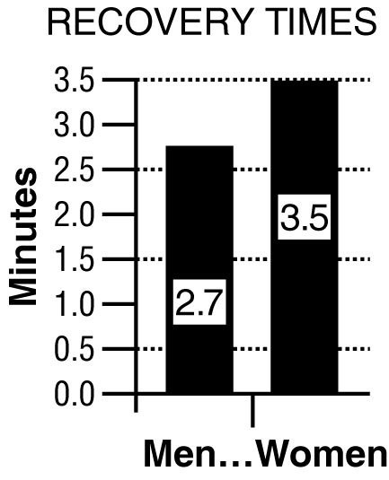

Skill: Level IV: Quantitative Problems

61) A. Write a hypothesis regarding the effects of breakfast consumption on reaction time.
B. What is the dependent variable? What is the independent variable?
Answer: A. A prediction such as "Eating breakfast prior to testing improves reaction time of subjects (compared to subjects who did not eat breakfast)" is appropriate.
B. The independent variable is breakfast consumption; the dependent variable is reaction time.
Skill: Level IV: Quantitative Problems

62) A. Disregarding gender, write a hypothesis that expresses the relationship between weight and height.
B. What is the dependent variable? What is the independent variable?
C. From the data in Table 1-3, construct a graph that examines this relationship.
Answer: A. A prediction such as "As height increases weight increases" would be appropriate.
B. The dependent variable would be weight, the independent variable is height.
C.
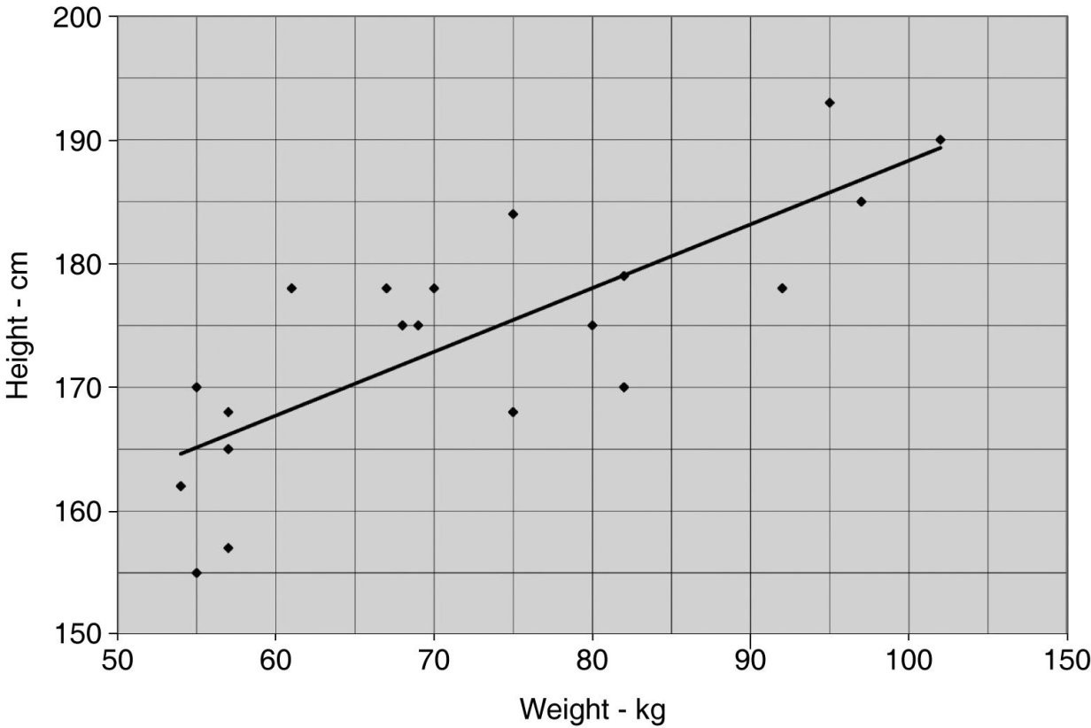
Skill: Level IV: Quantitative Problems
63) Table 1-3 shows data on various factors that may or may not be related to resting pulse rate, time to recovery to resting pulse rate after a few minutes of exercise, and reaction time measured by how quickly a student could press a keyboard key after seeing a computer-generated prompt. For each question below, write a testable hypothesis, identify the dependent and independent variables, sketch an appropriate graph of the results, and draw a conclusion from the data presented in the table. Discuss your results.
A. Does caffeine consumption have an effect on resting pulse rate?
B. Does age play a role in resting pulse rate? Does weight?
C. Is there a relationship between eating breakfast and recovery time?
D. Is there a relationship between reaction time and height?
E. Do women who smoke show differences in their resting pulse rates compared to female nonsmokers or to male smokers and nonsmokers?
F. Does regular exercise have an effect on resting pulse rate?
Answer: Answers will vary, but examples follow (conclusions written here are based on cursory examination of graphed datano statistical tests of significance were performed).
A. Hypothesis: Caffeine consumption increases heart rate.
Independent variable: caffeine consumption.
Dependent variable: resting pulse rate.
Conclusion: Mean pulse rates between caffeine-drinking (68 bpm) and control subjects (73 bpm) are similar; hypothesis rejected.
B. Hypothesis: Pulse rate is lower in older people and is higher in heavier people.
Independent variables: age and weight.
Dependent variables: resting pulse rate.
Conclusion: Pulse rate was similar in all groups; hypothesis rejected.
C. Hypothesis: People who ate breakfast have a faster reaction time.
Independent variable: breakfast consumption.
Dependent variable: pulse rate.
Conclusion: People who ate breakfast had a faster reaction time (168.7 msec vs. 180.5 msec); hypothesis supported.
D. Hypothesis: There is no relationship between height and reaction time.
Independent variable: height.
Dependent variable: reaction time.
Conclusion: Reaction time did not vary with height; hypothesis supported.
E. Hypothesis: Smokers of both genders have a higher resting pulse rate than nonsmokers of either gender, and males and females are affected equally.
Independent variables: smoking and gender.
Dependent variable: pulse rate.
Conclusion: There was no difference in pulse rate in any of the groups (70.4 bpm in nonsmokers vs. 70.3 bpm in smokers); hypothesis rejected.
F. Hypothesis: People who exercise regularly have a lower resting pulse rate.
Independent variable: exercise.
Dependent variable: pulse rate.
Conclusion: Regular exercise had no effect on resting pulse rate (68.9 bpm in nonexercisers vs. 71.8 bpm in exercisers); hypothesis rejected.

Discussion may cover issues such as the effect of small sample size, use of adults of limited age range, lack of control over treatments (were the subjects honest about age, eating breakfast, consuming caffeine, smoking, and exercising?; were the quantitative data of height and weight determined in the lab using the same equipment and same data collector?), the value of statistical analysis, and so on. It is likely that students will be surprised by some of the results and could make erroneous conclusions. For example, pulse rate may vary with age, but without including children and senior citizens in the sample population, this trend would be missed.
Skill: Level IV: Quantitative Problems

