Essentials of Geology, 13e (Lutgens/Tarbuck/Tasa)
Chapter 1 An Introduction to Geology

1) What are the basic differences between the disciplines of physical and historical geology?
A) Physical geology is the study of fossils and sequences of rock strata; historical geology is the study of how rocks and minerals were used in the past.
B) Historical geology involves the study of rock strata, fossils, and geologic events, utilizing the geologic time scale as a reference; physical geology includes the study of how rocks form and of how erosion shapes the land surface.
C) Physical geology involves the study of rock strata, fossils, and deposition in relation to plate movements in the geologic past; historical geology charts how and where the plates were moving in the past.
D) None of the above—physical geology and historical geology are essentially the same.
Answer: B
Diff: 1
Chapter Subhead: 1.1 Geology: The Science of Earth
Bloom's: Remembering/Understanding

2) ________ was the highly influential, ancient Greek philosopher noted for his writings and teachings on natural philosophy and on the workings of the Earth.
A) Nero
B) Odysseus
C) Aristotle
D) Pappagapolis
Answer: C
Diff: 1
Chapter Subhead: 1.2 The Development of Geology
Bloom's: Remembering/Understanding

3) Compared to the age of the Earth accepted as correct today, how did seventeenth and eighteenth century proponents of catastrophism envision the Earth's age?
A) They believed Earth to be much older than current estimates.
B) They believed it to be about the same as current estimates, give or take a few million years.
C) They believed Earth to be much younger than current estimates.
D) None of the above—they didn't really address the age of Earth.
Answer: C
Diff: 1
Chapter Subhead: 1.2 The Development of Geology
Bloom's: Remembering/Understanding

4) ________ was an important eighteenth century English geologist and proponent of uniformitarianism.
A) Charles Lyell
B) Isaac Newton
C) James Hutton
D) James Ussher
Answer: C
Diff: 1
Chapter Subhead: 1.2 The Development of Geology
Bloom's: Remembering/Understanding
5) ________ is often paraphrased as "the present is the key to the past."
A) Biblical prophecy
B) Uniformitarianism
C) Aristotelian logic
D) Catastrophism
Answer: B
Diff: 1
Chapter Subhead: 1.2 The Development of Geology
Bloom's: Remembering/Understanding

6) ________, a popular natural philosophy of the seventeenth and early eighteenth centuries, was based on a firm belief in a very short geologic history for Earth.
A) Ecospherism
B) Exoschism
C) Uniformitarianism
D) Catastrophism
Answer: D
Diff: 1
Chapter Subhead: 1.2 The Development of Geology
Bloom's: Remembering/Understanding

7) The currently accepted age of the Earth is ________ years.
A) 4.6 thousand
B) 6.4 trillion
C) 4.6 billion
D) 6.4 million
Answer: C
Diff: 1
Chapter Subhead: 1.2 The Development of Geology
Bloom's: Remembering/Understanding

8) Which of the following best describes the fundamental concept of superposition?
A) Strata with fossils are generally deposited on strata with no fossils.
B) Older strata generally are deposited on younger strata without intervening, intermediate age strata.
C) Older fossils in younger strata indicate a locally inverted geologic time scale.
D) Any sedimentary deposit accumulates on older rock or sediment layers.
Answer: D
Diff: 1
Chapter Subhead: 1.2 The Development of Geology
Bloom's: Remembering/Understanding

9) The Geologic Time Scale represents ________.
A) the previous 100,000 years of Earth's history
B) the entire 4.6 billion-year history of Earth
C) the span of geologic time since humans existed
D) the span of geologic time since dinosaurs existed
Answer: B
Diff: 1
Chapter Subhead: 1.2 The Development of Geology
Bloom's: Remembering/Understanding
10) The ________ division of the geologic time scale makes up over 88 percent of geologic time.
A) Cenozoic
B) Precambrian
C) Paleozoic
D) Mesozoic
Answer: B
Diff: 1
Chapter Subhead: 1.2 The Development of Geology
Bloom's: Remembering/Understanding

11) A ________ is a well-tested and widely accepted view that best explains certain scientific observations.
A) hypothesis
B) generalization
C) law
D) theory
Answer: D
Diff: 1
Chapter Subhead: 1.3 The Nature of Scientific Inquiry
Bloom's: Remembering/Understanding

12) All of the following are possible steps of scientific investigation EXCEPT for ________.
A) the collection of scientific facts through observation and measurement
B) assumption of conclusions without prior experimentation or observation
C) the development of one or more working hypotheses or models to explain facts
D) development of observations and experiments to test the hypotheses
Answer: B
Diff: 1
Chapter Subhead: 1.3 The Nature of Scientific Inquiry
Bloom's: Remembering/Understanding

13) Which of the following choices best illustrates the proper order of the steps in a scientific investigation?
A) Analyze data, conduct background research, form a hypothesis.
B) Form a hypothesis, conduct background research, analyze data.
C) Raise a question from the natural world, construct a hypothesis, test the hypothesis.
D) Develop observations, conduct background research, form a question about the natural world.
Answer: C
Diff: 2
Chapter Subhead: 1.3 The Nature of Scientific Inquiry
Bloom's: Applying/Analyzing

14) The ________ refers to the sum total of all life on Earth.
A) hydrosphere
B) atmosphere
C) biosphere
D) asthenosphere
Answer: C
Diff: 1
Chapter Subhead: 1.4 Earth as a System
Bloom's: Remembering/Understanding
15) The ________ is not a part of the Earth's physical environment.
A) solid Earth
B) astrosphere
C) hydrosphere
D) atmosphere
Answer: B
Diff: 1
Chapter Subhead: 1.4 Earth as a System
Bloom's: Remembering/Understanding

16) Which of the following cycles moves water among Earth's four spheres?
A) the rock cycle
B) the hydrologic cycle
C) the solar cycle
D) the volcanic cycle
Answer: B
Diff: 1
Chapter Subhead: 1.4 Earth as a System
Bloom's: Remembering/Understanding

17) Which of the following best describes the Earth system?
A) The different components of the system are totally independent of one another.
B) The Earth system includes only the hydrologic cycle and the rock cycle.
C) The Earth system has a nearly endless array of interconnected subsystems.
D) Geology is the only field of study related to the Earth system.
Answer: C
Diff: 2
Chapter Subhead: 1.4 Earth as a System
Bloom's: Applying/Analyzing

18) The ________ proposes that the bodies of our solar system formed at essentially the same time from a rotating cloud of gases and dust.
A) Big Bang theory
B) Plate Tectonics theory
C) Nebular theory
D) Heliocentric theory
Answer: C
Diff: 1
Chapter Subhead: 1.5 Origin and Early Evolution of Earth
Bloom's: Remembering/Understanding

19) The asthenosphere ________.
A) is a subdivision of the outer core
B) is a zone of strong material near the inner core
C) contains Earth's crust and upper mantle
D) is a relatively weak zone within the mantle
Answer: D
Diff: 1
Chapter Subhead: 1.6 Earth's Internal Structure
Bloom's: Remembering/Understanding
20) The ________ forms the relatively cool, brittle plates of plate tectonics.
A) asthenosphere
B) lithosphere
C) astrosphere
D) geosphere
Answer: B
Diff: 1
Chapter Subhead: 1.6 Earth's Internal Structure
Bloom's: Remembering/Understanding

21) Which of the following is an Earth layer defined based on its chemical composition?
A) asthenosphere
B) lithosphere
C) crust
D) transition zone
Answer: C
Diff: 1
Chapter Subhead: 1.6 Earth's Internal Structure
Bloom's: Remembering/Understanding

22) In correct order from the center outward, Earth includes which units?
A) core, inner mantle, outer mantle, crust
B) inner core, outer core, mantle, crust
C) inner core, crust, mantle, hydrosphere
D) core, crust, mantle, hydrosphere
Answer: B
Diff: 1
Chapter Subhead: 1.6 Earth's Internal Structure
Bloom's: Remembering/Understanding

23) The composition of the core of the Earth is thought to be ________.
A) basalt
B) granite
C) peridotite
D) solid iron-nickel alloy
Answer: D
Diff: 1
Chapter Subhead: 1.6 Earth's Internal Structure
Bloom's: Remembering/Understanding

24) Most of our understanding of Earth's interior comes from ________.
A) direct samples from the mantle
B) the activity of volcanoes
C) the study of seismic waves
D) sampling the composition of the crust
Answer: C
Diff: 1
Chapter Subhead: 1.6 Earth's Internal Structure — "Did You Know?" Box
Bloom's: Remembering/Understanding
25) The asthenosphere is actually a part of the ________ of the Earth.
A) outer core
B) crust
C) inner core
D) mantle
Answer: D
Diff: 1
Chapter Subhead: 1.6 Earth's Internal Structure
Bloom's: Remembering/Understanding

26) The ________ is thought to be a liquid, metallic region in the Earth's interior.
A) inner core
B) lithosphere
C) mantle
D) outer core
Answer: D
Diff: 1
Chapter Subhead: 1.6 Earth's Internal Structure
Bloom's: Remembering/Understanding

27) The ________ is the thinnest layer of the Earth.
A) crust
B) outer core
C) mantle
D) inner core
Answer: A
Diff: 1
Chapter Subhead: 1.6 Earth's Internal Structure
Bloom's: Remembering/Understanding

28) According to the rock cycle, which of the following statements is true?
A) Sedimentary rocks can be turned into igneous rocks, but not metamorphic rocks.
B) Metamorphic rocks are the end product, and cannot be altered.
C) Any rock type can ultimately be turned into any other rock type.
D) Sedimentary rocks can be turned into igneous rocks, but igneous rocks cannot become sedimentary rocks.
Answer: C
Diff: 1
Chapter Subhead: 1.7 Rocks and the Rock Cycle
Bloom's: Remembering/Understanding

29) ________ rocks form by crystallization and consolidation of molten magma.
A) Sedimentary
B) Indigenous
C) Primary
D) Igneous
Answer: D
Diff: 1
Chapter Subhead: 1.7 Rocks and the Rock Cycle
Bloom's: Remembering/Understanding
30) ________ rocks always originate at the surface of the solid Earth.
A) Secondary
B) Igneous
C) Metamorphic
D) Sedimentary
Answer: D
Diff: 1
Chapter Subhead: 1.7 Rocks and the Rock Cycle
Bloom's: Remembering/Understanding

31) ________ is the process by which rocks break down in place to produce soils and sediments.
A) Weathering
B) Lithification
C) Subduction
D) Metamorphism
Answer: A
Diff: 1
Chapter Subhead: 1.7 Rocks and the Rock Cycle
Bloom's: Remembering/Understanding

32) Which one of the following statements is NOT correct?
A) Metamorphic rocks may melt to magma.
B) Sedimentary rocks may weather to igneous rocks.
C) Magmas crystallize to form igneous rocks.
D) Igneous rocks can undergo metamorphism.
Answer: B
Diff: 1
Chapter Subhead: 1.7 Rocks and the Rock Cycle
Bloom's: Remembering/Understanding

33) In sedimentary rocks, lithification includes ________.
A) compaction and cementation
B) cementation and weathering
C) compaction and transportation
D) crystallization and cooling
Answer: A
Diff: 1
Chapter Subhead: 1.7 Rocks and the Rock Cycle
Bloom's: Remembering/Understanding

34) Active mountain belts are most likely to be found ________.
A) along the margins of continents
B) in the interior regions of continents
C) scattered throughout continents
D) along only the eastern margins of continents
Answer: A
Diff: 2
Chapter Subhead: 1.8 The Face of Earth
Bloom's: Applying/Analyzing
35) The continental shelf is located ________.
A) between the continental slope and continental rise
B) between the continental rise and the abyssal plains
C) seaward of the continental slope
D) landward of the continental slope
Answer: D
Diff: 1
Chapter Subhead: 1.8 The Face of Earth
Bloom's: Remembering/Understanding

36) The most prominent feature on the ocean floor are the ________.
A) deep-ocean trenches
B) oceanic ridges
C) seamounts
D) lava plateaus
Answer: B
Diff: 1
Chapter Subhead: 1.8 The Face of Earth
Bloom's: Remembering/Understanding

37) Which of the following is true of Earth's continents?
A) Most of their landmass lies at elevations substantially above sea level.
B) Most of their landmass is comprised of rocky mountains.
C) They are relatively flat and have an average elevation that is quite close to sea level.
D) They cover the vast majority of Earth's surface.
Answer: C
Diff: 1
Chapter Subhead: 1.8 The Face of Earth
Bloom's: Remembering/Understanding

38) The gently sloping platform that extends seaward from shore, found along most coasts, is called ________.
A) the continental shelf
B) the continental slope
C) the continental rise
D) the continental shield
Answer: A
Diff: 1
Chapter Subhead: 1.8 The Face of Earth
Bloom's: Remembering/Understanding

39) Examine the words and/or phrases below and determine the relationship among the majority of words/phrases. Choose the option that does not fit the pattern.
A) hydrosphere
B) biosphere
C) atmosphere
D) geosphere
Answer: B
Diff: 1
Chapter Subhead: 1.4 Earth as a System
Bloom's: Remembering/Understanding
40) Examine the words and/or phrases below and determine the relationship among the majority of words/phrases. Choose the option that does not fit the pattern.
A) transpiration
B) metamorphism
C) infiltration
D) precipitation
Answer: B
Diff: 1
Chapter Subhead: 1.4 Earth as a System
Bloom's: Remembering/Understanding

41) Examine the words and/or phrases below and determine the relationship among the majority of words/phrases. Choose the option that does not fit the pattern.
A) Mercury
B) Venus
C) Mars
D) Neptune
Answer: D
Diff: 1
Chapter Subhead: 1.5 Origin and Early Evolution of Earth
Bloom's: Remembering/Understanding

42) Examine the words and/or phrases below and determine the relationship among the majority of words/phrases. Choose the option that does not fit the pattern.
A) crust
B) asthenosphere
C) lithosphere
D) transition zone
Answer: A
Diff: 1
Chapter Subhead: 1.6 Earth's Internal Structure
Bloom's: Remembering/Understanding

43) Examine the words and/or phrases below and determine the relationship among the majority of words/phrases. Choose the option that does not fit the pattern.
A) lithification
B) weathering
C) cementation
D) transpiration
Answer: D
Diff: 1
Chapter Subhead: 1.7 Rocks and the Rock Cycle
Bloom's: Remembering/Understanding
44) Examine the words and/or phrases below and determine the relationship among the majority of words/phrases. Choose the option that does not fit the pattern.
A) sedimentary
B) craton
C) igneous
D) metamorphic
Answer: B
Diff: 1
Chapter Subhead: 1.7 Rocks and the Rock Cycle
Bloom's: Remembering/Understanding

45) Examine the words and/or phrases below and determine the relationship among the majority of words/phrases. Choose the option that does not fit the pattern.
A) abyssal plain
B) seamount
C) oceanic ridge
D) shield
Answer: D
Diff: 1
Chapter Subhead: 1.8 The Face of Earth
Bloom's: Remembering/Understanding

46) Examine the words and/or phrases below and determine the relationship among the majority of words/phrases. Choose the option that does not fit the pattern.
A) craton
B) shield
C) mountain belt
D) trench
Answer: D
Diff: 1
Chapter Subhead: 1.8 The Face of Earth
Bloom's: Remembering/Understanding

Critical thinking and discussion questions. Use complete sentences, correct spelling, and the information presented in chapter 1 to answer the questions below.

47) Catastrophism obviously influenced seventeenth and eighteenth century thought by implying that Earth only needed to be a few thousand years old in order to explain landscapes and geologic features. However, catastrophic and often sudden changes are at least a part of the rock record that geologists attempt to interpret. List three geologic catastrophes that would most likely affect landscapes or features on Earth and be recorded in rocks. How might these events be explained in the rock record using only uniformitarianism (or the implication of slow, gradual change)?
Answer: Even though the rates of Earth's processes vary in intensity throughout geologic time, they still will influence the landscape, typically over very long time periods. A classic example is the formation of the Grand Canyon (Figure 1.5). Other potential examples are mountain building, sedimentary rock deposition, and plate tectonics.
Diff: 3
Chapter Subhead: 1.2 The Development of Geology
Bloom's: Evaluating/Creating
48) Earth's physical environment is traditionally divided into the hydrosphere, atmosphere, and the solid Earth. Remembering the scientific method, why do you think that scientists tend to categorize and classify various features, phenomena, and characteristics of the natural world into groups or subdivisions? Also, are there potential pitfalls or problems if we only consider the natural world as individual groups or categories rather than as a whole?
Answer: Scientists organize and classify into group and subdivisions because the data are collected to answer a specific question or hypothesis. The potential problems are that scientists may become very focused on a research question that they may not realize that an answer may lie outside their discipline.
Diff: 3
Chapter Subhead: 1.3 The Nature of Scientific Inquiry
Bloom's: Evaluating/Creating

49) Label the layers of Earth's interior on the diagram below.

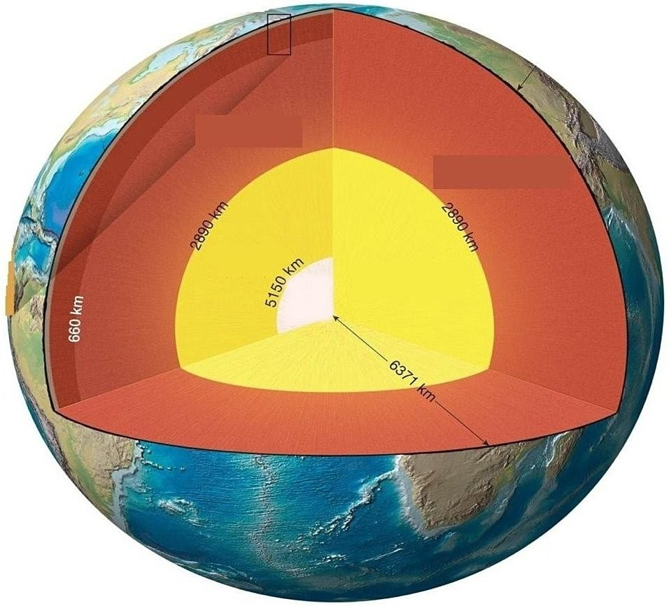

Answer: See Figure 1.20 in the Essentials of Geology, 13e textbook.
Diff: 1
Chapter Subhead: 1.6 Earth's Internal Structure
Bloom's: Remembering/Understanding
50) Using the following figure, please match each section of the rock cycle to the appropriate label.

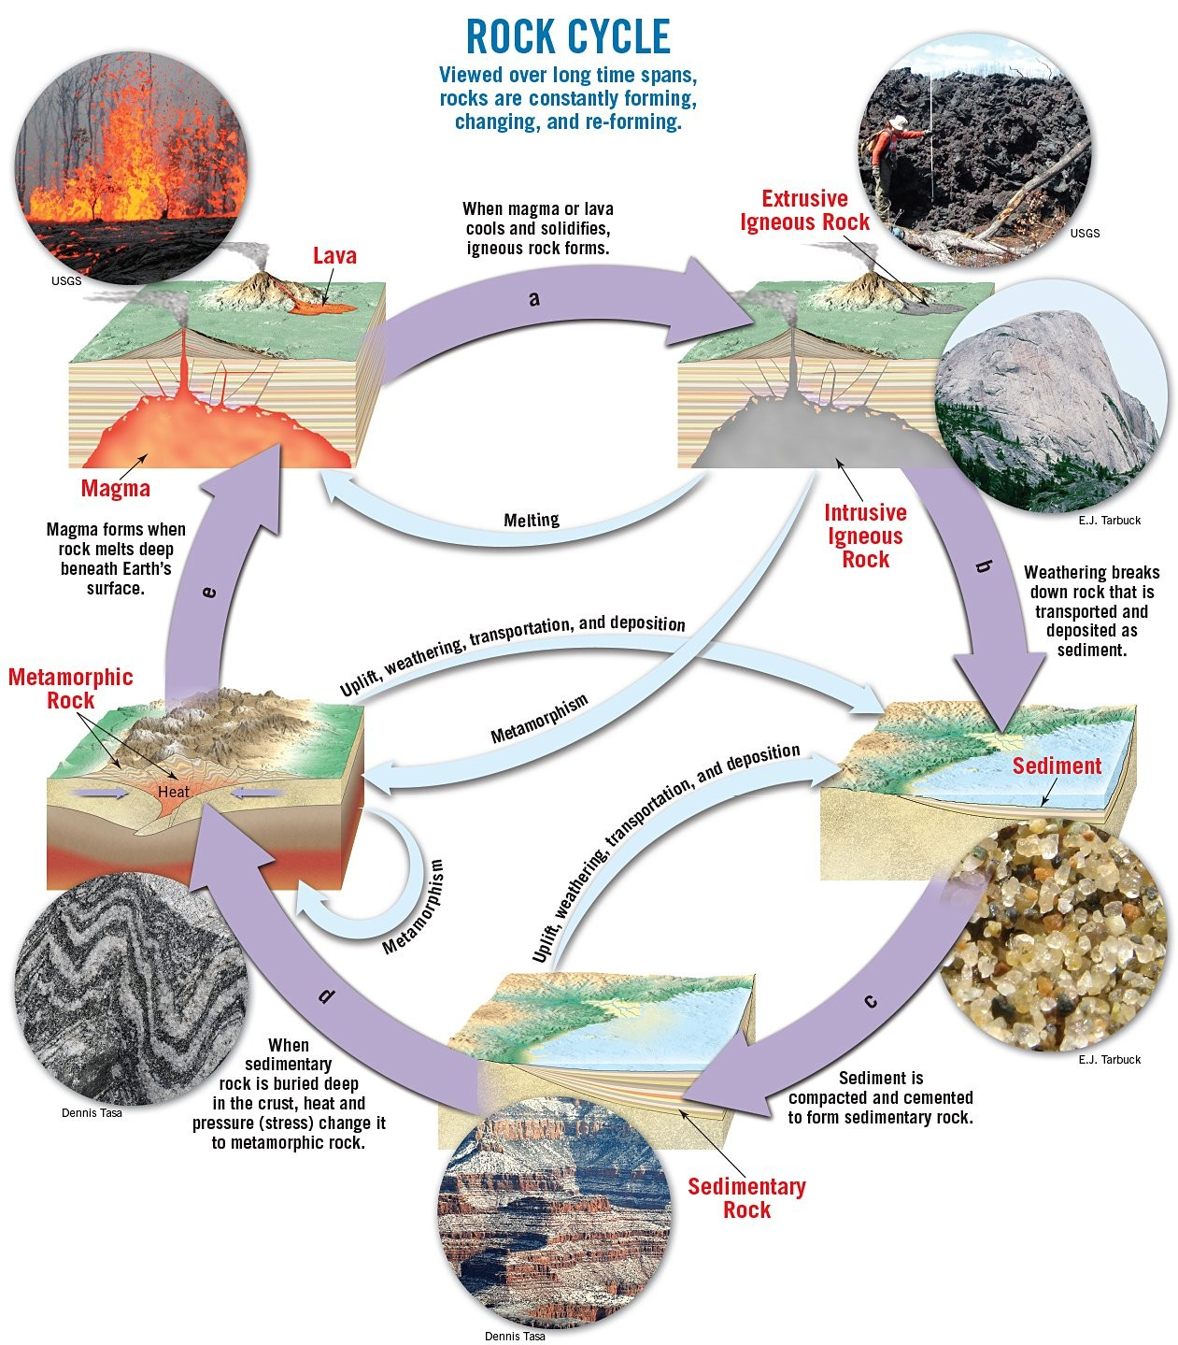

Answer:
A — Cooling, crystallization
B — Weathering, transport, deposition
C — Lithification (compaction, cementation)
D — Metamorphism (heat, intense pressure)
E — Melting
Diff: 1
Chapter Subhead: 1.7 Rocks and the Rock Cycle
Bloom's: Remembering/Understanding
51) Look at the three photographs below. Which one depicts sedimentary rocks?

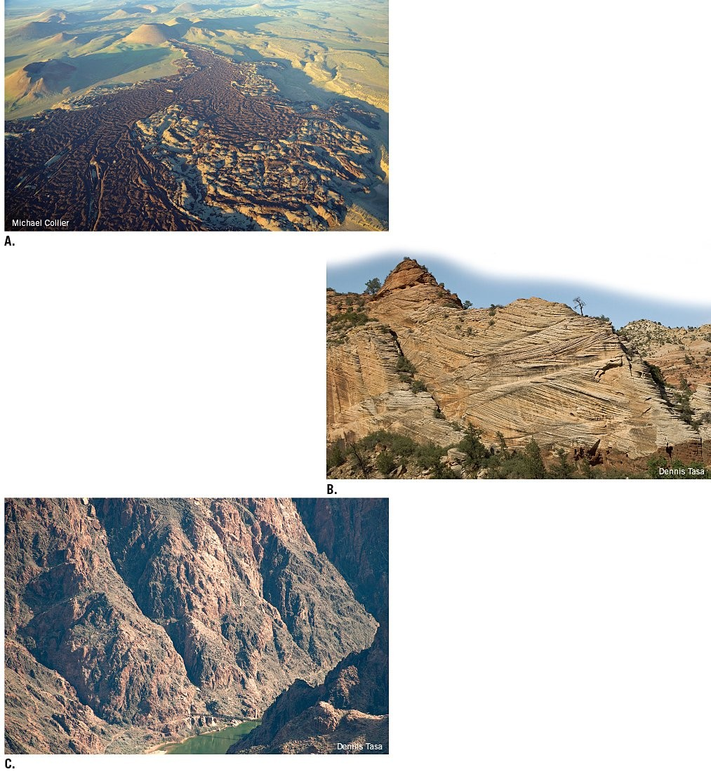
Answer: B
Diff: 2
Chapter Subhead: 1.7 Rocks and the Rock Cycle
Bloom's: Applying/Analyzing

