Essentials of Geology, 11e (Lutgens/Tarbuck/Tasa)
Chapter 1 An Introduction to Geology

1) What are the basic differences between the disciplines of physical and historical geology?
A) Physical geology is the study of fossils and sequences of rock strata; historical geology is the study of how rocks and minerals were used in the past.
B) Historical geology involves the study of rock strata, fossils, and geologic events, utilizing the geologic time scale as a reference; physical geology includes the study of how rocks form and of how erosion shapes the land surface.
C) Physical geology involves the study of rock strata, fossils, and deposition in relation to plate movements in the geologic past; historical geology charts how and where the plates were moving in the past.
D) None of the above—physical geology and historical geology are essentially the same.
Answer: B
Diff: 1
Chapter Subhead: 1.1 The Science of Geology
Bloom's: Analyzing

2) ________ was the highly influential, ancient Greek philosopher noted for his writings and teachings on natural philosophy and on the workings of Earth.
A) Nero
B) Odysseus
C) Aristotle
D) Pappagapolis
Answer: C
Diff: 1
Chapter Subhead: 1.3 Historical Notes about Geology
Bloom's: Remembering

3) Compared to the age of Earth accepted as correct today, how did seventeenth and eighteenth century proponents of catastrophism envision the Earth's age?
A) They believed Earth to be much older than current estimates.
B) They believed it to be about the same as current estimates, give or take a few million years.
C) They believed Earth to be much younger than current estimates.
D) None of the above – they didn't really address the age of Earth.
Answer: C
Diff: 1
Chapter Subhead: 1.3 Historical Notes about Geology
Bloom's: Evaluating
4) Which one of the following observations and inferences is consistent with the idea of uniformitarianism?
A) Sand rolling along a stream bottom shows that sediment is moving downstream.
B) Erupting volcanoes overlie burning, subterranean coal beds.
C) Lava flows on the seafloor precipitated from seawater.
D) all of the above
Answer: A
Diff: 1
Chapter Subhead: 1.3 Historical Notes about Geology
Bloom's: Applying

5) ________ was an important eighteenth century English geologist and proponent of uniformitarianism.
A) Charles Lyell
B) Isaac Newton
C) James Hutton
D) James Ussher
Answer: C
Diff: 1
Chapter Subhead: 1.3 Historical Notes about Geology
Bloom's: Remembering

6) The currently accepted age of Earth is ________ years.
A) 4.6 thousand
B) 6.4 trillion
C) 4.6 billion
D) 6.4 million
Answer: C
Diff: 1
Chapter Subhead: 1.4 Geologic Time
Bloom's: Remembering

7) Which of the following best describes the fundamental concept of superposition?
A) Strata with fossils are generally deposited on strata with no fossils.
B) Older strata generally are deposited on younger strata without intervening, intermediate age strata.
C) Older fossils in younger strata indicate a locally inverted geologic time scale.
D) Any sedimentary deposit accumulates on older rock or sediment layers.
Answer: D
Diff: 1
Chapter Subhead: 1.4 Geologic Time
Bloom's: Understanding
8) The ________ division of the geologic time scale is an era of the Phanerozoic eon.
A) Paleocene
B) Paleozoic
C) Permian
D) Proterozoic
Answer: B
Diff: 1
Chapter Subhead: 1.4 Geologic Time
Bloom's: Remembering

9) The ________ forms the relatively cool, brittle plates of plate tectonics.
A) asthenosphere
B) lithosphere
C) astrosphere
D) eosphere
Answer: B
Diff: 1
Chapter Subhead: 1.10 Earth's Internal Structure
Bloom's: Remembering

10) A ________ is a well-tested and widely accepted view that best explains certain scientific observations.
A) hypothesis
B) generalization
C) law
D) theory
Answer: D
Diff: 1
Chapter Subhead: 1.5 The Nature of Scientific Inquiry
Bloom's: Remembering

11) All of the following are possible steps of scientific investigation except for ________.
A) the collection of scientific facts through observation and measurement
B) assumption of conclusions without prior experimentation or observation
C) the development of one or more working hypotheses or models to explain facts
D) development of observations and experiments to test the hypotheses
Answer: B
Diff: 1
Chapter Subhead: 1.5 The Nature of Scientific Inquiry
Bloom's: Applying
12) ________ rocks form by crystallization and consolidation of molten magma.
A) Sedimentary
B) Indigenous
C) Primary
D) Igneous
Answer: D
Diff: 1
Chapter Subhead: 1.8 The Rock Cycle: One of Earth's Subsystems
Bloom's: Remembering

13) ________ rocks always originate at the surface of the solid Earth.
A) Secondary
B) Igneous
C) Metamorphic
D) Sedimentary
Answer: D
Diff: 1
Chapter Subhead: 1.8 The Rock Cycle: One of Earth's Subsystems
Bloom's: Applying

14) During the late nineteenth and early twentieth centuries, direct observations showed that a glacier in Switzerland flowed forward in the downhill direction while its snout (terminus) was retreating higher up the valley. Which of the following explains these observations in a rational, scientific way?
A) Cooler temperatures meant slower forward glacier flow resulting in snout retreat.
B) The glacial hypothesis was finally accepted as a scientific theory.
C) Rocky debris in the valley downhill from the snout was deposited by Noah's flood.
D) The melting rate of ice in the glacier exceeded the rate at which new snow and ice were added to the glacier.
Answer: D
Diff: 2
Chapter Subhead: 1.5 The Nature of Scientific Inquiry
Bloom's: Applying
15) In correct order from the center outward, Earth includes which units?
A) core, inner mantle, outer mantle, crust
B) inner core, outer core, mantle, crust
C) inner core, crust, mantle, hydrosphere
D) core, crust, mantle, hydrosphere
Answer: B
Diff: 1
Chapter Subhead: 1.10 Earth's Internal Structure
Bloom's: Remembering

16) The ________ refers to the sum total of all life on Earth.
A) hydrosphere
B) atmosphere
C) biosphere
D) asthenosphere
Answer: C
Diff: 1
Chapter Subhead: 1.6 Earth's Spheres
Bloom's: Remembering

17) A(n) ________ system is one in which energy moves freely in and out, but no matter enters or leaves the system.
A) closed
B) open
C) feedback
D) equilibrated
Answer: A
Diff: 1
Chapter Subhead: 1.7 Earth as a System
Bloom's: Remembering

18) ________ is often paraphrased as "the present is the key to the past."
A) Biblical prophecy
B) Uniformitarianism
C) Aristotelian logic
D) Catastrophism
Answer: B
Diff: 1
Chapter Subhead: 1.3 Historical Notes about Geology
Bloom's: Remembering
19) ________, a popular natural philosophy of the seventeenth and early eighteenth centuries, was based on a firm belief in a very short geologic history for Earth.
A) Ecospherism
B) Exoschism
C) Uniformitarianism
D) Catastrophism
Answer: D
Diff: 1
Chapter Subhead: 1.3 Historical Notes about Geology
Bloom's: Remembering

20) The ________ proposes that the bodies of our solar system formed at essentially the same time from a rotating cloud of gases and dust.
A) Big Bang theory
B) Plate Tectonics theory
C) Nebular hypothesis
D) Heliocentric theory
Answer: C
Diff: 1
Chapter Subhead: 1.9 Early Evolution of Earth
Bloom's: Remembering

21) The ________ is not a part of the Earth's physical environment.
A) solid Earth
B) astrosphere
C) hydrosphere
D) atmosphere
Answer: B
Diff: 1
Chapter Subhead: 1.6 Earth's Spheres
Bloom's: Applying

22) ________ is the process by which rocks breakdown in place to produce soils and sediments.
A) Weathering
B) Lithification
C) Subduction
D) Metamorphism
Answer: A
Diff: 1
Chapter Subhead: 1.8 The Rock Cycle: One of Earth's Subsystems
Bloom's: Remembering
23) Which one of the following statements is not correct?
A) Metamorphic rocks may melt to magma.
B) Sedimentary rocks may weather to igneous rocks.
C) Magmas crystallize to form igneous rocks.
D) Igneous rocks can undergo metamorphism.
Answer: A
Diff: 1
Chapter Subhead: 1.8 The Rock Cycle: One of Earth's Subsystems
Bloom's: Applying

24) The composition of the core of Earth is thought to be ________.
A) basalt
B) granite
C) peridotite
D) solid iron-nickel alloy
Answer: D
Diff: 1
Chapter Subhead: 1.10 Earth's Internal Structure
Bloom's: Remembering

25) The asthenosphere is actually a part of the ________ of the Earth.
A) outer core
B) crust
C) inner core
D) mantle
Answer: D
Diff: 1
Chapter Subhead: 1.10 Earth's Internal Structure
Bloom's: Remembering

26) The ________ is thought to be a liquid, metallic region in the Earth's interior.
A) inner core
B) lithosphere
C) mantle
D) outer core
Answer: D
Diff: 1
Chapter Subhead: 1.10 Earth's Internal Structure
Bloom's: Remembering
27) The ________ is the thinnest layer of the Earth.
A) crust
B) outer core
C) mantle
D) inner core
Answer: A
Diff: 1
Chapter Subhead: 1.10 Earth's Internal Structure
Bloom's: Understanding

28) Active mountain belts are most likely to be found ________.
A) along the margins of continents
B) in the interior regions of continents
C) scattered throughout continents
D) along only the eastern margins of continents
Answer: A
Diff: 1
Chapter Subhead: 1.11 The Face of the Earth
Bloom's: Evaluating

29) The continental shelf is located ________.
A) between the continental slope and continental rise
B) between the continental rise and the abyssal plains
C) seaward of the continental slope
D) landward of the continental slope
Answer: D
Diff: 1
Chapter Subhead: 1.11 The Face of the Earth
Bloom's: Understanding

30) The most prominent feature on the ocean floor are the ________.
A) deep-ocean trenches
B) oceanic ridges
C) seamounts
D) lava plateaus
Answer: B
Diff: 1
Chapter Subhead: 1.11 The Face of the Earth
Bloom's: Remembering
31) In sedimentary rocks, lithification includes ________.
A) compaction and cementation
B) cementation and weathering
C) compaction and transportation
D) crystallization and cooling
Answer: A
Diff: 1
Chapter Subhead: 1.8 The Rock Cycle: One of Earth's Subsystems
Bloom's: Remembering

Word Analysis. Examine the words and/or phrases for each question below and determine the relationship among the majority of words/phrases. Choose the option which does not fit the pattern.

32) a. hypothesis b. theory c. fact d. observation
Answer: c
Diff: 1
Chapter Subhead: 1.5 The Nature of Scientific Inquiry
Bloom's: Remembering

33) a. hydrosphere b. biosphere c. atmosphere d. solid Earth
Answer: b
Diff: 1
Chapter Subhead: 1.6 Earth's Spheres
Bloom's: Remembering

34) a. protosun b. Oort cloud c. protoplanets d. meteorites
Answer: b
Diff: 2
Chapter Subhead: 1.9 Early Evolution of Earth
Bloom's: Remembering

35) a. crust b. mantle c. lithosphere d. core
Answer: c
Diff: 1
Chapter Subhead: 1.10 Earth's Internal Structure
Bloom's: Understanding

36) a. abyssal plain b. seamount c. oceanic ridge d. continental slope
Answer: d
Diff: 1
Chapter Subhead: 1.11 The Face of the Earth
Bloom's: Remembering
37) Aristotle and other prominent Greek philosophers were the first ones to promote the doctrine of uniformitarianism.
Answer: FALSE
Diff: 1
Chapter Subhead: 1.3 Historical Notes about Geology
Bloom's: Remembering

38) Internally, the Earth consists of spherical shells with different compositions and densities.
Answer: TRUE
Diff: 1
Chapter Subhead: 1.10 Earth's Internal Structure
Bloom's: Understanding

39) The asthenosphere is a relatively cool and rigid shell that overlies the lithosphere.
Answer: FALSE
Diff: 1
Chapter Subhead: 1.10 Earth's Internal Structure
Bloom's: Remembering

40) The law of superposition applies primarily to sedimentary rocks and lava flows.
Answer: TRUE
Diff: 1
Chapter Subhead: 1.4 Geologic Time
Bloom's: Remembering

41) The currently accepted age of Earth is approximately 4.5 million years.
Answer: FALSE
Diff: 1
Chapter Subhead: 1.4 Geologic Time
Bloom's: Remembering

42) A scientific theory is a tentative or untested explanation that is proposed to explain scientific observations.
Answer: FALSE
Diff: 1
Chapter Subhead: 1.5 The Nature of Scientific Inquiry
Bloom's: Remembering

43) Oceans cover slightly less than half of the Earth's surface.
Answer: FALSE
Diff: 1
Chapter Subhead: 1.11 The Face of the Earth
Bloom's: Remembering
44) In an open system both energy and matter flow into and out of the system.
Answer: TRUE
Diff: 1
Chapter Subhead: 1.7 Earth as a System
Bloom's: Remembering

45) According to the nebular hypothesis, all of the bodies in the universe evolved from a rotating cloud of gases and dust about 5 billion years ago.
Answer: FALSE
Diff: 1
Chapter Subhead: 1.9 Early Evolution of Earth
Bloom's: Remembering

46) The lithosphere, asthenosphere, and mesosphere are all layers of Earth defined by their composition.
Answer: FALSE
Diff: 1
Chapter Subhead: 1.10 Earth's Internal Structure
Bloom's: Remembering

47) Much of our modeling of Earth's interior comes from the study of seismic or earthquake waves.
Answer: TRUE
Diff: 2
Chapter Subhead: 1.10 Earth's Internal Structure - "Did You Know?" Box
Bloom's: Understanding

48) According to the rock cycle, any type of rock (igneous, sedimentary, or metamorphic) may be transformed into another type of rock, given enough time.
Answer: TRUE
Diff: 1
Chapter Subhead: 1.8 The Rock Cycle: One of Earth's Subsystems
Bloom's: Remembering

49) Igneous rocks are produced largely by the deposition and consolidation of surface materials like sand and mud.
Answer: FALSE
Diff: 1
Chapter Subhead: 1.8 The Rock Cycle: One of Earth's Subsystems
Bloom's: Remembering
50) The statement, "the present is the key to the past," describes what basic geologic concept or doctrine?
Answer: uniformitarianism
Diff: 1
Chapter Subhead: 1.3 Historical Notes about Geology
Bloom's: Remembering

51) The ________ states that fossil organisms succeed one another in a definite and determinable order.
Answer: principle of fossil succession
Diff: 1
Chapter Subhead: 1.4 Geologic Time
Bloom's: Remembering

52) In natural systems, mechanisms that drive or enhance change are called ________.
Answer: positive feedback mechanisms
Diff: 1
Chapter Subhead: 1.7 Earth as a System
Bloom's: Remembering
53) The thin, outer layer of Earth, from 7 to 40 km in thickness, is called the ________.
Answer: crust
Diff: 1
Chapter Subhead: 1.10 Earth's Internal Structure
Bloom's: Remembering

54) The ________ is the relatively rigid zone above the asthenosphere that includes the crust and upper mantle.
Answer: lithosphere
Diff: 1
Chapter Subhead: 1.10 Earth's Internal Structure
Bloom's: Remembering

55) The ________ is the solid, rocky shell between the crust and outer core.
Answer: mantle
Diff: 1
Chapter Subhead: 1.10 Earth's Internal Structure
Bloom's: Remembering
56) The convective flow of liquid, metallic iron in the ________ is thought to generate Earth's magnetic field.
Answer: outer core
Diff: 1
Chapter Subhead: 1.10 Earth's Internal Structure
Bloom's: Remembering

57) Moving from the shoreline towards the deep-ocean basin, the continental margin may include the ________, ________, and the ________.
Answer: continental shelf, continental slope, continental rise
Diff: 1
Chapter Subhead: 1.11 The Face of the Earth
Bloom's: Remembering

58) What type of rock comprises most of the exposed surface of Earth (roughly 75%)?
Answer: sedimentary
Diff: 1
Chapter Subhead: 1.8 The Rock Cycle: One of Earth's Subsystems
Bloom's: Remembering

Critical thinking and discussion questions. Use complete sentences, correct spelling, and the information presented in Chapter 1 to answer the questions below.

59) Aside from near oceanic trenches, most earthquakes originate at depths of 100 kilometers or less. Considering the physical properties of Earth's interior, what type of mechanical behavior (in rocks) must be necessary for earthquakes to occur? Explain.
Diff: 2
Chapter Subhead: 1.12 Dynamic Earth
Bloom's: Understanding, Applying, Analyzing

60) Catastrophism obviously influenced seventeenth and eighteenth century thought by implying that Earth only needed to be a few thousand years old to explain landscapes and geologic features. However, catastrophic and often sudden changes are at least a part of the rock record that geologist's attempt to interpret. List three geologic catastrophes that would most likely affect landscapes or features on Earth and be recorded in rocks. How might these events be explained in the rock record using only uniformitarianism (or the implication of slow, gradual change)?
Diff: 3
Chapter Subhead: 1.3 Historical Notes about Geology
Bloom's: Evaluating, Analyzing
61) Earth's physical environment is traditionally divided in the hydrosphere, atmosphere, and the solid Earth. Remembering the scientific method, why do you think that scientists tend to categorize and classify various features, phenomena, and characteristics of the natural world into groups or subdivisions? Also, are there potential pitfalls or problems if we only consider the natural world as individual groups or categories rather than as a whole?
Diff: 3
Chapter Subhead: 1.5 The Nature of Scientific Inquiry; 1.6 Earth's Spheres
Bloom's: Applying, Evaluating

62) Label the layers of Earth's interior on the diagram below.
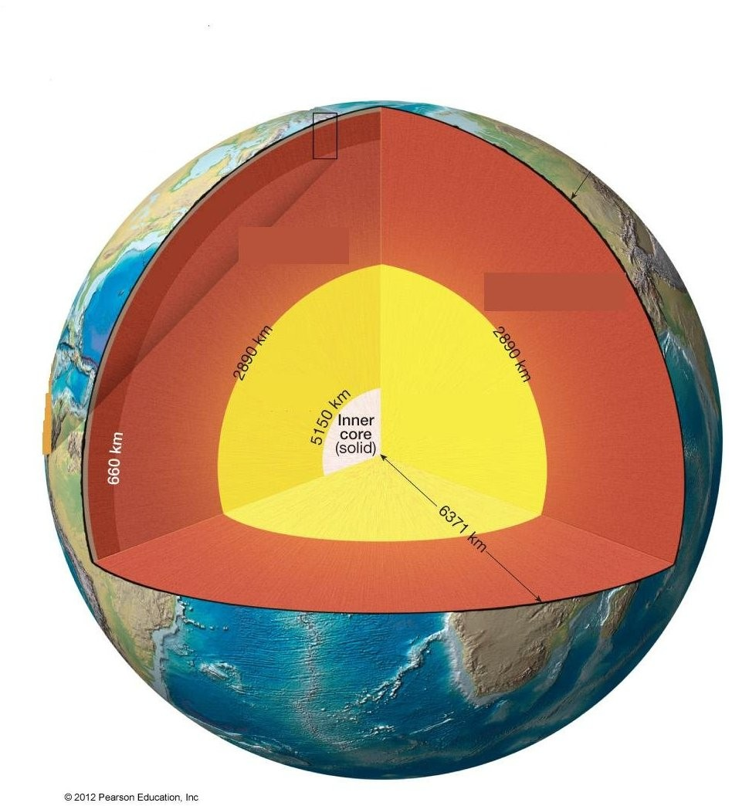
Answer: See Figure 1.26 in the Essentials of Geology, 11e textbook.
Diff: 1
Chapter Subhead: 1.10 Earth's Internal Structure
Bloom's: Remembering
63) Fill in the blanks with the correct name of the feature that is labeled.

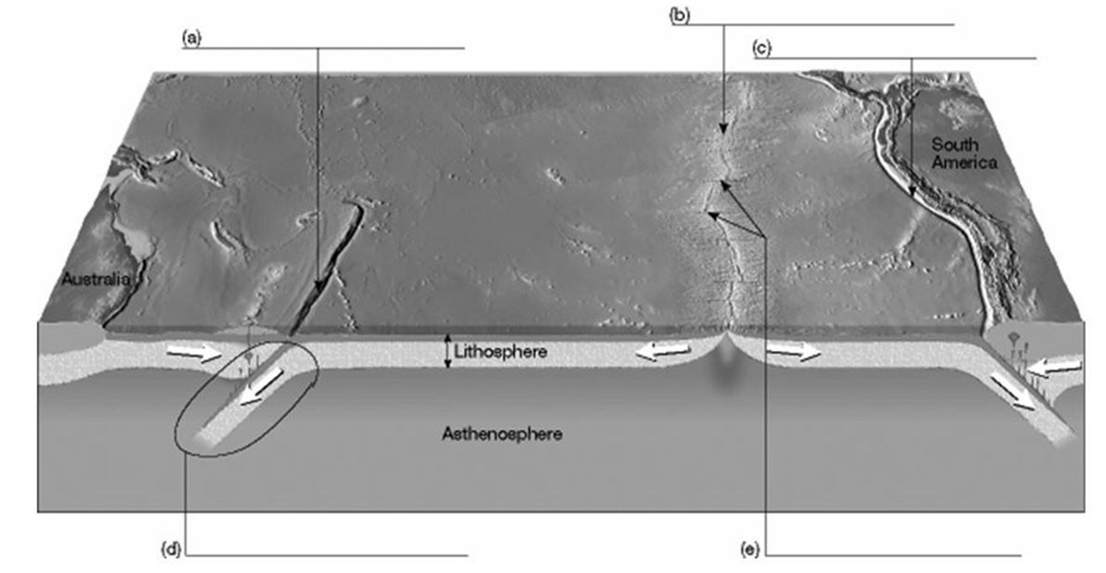
Answer:
(a) oceanic trench
(b) oceanic ridge
(c) oceanic trench
(d) subduction zone
(e) transform faults
Diff: 1
Chapter Subhead: 1.11 The Face of the Earth
Bloom's: Understanding

64) The asthenosphere ________.
A) is a subdivision of the outer core
B) is a zone of strong material
C) exists below a depth of 100 kilometers
D) exists below a depth of 700 kilometers
Answer: C
Diff: 1
Chapter Subhead: 1.6 Earth's Spheres
Bloom's: Analyzing

65) The Geologic Time Scale divisions are based on ________.
A) major extinction of flora and fauna
B) equal divisions of 1 million (era), 50,000 (period), and 5,000 (epoch) intervals
C) major climatic shifts
D) none of the above
Answer: A
Diff: 1
Chapter Subhead: 1.4 Geologic Time
Bloom's: Analyzing

