America: Past and Present, 9e (Divine et al.)
Chapter 2 New World Experiments: England's Seventeenth-Century Colonies

2.1 Multiple-Choice Questions

1) English settlers in seventeenth-century America could be characterized best in terms of their
A) striking social diversity.
B) similarity to French and Spanish migrants of the same period.
C) unity of purpose and motivation.
D) desire to help each other.
E) homogeneity.
Answer: A
Diff: 2 Page Ref: 28 [Conceptual]

2) Which one of the following was NOT a factor that stimulated English migration to the New World?
A) religious disagreements in England
B) poverty or the fear of falling into poverty
C) a desire for land ownership
D) government laws that forced the migration of the poorer classes
E) rapid population growth
Answer: D
Diff: 2 Page Ref: 29 [Conceptual]

3) Upon arriving in the New World, English settlers
A) quickly abandoned English beliefs and values.
B) generally adapted old beliefs to the new environment.
C) rarely were forced to significantly change their old English ways.
D) usually adopted the customs of the local Indian tribes as a way to survive.
E) immediately focused on converting the Native Americans.
Answer: B
Diff: 2 Page Ref: 31 [Factual]

4) To resolve the problem of the vast expenses New World settlement required, English merchant-capitalists introduced the concept of
A) proprietorship.
B) primogeniture.
C) the joint-stock company.
D) feudalism.
E) mercantilism.
Answer: C
Diff: 1 Page Ref: 31 [Factual]

5) The joint-stock company
A) required large capital investment.
B) promised immense wealth to investors.
C) encouraged investment in colonial enterprises, without fear of bankruptcy.
D) was not required to obtain a royal charter.
E) proved to be a failure in providing capital for colonization.
Answer: C
Diff: 2 Page Ref: 31 [Factual]

6) The selection of a site for Jamestown was primarily based on the settlers'
A) fear of surprise attacks.
B) desire for a healthful place to live.
C) belief that friendly Indians lived nearby.
D) need for close proximity to the open ocean.
E) fear of diseases in the swamps.
Answer: A
Diff: 1 Page Ref: 32 [Factual]

7) The labor system of Jamestown in its early years
A) provided indications of the laziness of settlers there.
B) replicated the traditional work experience of the settlers.
C) was highly organized and efficient.
D) relied heavily on African slaves.
E) was the basis for later sharecropping systems.
Answer: B
Diff: 2 Page Ref: 32 [Factual]

8) The ________ Company was responsible for the settlement of Jamestown in Virginia.
A) New England
B) Royal African
C) Virginia
D) American
E) New World
Answer: C
Diff: 1 Page Ref: 31 [Factual]

9) Jamestown might have gone the way of Roanoke had it not been for the perseverance of
A) John Winthrop.
B) Captain John Smith.
C) Pocahontas.
D) Richard Hakluyt.
E) Cotton Mather.
Answer: B
Diff: 1 Page Ref: 32 [Factual]

10) The first three years of Jamestown's history witnessed
A) terrible hardship and suffering.
B) the discovery of gold and silver.
C) successful attempts at growing many profitable crops.
D) the establishment of a representative form of government.
E) the erection of the first Christian church in North America.
Answer: A
Diff: 2 Page Ref: 33 [Factual]

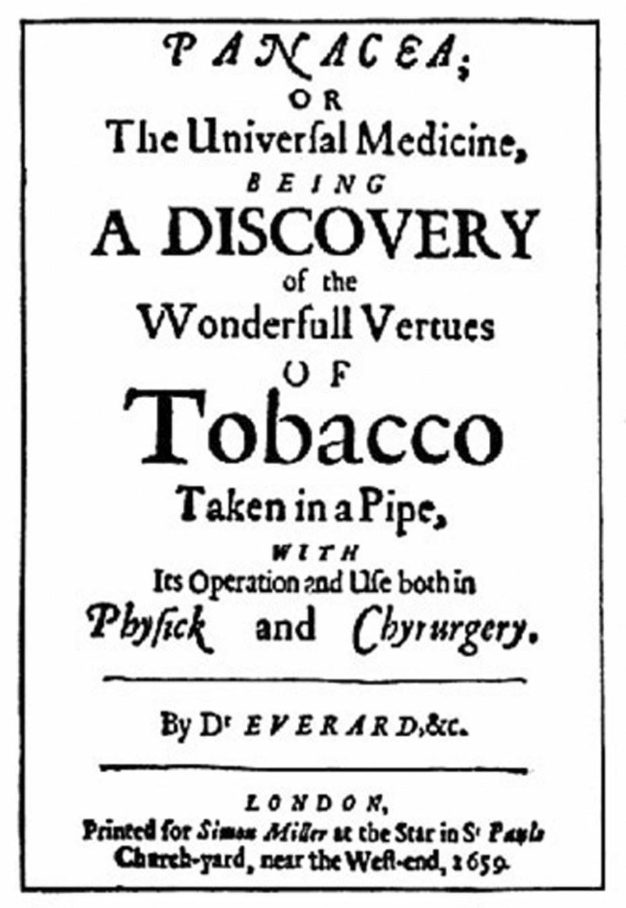

A tobacco company advertisement from 1659, lauding the drug as a medical
"panacea."Tobacco became one of the leading cash crops of the early colonies.
(Library of Congress)

11) Examine the advertisement shown above which was printed in London in 1659. The product shown proved to be the economic salvation of which colony?
A) Massachusetts Bay Colony
B) Georgia
C) New York
D) Jamestown
E) Plymouth
Answer: D
Diff: 1 Page Ref: 33 [Factual]

12) The man who taught Virginians how to grow tobacco was
A) Captain John Smith.
B) Powhatan.
C) John Rolfe.
D) Sir Edwin Sandys.
E) the Duke of Marlboro.
Answer: C
Diff: 1 Page Ref: 33 [Factual]

13) The attitude of King James I toward tobacco
A) demonstrated his concern for the health of his people.
B) showed that, in the end, he valued revenue more than good health.
C) changed very little during the course of his reign.
D) was strongly influenced by his own habit of smoking.
E) was influenced by its religious usage.
Answer: B
Diff: 1 Page Ref: 33 [Factual]

14) After 1618, the Virginia Company's principal means of attracting new settlers was
A) the granting of religious freedom.
B) liberal suffrage requirements.
C) a system of land grants.
D) payment of passage by the company.
E) impressment.
Answer: C
Diff: 1 Page Ref: 34 [Factual]

15) Under the "headright" system in Virginia,
A) every adult male could vote.
B) every child was guaranteed a primary education.
C) all new arrivals who had paid their trans-Atlantic fares received fifty-acre land grants.
D) new immigrants were guaranteed a year's provisions.
E) every new settler was entitled to one slave.
Answer: C
Diff: 1 Page Ref: 34 [Factual]

16) Indentured servants
A) were working off the cost of their passage to America.
B) all served the same number of years regardless of age or experience.
C) had no more legal rights than slaves.
D) received grants of land when their terms were up.
E) usually lived long enough to complete their terms of service.
Answer: A
Diff: 1 Page Ref: 34 [Factual]

17) Those who migrated to the Chesapeake Bay area as indentured servants were
A) usually from the dregs of English society.
B) English farmers who saw a better future in the New World.
C) normally single, lower-class males in their teens or early twenties.
D) married individuals who came with their families.
E) generally convicted criminals who traded jail time in England for indentures.
Answer: C
Diff: 1 Page Ref: 34 [Factual]

18) After 1618, the Virginia colonists were allowed to elect a representative assembly known as the
A) House of Burgesses.
B) House of Commons.
C) House of Representatives.
D) House of Delegates.
E) General Court.
Answer: A
Diff: 1 Page Ref: 34 [Factual]

19) In 1622, the Native American tribes of Virginia
A) attacked the English settlements.
B) formed an alliance with the Native American tribes of New England.
C) established permanently good relations with the English settlers.
D) learned from the English settlers how to grow tobacco.
E) migrated westward to avoid future contact with settlers.
Answer: A
Diff: 2 Page Ref: 34 [Factual]

20) In 1624, Virginia became
A) an independent commonwealth.
B) a proprietary colony.
C) a royal colony.
D) part of Maryland.
E) the primary destination for female settlers.
Answer: C
Diff: 1 Page Ref: 35 [Factual]

21) The most important institution of local government in colonial Virginia was the
A) parish vestry.
B) Anglican church.
C) county court.
D) House of Burgesses.
E) Virginia Company board of directors.
Answer: C
Diff: 1 Page Ref: 35 [Factual]
22) The first capital of colonial Maryland was
A) Annapolis.
B) Jamestown.
C) Baltimore.
D) St. Mary's City.
E) Williamsburg.
Answer: D
Diff: 1 Page Ref: 36 [Factual]

23) The individual largely responsible for Maryland's settlement was
A) Sir George Calvert.
B) William Penn.
C) Sir Edwin Penn.
D) Richard Hakluyt.
E) Sir Walter Raleigh.
Answer: A
Diff: 1 Page Ref: 35 [Factual]

24) Initially, Lord Baltimore intended that Maryland be a haven for
A) Quakers.
B) Puritans.
C) Catholics.
D) Baptists.
E) Separatists.
Answer: C
Diff: 1 Page Ref: 35 [Factual]

25) Lord Baltimore's settlement in Maryland
A) became a successful feudal outpost in America.
B) declared war on Virginia in 1639.
C) never succeeded in becoming a feudal society.
D) became a haven for persecuted Protestants.
E) was a total failure.
Answer: C
Diff: 1 Page Ref: 36 [Factual]

26) Unlike their southern counterparts, the first Englishmen who established colonies in New England were
A) in search of land and riches.
B) religious refugees.
C) Catholic missionaries.
D) wealthy aristocrats, hoping to establish a feudal system in America.
E) commercial traders.
Answer: B
Diff: 1 Page Ref: 37 [Factual]

27) The Pilgrims, who left Holland to settle in America,
A) were non-Separatists.
B) did so because they believed that their way of life was being undermined by the ways of their Dutch hosts.
C) had few alternatives because they were being harassed by the Dutch government.
D) arrived in Virginia, even though their destination was Massachusetts Bay.
E) were Catholic radicals.
Answer: B
Diff: 2 Page Ref: 37 [Factual]

28) The document in which the Pilgrims established a civil government for their Plymouth colony has become known as the
A) Bill of Rights.
B) Mayflower Compact.
C) Statement of Principles.
D) Cambridge Agreement.
E) Plymouth Agreement.
Answer: B
Diff: 1 Page Ref: 37 [Factual]

29) Seventeenth-century English Puritans
A) were only a tiny minority of all Englishmen.
B) were individuals committed to significant institutional change.
C) were firmly supportive of the status quo.
D) accepted the tenets of Catholicism with only a few reservations.
E) were neurotic and self-righteous.
Answer: B
Diff: 2 Page Ref: 37 [Factual]

30) King Charles I disbanded Parliament in 1629 because he could not deal with intense criticism from the
A) Puritans.
B) Baptists.
C) Catholics.
D) Anglicans.
E) Presbyterians.
Answer: A
Diff: 1 Page Ref: 38 [Factual]

31) The Puritans of Massachusetts Bay believed that the best way to reform the Church of England was to
A) separate from it and reform it from the outside.
B) rely on help from the English monarchy.
C) remain in the Church and reform it from the inside.
D) refuse to associate with it in any way.
E) actively work to destroy the tenets with which they disagreed.
Answer: C
Diff: 2 Page Ref: 38 [Factual]

32) In Massachusetts Bay, "freeman status" was granted to adult males who
A) were church members.
B) were no longer indentured servants.
C) owned land.
D) agreed to abide by the colony's legal codes.
E) were married.
Answer: A
Diff: 1 Page Ref: 40 [Factual]

33) Because of its policy of religious toleration, ________ attracted unusual numbers of independent-minded people.
A) Maryland
B) Connecticut
C) Pennsylvania
D) New York
E) Rhode Island
Answer: E
Diff: 1 Page Ref: 44 [Factual]

34) In 1636, authorities in Massachusetts Bay banished Roger Williams because
A) of his conversion to Roman Catholicism.
B) of his bitter hostility toward the Native Americans.
C) of his defense of Native American rights and demand for separation of church and state.
D) of his desire to launch a new colony in Connecticut.
E) of his crass pursuit of profit.
Answer: C
Diff: 1 Page Ref: 41 [Factual]

35) Puritan dissenter Roger Williams established the colony of
A) New York.
B) Connecticut.
C) Rhode Island.
D) Maryland.
E) New Jersey.
Answer: C
Diff: 1 Page Ref: 41 [Factual]
36) Anne Hutchinson's skillful self-defense at her trial before the magistrates of Massachusetts Bay was ruined by
A) her affinity for the dictum of works.
B) her claim of personal revelation.
C) her reliance on the Scriptures.
D) her rejection of free grace.
E) the fact that she was female.
Answer: B
Diff: 1 Page Ref: 41 [Factual]

37) The English takeover of New Netherland (which was subsequently renamed New York)
A) had little immediate effect on the colony.
B) was followed by the expulsion of the Dutch.
C) led to the prompt creation of a legislature.
D) met with armed resistance by the Dutch.
E) sparked a war between the English and the Dutch.
Answer: A
Diff: 1 Page Ref: 46 [Factual]

38) Seventeenth-century Quakers were known for their
A) aggressive and overbearing personalities.
B) belief in personal humility and pacifism.
C) concept of predestination.
D) unwillingness to seek the conversion of other individuals to their faith.
E) belief in the necessity of an educated clergy.
Answer: B
Diff: 1 Page Ref: 47 [Factual]

39) William Penn guaranteed the commercial success of Philadelphia by purchasing
A) Delaware.
B) Maryland.
C) Connecticut.
D) New Jersey.
E) New Hampshire.
Answer: A
Diff: 1 Page Ref: 47 [Factual]

40) The colony of New Jersey's main liability was
A) its Catholic proprietors.
B) lack of a good harbor.
C) lack of land.
D) its rugged, mountainous terrain.
E) diverse population.
Answer: B
Diff: 1 Page Ref: 46 [Factual]

41) The man most responsible for the survival of Carolina was
A) James Oglethorpe.
B) John Winthrop.
C) Captain John Smith.
D) William Penn.
E) Anthony Ashley Cooper.
Answer: E
Diff: 1 Page Ref: 49 [Factual]

42) Large numbers of the first English settlers in the Carolinas came from
A) Ireland.
B) Barbados.
C) Rhode Island.
D) Jamaica.
E) the Virgin Islands.
Answer: B
Diff: 2 Page Ref: 49 [Factual]

43) The main staple of the Carolina colonies' economy by the close of the seventeenth century was
A) rice.
B) cotton.
C) tobacco.
D) timber.
E) indigo.
Answer: A
Diff: 1 Page Ref: 50 [Factual]

44) The colony of Pennsylvania was established as a religious sanctuary for
A) Puritans.
B) Catholics.
C) Baptists.
D) Quakers.
E) Presbyterians.
Answer: D
Diff: 1 Page Ref: 47 [Factual]

45) To its founding leaders, ________ would be a "City on a Hill."
A) Massachusetts
B) Rhode Island
C) Connecticut
D) Maryland
E) Pennsylvania
Answer: A
Diff: 1 Page Ref: 39 [Factual]

46) Which one of the following individuals is INCORRECTLY associated with the colony he established?
A) John Smith/Virginia
B) George Calvert/Pennsylvania
C) Roger Williams/Rhode Island
D) John Winthrop/Massachusetts
E) Sir George Carteret/New Jersey
Answer: B
Diff: 1 Page Ref: 32-53 [Factual]

47) A feudal land system was associated with which one of the following colonies?
A) Plymouth
B) Rhode Island
C) New Jersey
D) Massachusetts
E) Maryland
Answer: E
Diff: 1 Page Ref: 36 [Factual]

48) In which one of the following were religious reasons the least important in explaining the founding of that colony?
A) Massachusetts
B) Rhode Island
C) Maryland
D) Virginia
E) Pennsylvania
Answer: D
Diff: 1 Page Ref: 31 [Factual]

49) In which one of the following colonies was the death rate for the early colonists the most severe?
A) Massachusetts
B) New York
C) Rhode Island
D) Virginia
E) Pennsylvania
Answer: D
Diff: 1 Page Ref: 34 [Factual]

50) Which of the following was a New England colony?
A) South Carolina
B) Connecticut
C) New Jersey
D) Maryland
E) Pennsylvania
Answer: B
Diff: 1 Page Ref: 41,44 [Factual]

2.2 True/False Questions

1) The only major factor behind the migration of thousands of English men and women to the New World was the intense and greedy desire for money.
Answer: FALSE
Diff: 1 Page Ref: 28[Factual]

2) Between 1580 and 1650, the population of England increased from 3.5 million to more than 5 million people.
Answer: TRUE
Diff: 1 Page Ref: 29 [Factual]

3) The lives of New Englanders differed considerably from those of their Chesapeake counterparts.
Answer: TRUE
Diff: 1 Page Ref: 30 [Factual]

4) Because of New York's ethnic diversity, the English cautiously asserted their hegemony over the area.
Answer: FALSE
Diff: 1 Page Ref: 46 [Factual]
5) William Penn went to great lengths to make Pennsylvania into an efficient and prosperous colony.
Answer: TRUE
Diff: 1 Page Ref: 47-48 [Factual]

6) From its very inception, the Jamestown colony was a success.
Answer: FALSE
Diff: 2 Page Ref: 32-33 [Factual]

7) The Puritans were a highly neurotic religious group that condemned liquor and sex.
Answer: FALSE
Diff: 1 Page Ref: 37 [Factual]

8) The Fundamental Orders were the blueprint for government in colonial Connecticut.
Answer: TRUE
Diff: 1 Page Ref: 44 [Factual]

9) The Dutch were the first to establish a colony in Maryland.
Answer: FALSE
Diff: 1 Page Ref: 35-36 [Factual]

2.3 Essay Questions

1) Describe the nature of England's first colonial settlement, Jamestown, as it evolved from a floundering, haphazard enterprise to a stable community.
Diff: 1 Page Ref: 31-35 [Factual and Conceptual]

2) Compare and contrast the English colonies of the Chesapeake with their counterparts at Massachusetts Bay. What were their similarities and their differences?
Diff: 1 Page Ref: 29-44 [Factual and Conceptual]

3) Describe the Puritans. What were their beliefs? Why did they leave England for Massachusetts Bay? What did they hope to accomplish in the New World? How did the dynamics of their faith affect their New World existence?
Diff: 1 Page Ref: 37-44 [Factual and Conceptual]

4) Explain how the economies and social structures of New England, the Chesapeake, and the middle colonies differed from one another.
Diff: 1 Page Ref: 28-53 [Factual and Conceptual]

5) In what ways was Pennsylvania unique in colonial America? What role did religion play in explaining that uniqueness?
Diff: 2 Page Ref: 46-48 [Factual and Conceptual]

