Chapter One

Multiple Choice

1. Why study chemistry?
A) To help inform us about our world
B) To be better able to make informed decisions
C) To help us learn a technique for identifying and solving problems
D) All the above
Answer: D; Difficulty: easy; Reference: Section 1.1

2. The science of chemistry may involve:
A) observation
B) hypothesis development
C) experimentation
D) all the above
Answer: D; Difficulty: easy; Reference: Section 1.5

3. Which is an observation?
A) Atoms consist of protons, neutrons, and electrons.
B) All matter is composed of atoms.
C) Water is colorless.
D) Atoms can form chemical bonds by sharing electrons.
Answer: C; Difficulty: easy; Reference: Section 1.5

4. A tentative explanation of certain facts that provides the basis for further experimentation is a(n)
A) observation
B) hypothesis
C) theory
D) law
Answer: B; Difficulty: easy; Reference: Section 1.5

5. A well established hypothesis is often called a(n)
A) observation
B) fact
C) theory
D) law
Answer: C; Difficulty: easy; Reference: Section 1.5

6. A simple statement of natural phenomena to which no exceptions are known under given
conditions is a(n)
A) theory
B) observation
C) model
D) scientific law
Answer: D; Difficulty: easy; Reference: Section 1.5

7. Which is a scientific observation?
A) Freezing and boiling are called physical changes
B) Water freezes at zero degrees C
C) If a substance has a density of 1.00g/mL it must be water.
D) When a substance freezes its molecules lose potential energy.
Answer: B; Difficulty: easy; Reference: Section 1.5

8. The statement, “An apple a day keeps the doctor away”, is best described as a(n)
A) observation
B) law
C) theory
D) hypothesis
Answer: D; Difficulty: easy; Reference: Section 1.5

9. The statement, “An atom consists of a dense nucleus surrounded by a cloud of electrons”,
is best described as a(n)
A) theory
B) law
C) hypothesis
D) observation
Answer: A; Difficulty: easy; Reference: Section 1.5

10. Which state of matter consists of particles in regular, repeating, three dimensional
geometrical patterns?
A) liquid
B) vapor
C) solid
D) gas
Answer: C; Difficulty: easy; Reference: Section 1.7

11. Which has both a definite shape and a definite volume?
A) solid
B) vapor
C) gas
D) liquid
Answer: A; Difficulty: easy; Reference: Section 1.7
12. Which state of matter consists of particles held together firmly but not rigidly? These
particles are held together by strong attractive forces, are in close contact with one another,
but are able to flow by one another.
A) gas
B) liquid
C) solid
D) vapor
Answer: B; Difficulty: easy; Reference: Section 1.7

13. Which has a definite volume but no definite shape?
A) vapor
B) gas
C) solid
D) liquid
Answer: D; Difficulty: easy; Reference: Section 1.7

14. Which is composed of particles with enough energy to completely overcome the attractive forces between them?
A) solid
B) gas
C) liquid
D) crystal
Answer: B; Difficulty: easy; Reference: Section 1.7

15. Which has neither a definite shape nor a definite volume?
A) crystal
B) solid
C) gas
D) liquid
Answer: C; Difficulty: easy; Reference: Section 1.7

16. In which phase of matter are the particles furthest apart?
A) gas
B) solid
C) liquid
D) crystal
Answer: A; Difficulty: easy; Reference: Section 1.7

17. Which phase of matter can be compressed or expanded to the greatest degree?
A) solid
B) gas
C) crystal
D) liquid
Answer: B; Difficulty: easy; Reference: Section 1.7
18. Which phase of matter contains the greatest force of attraction between particles?
A) solid
B) vapor
C) liquid
D) gas
Answer: A; Difficulty: easy; Reference: Section 1.7

19. Which phase of matter contains the least force of attraction between particles?
A) solid
B) gas
C) crystal
D) liquid
Answer: B; Difficulty: easy; Reference: Section 1.7

20. Which is a pure substance?
A) compound
B) mixture
C) solution
D) both B and C
Answer: A; Difficulty: easy; Reference: Section 1.8

21. Which is a pure substance ?
A) element
B) compound
C) mixture
D) both A and B
Answer: D; Difficulty: easy; Reference: Section 1.8

22. Which is a pure substance existing as different phases in a heterogeneous system?
A) Salt dissolved in water.
B) Flour suspended in water.
C) Cork floating in water.
D) Ice floating in water.
Answer: B; Difficulty: easy; Reference: Section 1.8

23. Which is a solution?
A) element
B) compound
C) homogeneous mixture
D) heterogeneous mixture
Answer: C; Difficulty: easy; Reference: Section 1.8

24. Which is a solution?
A) air
B) liquid water
C) solid iron
D) soil
Answer: A; Difficulty: medium; Reference: Section 1.8

25. Which is a pure substance?
A) table salt
B) bronze
C) air
D) soil
Answer: A; Difficulty: medium; Reference: Section 1.8

26. Which is a mixture?
A) copper wire
B) sugar
C) water
D) mud
Answer: D; Difficulty: easy; Reference: Section 1.8

27. Which of the following diagrams represents a solution?
A) 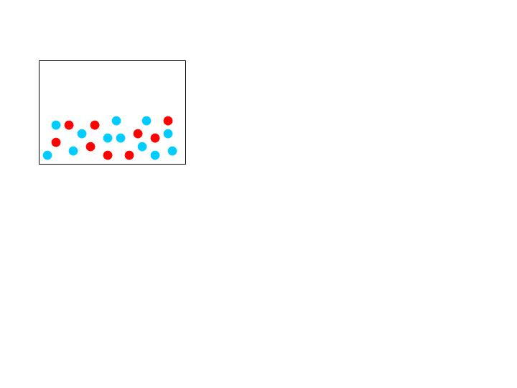
B) 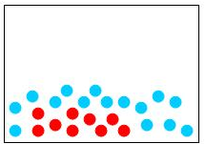
C) 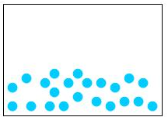
D) 
Answer: A; Difficulty: medium; Reference: Section 1.8

28. Which of the following diagrams represents an element?
A) 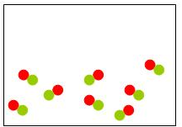
B) 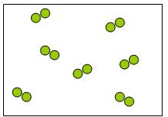
C)
D) 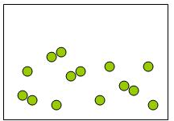
Answer: B; Difficulty: medium; Reference: Section 1.8

29. Your lab instructor gives you a red solid and tells you that it is a pure substance. Which of the following statements is true given this information?
A) The solid has a fixed composition by mass.
B) The solid is a compound.
C) The solid cannot be decomposed into simpler substances.
D) The solid cannot be melted.
Answer: A; Difficulty: medium; Reference: Section 1.8

30. “When Jill opened the bottle containing a clear liquid, the whole room smelled like roses.” Based on this statement we can infer that:
A) The liquid is a homogeneous mixture.
B) The liquid is a compound.
C) Inside the bottle there were a liquid and a gas.
D) Opening the bottle caused the liquid to evaporate.
Answer: C; Difficulty: easy; Reference: Section 1.8

31. In which phase do the particles possess the greatest amount of kinetic energy?
A) solid
B) liquid
C) gas
D) crystal
Answer: C; Difficulty: easy; Reference: Section 1.7

32. “ Life on Earth originated from the condensation of carbon monoxide molecules on hot mineral surfaces underground to form fatty acids, the building blocks of cellular membranes.” This statement is an example of:
A) a theory
B) a hypothesis
C) a natural law
D) an observation
Answer: B; Difficulty: easy; Reference: Section 1.5

33. What can you observe in the following beaker?

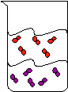
A) a pure substance in two phases.
B) a heterogeneous mixture
C) two compounds in the same phase
D) a homogeneous mixture
Answer: B; Difficulty: easy; Reference: Section 1.8

34. “Energy cannot be created nor destroyed, only transformed” is an example of a:
A) law
B) theory
C) observation
D) hypothesis
Answer: A; Difficulty: easy; Reference: Section 1.5

35. A mixture of citric acid and water is classified as homogeneous. What can you conclude from this description?
A) citric acid and water are clear liquids
B) the relative amounts of citric acid and water may vary
C) citric acid is a solid
D) water is present in a larger quantity compared to citric acid
Answer: B; Difficulty: medium; Reference: Section 1.8

True/False

36. A key feature of the scientific method is to design and perform experiments to test hypotheses.
Answer: T; Difficulty: easy; Reference: Section 1.5

37. Chemistry is the science that deals with the composition of substances and the transformations they undergo.

Answer: T; Difficulty: easy; Reference: Section 1.2

38. Chemistry has applications in all other fields of science.
Answer: T; Difficulty: easy; Reference: Section 1.2

39. Matter always has both mass and volume.
Answer: T; Difficulty: easy; Reference: Section 1.6

40. A substance must be heterogeneous and have a fixed composition.
Answer: F; Difficulty: easy; Reference: Section 1.7

41. A substance may be heterogeneous or homogeneous.
Answer: F; Difficulty: easy; Reference: Section 1.8

42. A mixture may be heterogeneous or homogeneous.
Answer: T; Difficulty: easy; Reference: Section 1.8

43. A liquid has a definite shape and a definite volume.
Answer: F; Difficulty: easy; Reference: Section 1.7

44. The majority of the volume of a gas is empty space.
Answer: T; Difficulty: easy; Reference: Section 1.7

45. Elements and compounds are the two types of pure substances.
Answer: T; Difficulty: easy; Reference: Section 1.7

46. Air is a substance.
Answer: F; Difficulty: medium; Reference: Section 1.8

47. If a piece of matter has no visible boundaries then it is a pure substance.
Answer: F; Difficulty: medium; Reference: Section 1.8

Free Response

48. Define matter.
Explain what is meant by mass and volume.
Is everything in nature matter? If not, what else exists?
Answer: Matter is anything that has both mass and volume. Mass is the amount of matter present and volume is the amount of space occupied. Everything in nature is not matter. Energy also exists in nature; Difficulty: easy; Reference: Section 1.2

49. Define solid, liquid, and gas.
Explain the differences in the three phases of matter on both the macroscopic and
molecular levels.
Answer: A solid has a definite shape and a definite volume. A liquid has a definite volume but no definite shape. A gas has neither a definite shape nor a definite volume.
In the solid phase, particles do not have enough energy to escape their position. They vibrate about points in space. This inability to escape their position gives the solid both definite shape and volume on the macroscopic level.

In the liquid phase the particles have enough energy to escape these rigid points and the
particles can flow by one another but they cannot escape from the larger group of particles.
When viewed on the macroscopic level, this gives the liquid a definite volume but no definite shape. The liquid will take the shape of its container.

Gas particles have enough energy to completely escape from one another. They will fill their entire container. On the macroscopic level they have no definite shape or volume. They will take both the shape and volume of the container.; Difficulty: easy; Reference: Section 1.7

50. Explain what chemistry is.
Answer: Chemistry is the study of matter and energy. Chemistry studies the composition and properties of matter. Chemistry also studies the transformations matter undergoes and the energy involvement in those changes.; Difficulty: easy; Reference: Section 1.2

51. Explain how the study of chemistry can be helpful to you in your everyday life.
Answer: The study of chemistry can be helpful because it will enhance your understanding of the properties of matter and how different forms of matter interact with one another. But, even more importantly, the study of chemistry will teach you the scientific method. This is a technique which is a powerful tool in studying the world around you. It can be used to deal with the problems of everyday life.; Difficulty: easy; Reference: Section 1.3

52. Matter is classified into substances and mixtures.
Explain how these are different.
Substances are either elements or compounds. Describe what these are and give examples of each.
Mixtures can be either heterogeneous or homogeneous. Explain how these are different and give examples of each.
What is a solution? Give examples of solutions.
Answer: Substances are pure, they have a fixed composition, and they have fixed properties that can be used for identification. Substances are homogeneous. Mixtures are combinations of two or more substances with no fixed proportions. Mixtures may be heterogeneous or homogeneous. Mixtures have no fixed properties.

Elements are the basic building blocks of matter. They cannot be broken down into simpler forms by chemical means. Some elements are copper, chlorine and iron.

Compounds are substances composed of two or more elements combined chemically in fixed proportion by mass. Some compounds are table salt (sodium chloride), sugar (sucrose), and water.

A heterogeneous mixture does not have a constant composition throughout. An example would be soil. A homogeneous mixture does have a uniform composition throughout. An example would be salt water.

A solution is a homogeneous mixture such as a soft drink or a piece of brass. Difficulty: medium; Reference: Section 1.8

53. Suppose someone brought you an unidentified material. List five questions a chemist might ask in an attempt to identify the material.
Answer: A chemist may ask questions such as: What is the color of the substance? What is the melting point of the substance? What is the boiling point of the substance? What is the density of the substance? What is the hardness of the substance? What is the substance’s solubility in water? At what temperature does the substance decompose? How does the substance react with other substances? These and other physical and chemical properties are used to identify the substance. Difficulty: medium; Reference: Section 1.3

54. Name four different ways in which you could classify or organize twenty different types of
fasteners such as nails or screws.
Answer: Any four properties of the fasteners, such as: length of the fasteners, color of the fasteners, composition of the fasteners, thickness of the fasteners, shape of the fasteners, Are the fasteners threaded? Are the fasteners curved or straight?; Difficulty: medium; Reference: Section 1.4

55. State the four steps of the scientific method.
Answer: The four steps of the scientific method are:
1. Making observations to collect facts or data.
2. Formulating a hypothesis to explain your observations.
3. Designing and performing experiments to test your hypothesis.
4. Using the results of your experiments to reformulate your hypothesis. You then retest
your hypothesis and continue on..
Difficulty: easy; Reference: Section 1.5

56. Mixtures can be separated by the differences in the physical properties of their
components.
What physical properties could be used to separate the components of the following mixtures?
A. Sand and salt
B. Salt and water
C. Iron filings and sulfur
D. Fine sand and coarse gravel
Answer: A. Sand and salt can be separated based on their solubility in water. The mixture can be placed in water and stirred. The salt will dissolve, but the sand will not. The salt water solution can then be poured off leaving the sand behind.

B. The mixture of salt and water can be separated because the water will evaporate while the salt will not. The mixture can be left in an open container and the water will
evaporate. This can be speeded up by heating the mixture.

C. Iron and sulfur can be separated because of their different responses to magnetism. Passing a magnet over the mixture will cause the iron to adhere to the magnet leaving the sulfur behind.

D. A mixture of fine sand and gravel can be separated based on particle size. The mixture can be passed through a series of sieves of different sized openings. The smaller sand particles will pass through while the larger sized gravel particles will be held behind.; Difficulty: medium; Reference: Section 1.8

