How Does Earth Work?, 2e (Smith/Pun)
Chapter 1 Why Study Earth?

1.1 Multiple Choice and True False Questions

1) Which of the following is not a valid reason for studying Earth?
A) All Earth processes can only be explained by supernatural forces.
B) Earth is the planet upon which you live.
C) Earth is an active planet that experiences cataclysmic earthquakes, volcanic eruptions, floods, landslides, and other processes that constantly reshape the surface and sometimes threaten human lives and property.
D) Earth is a source of raw materials for metals, plastics, building materials, and precious gemstones.
Answer: A
Skill: Knowledge
Objective: 1.0

2) Why is Mount Etna in Sicily an important place for geology?
A) It is very calm, showing the serenity of the earth.
B) It is a famous underwater volcano.
C) It is a famous mountain for geologists to climb.
D) It is an active volcano, showing that the earth is a dynamic place.
Answer: D
Skill: Knowledge
Objective: 1.0

3) True or False: Coal is one of the leading energy providers in the United States.
Answer: TRUE
Skill: Knowledge
Objective: 1.0

4) Geochemical studies of rocks show that earth is approximately ________ years old.
A) 500 million
B) 6 thousand
C) 30 billion
D) 4.56 billion
Answer: D
Skill: Knowledge
Objective: 1.1
5) Why can geologists observe the breaking of the ground during an earthquake much easier than other geologic events?
A) Ground breaking during an earthquake is much more violent than other events.
B) Geologists have better equipment to measure earthquakes than other geologic events.
C) Ground breaking during an earthquake occurs much faster than other events in the geologic history of the earth.
D) Geologists enjoy earthquakes more than other geologic events.
Answer: C
Skill: Application
Objective: 1.1

6) Why do scientists formulate hypotheses?
A) to explain the problem that accounts for existing data and predict additional phenomena that should exist
B) to state a law
C) to explain something that cannot be observed or measured by scientific procedures
D) to generalize data and observations about data without necessarily offering an explanation
Answer: A
Skill: Knowledge
Objective: 1.3

7) Direct laboratory experimentation is often not possible in geological studies for all of the following reasons except that
A) the number of variables is typically large.
B) the rates of many Earth processes are very slow.
C) the experimenter must outlive the experiment.
D) Earth conditions can be easily controlled and duplicated.
Answer: D
Skill: Knowledge
Objective: 1.3

8) Why do scientists formulate principles?
A) to describe a widely applicable and generally accepted explanation for natural phenomena
B) to explain something that cannot be observed or measured by scientific procedures
C) to make a statement or mathematical formula that always succeeds in generalizing data and observations about data without necessarily offering an explanation
D) to explain a problem that accounts for existing data and predict additional phenomena that should exist
Answer: C
Skill: Knowledge
Objective: 1.3
9) Why are supernatural explanations excluded from scientific theories?
A) Scientists dislike them.
B) They provide too much data, thus drawing out experiments for too long.
C) It is dangerous to study them.
D) They cannot be observed or measured by scientific procedures.
Answer: D
Skill: Knowledge
Objective: 1.3

10) Why is the San Andreas fault in California useful to geologists?
A) It is home to the most advanced geologic command center in the United States.
B) It is a convergent boundary, showing geologists firsthand what happens when plates are subducted.
C) It is a transform boundary, showing geologists firsthand what happens when plates slide past one another.
D) Geologists have explored caves made by earthquakes at the fault line, making many scientific breakthroughs.
Answer: C
Skill: Knowledge
Objective: 1.5

11) What is an important result of divergent plates?
A) They spread, resulting in the formation of new seafloor along lines of submarine volcanoes.
B) Plate subduction occurs, resulting in less seafloor.
C) Plates slide past each other, resulting in violent earthquakes.
D) They often cause tsunamis.
Answer: A
Skill: Knowledge
Objective: 1.5

12) Why is the Mid-Atlantic Ridge important to geologists?
A) It is a divergent boundary, causing the Atlantic Ocean to widen by about 5 centimeters each year.
B) Massive earthquakes take place there every day.
C) It is the source of tsunamis.
D) Plate subduction occurs, shrinking the Atlantic ocean about 5 centimeters each year.
Answer: A
Skill: Knowledge
Objective: 1.5
13) Using the principle of Uniformitarianism, which makes the most sense?
A) A crater from 4 million years ago is similar to one from an impact last year; the ancient crater probably wasn't caused by an impact however.
B) A crater from 4 million years ago is similar to one from an impact last year; the ancient crater was probably also caused by an impact.
C) A crater from 4 million years ago is similar to one from an impact last year; the ancient crater must not be as ancient as scientists thought.
D) A crater from 4 million years ago is similar to one from an impact last year; the new crater must be a lot older than scientists thought.
Answer: B
Skill: Knowledge
Objective: 1.4

14) Why is heat the most important form of energy transfer for geologic processes?
A) Heat from the Sun fuels Earth-surface processes, such as wind, ocean waves, and the evaporation and precipitation of water.
B) Heat cancels out the cold, allowing geologic processes to occur.
C) Heat makes rock melt so the plates can move.
D) Heat from the earth warms human's houses during the winter.
Answer: A
Skill: Comprehension
Objective: 1.6

15) Why are hot spots so strange?
A) They occur at plate boundaries,
B) The volcanoes at hot spots erupt once a year.
C) They only occur near transform boundaries.
D) Molten material rises from deep in the mantle below the moving lithosphere as a result of processes not explained by plate tectonics,
Answer: D
Skill: Knowledge
Objective: 1.5

16) How does convection cause the motion of plates that drives plate tectonics?
A) Convection blows the plates around the earth.
B) Cold, dense lithosphere sinks, while hot, low-density mantle rises to the surface at hot spots
C) Radiation of heat causes the plates to move, which in turn causes convection
D) Refraction of heat from the sun heats the plates, causing convection and the motion of the plates.
Answer: B
Skill: Knowledge
Objective: 1.6
17) Why would a box on a shelf have a higher potential energy than that of a box on a lower shelf?
A) The box on the higher shelf is heavier
B) The box on the lower shelf was placed there after the higher box.
C) The box on the higher shelf experiences less gravitational pull; with less gravitational pull comes more weight, thus more potential energy.
D) It took more work to move the box to the high shelf than to the low shelf
Answer: D
Skill: Knowledge
Objective: 1.6

18) Landslides, rock falls, and floods illustrate
A) that Earth is made of rock.
B) that Earth is very old.
C) that Earth is dynamic.
D) that the crust of Earth is stationary and static.
Answer: C
Skill: Application
Objective: 1.1

19) About a half of the United states energy comes from coal. Why could that be a problem?
A) Coal emits high CO2 concentrations.
B) Coal is very rare.
C) Coal is very expensive.
D) Coal is not found in the U.S., therefore we are dependent on foreign countries for our energy.
Answer: A
Skill: Knowledge
Objective: 1.1

20) Why is physical geology important?
A) It helps us to understand the physical and chemical interior workings of the planet.
B) It helps us to understand how the earth looks.
C) It helps us to better understand the physical surface for use in mapping.
D) It helps us to understand the Earth's interior crust.
Answer: A
Skill: Knowledge
Objective: 1.1

21) Why is the Grand Canyon an interesting landmark?
A) It is the smallest canyon in the world.
B) It was created through a meteorite impact.
C) Thousands of dinosaur fossils have been found there.
D) It is a gorge that was eroded by a river about 1.7 billion years old and is about 1700 m deep.
Answer: D
Skill: Knowledge
Objective: 1.1
22) Which option correctly matches the scientists with what they study?
A) geochemists: determine the age of Earth materials; petrologists: study petroleum; mineralogists: study minerals
B) geomorphologists: study the origin of landscapes; paleontologists: study fossilized organisms; geophysicists: study the physical properties of rock
C) stratigraphers: study ocean currents; mineralogists: study minerals; petrologists: study processes that form rock
D) hydrogeologist: study ground water; environmental geologists: study the growth of vegetation; geomorphologists: study the shapes of fossil species
Answer: B
Skill: Knowledge
Objective: 1.1

23) What is the lithosphere's role in plate tectonics?
A) It is at the center of the earth and causes the earthquakes that move the plates.
B) It is the source of the heaviest metals.
C) It is the outermost layer of the earth broken into plates.
D) It is the less rigid layer beneath the asthenosphere.
Answer: C
Skill: Knowledge
Objective: 1.1

24) How is convection in nature similar to convection on a stovetop?
A) Convection heats up water in nature and on a stovetop.
B) Convection makes animals happy in nature and on a stovetop.
C) Convection heats water on the stovetop much like it heats cold air in the atmosphere, which rises while cool air sweeps in to replace it, causing wind.
D) Convection is completely different in nature and on a stovetop.
Answer: C
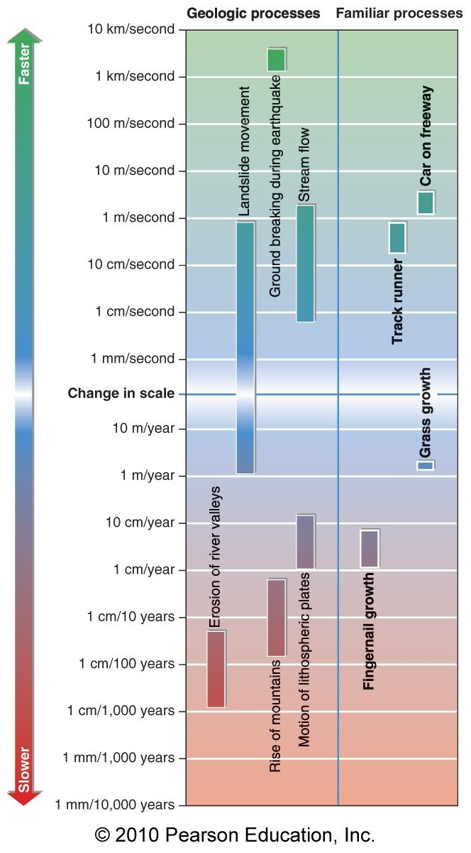
Figure 1.3

25) Based on the rates shown in Figure 1.3 in your textbook, which of the options correctly lists the geologic processes from slowest to fastest?
A) rise of mountains, glacier flow, stream flow
B) landslide, stream flow, glacier flow
C) rise of mountains, glacier flow, ground water flow
D) motion of lithospheric plates, sediment accumulation in the deep sea, glacier flow
Answer: A
Skill: Analysis
Objective: 1.1
26) Could a warming trend in Colorado be caused by currents from the Pacific Ocean?
A) No; Colorado is too far away from the ocean.
B) Yes; air currents can move over the mountains.
C) No; ocean currents have a cooling effect.
D) No; the warming effect of the sun overrides the effect of ocean currents on local Colorado weather.
Answer: B
Skill: Evaluation
Objective: 1.2

27) Why is water the most fundamental resource derived from the planet?
A) It has high surface tension.
B) Its solid form is ice, another fundamental resource.
C) Water is used for drinking and irrigating crops.
D) Water weathers rock to form valleys and canyons.
Answer: C
Skill: Knowledge
Objective: 1.2

28) Which factor is not a geologic factor in soil quality in an area?
A) slope
B) rock type
C) reactions with acid rain
D) age of rock
Answer: D
Skill: Comprehension
Objective: 1.2

29) Why would a geologist study how water is stored underground and how it moves to the surface?
A) to prevent contamination
B) to judge earthquake danger
C) to assess the functionality of a nearby hydroelectric power dam
D) to find diamonds associated with the water table
Answer: A
Skill: Analysis
Objective: 1.2

30) Which is not a way that volcanoes can drastically change environments?
A) Volcanoes emit poisonous gases, potentially killing organisms within the environment.
B) Volcanoes release heatwaves, making environments too hot for organisms to live.
C) Lava flows from volcanoes, burning organisms and creating new rock.
D) Volcanoes can trigger earthquakes , potentially causing ground breaks and altering the landscape.
Answer: B
Skill: Knowledge
Objective: 1.2
31) Which of the following is not a characteristic of a hypothesis?
A) indisputable
B) testable
C) accounts for existing data
D) predicts future behavior or data
Answer: A
Skill: Application
Objective: 1.3

32) When a new theory is proposed,
A) scientists consider it a tentative explanation.
B) it will not undergo further testing.
C) it will undergo further testing in new studies.
D) scientists can utilize supernatural phenomena to test it.
Answer: C
Skill: Application
Objective: 1.3

33) Which statement is false about the application of the scientific method in geology?
A) The rates of geological processes are slow, so real-time experiments are difficult to carry out.
B) It is difficult to reproduce controlled laboratory conditions to test geological theories.
C) There are too many variables to run a controlled experiment in geology.
D) Computer simulations are impractical in the study of geology.
Answer: D
Skill: Comprehension
Objective: 1.3

34) Which of the following is not a problem associated with computer simulations in geology?
A) Assumptions and simplifications must be used.
B) Computers cannot calculate quickly enough to make up for the vast time span involved in geologic processes.
C) Computers may not have enough memory to account for all the necessary variables in the calculations.
D) Mathematical formulas are an uncertain way to measure the real-world phenomena.
Answer: B
Skill: Application
Objective: 1.3

35) There is a mountain at 10,000 feet and one next to it at 12,000 feet. Which has more potential energy?
A) The mountain at 12,000 feet.
B) The mountain at 10,000 feet.
C) They have the same potential energy, because weight is more important than height.
D) You can't tell; the weight wasn't given.
Answer: A
Skill: Comprehension
Objective: 1.6
36) Read carefully through the paragraph below, and decide which of the options is correct.

Nineteenth century geologists recognized that no extraordinary means are required to explain geologic features. For example, we can observe the slow, persistent processes of erosion, transportation and deposition of sediment by flowing water and wind. Over the immense span of geologic time these processes result in the formation of great thicknesses of sand, gravel and mud which never consolidate into rock. No cataclysms are required. Using observations of processes and results to interpret other results where the process was not observed is called the Principle of Supernatural.
A) The word "water" should be replaced by "lava."
B) The word "transportation" should be replaced by "crystallization."
C) The word "Uniformitarianism" should be replaced by " Supernatural."
D) The word "never" should be replaced by " eventually."
Answer: D
Skill: Analysis
Objective: 1.4

37) Uniformitarian principles cannot
A) accurately describe past events.
B) predict where geologic events will likely occur in the future.
C) forecast the severity of upcoming geologic events.
D) closely predict the timing of upcoming geologic events.
Answer: D
Skill: Comprehension
Objective: 1.4

38) How are past volcanic eruptions most commonly recorded in the geologic record?
A) by changes in rock cracks
B) by fossils of organisms that died during the eruptions
C) by deposits of ash and lava
D) by changes in the water table
Answer: C
Skill: Analysis
Objective: 1.4

39) What is the main function of controlled laboratory experiments in the study of geology?
A) They help simulate unseen processes.
B) Rocks can be tested for stress, cleavage, and chemical reactions more realistically than in nature.
C) Many data points can be generated through laboratory trials to support theories.
D) Calculations can be made that are more reliable than the processes in nature.
Answer: A
Skill: Analysis
Objective: 1.4
40) For what percent of Earth's history have geologic processes been studied?
A) 0.000 004
B) 0.000 000 4
C) 0.000 000 04
D) 0.000 04
Answer: D
Skill: Analysis
Objective: 1.4

41) Which of the following was not a revolutionary advance in science?
A) plate tectonic theory
B) the pasteurization process
C) the gasoline engine
D) discovery of the genetic code
Answer: C
Skill: Evaluation
Objective: 1.5

42) How does the asthenosphere differ from the lithosphere?
A) The asthenosphere is the outermost layer made of solid rock while the lithosphere is the innermost layer made of molten rock.
B) The asthenosphere is the innermost layer made of molten rock while the lithosphere is the outermost layer made of solid rock.
C) The asthenosphere is at the core of the earth and the lithosphere surrounds it.
D) The hundred-kilometer plates of the lithosphere rest upon the weaker and less rigid rock of the asthenosphere.
Answer: D
Skill: Knowledge
Objective: 1.5

43) Where does most mountain-building activity actually occur on Earth?
A) in the inner mantle, where force causes pressure to build up
B) mountain pressures that build up end up forming mountains in the middle of the tectonic plates
C) at tectonic plate boundaries
D) anywhere on Earth where the necessary forces are evident
Answer: C
Skill: Comprehension
Objective: 1.5

44) What happens at subduction zones?
A) Where plates converge, one plunges into the deeper mantle while the overriding plate experiences volcanic activity and buckling that uplifts tall mountain ranges.
B) Plates slide past one another without creating or destroying lithosphere.
C) Plate edges move away from one another.
D) Huge earthquakes occur constantly.
Answer: A
Skill: Knowledge
Objective: 1.5
45) Transform boundaries
A) involve no destruction or creation of new crust.
B) occur near subduction zones.
C) involve destruction of crust as one plate slips beneath another.
D) involve creation of crust as two plates collide.
Answer: A
Skill: Comprehension
Objective: 1.5

46) Earthquakes may occur along
A) transform boundaries.
B) convergent boundaries.
C) divergent boundaries.
D) plate boundaries.
Answer: D
Skill: Comprehension
Objective: 1.5
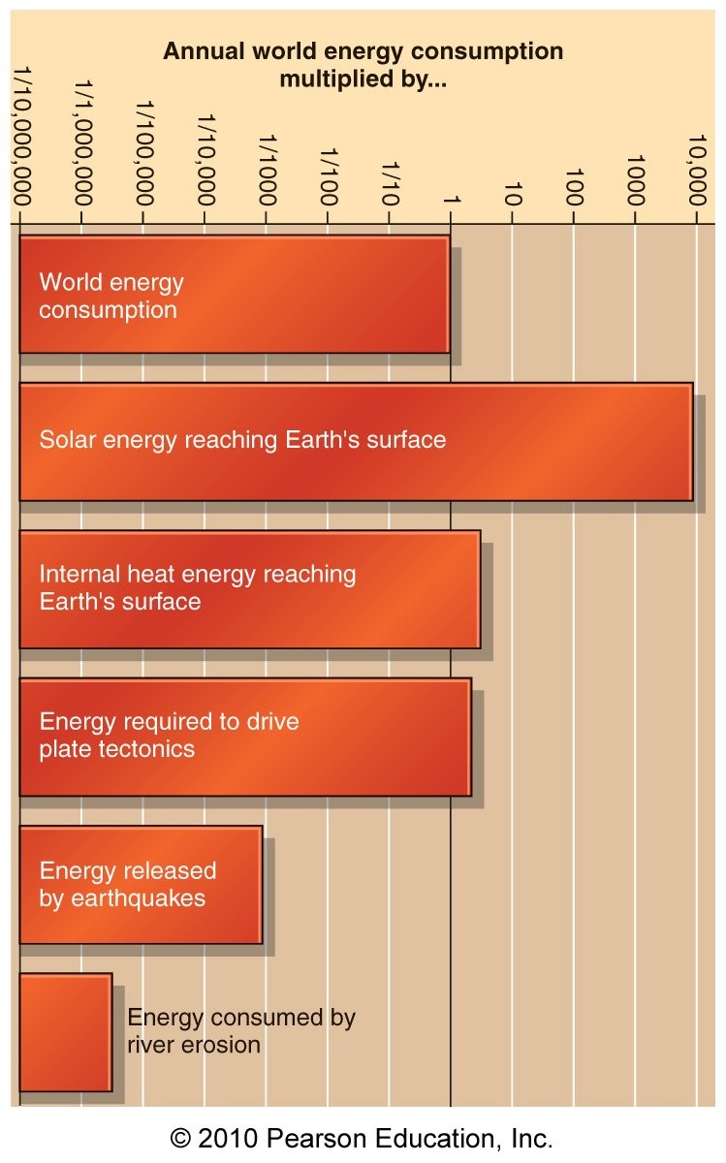
Figure 1.13

47) Based on the energy-related graph in Figure 1.13 of your textbook, what is the ratio of the amount of solar energy reaching Earth's surface to the amount of energy required to drive plate tectonics?
A) 10 000 to 3
B) 3 to 10
C) 10 to 3
D) about 100 to 1
Answer: A
Skill: Application
Objective: 1.6
48) Which of the following is least affected by convection heating?
A) a volcano erupting
B) Earth's mantle
C) wind
D) rain
Answer: D
Skill: Comprehension
Objective: 1.6

49) Rockfalls, landslides, and glacier movement are processes that are due to which physical principle?
A) Hooke's law
B) potential energy
C) heat
D) kinetic energy
Answer: B
Skill: Analysis
Objective: 1.6

50) Against which variable force must work be done to raise mountains?
A) the rigidity and tensile strength of the rock, which varies with rock type
B) gravitational pull, which varies with distance from Earth's core
C) the attractive force of the mantle and the melting and subduction of the Earth's crust at boundary zones, which varies according to plate speed
D) the magnetic attraction of Earth's core, which will vary according to the composition of the rock in the mountains being pushed up
Answer: B
Skill: Comprehension
Objective: 1.6

51) Which sphere does not experience convection forces?
A) the geosphere
B) the hydrosphere
C) the atmosphere
D) the biosphere
Answer: D
Skill: Comprehension
Objective: 1.6

52) The painful burn you feel when touching something hot is an example of the
A) radiation of heat.
B) conduction of heat.
C) refraction of heat.
D) convection of heat.
Answer: B
Skill: Knowledge
Objective: 1.6
53) Why is historical geology important?
A) It integrates the chemical, physical and biologic processes to interpret the history of the Earth.
B) It helps to update a list of records for every geologic event in history.
C) It helps geologists to understand groundwater and its uses.
D) It helps geologists find oil.
Answer: A
Skill: Knowledge
Objective: 1.1

54) Why must the process of mountain building be inferred through the principle of Uniformitarianism?
A) Uniformitarianism is a law so it must be so.
B) Mountain building occurs over millions of years so geologists must assume what takes place during the process.
C) Mountain building occurs very quickly.
D) Uniformitarianism describes mountain building word for word.
Answer: B
Skill: Comprehension
Objective: 1.4

55) If a continental plate meets an oceanic plate at a convergent boundary, which would be subducted?
A) Neither, the crust of each would both uplift.
B) continental plate
C) oceanic plate
D) They would both be subducted.
Answer: C
Skill: Knowledge
Objective: 1.1

56) If metals are the heaviest solids, in which layer of the Earth would they mostly be located?
A) oceanic crust
B) continental crust
C) mantle
D) core
Answer: D
Skill: Knowledge
Objective: 1.1
57) Which is the correct order of the scientific method?
A) experiment, hypothesis, conclusion, results
B) hypothesis, experiment, conclusion, results
C) hypothesis, experiment, results, conclusion
D) results, hypothesis, experiment, conclusion
Answer: C
Skill: Knowledge
Objective: 1.3
58) The rate of motion of lithospheric plates is comparable to ________.
A) fingernail growth
B) stream flow
C) highway traffic
D) grass growth
Answer: A
Skill: Application
Objective: 1.1

59) ________ is faster than ground water flow.
A) Sediment accumulation
B) Stream flow
C) River valley erosion
D) The rise of mountains
Answer: B
Skill: Application
Objective: 1.1

60) The erosion rate of river valleys is faster than the rate of ________.
A) landslide movement
B) stream flow
C) sediment accumulation in the deep sea
D) ground breaking during an earthquake
Answer: C
Skill: Application
Objective: 1.1

61) True or False: Geologic topics impact virtually every aspect of our daily lives, including such diverse issues as the economy, environmental health, and climate.
Answer: TRUE
Skill: Knowledge
Objective: 1.2

62) True or False: All natural geologic disasters are expressions of the dynamic nature of the planet.
Answer: TRUE
Skill: Knowledge
Objective: 1.2
63) True or False: The scientific method is a description of how scientists measure natural phenomena and rigorously test new ideas about how some part of the natural world works.
Answer: TRUE
Skill: Knowledge
Objective: 1.3

64) True or False: The scientific method is a step-by-step cookbook recipe for doing science.
Answer: FALSE
Skill: Knowledge
Objective: 1.3
65) True or False: Library research is essential during the early stages of a scientific study.
Answer: TRUE
Skill: Knowledge
Objective: 1.3

66) True or False: Scientific research always leads immediately to correct explanations of natural phenomena.
Answer: FALSE
Skill: Knowledge
Objective: 1.3

67) True or False: Changes in widely accepted hypotheses represent the failure of science to provide the right result.
Answer: FALSE
Skill: Knowledge
Objective: 1.3

68) True or False: Geologists use a single tool to gather information about Earth.
Answer: FALSE
Skill: Knowledge
Objective: 1.3

69) True or False: Principles, or laws, simply describe how humans observe nature to behave.
Answer: TRUE
Skill: Knowledge
Objective: 1.3

70) True or False: It is appropriate to criticize a scientific theory by saying "it's only a theory" because it is a tentative explanation that accounts for the existing data.
Answer: FALSE
Skill: Knowledge
Objective: 1.3

71) True or False: Geologic processes have been active in the past that humans have not witnessed.
Answer: TRUE
Skill: Knowledge
Objective: 1.4

72) True or False: The lithospheric plates are rigid and strong, in contrast to the underlying weaker asthenosphere.
Answer: TRUE
Skill: Knowledge
Objective: 1.5

73) True or False: Work on or within Earth does not require energy.
Answer: FALSE
Skill: Knowledge
Objective: 1.6
74) True or False: Energy is the measure of the ability to do work.
Answer: TRUE
Skill: Knowledge
Objective: 1.6

75) True or False: The higher rocks are uplifted as mountains, the greater the work required in overcoming the downward gravitational pull.
Answer: TRUE
Skill: Knowledge
Objective: 1.6

76) True or False: Rocks high on mountain peaks have less potential energy than those on valley bottoms.
Answer: FALSE
Skill: Knowledge
Objective: 1.6

77) True or False: The potential energy of water decreases as it flows downhill in stream channels to the ocean.
Answer: TRUE
Skill: Knowledge
Objective: 1.6

1.2 Short Answer Questions

1) Why is geology such a useful tool in our ever-changing society?
Answer: It is human nature to be inquisitive of our surroundings, whether it is about why something grows here or why earthquakes occur. Geology helps explain these natural phenomena. However, geology has even more important uses! Geology teaches us economically viable uses of almost all of our resources! From distribution of drinking water to the drilling of oil that gets us about on the Earth, geology is the basis of it all.

2) An environmental geologist discovers contamination in soil surrounding groundwater which supplies a local reservoir. What are some steps he/she should take to figure out where the contamination stems from? (Scientific method).
Answer: Although not a step of the scientific method, the geologist should immediately notify all emergency personnel in order to keep people from drinking contaminated water! First, the geologist proposes a simple question: Where is this coming from? After collecting data and seeing what the contaminant is (mercury), the geologist can narrow the possibilities to a few sources. After research on the data, the geologist sees that mercury is a common pollutant from factories. The geologist then formulates a hypothesis that the mercury stems from a factory located several miles away. This hypothesis is then tested through several field and lab experiments. The results support the hypothesis, and so the geologist writes reports analyzing, discussing, and concluding the results. He/she then communicates the results to other colleagues or officials in order to shut down the source and clean the soil, creating clean drinking water once again.
3) Archaeologists uncover a fossil imprint of a palm frond in New Jersey. Through various tests and analyses, they see that the fossil is from about 200 million years ago — the Jurassic period. What can you conclude about the climate of this ancient environment, based on today's environments? (Principle of Uniformitarianism).
Answer: Today, in most cases, palms are found in regions of tropical climates. So, using the principle of Uniformitarianism, you can conclude that New Jersey had a tropical climate during the Jurassic period.

4) The Andes mountain chain was created as a result of plate tectonics. An ocean plate (the Nazca plate) collided with a continental plate (the South American Plate), and the Andes were the result. Which type of boundary is associated with this mountain building event, and what took place in order for the mountains to form? (Theory of Plate Tectonics).
Answer: This mountain building event is associated with a convergent boundary. In order for the mountains to form, the oceanic plate, being the lighter of the two, was subducted beneath the continental plate, which pushed rock material upwards, creating the Andes Mountains. This, of course, took place over millions of years.

5) What is a hot spot, and how are these natural phenomena explained?
Answer: Hot spots are areas where molten material rises from deep in the mantle below the moving lithosphere. They are often in the middle of plates, such as Hawaii in the middle of the Pacific plate. Large volcanic islands build up as the Pacific plate moves over the Hawaiian hot spot. A volcano becomes extinct as plate motion carries it away from the hot spot, the area of rising hot mantle, and a new volcano appears in its wake. These are the result of processes not explained by plate tectonics.

6) Briefly explain plate tectonics in terms of convection. (Plate tectonics and work).
Answer: Through convection, a process involving heat energy, plates move towards one another and collide at convergent boundaries. The lighter, cooler rock from the Earth's surface sinks, while less dense rock expanded by radioactive heating in the interior rises. Convection motion of the mostly solid mantle is extremely slow.

7) Mt. Everest is 29,028 feet tall, while K2 is 28,251 feet tall. Which has more potential energy, and why? (Potential energy).
Answer: Considerable work must be done to raise mountains, because the force of gravity pulls all materials toward Earth's interior. The higher that rocks are uplifted, the greater the work required to overcome the downward gravitational pull. The mountains appear to just sit there, but it actually contains a form of stored energy called potential energy. Potential energy is the energy an object possesses because of its elevation and weight. Therefore, a mountain with higher elevation has more potential energy!

