Basic Business Statistics, 12e, Global Edition (Berenson/Levine/Krehbiel/Stephan)
Chapter 2 Organizing and Visualizing Data

Chapter 2 Questions

1) Jared was working on a project to look at global warming and accessed an Internet site where he captured average global surface temperatures from 1866. Which of the four methods of data collection was he using?
A) Published sources
B) Experimentation
C) Surveying
D) Observation
Answer: A
Difficulty: Easy
Keywords: sources of data

2) The British Airways Internet site provides a questionnaire instrument that can be answered electronically. Which of the 4 methods of data collection is involved when people complete the questionnaire?
A) Published sources
B) Experimentation
C) Surveying
D) Observation
Answer: C
Difficulty: Easy
Keywords: sources of data

3) A marketing research firm, in conducting a comparative taste test, provided three types of peanut butter to a sample of households randomly selected within the state. Which of the 4 methods of data collection is involved when people are asked to compare the three types of peanut butter?
A) Published sources
B) Experimentation
C) Surveying
D) Observation
Answer: B
Difficulty: Easy
Keywords: sources of data
4) Tim was planning for a meeting with his boss to discuss a raise in his annual salary. In preparation, he wanted to use the Consumer Price Index to determine the percentage increase in his real (inflation-adjusted) salary over the last three years. Which of the 4 methods of data collection was involved when he used the Consumer Price Index?
A) Published sources
B) Experimentation
C) Surveying
D) Observation
Answer: A
Difficulty: Easy
Keywords: sources of data

5) Which of the 4 methods of data collection is involved when a person counts the number of cars passing designated locations on the Los Angeles freeway system?
A) Published sources
B) Experimentation
C) Surveying
D) Observation
Answer: D
Difficulty: Moderate
Keywords: sources of data

6) A statistics student found a reference in the campus library that contained the median family incomes for all 50 states. She would report her data as being collected using
A) a designed experiment.
B) observational data.
C) a random sample.
D) a published source.
Answer: D
Difficulty: Easy
Keywords: sources of data
7) The personnel director at a large company studied the eating habits of the company's employees. The director noted whether employees brought their own lunches to work, ate at the company cafeteria, or went out to lunch. The goal of the study was to improve the food service at the company cafeteria. This type of data collection would best be considered as
A) an observational study.
B) a designed experiment.
C) a random sample.
D) a quota sample.
Answer: A
Difficulty: Easy
Keywords: sources of data

8) A study attempted to estimate the proportion of Florida residents who were willing to spend more tax dollars on protecting the beaches from environmental disasters. Twenty-five hundred Florida residents were surveyed. What type of data collection procedure was most likely used to collect the data for this study?
A) A designed experiment
B) A published source
C) A random sample
D) Observational data
Answer: C
Difficulty: Easy
Keywords: sources of data
TABLE 2-1

An insurance company evaluates many numerical variables about a person before deciding on an appropriate rate for automobile insurance. A representative from a local insurance agency selected a random sample of insured drivers and recorded, X, the number of claims each made in the last 3 years, with the following results.

X f
1 14
2 18
3 12
4 5
5 1

9) Referring to Table 2-1, how many drivers are represented in the sample?
A) 5
B) 15
C) 18
D) 50
Answer: D
Difficulty: Easy
Keywords: frequency distribution

10) Referring to Table 2-1, how many total claims are represented in the sample?
A) 15
B) 50
C) 111
D) 250
Answer: C
Difficulty: Moderate
Keywords: interpretation, frequency distribution

11) A type of vertical bar chart in which the categories are plotted in the descending rank order of the magnitude of their frequencies is called a
A) contingency table.
B) Pareto chart.
C) stem-and-leaf display.
D) pie chart.
Answer: B
Difficulty: Easy
Keywords: Pareto chart
TABLE 2-2

At a meeting of information systems officers for regional offices of a national company, a survey was taken to determine the number of employees the officers supervise in the operation of their departments, where X is the number of employees overseen by each information systems officer.

X f
1 7
2 5
3 11
4 8
5 9

12) Referring to Table 2-2, how many regional offices are represented in the survey results?
A) 5
B) 11
C) 15
D) 40
Answer: D
Difficulty: Easy
Keywords: interpretation, frequency distribution

13) Referring to Table 2-2, across all of the regional offices, how many total employees were supervised by those surveyed?
A) 15
B) 40
C) 127
D) 200
Answer: C
Difficulty: Moderate
Keywords: interpretation, frequency distribution

14) The width of each bar in a histogram corresponds to the
A) differences between the boundaries of the class.
B) number of observations in each class.
C) midpoint of each class.
D) percentage of observations in each class.
Answer: A
Difficulty: Easy
Keywords: frequency distribution
TABLE 2-3

Every spring semester, the School of Business coordinates a luncheon with local business leaders for graduating seniors, their families, and friends. Corporate sponsorship pays for the lunches of each of the seniors, but students have to purchase tickets to cover the cost of lunches served to guests they bring with them. The following histogram represents the attendance at the senior luncheon, where X is the number of guests each graduating senior invited to the luncheon and f is the number of graduating seniors in each category.

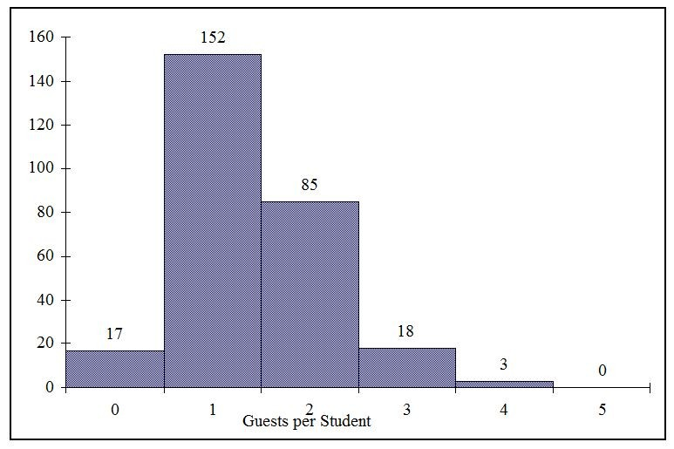
15) Referring to the histogram from Table 2-3, how many graduating seniors attended the luncheon?
A) 4
B) 152
C) 275
D) 388
Answer: C
Explanation: C) The number of graduating seniors is the sum of all the frequencies, f.
Difficulty: Difficult
Keywords: interpretation, histogram
16) Referring to the histogram from Table 2-3, if all the tickets purchased were used, how many guests attended the luncheon?
A) 4
B) 152
C) 275
D) 388
Answer: D
Explanation: D) The total number of guests is X_{i}ƒ_{i}
Difficulty: Difficult
Keywords: interpretation, histogram

17) A professor of economics at a small Texas university wanted to determine what year in school students were taking his tough economics course. Shown below is a pie chart of the results. What percentage of the class took the course prior to reaching their senior year?
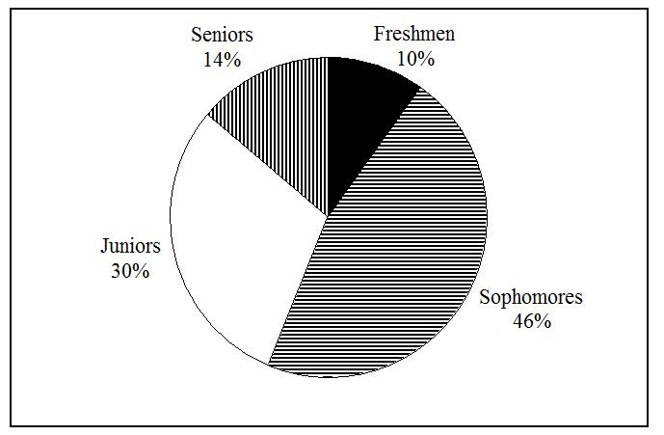
A) 14%
B) 44%
C) 54%
D) 86%
Answer: D
Difficulty: Easy
Keywords: interpretation, pie chart
18) When polygons or histograms are constructed, which axis must show the true zero or "origin"?
A) The horizontal axis
B) The vertical axis
C) Both the horizontal and vertical axes
D) Neither the horizontal nor the vertical axis
Answer: B
Difficulty: Easy
Keywords: polygon, histogram

19) When constructing charts, the following is plotted at the class midpoints:
A) frequency histograms.
B) percentage polygons.
C) cumulative percentage polygon (ogives).
D) All of the above.
Answer: B
Difficulty: Easy
Keywords: percentage polygons

TABLE 2-4

A survey was conducted to determine how people rated the quality of programming available on television. Respondents were asked to rate the overall quality from 0 (no quality at all) to 100 (extremely good quality). The stem-and-leaf display of the data is shown below.

Stem Leaves
3 2 4
4 0 3 4 7 8 9 9 9
5 0 1 1 2 3 4 5
6 1 2 5 6 6
7 0 1
8
9 2

20) Referring to Table 2-4, what percentage of the respondents rated overall television quality with a rating of 80 or above?
A) 0
B) 4
C) 96
D) 100
Answer: B
Difficulty: Easy
Keywords: stem-and-leaf display, interpretation
21) Referring to Table 2-4, what percentage of the respondents rated overall television quality with a rating of 50 or below?
A) 11
B) 40
C) 44
D) 56
Answer: C
Difficulty: Moderate
Keywords: stem-and-leaf display, interpretation

22) Referring to Table 2-4, what percentage of the respondents rated overall television quality with a rating from 50 through 75?
A) 11
B) 40
C) 44
D) 56
Answer: D
Difficulty: Moderate
Keywords: stem-and-leaf display, interpretation

TABLE 2-5

The following are the duration in minutes of a sample of long-distance phone calls made within the continental United States reported by one long-distance carrier.

Relative
Time (in Minutes) Frequency
0 but less than 5 0.37
5 but less than 10 0.22
10 but less than 15 0.15
15 but less than 20 0.10
20 but less than 25 0.07
25 but less than 30 0.07
30 or more 0.02

23) Referring to Table 2-5, what is the width of each class?
A) 1 minute
B) 5 minutes
C) 2%
D) 100%
Answer: B
Difficulty: Easy
Keywords: class interval, relative frequency distribution
24) Referring to Table 2-5, if 1,000 calls were randomly sampled, how many calls lasted under 10 minutes?
A) 220
B) 370
C) 410
D) 590
Answer: D
Difficulty: Moderate
Keywords: relative frequency distribution, interpretation

25) Referring to Table 2-5, if 100 calls were randomly sampled, how many calls lasted 15 minutes or longer?
A) 10
B) 14
C) 26
D) 74
Answer: C
Difficulty: Moderate
Keywords: relative frequency distribution, interpretation

26) Referring to Table 2-5, if 10 calls lasted 30 minutes or more, how many calls lasted less than 5 minutes?
A) 10
B) 185
C) 295
D) 500
Answer: B
Difficulty: Moderate
Keywords: relative frequency distribution, interpretation

27) Referring to Table 2-5, what is the cumulative relative frequency for the percentage of calls that lasted under 20 minutes?
A) 0.10
B) 0.59
C) 0.76
D) 0.84
Answer: D
Difficulty: Easy
Keywords: cumulative relative frequency
28) Referring to Table 2-5, what is the cumulative relative frequency for the percentage of calls that lasted 10 minutes or more?
A) 0.16
B) 0.24
C) 0.41
D) 0.90
Answer: C
Difficulty: Moderate
Keywords: cumulative relative frequency

29) Referring to Table 2-5, if 100 calls were randomly sampled, ________ of them would have lasted at least 15 minutes but less than 20 minutes.
A) 6
B) 8
C) 10
D) 16
Answer: C
Difficulty: Easy
Keywords: relative frequency distribution, interpretation

30) Referring to Table 2-5, if 100 calls were sampled, ________ of them would have lasted less than 15 minutes.
A) 26
B) 74
C) 10
D) None of the above
Answer: B
Difficulty: Moderate
Keywords: relative frequency distribution, interpretation

31) Referring to Table 2-5, if 100 calls were sampled, ________ of them would have lasted 20 minutes or more.
A) 26
B) 16
C) 74
D) None of the above
Answer: B
Difficulty: Moderate
Keywords: relative frequency distribution, interpretation
32) Referring to Table 2-5, if 100 calls were sampled, ________ of them would have lasted less than 5 minutes or at least 30 minutes or more.
A) 35
B) 37
C) 39
D) None of the above
Answer: C
Difficulty: Difficult
Keywords: relative frequency distribution, interpretation

33) Which of the following is appropriate for displaying data collected on the different brands of cars students at a major university drive?
A) A Pareto chart
B) A two-way classification table
C) A histogram
D) A scatter plot
Answer: A
Difficulty: Easy
Keywords: Pareto diagram

34) One of the developing countries is experiencing a baby boom, with the number of births rising for the fifth year in a row, according to a BBC News report. Which of the following is best for displaying this data?
A) A Pareto chart
B) A two-way classification table
C) A histogram
D) A time-series plot
Answer: D
Difficulty: Easy
Keywords: time-series plot

35) When studying the simultaneous responses to two categorical questions, you should set up a
A) contingency table.
B) frequency distribution table.
C) cumulative percentage distribution table.
D) histogram.
Answer: A
Difficulty: Easy
Keywords: contingency table
36) Data on 1,500 students' height were collected at a larger university in the East Coast. Which of the following is the best chart for presenting the information?
A) A pie chart
B) A Pareto chart
C) A side-by-side bar chart
D) A histogram
Answer: D
Difficulty: Easy
Keywords: choice of chart, histogram

37) Data on the number of part-time hours students at a public university worked in a week were collected. Which of the following is the best chart for presenting the information?
A) A pie chart
B) A Pareto chart
C) A percentage table
D) A percentage polygon
Answer: D
Difficulty: Easy
Keywords: choice of chart, percentage polygon

38) Data on the number of credit hours of 20,000 students at a public university enrolled in a spring semester were collected. Which of the following is the best for presenting the information?
A) A pie chart
B) A Pareto chart
C) A stem-and-leaf display
D) A contingency table
Answer: C
Difficulty: Easy
Keywords: choice of chart, stem-and-leaf

39) A survey of 150 executives were asked what they think is the most common mistake candidates make during job interviews. Six different mistakes were given. Which of the following is the best for presenting the information?
A) A bar chart
B) A histogram
C) A stem-and-leaf display
D) A contingency table
Answer: A
Difficulty: Easy
Keywords: choice of chart, bar chart
40) You have collected information on the market share of 5 different search engines used by U.S. Internet users in January 2011. Which of the following is the best for presenting the information?
A) A pie chart
B) A histogram
C) A stem-and-leaf display
D) A contingency table
Answer: A
Difficulty: Easy
Keywords: choice of chart, pie chart

41) You have collected information on the consumption by the 15 largest coffee-consuming nations. Which of the following is the best for presenting the shares of the consumption?
A) A pie chart
B) A Pareto chart
C) A side-by-side bar chart
D) A contingency table
Answer: B
Explanation: B) Even though a pie chart can also be used, the Pareto chart is preferable for separating the "vital few" from the "trivial many".
Difficulty: Moderate
Keywords: choice of chart, Pareto chart

42) You have collected data on the approximate retail price (in $) and the energy cost per year (in $) of 15 refrigerators. Which of the following is the best for presenting the data?
A) A pie chart
B) A scatter plot
C) A side-by-side bar chart
D) A contingency table
Answer: B
Difficulty: Easy
Keywords: choice of chart, scatter chart
43) You have collected data on the number of U.S. households actively using online banking and/or online bill payment from 1995 to 2010. Which of the following is the best for presenting the data?
A) A pie chart
B) A stem-and-leaf display
C) A side-by-side bar chart
D) A time-series plot
Answer: D
Difficulty: Easy
Keywords: choice of chart, time-series plot

44) You have collected data on the monthly seasonally adjusted civilian unemployment rate for the United States from 1998 to 2010. Which of the following is the best for presenting the data?
A) A contingency table
B) A stem-and-leaf display
C) A time-series plot
D) A side-by-side bar chart
Answer: C
Difficulty: Easy
Keywords: choice of chart, time-series plot

45) You have collected data on the number of complaints for 6 different brands of automobiles sold in the US in 2006 and in 2010. Which of the following is the best for presenting the data?
A) A contingency table
B) A stem-and-leaf display
C) A time-series plot
D) A side-by-side bar chart
Answer: D
Difficulty: Moderate
Keywords: choice of chart, side-by-side bar chart

46) You have collected data on the responses to two questions asked in a survey of 40 college students majoring in businessWhat is your gender? (Male = M; Female = F) and What is your major? (Accountancy = A; Computer Information Systems = C; Marketing = M). Which of the following is the best for presenting the data?
A) A contingency table
B) A stem-and-leaf display
C) A time-series plot
D) A Pareto chart
Answer: A
Difficulty: Moderate
Keywords: choice of chart, contingency table
TABLE 2-6

A sample of 200 students at a Big-Ten university was taken after the midterm to ask them whether they went bar hopping the weekend before the midterm or spent the weekend studying, and whether they did well or poorly on the midterm. The following table contains the result.

 | Did Well in Midterm | Did Poorly in Midterm
Studying for Exam | 80 | 20
Went Bar Hopping | 30 | 70

47) Referring to Table 2-6, of those who went bar hopping the weekend before the midterm in the sample, ________ percent of them did well on the midterm.
A) 15
B) 27.27
C) 30
D) 55
Answer: C
Difficulty: Easy
Keywords: contingency table, interpretation

48) Referring to Table 2-6, of those who did well on the midterm in the sample, ________ percent of them went bar hopping the weekend before the midterm.
A) 15
B) 27.27
C) 30
D) 50
Answer: B
Difficulty: Easy
Keywords: contingency table, interpretation

49) Referring to Table 2-6, ________ percent of the students in the sample went bar hopping the weekend before the midterm and did well on the midterm.
A) 15
B) 27.27
C) 30
D) 50
Answer: A
Difficulty: Easy
Keywords: contingency table, interpretation
50) Referring to Table 2-6, ________ percent of the students in the sample spent the weekend studying and did well on the midterm.
A) 40
B) 50
C) 72.72
D) 80
Answer: A
Difficulty: Easy
Keywords: contingency table, interpretation

51) Referring to Table 2-6, if the sample is a good representation of the population, we can expect ________ percent of the students in the population to spend the weekend studying and do poorly on the midterm.
A) 10
B) 20
C) 45
D) 50
Answer: A
Difficulty: Easy
Keywords: contingency table, interpretation

52) Referring to Table 2-6, if the sample is a good representation of the population, we can expect ________ percent of those who spent the weekend studying to do poorly on the midterm.
A) 10
B) 20
C) 45
D) 50
Answer: B
Difficulty: Moderate
Keywords: contingency table, interpretation

53) Referring to Table 2-6, if the sample is a good representation of the population, we can expect ________ percent of those who did poorly on the midterm to have spent the weekend studying.
A) 10
B) 22.22
C) 45
D) 50
Answer: B
Difficulty: Moderate
Keywords: contingency table, interpretation
54) In a contingency table, the number of rows and columns
A) must always be the same.
B) must always be 2.
C) must add to 100%.
D) None of the above
Answer: D
Difficulty: Moderate
Keywords: contingency table

55) Retailers are always interested in determining why a customer selected their store to make a purchase. A sporting goods retailer conducted a customer survey to determine why its customers shopped at the store. The results are shown in the bar chart below. What proportion of the customers responded that they shopped at the store because of the merchandise or the convenience?
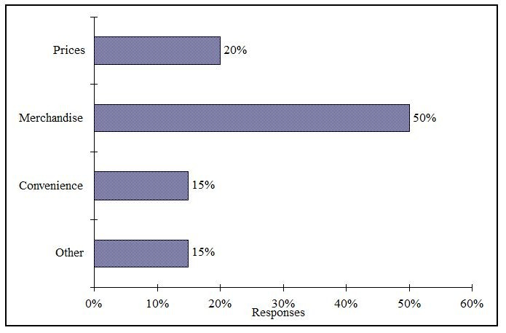
A) 35%
B) 50%
C) 65%
D) 85%
Answer: C
Difficulty: Easy
Keywords: bar chart, interpretation
TABLE 2-7

The Stem-and-Leaf display below contains data on the number of months between the date a civil suit is filed and when the case is actually adjudicated for 50 cases heard in superior court.

Stem Leaves
1 2 3 4 4 4 7 8 9 9
2 2 2 2 2 3 4 5 5 6 7 8 8 8 9
3 0 0 1 1 1 3 5 7 7 8
4 0 2 3 4 5 5 7 9
5 1 1 2 4 6 6
6 1 5 8

56) Referring to Table 2-7, locate the first leaf, i.e., the lowest valued leaf with the lowest valued stem. This represents a wait of ________ months.
Answer: 12
Difficulty: Easy
Keywords: stem-and-leaf display, interpretation
57) Referring to Table 2-7, the civil suit with the longest wait between when the suit was filed and when it was adjudicated had a wait of ________ months.
Answer: 68
Difficulty: Easy
Keywords: stem-and-leaf display, interpretation

58) Referring to Table 2-7, the civil suit with the fourth shortest waiting time between when the suit was filed and when it was adjudicated had a wait of ________ months.
Answer: 14
Difficulty: Moderate
Keywords: stem-and-leaf display, interpretation

59) Referring to Table 2-7, ________ percent of the cases were adjudicated within the first 2 years.
Answer: 30
Difficulty: Moderate
Keywords: stem-and-leaf display, interpretation

60) Referring to Table 2-7, ________ percent of the cases were not adjudicated within the first 4 years.
Answer: 20
Difficulty: Moderate
Keywords: stem-and-leaf display, interpretation
61) Referring to Table 2-7, if a frequency distribution with equal sized classes was made from this data, and the first class was "10 but less than 20," the frequency of that class would be ________.
Answer: 9
Difficulty: Easy
Keywords: stem-and-leaf display, interpretation

62) Referring to Table 2-7, if a frequency distribution with equal sized classes was made from this data, and the first class was "10 but less than 20," the relative frequency of the third class would be ________.
Answer: 0.20 or 20% or 10/50
Difficulty: Moderate
Keywords: stem-and-leaf display, relative frequency distribution

63) Referring to Table 2-7, if a frequency distribution with equal sized classes was made from this data, and the first class was "10 but less than 20," the cumulative percentage of the second class would be ________.
Answer: 46% or 0.46 or 23/50
Difficulty: Moderate
Keywords: stem-and-leaf display, cumulative percentage distribution

TABLE 2-8

The Stem-and-Leaf display represents the number of times in a year that a random sample of 100 "lifetime" members of a health club actually visited the facility.

Stem Leaves
0 0 1 2 2 2 2 2 3 3 3 3 3 3 4 4 5 6 6 6 6 6 6 6 7 7 8 9 9 9 9
1 1 1 1 1 2 2 2 2 3 4 4 4 4 4 5 5 6 6 9 9 9 9
2 0 0 0 1 1 2 2 3 4 5 5 5 5 6 8 8 9
3 0 0 0 0 4 4 6 7 9 9
4 0 1 1 3 4 5 5 6 7
5 0 0 7 7
6 8
7 6 7
8 3
9 0 2 4 7

64) Referring to Table 2-8, the person who has the largest leaf associated with the smallest stem visited the facility ________ times.
Answer: 9
Difficulty: Moderate
Keywords: stem-and-leaf display, interpretation
65) Referring to Table 2-8, the person who visited the health club less than anyone else in the sample visited the facility ________ times.
Answer: 0 or no
Difficulty: Easy
Keywords: stem-and-leaf display, interpretation

66) Referring to Table 2-8, the person who visited the health club more than anyone else in the sample visited the facility ________ times.
Answer: 97
Difficulty: Easy
Keywords: stem-and-leaf display, interpretation

67) Referring to Table 2-8, ________ of the 100 members visited the health club at least 52 times in a year.
Answer: 10
Difficulty: Moderate
Keywords: stem-and-leaf display, interpretation

68) Referring to Table 2-8, ________ of the 100 members visited the health club no more than 12 times in a year.
Answer: 38
Difficulty: Moderate
Keywords: stem-and-leaf display, interpretation

69) Referring to Table 2-8, if a frequency distribution with equal sized classes was made from this data, and the first class was "0 but less than 10," the frequency of the fifth class would be ________.
Answer: 9
Difficulty: Moderate
Keywords: stem-and-leaf display, frequency distribution

70) Referring to Table 2-8, if a frequency distribution with equal sized classes was made from this data, and the first class was "0 but less than 10," the relative frequency of the last class would be ________.
Answer: 4% or 0.04 or 4/100
Difficulty: Moderate
Keywords: stem-and-leaf display, relative frequency distribution

71) Referring to Table 2-8, if a frequency distribution with equal sized classes was made from this data, and the first class was "0 but less than 10," the cumulative percentage of the next-to-last class would be ________.
Answer: 96% or 0.96 or 96/100
Difficulty: Moderate
Keywords: stem-and-leaf display, cumulative percentage distribution
72) Referring to Table 2-8, if a frequency distribution with equal sized classes was made from this data, and the first class was "0 but less than 10," the class midpoint of the third class would be ________.
Answer: 25 or (20+30)/2
Difficulty: Moderate
Keywords: stem-and-leaf display, class midpoint

TABLE 2-9

The frequency distribution below represents the rents of 250 randomly selected federally subsidized apartments in a small town.

Rent in $ Frequency
300 but less than 400 113
400 but less than 500 85
500 but less than 600 32
600 but less than 700 16
700 but less than 800 4

73) Referring to Table 2-9, ________ apartments rented for at least $400 but less than $600.
Answer: 117
Difficulty: Easy
Keywords: frequency distribution

74) Referring to Table 2-9, ________ percent of the apartments rented for $600 or more.
Answer: 8% or 20/250
Difficulty: Easy
Keywords: frequency distribution, cumulative percentage distribution

75) Referring to Table 2-9, ________ percent of the apartments rented for at least $500.
Answer: 20.8% or 52/250
Difficulty: Moderate
Keywords: frequency distribution, cumulative percentage distribution

76) Referring to Table 2-9, the class midpoint of the second class is ________.
Answer: 450
Difficulty: Easy
Keywords: frequency distribution, class midpoint
77) Referring to Table 2-9, the relative frequency of the second class is ________.
Answer: 85/250 or 17/50 or 34% or 0.34
Difficulty: Easy
Keywords: frequency distribution, relative frequency distribution

78) Referring to Table 2-9, the percentage of apartments renting for less than $600 is ________.
Answer: 230/250 or 23/25 or 92% or 0.92
Difficulty: Moderate
Keywords: frequency distribution, cumulative percentage distribution

TABLE 2-10

The histogram below represents scores achieved by 200 job applicants on a personality profile.

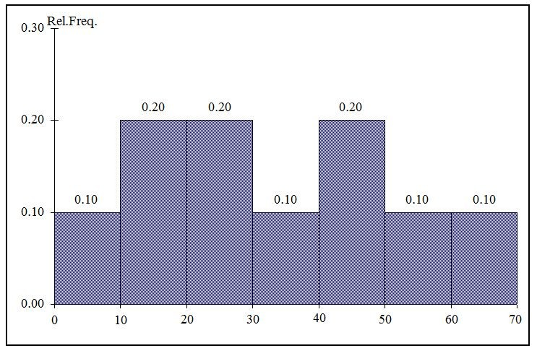

79) Referring to the histogram from Table 2-10, ________ percent of the job applicants scored between 10 and 20.
Answer: 20%
Difficulty: Easy
Keywords: histogram, percentage distribution

80) Referring to the histogram from Table 2-10, ________ percent of the job applicants scored below 50.
Answer: 80%
Difficulty: Moderate
Keywords: histogram, percentage distribution
81) Referring to the histogram from Table 2-10, the number of job applicants who scored between 30 and below 60 is ________.
Answer: 80
Difficulty: Moderate
Keywords: histogram

82) Referring to the histogram from Table 2-10, the number of job applicants who scored 50 or above is ________.
Answer: 40
Difficulty: Moderate
Keywords: histogram

83) Referring to the histogram from Table 2-10, 90% of the job applicants scored above or equal to ________.
Answer: 10
Difficulty: Moderate
Keywords: histogram, cumulative percentage distribution

84) Referring to the histogram from Table 2-10, half of the job applicants scored below ________.
Answer: 30
Difficulty: Moderate
Keywords: histogram, cumulative percentage distribution

85) Referring to the histogram from Table 2-10, ________ percent of the applicants scored below 20 or at least 50.
Answer: 50%
Difficulty: Moderate
Keywords: histogram, cumulative percentage distribution

86) Referring to the histogram from Table 2-10, ________ percent of the applicants scored between 20 and below 50.
Answer: 50%
Difficulty: Moderate
Keywords: histogram, cumulative percentage distribution
TABLE 2-11

The ordered array below resulted from selecting a sample of 25 batches of 500 computer chips and determining how many in each batch were defective.

Defects
1 2 4 4 5 5 6 7 9 9 12 12 15
17 20 21 23 23 25 26 27 27 28 29 29

87) Referring to Table 2-11, if a frequency distribution for the defects data is constructed, using "0 but less than 5" as the first class, the frequency of the "20 but less than 25" class would be ________.
Answer: 4
Difficulty: Easy
Keywords: frequency distribution

88) Referring to Table 2-11, if a frequency distribution for the defects data is constructed, using "0 but less than 5" as the first class, the relative frequency of the "15 but less than 20" class would be ________.
Answer: 0.08 or 8% or 2/25
Difficulty: Moderate
Keywords: relative frequency distribution

89) Referring to Table 2-11, construct a frequency distribution for the defects data, using "0 but less than 5" as the first class.
Answer:
Defects Frequency
0 but less than 5 4
5 but less than 10 6
10 but less than 15 2
15 but less than 20 2
20 but less than 25 4
25 but less than 30 7
Difficulty: Easy
Keywords: frequency distribution
90) Referring to Table 2-11, construct a relative frequency or percentage distribution for the defects data, using "0 but less than 5" as the first class.
Answer:
Defects Percentage
0 but less than 5 16
5 but less than 10 24
10 but less than 15 8
15 but less than 20 8
20 but less than 25 16
25 but less than 30 28
Difficulty: Moderate
Keywords: relative frequency distribution, percentage distribution

91) Referring to Table 2-11, construct a cumulative percentage distribution for the defects data if the corresponding frequency distribution uses "0 but less than 5" as the first class.
Answer:
Defects CumPct
0 0
5 16
10 40
15 48
20 56
25 72
30 100
Difficulty: Moderate
Keywords: cumulative percentage distribution
92) Referring to Table 2-11, construct a histogram for the defects data, using "0 but less than 5" as the first class.
Answer:
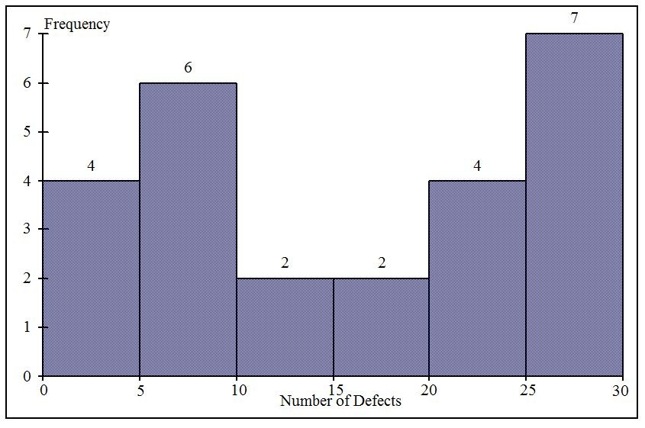
Difficulty: Easy
Keywords: histogram, frequency distribution
93) Referring to Table 2-11, construct a cumulative percentage polygon for the defects data if the corresponding frequency distribution uses "0 but less than 5" as the first class.
Answer:
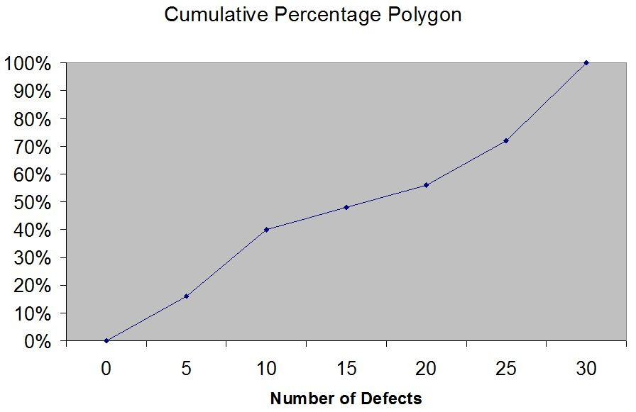
Difficulty: Moderate
Keywords: cumulative percentage polygon

94) The point halfway between the boundaries of each class interval in a grouped frequency distribution is called the ________.
Answer: class midpoint
Difficulty: Easy
Keywords: cumulative percentage polygon, frequency distribution

95) A ________ is a vertical bar chart in which the rectangular bars are constructed at the boundaries of each class interval.
Answer: histogram
Difficulty: Easy
Keywords: histogram

96) It is essential that each class grouping or interval in a frequency distribution be ________ and ________.
Answer: non-overlapping; of equal width
Difficulty: Moderate
Keywords: frequency distribution, class interval
97) In order to compare one large set of numerical data to another, a ________ distribution must be developed from the frequency distribution.
Answer: relative frequency or percentage
Difficulty: Easy
Keywords: relative frequency distribution, percentage distribution

98) When comparing two or more large sets of numerical data, the distributions being developed should use the same ________.
Answer: class boundaries
Difficulty: Easy
Keywords: class boundaries

99) The width of each class grouping or interval in a frequency distribution should be ________.
Answer: the same or equal
Difficulty: Easy
Keywords: class interval, frequency distribution

100) In constructing a polygon, each class grouping is represented by its ________ and then these are consecutively connected to one another.
Answer: midpoint
Difficulty: Easy
Keywords: polygon, class interval, midpoint

101) A ________ is a summary table in which numerical data are tallied into class intervals or categories.
Answer: frequency distribution
Difficulty: Easy
Keywords: frequency distribution, class interval

102) In general, grouped frequency distributions should have between 5 and 15 class intervals.
Answer: TRUE
Difficulty: Easy
Keywords: frequency distribution, number of classes

103) The sum of relative frequencies in a distribution always equals 1.
Answer: TRUE
Difficulty: Easy
Keywords: relative frequency
104) The sum of cumulative frequencies in a distribution always equals 1.
Answer: FALSE
Difficulty: Moderate
Keywords: cumulative distribution

105) In graphing two categorical data, the side-by-side bar chart is best suited when comparing joint responses.
Answer: TRUE
Difficulty: Moderate
Keywords: side-by-side chart

106) When constructing a frequency distribution, classes should be selected so that they are of equal width.
Answer: TRUE
Difficulty: Easy
Keywords: frequency distribution

107) A research analyst was directed to arrange raw data collected on the yield of wheat, ranging from 40 to 93 bushels per acre, in a frequency distribution. He should choose 30 as the class interval width.
Answer: FALSE
Difficulty: Easy
Keywords: frequency distribution, class interval

108) If the values of the seventh and eighth class in a cumulative percentage distribution are the same, we know that there are no observations in the eighth class.
Answer: TRUE
Difficulty: Moderate
Keywords: cumulative percentage distribution

109) One of the advantages of a pie chart is that it clearly shows that the total of all the categories of the pie adds to 100%.
Answer: TRUE
Difficulty: Easy
Keywords: pie chart

110) The larger the number of observations in a numerical data set, the larger the number of class intervals needed for a grouped frequency distribution.
Answer: TRUE
Difficulty: Easy
Keywords: class interval, frequency distribution
111) Determining the class boundaries of a frequency distribution is highly subjective.
Answer: TRUE
Difficulty: Easy
Keywords: class boundaries, frequency distribution

112) The original data values cannot be determined once they are grouped into a frequency distribution table.
Answer: TRUE
Difficulty: Easy
Keywords: frequency distribution
113) The percentage distribution cannot be constructed from the frequency distribution directly.
Answer: FALSE
Difficulty: Easy
Keywords: percentage distribution, frequency distribution

114) The stem-and-leaf display is often superior to the frequency distribution in that it maintains the original values for further analysis.
Answer: TRUE
Difficulty: Easy
Keywords: stem-and-leaf display, frequency distribution

115) The relative frequency is the frequency in each class divided by the total number of observations.
Answer: TRUE
Difficulty: Easy
Keywords: relative frequency distribution

116) Ogives are plotted at the midpoints of the class groupings.
Answer: FALSE
Difficulty: Easy
Keywords: ogives, midpoint

117) Percentage polygons are plotted at the boundaries of the class groupings.
Answer: FALSE
Difficulty: Easy
Keywords: percentage polygons

118) The main principle behind the Pareto chart is the ability to separate the "vital few" from the "trivial many."
Answer: TRUE
Difficulty: Easy
Keywords: Pareto chart
119) A histogram can have gaps between the bars, whereas bar charts cannot have gaps.
Answer: FALSE
Difficulty: Easy
Keywords: histogram, bar chart

120) Histograms are used for numerical data while bar charts are suitable for categorical data.
Answer: TRUE
Difficulty: Easy
Keywords: histogram, bar chart

121) A Wal-Mart store in a small town monitors customer complaints and organizes these complaints into six distinct categories. Over the past year, the company has received 534 complaints. One possible graphical method for representing these data would be a Pareto chart.
Answer: TRUE
Difficulty: Moderate
Keywords: Pareto chart

122) Apple Computer, Inc. collected information on the age of their customers. The youngest customer was 12 and the oldest was 72. To study the distribution of the age among its customers, it can use a Pareto chart.
Answer: FALSE
Difficulty: Moderate
Keywords: Pareto chart

123) Apple Computer, Inc. collected information on the age of their customers. The youngest customer was 12 and the oldest was 72. To study the distribution of the age among its customers, it is best to use a pie chart.
Answer: FALSE
Difficulty: Moderate
Keywords: pie chart

124) Apple Computer, Inc. collected information on the age of their customers. The youngest customer was 12 and the oldest was 72. To study the distribution of the age among its customers, it can use a percentage polygon.
Answer: TRUE
Difficulty: Moderate
Keywords: percentage polygons
125) Apple Computer, Inc. collected information on the age of their customers. The youngest customer was 12 and the oldest was 72. To study the percentage of their customers who are below a certain age, it can use an ogive.
Answer: TRUE
Difficulty: Moderate
Keywords: ogive

126) If you wish to construct a graph of a relative frequency distribution, you would most likely construct an ogive first.
Answer: FALSE
Difficulty: Moderate
Keywords: ogive

127) An ogive is a cumulative percentage polygon.
Answer: TRUE
Difficulty: Easy
Keywords: Ogive, cumulative percentage polygon

128) A side-by-side chart is two histograms plotted side-by-side.
Answer: FALSE
Difficulty: Moderate
Keywords: side-by-side chart

129) A good choice for the number of class groups to use in constructing frequency distribution is to have at least 5 but no more than 15 class groups.
Answer: TRUE
Difficulty: Easy
Keywords: number of classes

130) In general, a frequency distribution should have at least 8 class groups but no more than 20.
Answer: FALSE
Difficulty: Easy
Keywords: number of classes

131) To determine the width of class interval, divide the number of class groups by the range of the data.
Answer: FALSE
Difficulty: Easy
Keywords: class interval
132) The percentage polygon is formed by having the lower boundary of each class represent the data in that class and then connecting the sequence of lower boundaries at their respective class percentages.
Answer: FALSE
Difficulty: Easy
Keywords: percentage polygons

133) A polygon can be constructed from a bar chart.
Answer: FALSE
Difficulty: Moderate
Keywords: polygon

134) To evaluate two categorical variables at the same time, a ________ could be developed.
Answer: contingency or cross-classification table or side-by-side bar chart
Difficulty: Easy
Keywords: contingency table, cross-classification table

135) Relationships in a contingency table can be examined more fully if the frequencies are converted into ________.
Answer: percentages or proportions
Difficulty: Easy
Keywords: contingency table

TABLE 2-12

The table below contains the opinions of a sample of 200 people broken down by gender about the latest congressional plan to eliminate anti-trust exemptions for professional baseball.

For Neutral Against Totals
Female 38 54 12 104
Male 12 36 48 96
Totals 50 90 60 200

136) Referring to Table 2-12, construct a table of row percentages.
Answer:
For Neutral Against Totals
Female 36.54 51.92 11.54 100.00
Male 12.50 37.50 50.00 100.00
Totals 25.00 45.00 30.00 100.00
Difficulty: Easy
Keywords: row percentages
137) Referring to Table 2-12, construct a table of column percentages.
Answer:
For Neutral Against Totals
Female 76.00 60.00 20.00 52.00
Male 24.00 40.00 80.00 48.00
Totals 100.00 100.00 100.00 100.00
Difficulty: Easy
Keywords: column percentages

138) Referring to Table 2-12, construct a table of total percentages.
Answer:
For Neutral Against Totals
Female 19.00 27.00 6.00 52.00
Male 6.00 18.00 24.00 48.00
Totals 25.00 45.00 30.00 100.00
Difficulty: Easy
Keywords: total percentages

139) Referring to Table 2-12, of those for the plan in the sample, ________ percent were females.
Answer: 76%
Difficulty: Moderate
Keywords: contingency table, column percentages

140) Referring to Table 2-12, of those neutral in the sample, ________ percent were males.
Answer: 40%
Difficulty: Moderate
Keywords: contingency table, column percentages
141) Referring to Table 2-12, of the males in the sample, ________ percent were for the plan.
Answer: 12.50%
Difficulty: Moderate
Keywords: contingency table

142) Referring to Table 2-12, of the females in the sample, ________ percent were against the plan.
Answer: 11.54%
Difficulty: Moderate
Keywords: contingency table
143) Referring to Table 2-12, of the females in the sample, ________ percent were either neutral or against the plan.
Answer: 63.46% or (51.92 + 11.54)%
Difficulty: Moderate
Keywords: contingency table

144) Referring to Table 2-12, ________ percent of the 200 were females who were against the plan.
Answer: 6%
Difficulty: Moderate
Keywords: contingency table

145) Referring to Table 2-12, ________ percent of the 200 were males who were neutral.
Answer: 18%
Difficulty: Moderate
Keywords: contingency table

146) Referring to Table 2-12, ________ percent of the 200 were females who were either neutral or against the plan.
Answer: 33%
Difficulty: Difficult
Keywords: contingency table

147) Referring to Table 2-12, ________ percent of the 200 were males who were not against the plan.
Answer: 24%
Difficulty: Difficult
Keywords: contingency table

148) Referring to Table 2-12, ________ percent of the 200 were not neutral.
Answer: 55%
Difficulty: Difficult
Keywords: contingency table, row percentages

149) Referring to Table 2-12, ________ percent of the 200 were against the plan.
Answer: 30%
Difficulty: Moderate
Keywords: contingency table, row percentages

150) Referring to Table 2-12, ________ percent of the 200 were males.
Answer: 48%
Difficulty: Easy
Keywords: contingency table, column percentages
151) Referring to Table 2-12, if the sample is a good representation of the population, we can expect ________ percent of the population will be for the plant.
Answer: 25%
Difficulty: Moderate
Keywords: contingency table, row percentages

152) Referring to Table 2-12, if the sample is a good representation of the population, we can expect ________ percent of the population will be males.
Answer: 48%
Difficulty: Moderate
Keywords: contingency table, column percentages

153) Referring to Table 2-12, if the sample is a good representation of the population, we can expect ________ percent of those for the plan in the population will be males.
Answer: 24%
Difficulty: Moderate
Keywords: contingency table

154) Referring to Table 2-12, if the sample is a good representation of the population, we can expect ________ percent of the males in the population will be against the plan.
Answer: 50%
Difficulty: Moderate
Keywords: contingency table

155) Referring to Table 2-12, if the sample is a good representation of the population, we can expect ________ percent of the females in the population will not be against the plan.
Answer: 88.46% or (36.54 + 51.92)
Difficulty: Moderate
Keywords: contingency table
TABLE 2-13

Given below is the stem-and-leaf display representing the amount of detergent used in gallons (with leaves in tenths of gallons) in a day by 25 drive-through car wash operations in Phoenix.

9 | 1 4 7
10 | 0 2 2 3 8
11 | 1 3 5 5 6 6 7 7 7
12 | 2 2 3 4 8 9
13 | 0 2

156) Referring to Table 2-13, if a frequency distribution for the amount of detergent used is constructed, using "9.0 but less than 10.0 gallons" as the first class, the frequency of the "11.0 but less than 12.0 gallons" class would be ________.
Answer: 9
Difficulty: Easy
Keywords: frequency distribution

157) Referring to Table 2-13, if a percentage histogram for the detergent data is constructed, using "9.0 but less than 10.0 gallons" as the first class, the percentage of drive-through car wash operations that use "12.0 but less than 13.0 gallons" of detergent would be ________.
Answer: 24%
Difficulty: Moderate
Keywords: relative frequency distribution, percentage distribution

158) Referring to Table 2-13, if a percentage histogram for the detergent data is constructed, using "9.0 but less than 10.0 gallons" as the first class, what percentage of drive-through car wash operations use less than 12 gallons of detergent in a day?
Answer: 68%
Difficulty: Easy
Keywords: percentage distribution, cumulative relative frequency

159) Referring to Table 2-13, if a relative frequency or percentage distribution for the detergent data is constructed, using "9.0 but less than 10.0 gallons" as the first class, what percentage of drive-through car wash operations use at least 10 gallons of detergent in a day?
Answer: 88%
Difficulty: Easy
Keywords: relative frequency distribution, percentage distribution
160) Referring to Table 2-13, if a relative frequency or percentage distribution for the detergent data is constructed, using "9.0 but less than 10.0 gallons" as the first class, what percentage of drive-through car wash operations use at least 10 gallons but less than 13 gallons of detergent in a day?
Answer: 80%
Difficulty: Easy
Keywords: relative frequency distribution, percentage distribution

161) Referring to Table 2-13, construct a frequency distribution for the detergent data, using "9.0 but less than 10.0 gallons" as the first class.
Answer:
Purchases (gals) Frequency
9.0 but less than 10.0 3
10.0 but less than 11.0 5
11.0 but less than 12.0 9
12.0 but less than 13.0 6
13.0 but less than 14.0 2
Difficulty: Moderate
Keywords: frequency distribution

162) Referring to Table 2-13, construct a relative frequency or percentage distribution for the detergent data, using "9.0 but less than 10.0" as the first class.
Answer:
Purchases (gals) Percentage
9.0 but less than 10.0 12%
10.0 but less than 11.0 20
11.0 but less than 12.0 36
12.0 but less than 13.0 24
13.0 but less than 14.0 8
Difficulty: Moderate
Keywords: relative frequency distribution, percentage distribution

163) Referring to Table 2-13, construct a cumulative percentage distribution for the detergent data if the corresponding frequency distribution uses "9.0 but less than 10.0" as the first class.
Answer:
Frequency Percentage
Purchases (gals) Less Than Less Than
9.0 but less than 10.0 3 12
10.0 but less than 11.0 8 32
11.0 but less than 12.0 17 68
12.0 but less than 13.0 23 92
13.0 but less than 14.0 25 100
Difficulty: Moderate
Keywords: cumulative percentage distribution
164) Referring to Table 2-13, construct a percentage histogram for the detergent data, using "9.0 but less than 10.0" as the first class.
Answer:
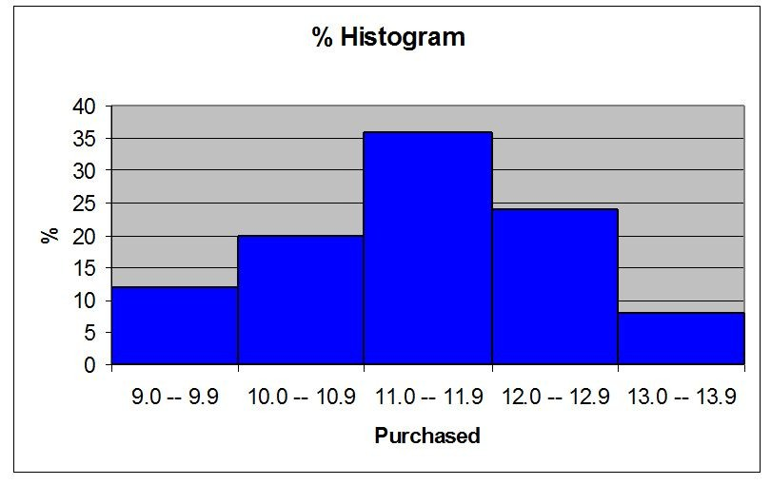
Difficulty: Moderate
Keywords: histogram, frequency distribution

165) Referring to Table 2-13, construct a cumulative percentage polygon for the detergent data if the corresponding frequency distribution uses "9.0 but less than 10.0" as the first class.
Answer:
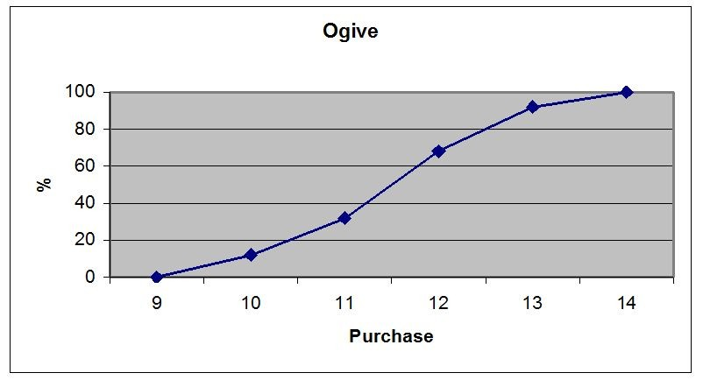
Difficulty: Moderate
Keywords: cumulative percentage polygon
166) Referring to Table 2-13, construct a percentage polygon for the detergent data if the corresponding frequency distribution uses "9.0 but less than 10.0" as the first class.
Answer:
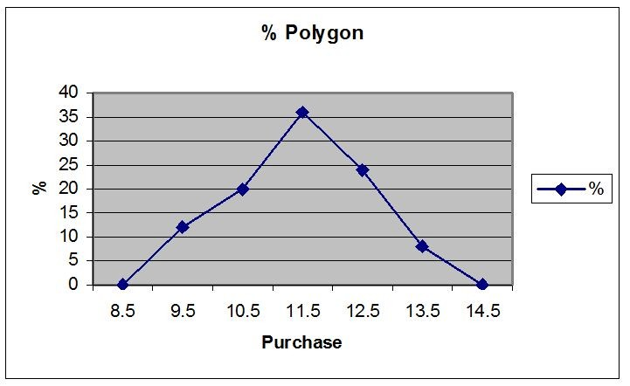
Difficulty: Moderate
Keywords: percentage distribution, percentage polygon

TABLE 2-14

The table below contains the number of people who own a portable DVD player in a sample of 600 broken down by gender.

Own a Portable
DVD Player Male Female
Yes 96 40
No 224 240

167) Referring to Table 2-14, construct a table of row percentages.
Answer:
Own | Male | Female | Total
Yes | 70.59% | 29.41% | 100.00%
No | 48.28% | 51.72% | 100.00%
Total | 53.33% | 46.67% | 100.00%

Difficulty: Easy
Keywords: row percentages
168) Referring to Table 2-14, construct a table of column percentages.
Answer:
Own | Male | Female | Total
Yes | 30.00% | 14.29% | 22.67%
No | 70.00% | 85.71% | 77.33%
Total | 100.00% | 100.00% | 100.00%

Difficulty: Easy
Keywords: column percentages

169) Referring to Table 2-14, construct a table of total percentages.
Answer:
Own | Male | Female | Total
Yes | 16.00% | 6.67% | 22.67%
No | 37.33% | 40.00% | 77.33%
Total | 53.33% | 46.67% | 100.00%

Difficulty: Easy
Keywords: total percentages

170) Referring to Table 2-14, of those who owned a portable DVD in the sample, ________ percent were females.
Answer: 29.41%
Difficulty: Moderate
Keywords: contingency table, row percentages

171) Referring to Table 2-14, of those who did not own a portable DVD in the sample, ________ percent were males.
Answer: 48.28%
Difficulty: Moderate
Keywords: contingency table, row percentages

172) Referring to Table 2-14, of the males in the sample, ________ percent owned a portable DVD.
Answer: 30%
Difficulty: Moderate
Keywords: contingency table, column percentages

173) Referring to Table 2-14, of the females in the sample, ________ percent did not own a portable DVD.
Answer: 85.71%
Difficulty: Moderate
Keywords: contingency table, column percentages
174) Referring to Table 2-14 of the females in the sample, ________ percent owned a portable DVD.
Answer: 14.29%
Difficulty: Moderate
Keywords: contingency table, column percentages

175) Referring to Table 2-14, ________ percent of the 600 were females who owned a portable DVD.
Answer: 6.67%
Difficulty: Moderate
Keywords: contingency table, total percentage

176) Referring to Table 2-14, ________ percent of the 600 were males who owned a portable DVD.
Answer: 16%
Difficulty: Moderate
Keywords: contingency table, total percentage

177) Referring to Table 2-14, ________ percent of the 600 were females who either owned or did not own a portable DVD.
Answer: 46.67%
Difficulty: Moderate
Keywords: contingency table, total percentage

178) Referring to Table 2-14, ________ percent of the 600 were males who did not own a portable DVD.
Answer: 37.33%
Difficulty: Moderate
Keywords: contingency table, total percentage

179) Referring to Table 2-14, ________ percent of the 600 owned a portable DVD.
Answer: 22.67%
Difficulty: Moderate
Keywords: contingency table, column percentages

180) Referring to Table 2-14, ________ percent of the 600 did not own a portable DVD.
Answer: 77.33%
Difficulty: Moderate
Keywords: contingency table, column percentages

181) Referring to Table 2-14, ________ percent of the 600 were females.
Answer: 46.67%
Difficulty: Easy
Keywords: contingency table, row percentages
182) Referring to Table 2-14, if the sample is a good representation of the population, we can expect ________ percent of the population will own a portable DVD.
Answer: 22.67%
Difficulty: Moderate
Keywords: contingency table, column percentages

183) Referring to Table 2-14, if the sample is a good representation of the population, we can expect ________ percent of the population will be males.
Answer: 53.33%
Difficulty: Moderate
Keywords: contingency table, column percentages

184) Referring to Table 2-14, if the sample is a good representation of the population, we can expect ________ percent of those who own a portable DVD in the population will be males.
Answer: 70.59%
Difficulty: Moderate
Keywords: contingency table, row percentages

185) Referring to Table 2-14, if the sample is a good representation of the population, we can expect ________ percent of the males in the population will own a portable DVD.
Answer: 30%
Difficulty: Moderate
Keywords: contingency table, column percentages

186) Referring to Table 2-14, if the sample is a good representation of the population, we can expect ________ percent of the females in the population will not own a portable DVD.
Answer: 85.71%
Difficulty: Moderate
Keywords: contingency table, column percentages
TABLE 2-15
The figure below is the ogive for the amount of fat (in grams) for a sample of 36 pizza products where the upper boundaries of the intervals are: 5, 10, 15, 20, 25, and 30.

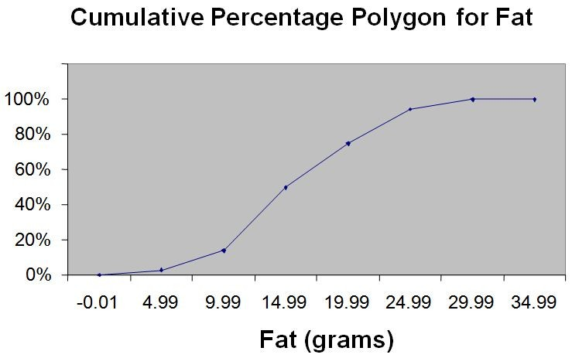
187) Referring to Table 2-15, roughly what percentage of pizza products contains less than 10 grams of fat?
A) 3%
B) 14%
C) 50%
D) 75%
Answer: B
Difficulty: Easy
Keywords: cumulative percentage polygon, ogive, interpretation

188) Referring to Table 2-15, what percentage of pizza products contains at least 20 grams of fat?
A) 5%
B) 25%
C) 75%
D) 96%
Answer: B
Difficulty: Easy
Keywords: cumulative percentage polygon, ogive, interpretation
189) Referring to Table 2-15, what percentage of pizza products contains between 10 and 25 grams of fat?
A) 14%
B) 44%
C) 62%
D) 81%
Answer: D
Difficulty: Easy
Keywords: cumulative percentage polygon, ogive, interpretation

TABLE 2-16

The figure below is the percentage polygon for the amount of calories for a sample of 36 pizzas products where the upper limits of the intervals are: 310, 340, 370, 400 and 430.

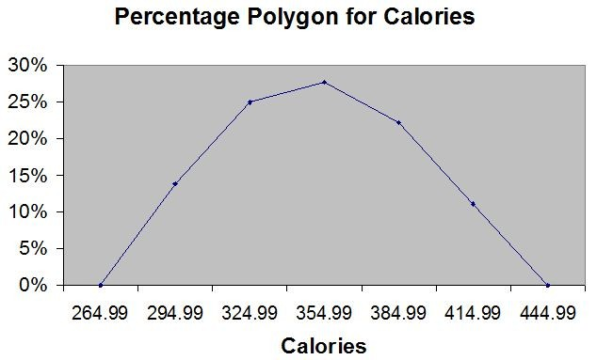

190) Referring to Table 2-16, roughly what percentage of pizza products contains between 400 and 430 calories?
A) 0%
B) 11%
C) 89%
D) 100%
Answer: B
Difficulty: Easy
Keywords: percentage polygon, interpretation
191) Referring to Table 2-16, roughly what percentage of pizza products contains between 340 and 400 calories?
A) 22%
B) 25%
C) 28%
D) 50%
Answer: D
Difficulty: Moderate
Keywords: percentage polygon, interpretation
192) Referring to Table 2-16, roughly what percentage of pizza products contains at least 340 calories?
A) 25%
B) 28%
C) 39%
D) 61%
Answer: D
Difficulty: Moderate
Keywords: percentage polygon, interpretation
TABLE 2-17

The following table presents total retail sales in millions of dollars for the leading apparel companies during April 2009 and April 2010.

APPAREL COMPANY | April 2009 | April 2010
Gap | 1,159.00 | 962
TJX | 781.7 | 899
Limited | 596.5 | 620.4
Kohl's | 544.9 | 678.9
Nordstrom | 402.6 | 418.3
Talbots | 139.9 | 130.1
Ann Taylor | 114.2 | 124.8

193) Referring to Table 2-17, construct a table of column percentages.
Answer:
APPAREL COMPANY | April 2009 | April 2010
Gap | 31.00% | 25.09%
TJX | 20.91% | 23.45%
Limited | 15.95% | 16.18%
Kohl's | 14.57% | 17.71%
Nordstrom | 10.77% | 10.91%
Talbots | 3.74% | 3.39%
Ann Taylor | 3.05% | 3.26%
Total | 100.00% | 100.00%

Difficulty: Moderate
Keywords: column percentages
194) Referring to Table 2-17, construct a side-by-side bar chart.
Answer:
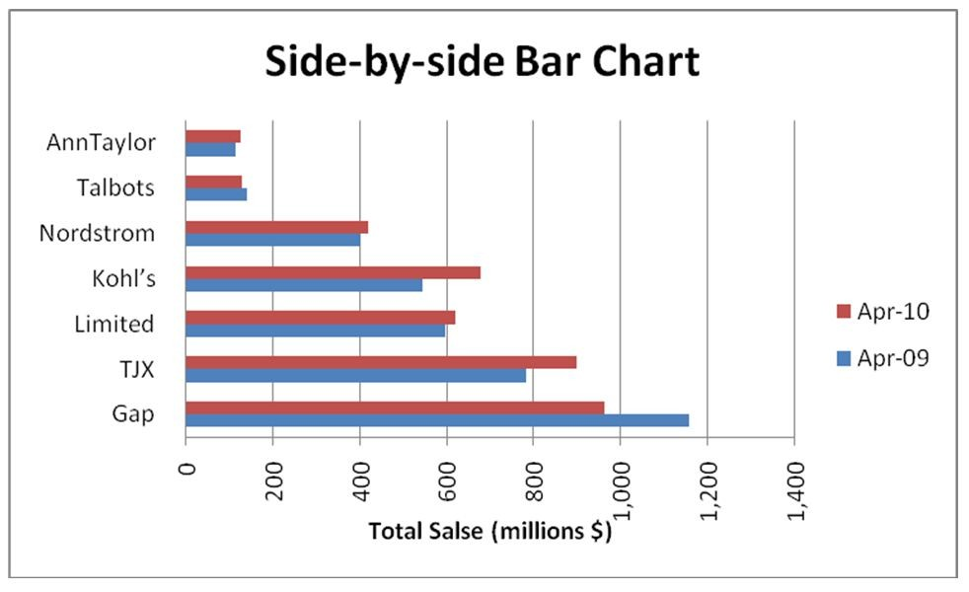
Difficulty: Moderate
Keywords: column percentages, side-by-side chart

195) Referring to Table 2-17, in general, retail sales for the apparel industry have seen a modest growth between April 2008 and April 2009.
Answer: TRUE
Difficulty: Easy
Keywords: column percentages, side-by-side chart, interpretation

196) Referring to Table 2-17, among the 8 stores, ________ saw a sales decline.
Answer: Gap and Talbots
Difficulty: Easy
Keywords: column percentages, side-by-side chart, interpretation
TABLE 2-18

The stem-and-leaf display below shows the result of a survey on 50 students on their satisfaction with their school with the higher scores represent higher level of satisfaction.

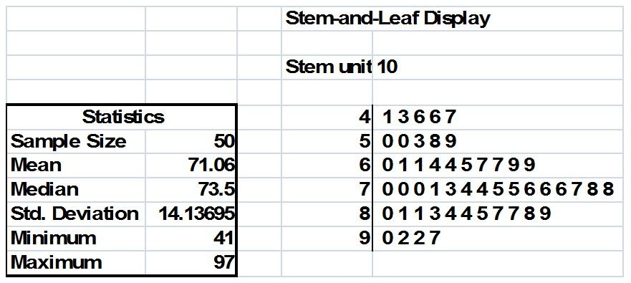

197) Referring to Table 2-18, what was the highest level of satisfaction?
Answer: 97
Difficulty: Easy
Keywords: stem-and-leaf display

198) Referring to Table 2-18, what was the lowest level of satisfaction?
Answer: 41
Difficulty: Easy
Keywords: stem-and-leaf display

199) Referring to Table 2-18, how many students have a satisfaction level in the 50s?
Answer: 5
Difficulty: Easy
Keywords: stem-and-leaf display

200) Referring to Table 2-18, how many students have a satisfaction level below 60?
Answer: 10
Difficulty: Easy
Keywords: stem-and-leaf display

201) Referring to Table 2-18, how many students have a satisfaction level of at least 80?
Answer: 15
Difficulty: Easy
Keywords: stem-and-leaf display

202) Referring to Table 2-18, the level of satisfaction is concentrated around 75.
Answer: TRUE
Difficulty: Easy
Keywords: stem-and-leaf display
203) Referring to Table 2-18, if a student is randomly selected, his/her most likely level of satisfaction will be in the 70s among the 40s, 50s, 60s, 70s, 80s and 90s.
Answer: TRUE
Difficulty: Easy
Keywords: stem-and-leaf display

204) Referring to Table 2-18, if a student is randomly selected, his/her most likely level of satisfaction will be in the 60s among the 40s, 50s, 60s, 70s, 80s and 90s.
Answer: FALSE
Difficulty: Easy
Keywords: stem-and-leaf display

205) Given below is the scatter plot of the price/earnings ratio versus earnings per share of 20 U.S. companies. There appears to be a negative relationship between price/earnings ratio and earnings per share.

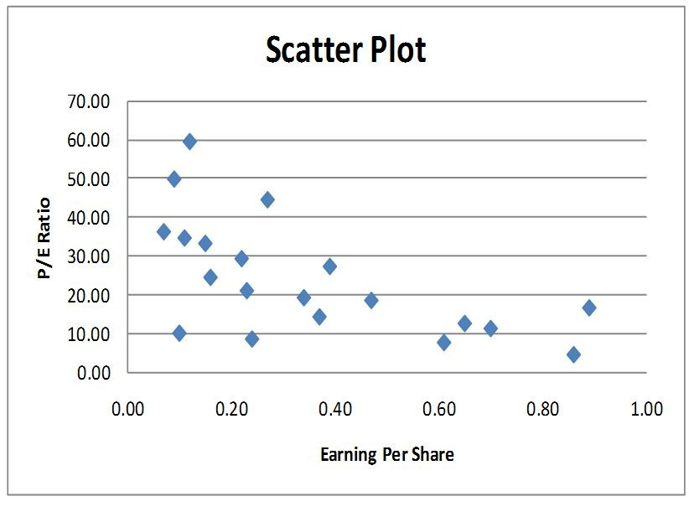
Answer: TRUE
Difficulty: Easy
Keywords: scatter plot
206) Given below is the scatter plot of the price/earnings ratio versus earnings per share of 20 U.S. companies. There appear to be a positive relationship between price/earnings ratio and earnings per share.
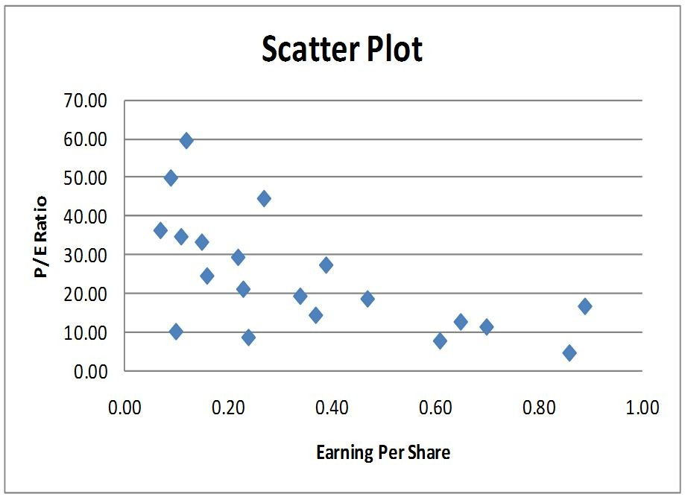
Answer: FALSE
Difficulty: Moderate
Keywords: scatter plot
207) Given below is the scatter plot of the market value (thousands$) and profit (thousands$) of 50 U.S. companies. Higher market values appear to be associated with higher profits.

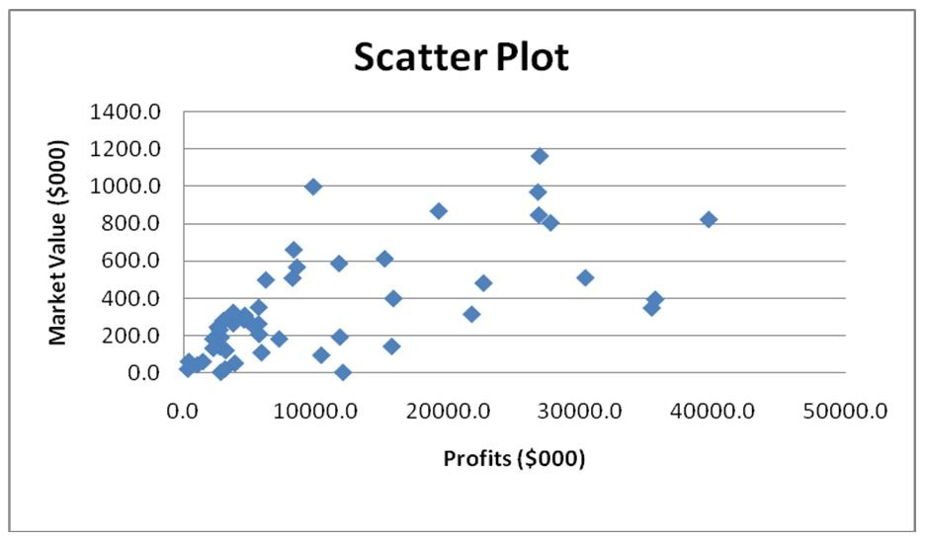
Answer: TRUE
Difficulty: Easy
Keywords: scatter plot
208) Given below is the scatter plot of the market value (thousands$) and profit (thousands$) of 50 U.S. companies. There appears to be a negative relationship between market value and profit.

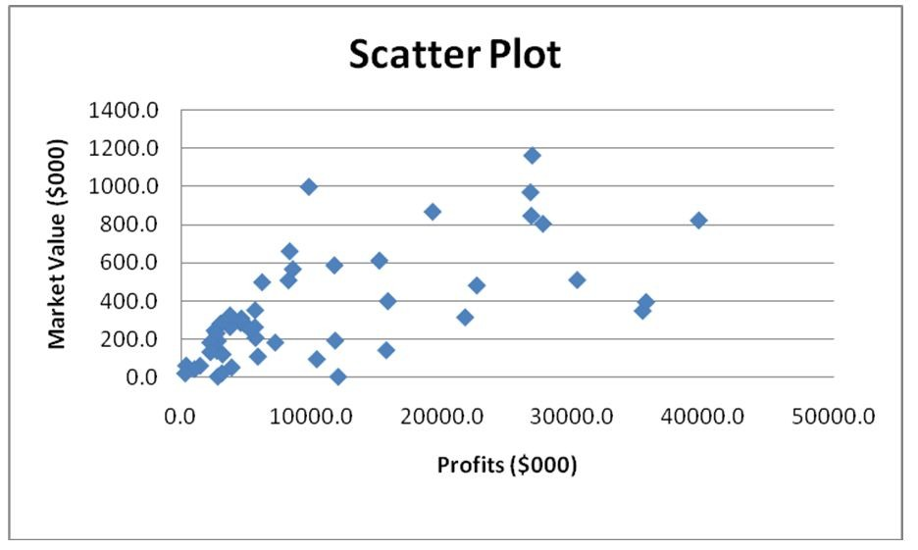
Answer: FALSE
Difficulty: Easy
Keywords: scatter plot
209) Given below is the scatter plot of the number of employees and the total revenue ($millions) of 20 U.S. companies. There appears to be a positive relationship between total revenue and the number of employees.
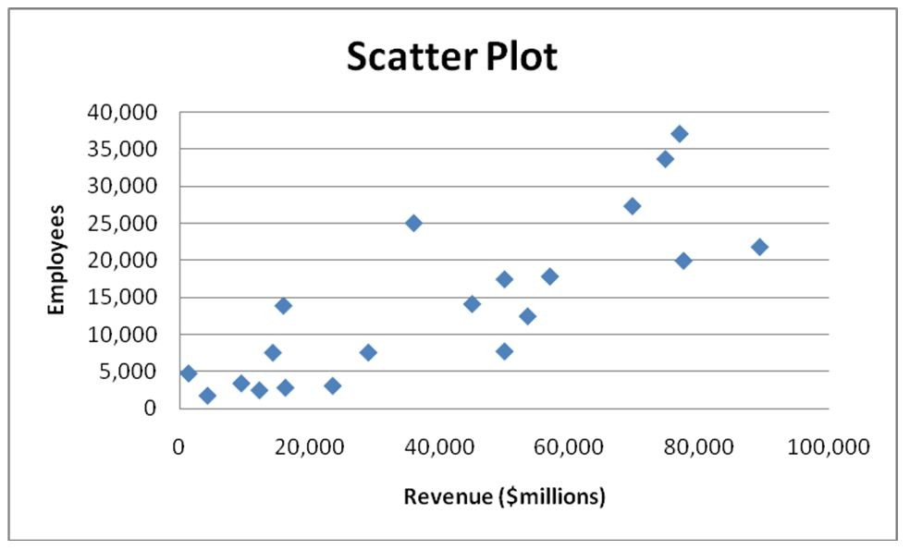
Answer: TRUE
Difficulty: Moderate
Keywords: scatter plot
210) Given below is the scatter plot of the number of employees and the total revenue ($millions) of 20 U.S. companies. Companies that have higher numbers of employees appear to also have higher total revenue.

Answer: TRUE
Difficulty: Moderate
Keywords: scatter plot

