***Organic Chemistry: A Learner-Centered Approach, 1e* (Mullins)**

**Chapter 2 General Chemistry Translated: Finding the Electrons**

1) Atoms with the same number of protons but different numbers of neutrons are called ________.

Answer: isotopes

Diff: 1

Section: 2.1

LO: G1 | 2.0.1

2) The atomic number of boron is 5. The correct electronic configuration of boron is:

A) 1s22s3

B) 1s22p3

C) 1s22s22p1

D) 2s22p3

E) 1s22s23s1

Answer: C

Diff: 1

Section: 2.2

LO: G1 | 2.0.1

3) How many distinct p orbitals exist in the second electron shell, where n = 2?

A) 2

B) 3

C) 4

D) 5

E) 6

Answer: B

Diff: 1

Section: 2.2

LO: G1 | 2.0.1

4) The ________ tells us that each orbital can hold a maximum of 2 electrons.

A) aufbau principle

B) Pauli exclusion principle

C) Hund's rule principle

D) LeChatelier principle

E) uncertainty principle

Answer: B

Diff: 1

Section: 2.2

LO: G1 | 2.0.4

5) A node is a region of high electron density between the two atoms in a covalent bond.

Answer: FALSE

Diff: 1

Section: 2.2

LO: G1 | 2.0.3

6) When filling two or more orbitals of the same energy with electrons, the electrons will go into different orbitals rather than pair up in the same orbital.

Answer: TRUE

Diff: 1

Section: 2.2

LO: G1 | 2.0.3

7) The electron density of ________ orbitals has spherical symmetry.

Answer: s

Diff: 1

Section: 2.2

G1 | 2.0.1 | 2.0.3

8) An oxygen atom has ________ valence electrons.

Answer: 6

Diff: 1

Section: 2.2

LO: G1 | 2.0.4

9) In a carbon atom, the 2s and 2p orbitals are the same energy.

Answer: FALSE

Diff: 2

Section: 2.2

LO: G1 | 2.0.3

10) The element with the electronic configuration 1s22s22p63s1 is ________.

Answer: sodium

Diff: 2

Section: 2.2

LO: G1 | 2.0.1

11) Provide the electron configuration of phosphorus.

Answer: 1s22s22p63s23p3

Diff: 2

Section: 2.2

LO: G1 | 2.0.1

12) A carbon-hydrogen bond in ethane (CH3CH3) is best described a ________.

A) highly polar

B) essentially nonpolar

C) ionic

D) a multiple bond

E) resonance stabilized

Answer: B

Diff: 1

Section: 2.3

LO: G2 | 2.1.5

MCAT LO: MCAT1.3

13) The electronegativity of elements on the periodic table increases going ________ a column and to the ________ in each row.

A) up; right

B) up; left

C) down; right

D) down; left

Answer: A

Diff: 1

Section: 2.3

LO: G1 | 2.1.4

MCAT LO: MCAT1.5

14) Which of the following molecules contains a polar covalent bond?

A) H2

B) F2

C) CH3Cl

D) NaCl

E) He

Answer: C

Diff: 1

Section: 2.3

LO: G2 | 2.1.5

MCAT LO: MCAT1.3

15) Covalent bonds may be polar or nonpolar. What property of the atoms forming a given bond determines this?

Answer: Electronegativity

Diff: 2

Section: 2.3

LO: G2 | 2.1.3

16) The compound methylamine, CH3NH2, contains a C-N bond. In this bond, which of the following best describes the charge on the carbon atom?

A) +1

B) slightly positive

C) neutral

D) slightly negative

E) -1

Answer: B

Diff: 3

Section: 2.3

LO: G2 | 2.1.2

MCAT LO: MCAT1.5

17) Provide a Lewis structure for a molecule with molecular formula CH2O2.

Answer:

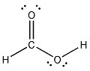

Diff: 2

Section: 2.4

LO: G2 | 2.2.2

GO: G2

MCAT LO: MCAT11.2

18) Write a Lewis structure for a compound with the molecular formula H2N2.

Answer:



Diff: 2

Section: 2.4

LO: G2 | 2.2.2

MCAT LO: MCAT1.2

19) The formal charge on oxygen in dimethyl ether, CH3OCH3, is ________.

A) +2

B) +1

C) 0

D) -1

E) -2

Answer: C

Diff: 1

Section: 2.4

LO: G4 | 2.2.3

MCAT LO: MCAT1.2

20) For most compounds in which a nitrogen atom bears no formal charge, the valence of this nitrogen atom is ________.

Answer: 3

Diff: 1

Section: 2.4

LO: G1 | 2.2.1

21) Assign the correct formal charge to each nitrogen atom in the following Lewis structure. (All non-bonding electrons are included.)



Answer:



Diff: 2

Section: 2.4

LO: G4 | 2.2.3

MCAT LO: MCAT1.2

22) Add the appropriate formal charge to each atom in the molecule below. It is not necessary to indicate formal charges when zero. (All non-bonding electrons are included.)

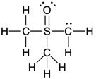

Answer:

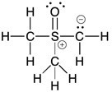

Diff: 2

Section: 1.7

LO: G4 | 2.2.3

MCAT LO: MCAT1.2

23) Add the appropriate formal charge to each atom in the molecule below. It is not necessary to indicate formal charges when zero. (All non-bonding electrons are included.)

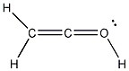

Answer:

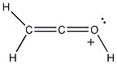

Diff: 2

Section: 2.4

LO: G4 | 2.2.3

MCAT LO: MCAT1.2

24) One or more of the atoms in the structure shown should have nonzero formal charges. Redraw the structure and the atoms with non-zero formal charges.

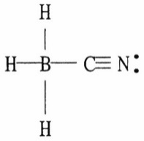

Answer:

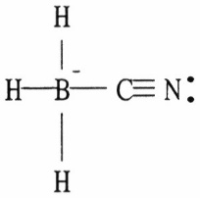

Diff: 2

Section: 2.4

LO: G4 | 2.2.3

MCAT LO: MCAT1.3

25) Which of the following are acceptable Lewis structures, including formal charges, for nitric acid, HNO3?

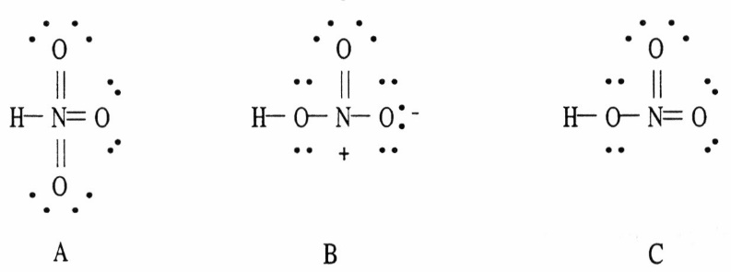

A) A only

B) B only

C) C only

D) both B and C

E) A, B, and C

Answer: B

Diff: 3

Section: 2.4

LO: G2 | 2.2.2 | 2.2.3

MCAT LO: MCAT1.3

26) A molecule of acetylene (C2H2) has a ________ geometry and a molecular dipole moment that is ________.

A) tetrahedral; nonzero

B) bent; nonzero

C) bent; zero

D) linear; nonzero

E) linear; zero

Answer: E

Diff: 1

Section: 2.5

LO: G2 | 2.3.1 | 2.3.2

MCAT LO: MCAT2.6

27) Which one of the molecules shown below has no net molecular dipole moment?

A) CH3Cl

B) H2CCH2

C) CH2O

D) CH2Cl2

E) CH3OH

Answer: B

Diff: 2

Section: 2.5

LO: G2 | 2.3.1 | 2.3.2

MCAT LO: MCAT2.6

28) Which one of the molecules shown below has a net molecular dipole moment?

A) CCl4

B) CO2

C) CH3CCl3

D) BeCl2

Answer: C

Diff: 2

Section: 2.5

LO: G2 | 2.3.2

MCAT LO: MCAT2.6

29) Does 1,1-dichloroethene (Cl2CCH2) have a net molecular dipole moment? If it does, draw the molecule and indicate the direction of this molecular dipole moment.

Answer: Net molecular dipole moment present.

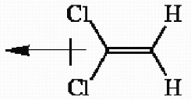

Diff: 2

Section: 2.1

LO: G2 | 2.3.2

MCAT LO: MCAT2.6

30) Draw the three-dimensional structure of chloroform (CHCl3) and show the direction of the molecular dipole moment.

Answer:

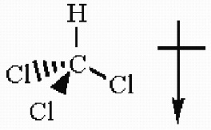

Diff: 2

Section: 2.5

LO: G2 | 2.3.2

MCAT LO: MCAT2.6

31) When a negatively charged species is most appropriately depicted as a hybrid of several resonance forms, the negative charge present is considered to be rapidly moving between the resonance forms bearing the formal negative charge.

Answer: FALSE

Diff: 1

Section: 2.8

LO: G1 | 2.6.4

MCAT LO: MCAT1.3

32) When a molecule can best be represented as a series of resonance forms, each of these forms always contributes to the same degree in the hybrid.

Answer: FALSE

Diff: 1

Section: 2.8

LO: G1 | 2.6.3

MCAT LO: MCAT1.3

33) Which of the following structures (a-d) is another resonance structure of the following organic molecule?

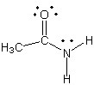

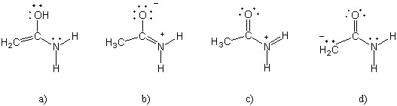

Answer: b

Diff: 2

Section: 2.8

LO: G2 | 2.6.2

MCAT LO: MCAT1.3

34) One resonance structure of a cation is shown. Provide the other reasonable resonance structures.

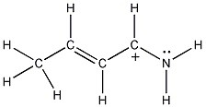

Answer:

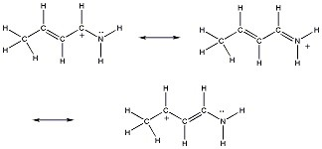

Diff: 2

Section: 2.8

LO: G2 | 2.6.2

MCAT LO: MCAT2.3

35) Draw additional resonance contributors for:

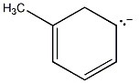

Answer:

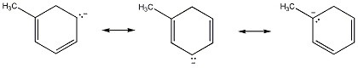

Diff: 2

Section: 2.8

LO: G2 | 2.6.2

MCAT LO: MCAT2.3

36) Which of the following choices represent(s) a pair of resonance forms?

A)

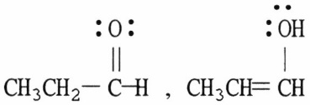

B)

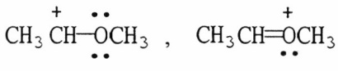

C)

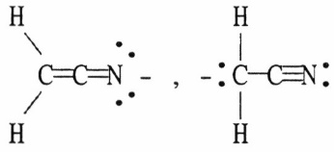

D) both A and C

E) both B and C

Answer: E

Diff: 3

Section: 2.8

LO: G2 | 2.6.2

MCAT LO: MCAT1.3

37) Structures ________, shown below, are resonance structures, and structure ________ is the major contributor to the overall resonance hybrid.

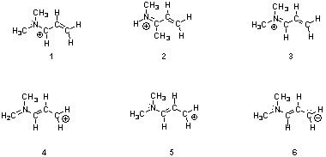

A) 2 & 4; 2

B) 1, 3 & 5; 3

C) 4 & 6; 6

D) 1, 3 & 5; 1

E) 1, 3, 4 & 5; 3

Answer: B

Diff: 3

Section: 2.8

LO: G2 | 2.6.3

MCAT LO: MCAT1.3

38) Nitroamines are common functional groups found in energetic materials, such as RDX and HMX. For the structure below, draw two other significant resonance structures, include any formal charges, and indicate the hybridization on each nitrogen and oxygen.



Answer: All nitrogen and oxygen atoms are sp2 hybridized.

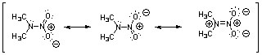

Diff: 3

Section: 2.8

LO: G2 | 2.6.2

GO: G5

MCAT LO: MCAT2.3

39) Draw the other important resonance form of:

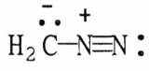

Answer:

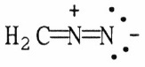

Diff: 3

Section: 2.8

LO: G2 | 2.6.2

MCAT LO: MCAT2.3

40) Draw the important resonance forms for the structure shown below.

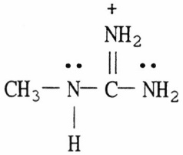

Answer:

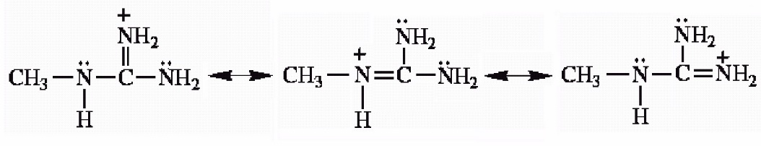

Diff: 3

Section: 2.8

LO: G2 | 2.6.3

MCAT LO: MCAT2.3

41) Draw the important resonance forms for the structure shown below.

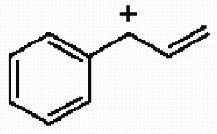

Answer:

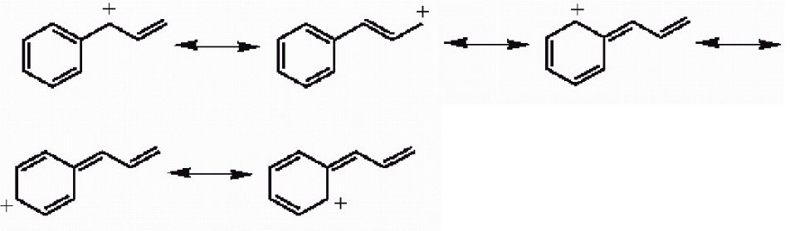

Diff: 3

Section: 2.8

LO: G2 | 2.6.2

MCAT LO: MCAT2.3

42) Draw 3 significant resonance structures for the compound shown below. Place a box around the major contributor. Fill in any missing formal charges.

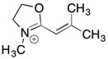

Answer:

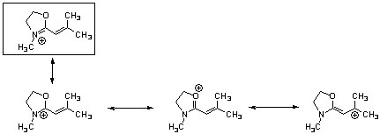

Diff: 3

Section: 2.8

LO: G2 | 2.6.2

MCAT LO: MCAT2.3