Essentials of Anatomy and Physiology, 9e (Marieb)

Chapter 1

The Human Body: An Orientation

Short Answer

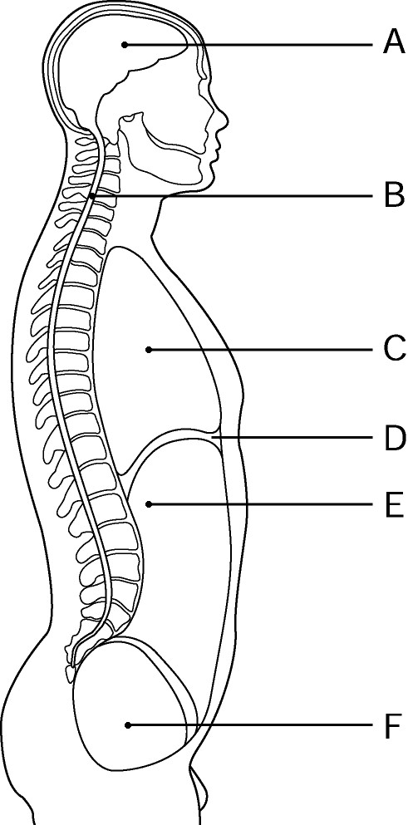
Figure 1.1

Using Figure 1.1, identify the following:

1)

Label A points to the __________ cavity.

Answer:

cranial

Diff: 1

Page Ref: 20

2)

Label B points to the __________ cavity.

Answer:

spinal

Diff: 1

Page Ref: 20

3)

Label C points to the __________ cavity.

Answer:

thoracic

Diff: 1

Page Ref: 20

4)

Label D points to the __________.

Answer:

diaphragm

Diff: 1

Page Ref: 20

5)

Label E points to the __________ cavity.

Answer:

abdominal

Diff: 1

Page Ref: 20

6)

Label F points to the __________ cavity.

Answer:

pelvic

Diff: 1

Page Ref: 20

Fill in the blank or provide a short answer:

7)

Groups of cells that have a common function are termed __________.

Answer:

tissues

Diff: 1

Page Ref: 4

8)

The larynx is an organ of the __________ system.

Answer:

respiratory

Diff: 1

Page Ref: 7

9)

The system that functions in the storage of minerals, such as calcium, is called the __________ system.

Answer:

skeletal

Diff: 1

Page Ref: 4

10)

The breakdown of ingested foods into simple molecules that can then be absorbed into the bloodstream is termed __________.

Answer:

digestion

Diff: 1

Page Ref: 11

11)

__________ refers to all of the chemical reactions in the body.

Answer:

Metabolism

Diff: 1

Page Ref: 11

12)

The ability to sense changes and react to them is termed __________ or __________.

Answer:

irritability; responsiveness

Diff: 1

Page Ref: 11

13)

The component of a control system that provides the means for the control center's response (output) is called the __________.

Answer:

effector

Diff: 1

Page Ref: 12-13

14)

The study of the body's small structures using a microscope is called __________.

Answer:

microscopic anatomy

Diff: 1

Page Ref: 2

15)

A control mechanism that responds to a stimulus by decreasing its intensity is called a __________ mechanism.

Answer:

negative feedback

Diff: 1

Page Ref: 13

16)

The body's ability to maintain stable internal conditions is referred to as __________.

Answer:

homeostasis

Diff: 1

Page Ref: 12

17)

The navel is __________ to the spine.

Answer:

ventral or anterior

Diff: 2

Page Ref: 18

18)

The armpit area is called the __________ region.

Answer:

axillary

Diff: 1

Page Ref: 16-17

19)

A cut that is made along the midline is called a __________ section.

Answer:

midsagittal or median

Diff: 1

Page Ref: 17

20)

The central region of the thoracic cavity containing the heart is called the __________.

Answer:

mediastinum

Diff: 1

Page Ref: 20

21)

The right and left iliac (inguinal) regions are lateral to the __________ region.

Answer:

hypogastric

Diff: 2

Page Ref: 22

22)

The cranial and spinal cavities are subdivisions of the __________ cavity.

Answer:

dorsal

Diff: 1

Page Ref: 20

23)

The __________ system is composed of kidneys, bladder, ureters, and urethra.

Answer:

urinary or excretory

Diff: 1

Page Ref: 7

24)

Blood is categorized as a __________ because it is compared of similar cells with a common function.

Answer:

tissue

Diff: 1

Page Ref: 4

25)

Ventral is a directional term synonymous with __________ in humans.

Answer:

anterior

Diff: 1

Page Ref: 18

26)

The three medial regions of the abdominopelvic cavity are __________, __________, and __________.

Answer:

epigastric region, umbilical region, hypogastric region

Diff: 1

Page Ref: 21

27)

The function of the __________ system is to control body activities via hormones.

Answer:

endocrine

Diff: 1

Page Ref: 5; 7

28)

__________ is the process of breaking down ingested food in preparation for absorption.

Answer:

Digestion

Diff: 1

Page Ref: 11

29)

Blood clotting and the birth of a baby are examples of the __________ feedback mechanism.

Answer:

positive

Diff: 1

Page Ref: 13

30)

The patellar region is __________ to the popliteal region.

Answer:

ventral or anterior

Diff: 1

Page Ref: 16

31)

The abdominal cavity has __________ quadrants and __________ regions.

Answer:

4; 9

Diff: 2

Page Ref: 21

32)

The thoracic cavity is __________ to the abdominopelvic cavity.

Answer:

superior

Diff: 1

Page Ref: 20

33)

The epigastric region is __________ to the right hypochondriac region of the abdominopelvic cavity.

Answer:

medial

Diff: 2

Page Ref: 21

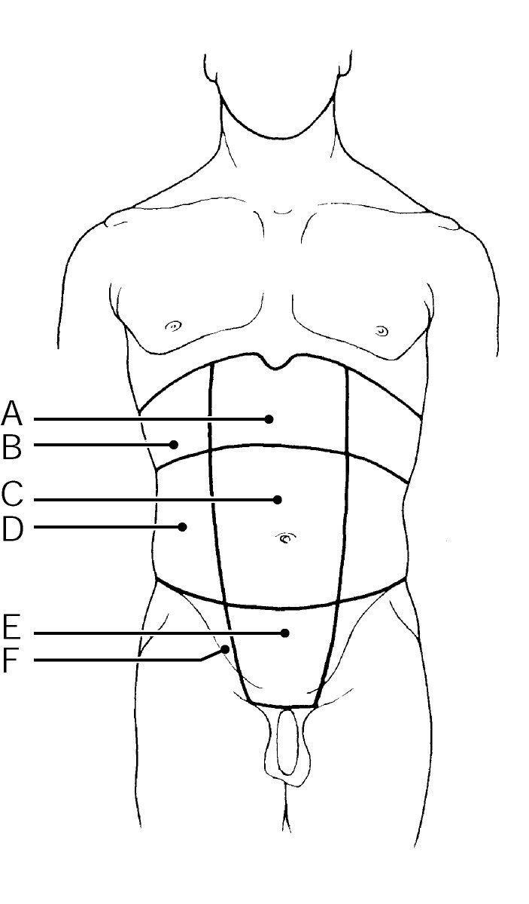
Figure 1.2

Using Figure 1.2, identify the following:

34)

Label A points to the __________ region.

Answer:

epigastric

Diff: 1

Page Ref: 21

35)

Label B points to the __________ region.

Answer:

right hypochondriac

Diff: 1

Page Ref: 21

36)

Label C points to the __________ region.

Answer:

umbilical

Diff: 1

Page Ref: 21

37)

Label D points to the __________ region.

Answer:

right lumbar

Diff: 1

Page Ref: 21

38)

Label E points to the __________ region.

Answer:

hypogastric

Diff: 1

Page Ref: 21

39)

Label F points to the __________ region.

Answer:

right iliac (inguinal)

Diff: 1

Page Ref: 21

Multiple Choice

1)

The study of the function of the body and body parts is called:

A)

anatomy

B)

physiology

C)

homeostasis

D)

negative feedback

E)

irritability

Answer:

B

Diff: 1

Page Ref: 2

2)

Which of the following activities does not represent an anatomical study:

A)

making a section through the heart to observe its interior

B)

examining the surface of a bone

C)

viewing muscle tissue through a microscope

D)

studying how the nerves conduct electrical impulses

E)

observing the parts of a reproducing cell

Answer:

D

Diff: 2

Page Ref: 2

3)

Which of the following is the correct sequence, going from simplest to most complex, in the levels of structural organization of the human body:

A)

chemical level, cellular level, tissue level, organ level, organ system level, organismal level

B)

chemical level, tissue level, cellular level, organ system level, organ level, organismal level

C)

cellular level, chemical level, tissue level, organ level, organ system level, organismal level

D)

cellular level, tissue level, chemical level, organ level, organ system level, organismal level

E)

cellular level, chemical level, tissue level, organ system level, organismal level, organ level

Answer:

A

Diff: 3

Page Ref: 3-4

4)

Which of these structures is the most complex:

A)

an organ

B)

a tissue

C)

a molecule

D)

organ system

E)

a cell

Answer:

D

Diff: 2

Page Ref: 3-4

5)

The lymphatic system:

A)

responds to internal and external changes by activating appropriate muscles and glands

B)

picks up fluid leaked from blood vessels and returns it to the blood

C)

synthesizes vitamin D

D)

produces heat

E)

secretes hormones that regulate processes such as growth, reproduction, and nutrient use (metabolism) by body cells

Answer:

B

Diff: 2

Page Ref: 7

6)

The system that takes in oxygen and releases carbon dioxide to the exterior is the:

A)

respiratory system

B)

cardiovascular system

C)

reproductive system

D)

muscular system

E)

urinary system

Answer:

A

Diff: 2

Page Ref: 7

7)

The system that controls and coordinates the body through hormones is the:

A)

integumentary system

B)

skeletal system

C)

nervous system

D)

endocrine system

E)

digestive system

Answer:

D

Diff: 2

Page Ref: 7

8)

The muscular system consists of the:

A)

skeletal muscles

B)

muscles of the heart

C)

muscles in the walls of hollow organs

D)

skeletal muscles and the muscles of the heart

E)

muscles of the heart and those in the walls of the hollow organs

Answer:

A

Diff: 1

Page Ref: 4

9)

The ovary is part of which of the following two systems:

A)

digestive and endocrine systems

B)

digestive and respiratory systems

C)

reproductive and endocrine systems

D)

reproductive and respiratory systems

E)

endocrine and respiratory systems

Answer:

C

Diff: 2

Page Ref: 7

10)

Which system covers the external surface of the body and manufactures vitamin D:

A)

endocrine system

B)

integumentary system

C)

nervous system

D)

lymphatic system

E)

skeletal system

Answer:

B

Diff: 2

Page Ref: 4; 5

11)

Elimination of metabolic wastes from the body is the function of the:

A)

digestive system

B)

urinary system

C)

respiratory system

D)

digestive and urinary systems

E)

digestive and respiratory systems

Answer:

B

Diff: 3

Page Ref: 7

12)

Which of the following is NOT a necessary life function:

A)

maintaining boundaries

B)

movement

C)

responsiveness

D)

nutrients

E)

metabolism

Answer:

D

Diff: 2

Page Ref: 10-11

13)

Which of the following systems is matched most accurately to the life function it provides:

A)

integumentary system - movement

B)

nervous system - excretion

C)

muscular system - maintaining boundaries

D)

nervous system - responsiveness

E)

respiratory system - digestion

Answer:

D

Diff: 1

Page Ref: 4-7

14)

Which of these is NOT a survival need:

A)

nutrients

B)

oxygen

C)

water

D)

reproduction

E)

body temperature

Answer:

D

Diff: 2

Page Ref: 11-12

15)

Which of the following is the correct order of elements in a control system:

A)

receptor, stimulus, afferent pathway, control center, efferent pathway, effector, response

B)

receptor, stimulus, efferent pathway, control center, afferent pathway, effector, response

C)

effector, stimulus, efferent pathway, control center, afferent pathway, receptor, response

D)

stimulus, receptor, afferent pathway, control center, efferent pathway, effector, response

E)

stimulus, receptor, efferent pathway, control center, afferent pathway, effector, response

Answer:

D

Diff: 3

Page Ref: 12-13

16)

Which of the following elements of a control system detects a change:

A)

control center

B)

stimulus

C)

effector

D)

receptor

E)

efferent pathway

Answer:

D

Diff: 1

Page Ref: 12

17)

Positive feedback systems:

A)

regulate heart and breathing rates

B)

operate in such a way that the initial stimulus is enhanced and increases

C)

operate in such a way that the initial stimulus is shut off or reduced

D)

regulate heart and breathing rates, and operate in such a way that the initial stimulus is enhanced and increases

E)

regulate heart and breathing rates, and operate in such a way that the initial stimulus is shut off or reduced

Answer:

B

Diff: 2

Page Ref: 13

18)

Your body thermostat is located in a part of the brain called the hypothalamus. Which of the following elements of a control system does this area in the brain represent:

A)

control center

B)

stimulus

C)

effector

D)

efferent pathway

E)

afferent pathway

Answer:

A

Diff: 2

Page Ref: 12

19)

In anatomical position:

A)

the body is erect with the feet parallel and the arms hanging at the sides with the palms facing backward

B)

the body is erect with the feet parallel and the arms hanging at the sides with the palms facing forward

C)

the body is lying face up with the feet parallel and the arms at the sides with the palms facing backward

D)

the body is lying face down with the feet parallel and the arms at the sides with the palms facing backward

E)

the body is lying face up with the feet parallel and the arms at the sides with the palms facing forward

Answer:

B

Diff: 1

Page Ref: 15

20)

Which of the following orientation and directional terms have the same meaning (in humans):

A)

superior and caudal

B)

inferior and cranial

C)

inferior and cephalad

D)

anterior and ventral

E)

anterior and dorsal

Answer:

D

Diff: 2

Page Ref: 18

21)

Which of the following orientation terms have opposite meanings (in humans):

A)

superficial and proximal

B)

distal and proximal

C)

medial and distal

D)

medial and anterior

E)

posterior and intermediate

Answer:

B

Diff: 2

Page Ref: 18

22)

Which of the following regional terms means the anterior surface of the elbow:

A)

calcaneal region

B)

scapular region

C)

gluteal region

D)

vertebral region

E)

antecubital region

Answer:

E

Diff: 2

Page Ref: 16

23)

Sarah fell while ice skating and broke a bone in her carpal region. Where is this region?

A)

hip

B)

lower leg

C)

wrist

D)

shoulder

E)

knee

Answer:

C

Diff: 2

Page Ref: 16-17

24)

In describing the relationship between the patellar and popliteal regions:

A)

the patellar region is superior to the popliteal region

B)

the patellar region is proximal to the popliteal region

C)

the patellar region is distal to the popliteal region

D)

the patellar region is lateral to the popliteal region

E)

the patellar region is anterior to the popliteal region

Answer:

E

Diff: 3

Page Ref: 16-17

25)

In describing the relationship of the thoracic and spinal cavities:

A)

the thoracic cavity is superior to the spinal cavity

B)

the thoracic cavity is inferior to the spinal cavity

C)

the thoracic cavity is proximal to the spinal cavity

D)

the thoracic cavity is medial to the spinal cavity

E)

the thoracic cavity is ventral to the spinal cavity

Answer:

E

Diff: 3

Page Ref: 20

26)

The lungs and heart are in the __________ body cavity.

A)

dorsal

B)

spinal

C)

thoracic

D)

cranial

E)

abdominopelvic

Answer:

C

Diff: 1

Page Ref: 20

27)

The gluteal region is the:

A)

buttock

B)

shoulder blade region

C)

posterior knee area

D)

posterior surface of the head

E)

curve of the shoulder

Answer:

A

Diff: 1

Page Ref: 16-17

28)

The region that contains the navel is the:

A)

carpal region

B)

umbilical region

C)

inguinal region

D)

orbital region

E)

anterior knee

Answer:

B

Diff: 1

Page Ref: 16-17; 21-22

29)

The dorsal body cavity houses the:

A)

urinary and reproductive organs

B)

heart and lungs

C)

digestive and reproductive organs

D)

tongue

E)

spinal cord and brain

Answer:

E

Diff: 2

Page Ref: 20

30)

Which of these regions are associated with the parts of the arm:

A)

femoral, popliteal, patellar

B)

brachial, antecubital, carpal

C)

nasal, oral, occipital

D)

acromial, sacral, gluteal

E)

pelvic, pubic, inguinal

Answer:

B

Diff: 2

Page Ref: 16-17

31)

Which of these regions are NOT associated with the ventral (anterior) portion of the head:

A)

buccal

B)

oral

C)

orbital

D)

occiptal

E)

nasal

Answer:

D

Diff: 2

Page Ref: 16-17

32)

A section that divides the body on the longitudinal plane into equal right and left parts is called:

A)

median (midsagittal)

B)

frontal

C)

transverse

D)

oblique

E)

coronal

Answer:

A

Diff: 1

Page Ref: 17; 19

33)

Which type of section could be used to separate the thoracic cavity from the abdominopelvic cavity:

A)

coronal

B)

sagittal

C)

dorsal

D)

ventral

E)

transverse

Answer:

E

Diff: 1

Page Ref: 17; 19

34)

Which ventral cavity subdivision has no bony protection:

A)

thoracic

B)

pelvic

C)

abdominal

D)

cranial

E)

spinal

Answer:

C

Diff: 2

Page Ref: 20

35)

Which of these regions in the abdominopelvic cavity are medial:

A)

umbilical, right lumbar, and left lumbar regions

B)

epigastric, umbilical, and hypogastric regions

C)

iliac (inguinal), lumbar, and hypogastric regions

D)

epigastric, right, and left hypochondriac regions

E)

right and left iliac (inguinal), and hypogastric regions

Answer:

B

Diff: 3

Page Ref: 21; 22

36)

The stomach, liver, intestines, bladder, rectum, and reproductive organs are housed in the:

A)

cranial cavity

B)

spinal cavity

C)

dorsal cavity

D)

abdominopelvic cavity

E)

thoracic cavity

Answer:

D

Diff: 2

Page Ref: 20

37)

The ribs are located in the:

A)

right and left iliac regions

B)

right and left lumbar regions

C)

right and left pubic regions

D)

right and left hypochondriac regions

E)

right and left inguinal regions

Answer:

D

Diff: 2

Page Ref: 21; 22

38)

Which of the following statements is correct regarding the location of the spleen and stomach:

A)

both of these organs are located in the left upper quadrant

B)

both of these organs are located in the right upper quadrant

C)

the spleen is located in the left upper quadrant and the stomach is located in the right upper quadrant

D)

the spleen is located in the right upper quadrant and the stomach is located in the left upper quadrant

E)

both of these organs are located medially

Answer:

A

Diff: 3

Page Ref: 21

True/False

1)

The highest level of structural organization in humans is the organ level.

Answer:

FALSE

Diff: 1

Page Ref: 3-4

2)

The endocrine system is the fast-acting body control system.

Answer:

FALSE

Diff: 1

Page Ref: 4; 7

3)

The spleen and the tonsils are part of the digestive system.

Answer:

FALSE

Diff: 2

Page Ref: 7

4)

The lymphatic system collects fluids leaked by the cardiovascular system and returns them to the bloodstream.

Answer:

TRUE

Diff: 1

Page Ref: 7

5)

Excretion is the process of removing wastes from the body.

Answer:

TRUE

Diff: 1

Page Ref: 11

6)

Most homeostatic control mechanisms are negative feedback reactions.

Answer:

TRUE

Diff: 2

Page Ref: 12

7)

As body temperature drops below normal, chemical reactions proceed too rapidly and body proteins begin to break down.

Answer:

FALSE

Diff: 2

Page Ref: 12

8)

The sacral region is on the ventral (anterior) body surface.

Answer:

FALSE

Diff: 1

Page Ref: 16-17

9)

The heel of the foot constitutes the plantar region.

Answer:

FALSE

Diff: 1

Page Ref: 16-17

10)

Proximal means farther from the origin of a body part.

Answer:

FALSE

Diff: 2

Page Ref: 18

11)

The hypogastric region is directly superior to the umbilical region.

Answer:

FALSE

Diff: 2

Page Ref: 21-22

12)

The thoracic cavity is separated from the abdominopelvic cavity by the diaphragm.

Answer:

TRUE

Diff: 2

Page Ref: 20

13)

The spinal cavity is part of the ventral body cavity.

Answer:

FALSE

Diff: 2

Page Ref: 20

14)

The dorsal body cavity is subdivided into four quadrants and nine regions.

Answer:

FALSE

Diff: 2

Page Ref: 20-22

15)

There is no physical structure that separates the abdominal cavity from the pelvic cavity.

Answer:

TRUE

Diff: 2

Page Ref: 20

Matching

Match the following:

1)

Inferior
A)
toward the midline

Diff: 1

Page Ref: 18
B)
toward the side

2)

Dorsal
C)
close to the origin of the body part or the point of attachment of a limb to the body trunk

Diff: 1

Page Ref: 18

3)

Lateral

Diff: 1

Page Ref: 18
D)
below

4)

Deep
E)
in front of

Diff: 2

Page Ref: 18

5)

Distal
F)
farther from the origin of a body part or the point of attachment of a limb to the body trunk

Diff: 3

Page Ref: 18

6)

Medial
G)
away from the body surface

Diff: 1

Page Ref: 18

7)

Superior
H)
toward the body surface

Diff: 1

Page Ref: 18
I)
above

8)

Proximal
J)
behind

Diff: 2

Page Ref: 18

9)

Ventral

Diff: 1

Page Ref: 18

1)

D
2)
J
3)
B
4)
G
5)
F
6)
A

7)

I
8)
C
9)
E

Match the following:

10)

Axillary
A)
thigh

Diff: 1

Page Ref: 16-17
B)
anterior knee

11)

Tarsal
C)
navel

Diff: 1

Page Ref: 16-17

12)

Coxal
D)
area where thigh meets body trunk

Diff: 2

Page Ref: 16-17

13)

Orbital
E)
mouth

Diff: 2

Page Ref: 16-17
F)
hip

14)

Inguinal
G)
armpit

Diff: 2

Page Ref: 16-17

15)

Umbilical
H)
eye area

Diff: 1

Page Ref: 16-17
I)
ankle

16)

Oral
J)
posterior knee area

Diff: 1

Page Ref: 16-17

17)

Femoral

Diff: 1

Page Ref: 16-17

18)

Patellar

Diff: 1

Page Ref: 16-17

19)

Popliteal

Diff: 1

Page Ref: 16-17

10)

G
11)
I
12)
F
13)
H
14)
D
15)
C

16)

E
17)
A
18)
B
19)
J

Match the following.

20)

Slow-acting body control system
A)
skeletal system

Diff: 1

Page Ref: 4-7
B)
muscular system

21)

Houses blood cells involved in immunity
C)
urinary system

Diff: 1

Page Ref: 4-7
D)
endocrine system

22)

Site of hematopoiesis
E)
lymphatic system

Diff: 1

Page Ref: 4-7
F)
nervous system

23)

Regulation of water and electrolytes
G)
digestive system

Diff: 1

Page Ref: 4-7
H)
respiratory system

24)

Heat production

Diff: 1

Page Ref: 4-7

25)

Responds to stimuli (internal and external)

Diff: 1

Page Ref: 4-7

20)

D
21)
E
22)
A
23)
C
24)
B
25)
F

Essay

1)

Distinguish between anatomy and physiology.

Answer:

Anatomy is the study of the structure and shape of the body and body parts, and their relationships to one another. Physiology is the study of how the body and its parts work or function.

Diff: 1

Page Ref: 2

2)

List, and briefly define, the human body's organization levels from smallest to largest.

Answer:

1. chemical level:
a. atoms are the basic building blocks of matter
b. molecules are units formed by atoms combining

2. cellular level: cells are the smallest living unit in living organisms

3. tissue level: tissues are groupings of cells performing a common function

4. organ level: an organ is a structure consisting of two or more tissue types

5. organ system level: an organ system describes a group of organs functioning
cooperatively for a common purpose

6. organism level: a human organism consists of all of the organ systems of the
body working together to promote healthy functioning
(homeostasis)

Diff: 1

Page Ref: 3-4

3)

List and explain the eight necessary human life functions.

Answer:

1. Maintenance of boundaries—keeps the internal environment distinct from the external environment; membranes perform this function at the cellular level and skin performs this function for the organism.
2. Movement—includes a change in the position of the body or the propelling of a substance (such as blood, urine, or food) through the body organs; constitutes a major role of the muscular system.
3. Responsiveness (irritability)—the ability to react to stimuli; constitutes a major role of the nervous system.
4. Metabolism—includes all the chemical reactions that occur within the body's cells.
5. Excretion—elimination of carbon dioxide by the lungs and nitrogenous wastes by the kidneys.
6. Digestion—the process of breaking down ingested foodstuffs into simpler molecules that can then be absorbed into the blood for delivery to the body's cells.
7. Growth—an increase in size, which is usually accompanied by an increase in the number of cells.
8. Reproduction—the production of new cells for growth and repair, and also the production of offspring.

Diff: 3

Page Ref: 10-11

4)

List and explain the five survival needs of humans.

Answer:

1. Nutrients—include carbohydrates, proteins, and fats, which are taken in via the diet for energy and cell building.
2. Oxygen—required to release energy from food.
3. Water—accounts for over 60% of the body weight, and provides the basis for various body fluids.
4. Appropriate body temperature—when too high or too low, physiological activities cease, primarily because molecules are destroyed or become nonfunctional.
5. Appropriate atmospheric pressure—the force exerted on the surface of the body by the weight of air; is essential for normal operation of the respiratory system and breathing.

Diff: 3

Page Ref: 11-12

5)

List and explain the three major body planes and sections.

Answer:

1. Sagittal—cut is made along the longitudinal (lengthwise) plane of the body (or an organ), dividing it into right and left parts.
2. Frontal (coronal)—cut is made along the longitudinal (lengthwise) plane of the body (or an organ), dividing it into anterior and posterior parts.
3. Transverse (cross-section)—cut is made along the transverse (horizontal) plane, dividing the body into superior and inferior parts.

Diff: 2

Page Ref: 17; 19

6)

Identify the two dorsal body cavities, and state their locations and the organs contained therein.

Answer:

1. Cranial cavity—the superior posterior space inside the bony skull that houses the brain.
2. Spinal cavity—the inferior posterior space inside the bony vertebral column that houses the spinal cord.

Diff: 2

Page Ref: 22

7)

List the four quadrants and nine regions of the abdominopelvic cavity. Explain why this cavity has these subdivisions.

Answer:

1. The four quadrants are:
a. right upper quadrant
b. right lower quadrant
c. left upper quadrant
d. right lower quadrant
2. The nine regions are:
a. epigastric region
b. umbilical region
c. hypogastric region
d. right hypochondriac region
e. left hypochondriac region
f. right lumbar region
g. left lumbar region
h. right iliac region
i. left iliac region
This cavity has been subdivided into these quadrants and regions because it is large and has many organs.

Diff: 2

Page Ref: 20-22

8)

Explain how scratching an itch is an example of the negative feedback mechanism.

Answer:

1. Stimulus or input is the itch.
2. A receptor carries the information about the stimulus (itch) to the brain via an afferent pathway.
3. Control center (brain) analyzes this information an turns on an effector which will cancel the stimulus.
4. Information reaches the effector via the efferent pathway from the brain. Muscles move the hand to scratch the itch.
5. Scratching continues until the itch goes away. The brain shuts off the effector once homeostatis is restored.

Diff: 3

Page Ref: 12-13

9)

Explain the difference between homeostatis and metabolism.

Answer:

Homeostasis is the body's attempt to maintain balance during which time internal conditions may vary. Metabolism is all chemical reactions that occur in the body.

Diff: 2

Page Ref: 11-12

10)

Describe anatomical position. Explain why anatomical position is used.

Answer:

Anatomical position is defined as standing erect, feet parallel to the arms, palms facing forward. Anatomical position is used because it is a standard position; it also helps us to avoid confusion. Additionally, anatomical position is a reference point that helps us accurately describe body parts and position.

Diff: 2

Page Ref: 15

11)

Describe the role of the effector in the negative feedback system.

Answer:

The effector is the control center's output and response to the stimulus. The effector's job is to cancel or shut off the control mechanism.

Diff: 1

Page Ref: 12-13

