Problem 1.1:

The following lists are representative, but not exhaustive.

Asphalt for road paving: Cost is a very significant factor because of the amount of roadways. Material must have sufficient compressive strength to withstand loaded tractor trailers, low enough coefficient of thermal expansion to survive temperature variations, sufficient hardness not to abrade easily, viscosity enough to be spread on new roads without flowing away, isotropic properties, etc.

Brake pads for a car: Cost is a factor, but performance is essential. The material must have sufficient hardness that it does not abrade easily. It must have sufficient thermal stability to maintain properties at high temperatures and it must be moldable to fit in the assembly.

Wings on an aircraft: Cost is secondary to performance, though it is always a factor. The material must have sufficient tensile and compressive strength to withstand the stresses associated with takeoff and landing. The material must be lightweight and have exceptional fatigue properties to withstand multiple cycles.

Piping in a house: Cost is significant. The material must be rigid, inert in water, not allow toxic materials to leach into the water, capable of being shaped into pipes, elbows, and other shapes. It must be capable of having different pieces fused together in water-tight blends. It must have sufficient toughness to withstand minor impact.

Problem 1.2:

The following lists are representative, but not exhaustive:

- Bicycle Frames: The material must be lightweight, strong enough in tension and compression to withstand the weight of the rider and stresses from bumps, etc. It must be rigid and tough enough to resist views. The role of economics varies. Frames for children’s bicycles must be inexpensive, but those for high-end racing bikes are often far more expensive (including the one of the cover of the book).

- Tires for Nascar Cars: Cost is far less important than performance. The material must resist high temperatures and have sufficient hardness to resist abrasion, even at elevated temperatures. Durability is a major issue because fewer tire changes lead to less time in the pits.

- Synthetic Leather for Briefcases: Cost is a dominant factor because if the synthetic was more expensive than real leather, there would be no point. It must be easily shaped, look like leather (more or less), be hard enough to resist penetration by static forces, easily dyed, and durable enough to retain its properties over time.

- Scissors: Cost is very important as the item must sell for little money. The handles must be comfortable and smooth. The blades must be capable of holding a sharp age. They must resist rusting and be capable of being shaped into a mold and riveted together. Toughness and hardness are also factors.

Problem 1.3

Vinyl records needed a material that could be easily mass-produced and was capable of holding the small groves that provided the sound. Vinyl records were petroleum based. Cost was a major factor. They tended to retain their shape indefinitely, but would melt if temperatures elevated (like when locked in a hot car in the summer). They were somewhat brittle and tended to warp over time and develop skips and bumps. The movement to CDs resulted in a complete conceptual shift. The new materials needed to be inexpensive and easy to mass produce, but now the optical properties of the active side became of paramount importance.

Problem 1.4

Factors to consider include:

1 – How long will the plant operate in the current fashion? There is no point in purchasing 6-year valves if the process is slated to run for just two years.

2 – How stable are the prices? Might the stainless steel valves be much cheaper in the future? This is a particular concern with electronics.

3 – Are there other performance differences to worry about?

4 – Can we afford the more expensive valves?

5 – What is a reasonable rate-of-return on the extra cost?
Problem 1.5:

- Carbon-Oxygen in primarily covalent
- Sodium – potassium is metallic
- Silicon – carbon is primarily covalent
- Potassium – chlorine is primarily ionic

Problem 1.6:

Valence electrons are in the outermost energy levels and are the first to react with each other and with the nuclei of nearby atoms.

Problem 1.7:

Primary bonding are relatively high-energy interactions between atoms and include ionic, metallic, and covalent bonds. Secondary bonds tend to be less strong individually and include hydrogen bonds (attractions between hydrogen and highly electronegative materials such as fluorine), dipole interactions (electrostatic interactions caused by alignment of charges), and van der Waals forces (temporary attractions caused by the momentary concentration variations of the electron clouds of adjacent atoms).

Problem 1.8:

There are infinite possible examples, but as an example:

The glass layers of a windshield are made from glass (SiO₂) because it is transparent, easily shaped, inexpensive, durable.

Alumina is used as an abrasive on sandpaper because it is plentiful, hard, inexpensive and friable.

Problem 1.9:

There are many possible answers, but examples would include:

Soda bottles are made from PET (polyethylene terephthalate). The polymer is transparent, easily recycled, fairly inexpensive, and strong enough to withstand both the pressurization process and the stresses associated with transport and storage.

Drinking straws are made from polypropylene. It is inert, inexpensive, but with enough tensile strength to retain its shape during use.
Problem 1.10:

There are infinite possible answers. Examples include:

Steel is used in rebar for reinforced concrete. It is plentiful, has high tensile strength yet is easy to shape and work, and is relatively inexpensive.

Copper is used for electrical wiring because of its high thermal conductivity, ease of manufacture, and relatively low cost.

Problem 1.11:

The thermoplastic polymer can be remelted and reformed into different products when the useful life of the original material has ended. The thermoset cannot be recycled (at least not easily) and will usually be landfilled or incinerated at the end of its useful life.

Problem 1.12:

- Boron nitride is a ceramic
- Bricks are composites (if made with straw).
- Plexiglass is a polymer.
- Concrete is a composite with hard particles (gravel) in a ceramic matrix.
- Manganese is a metal

Problem 1.13

  - Fiberglass is a composite with glass (ceramic) fibers in a polymer matrix.
  - Silicon carbide is a ceramic
  - Aluminum foil is a metal
  - Teflon is a polymer
  - Silk is a polymer.
Problem 1.14:

A baseball consists of an inner core of 0.5 ounces of cork encased in two thin layers of rubber. Three layers of tightly wound yarn cover the ball that then is stitched with cowhide. Early balls had a soft rubber center and the ball was hand wound, making it softer. The era from 1901-1919 was called the deadball era. During World War II, the softer balata core deformed when hit causing less momentum to transfer from the bat to propelling the ball.

Problem 1.15

Every university will have a unique answer to this question.

Problem 1.16

Electronic newsletters are cheaper (no paper, no postage), more environmentally friendly (no trees were harmed in the process), and can be distributed to a wide audience almost instantly. The disadvantages are that people are more likely to delete the newsletter unread and are limited to a site with internet access to read it at all. Many people will choose to print out the letter, eliminating much of the “green” benefits.

Problem 1.17

Paper Bags: A tree is needed to provide the wood.
Energy is used to transport the lumberjack to the tree, to power the saw, to lift the tree onto a truck and to transport it to a paper mill.
At the mill, the tree is shredded, chemicals are added to breakdown the wood into pulp and energy is needed to process it into paper.
Energy is required to transport the paper to a bag manufacturer where more energy is used to make the bag and to print the markings.
Energy is required to transport the bag to the grocery store.

Plastic bags: Oil is pumped from the ground and shipped (usually by pipeline) to a chemical company.
Energy is required for the complex chemical reactions that convert the oil into feedstocks.
More energy is required for the polymerization reactions needed to make the polymer.
Polymer pellets are shipped (usually by rail) to bag manufacturers where more energy is required to convert the pellets into bags and apply color and printing.
More energy is required to ship the bags to the grocery store.

Most paper and plastic bags wind up in landfills after one use (maybe two for dog owners).

Reusable canvas bags have similar energy and material inputs but can be reused indefinitely and are bigger and stronger than either paper or plastic.

Problem 1.18:
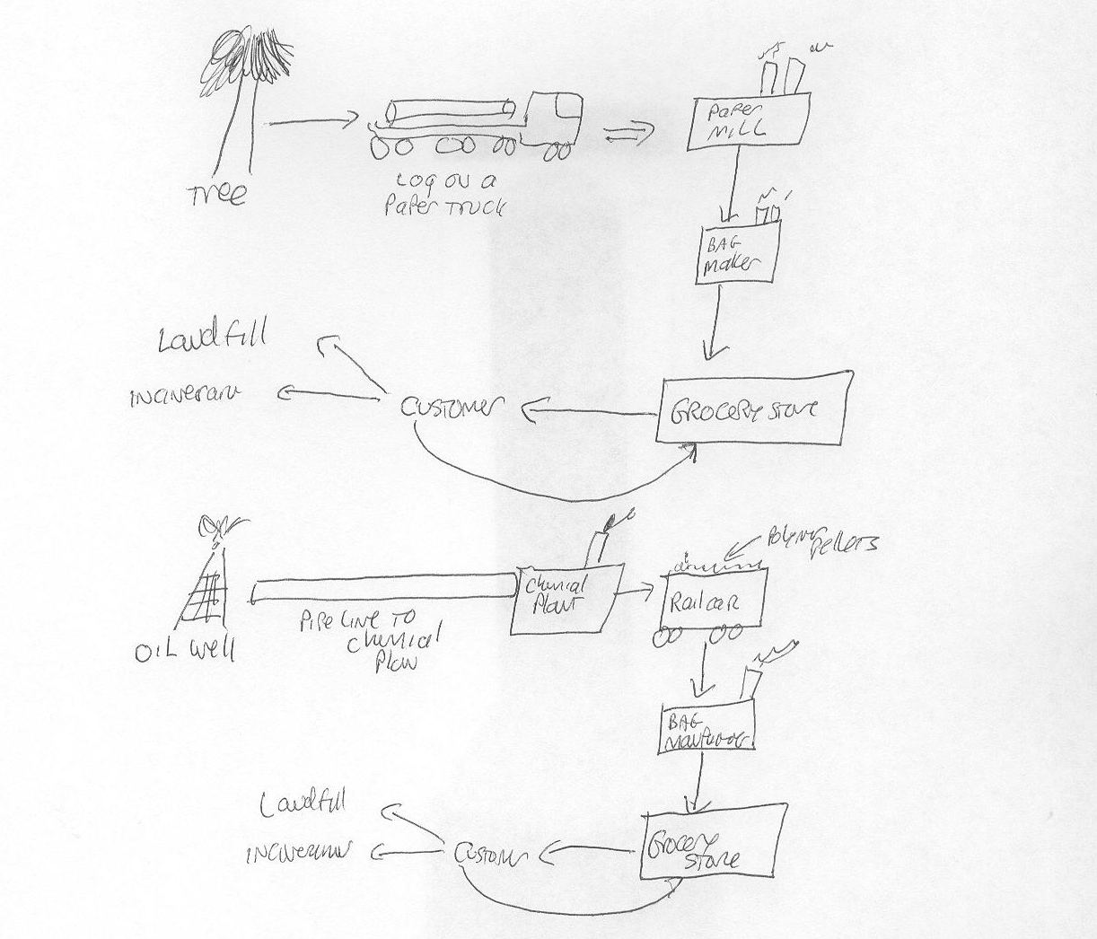

- Trees are a renewable resource, but paper bags are more expensive, require considerable energy to produce and lack handles

- Oil is a finite resource, but many more plastic bags are reused and recycled. They have handles and are generally more convenient.
Problem 1.19:

Lithium contains three electrons. The quantum numbers for the three would be

- n = 1; λ = 0, M_{λ} =0, M_{s} = + ½
- n = 1; λ = 0, M_{λ} =0, M_{s} = - ½
- n = 2; λ = 0, M_{λ} =-1, M_{s} = + ½

Helium contains two electrons, the quantum numbers are

- n = 1; λ = 0, M_{λ} =0, M_{s} = + ½
- n = 1; λ = 0, M_{λ} =0, M_{s} = - ½

Carbon contains six electrons. Their quantum numbers are

- n = 1; λ = 0, M_{λ} =0, M_{s} = + ½
- n = 1; λ = 0, M_{λ} =0, M_{s} = - ½
- n = 2; λ = 0, M_{λ} =-1, M_{s} = + ½
- n = 2; λ = 0, M_{λ} =-1, M_{s} = - ½
- n = 2; λ = 0, M_{λ} = 0, M_{s} = + ½
- n = 2; λ = 0, M_{λ} = 0, M_{s} = - ½
Problem 1.20

The Pauli exclusion principle prevents electrons with the same spin from occupying the same suborbital. The fourth quantum number represents the spin ( + ½ or – ½ ), so the Pauli exclusion principle prevents identical spin values from existing together.

