Biology: Science for Life, 3e (Belk/Borden)
Chapter 2 Are We Alone in the Universe? Water, Biochemistry, and Cells

1) Each of the following is a feature of all known living things EXCEPT
A) genes made from proteins.
B) growth.
C) homeostasis.
D) metabolism.
Answer: A
Diff: 1 Type: MC
Topic: 2.1
Skill: Factual

2) Imagine some table sugar dissolved in water. Which term best describes the water?
A) product
B) reactant
C) solute
D) solvent
Answer: D
Diff: 1 Type: MC
Topic: 2.1
Skill: Conceptual

3) Which term best describes the sugar in a sugar-water solution?
A) product
B) reactant
C) solute
D) solvent
Answer: C
Diff: 1 Type: MC
Topic: 2.1
Skill: Conceptual

4) Because the electrons in a water molecule are shared unequally between hydrogen and oxygen, water is said to be
A) hydrophobic.
B) ionic.
C) noncovalent.
D) nonpolar.
E) polar.
Answer: E
Diff: 2 Type: MC
Topic: 2.1
Skill: Factual
5) Which of the following are found in the nucleus of an atom?
A) electrons
B) neutrons
C) protons
D) electrons and protons
E) neutrons and protons
Answer: E
Diff: 1 Type: MC
Topic: 2.1
Skill: Factual

6) Many features of living things are also found in nonliving things, such as fire. Of the following features, which is least likely to be found in nonliving things?
A) consumption of energy-containing molecules
B) growth
C) homeostasis
D) reproduction
E) response to external stimuli
Answer: C
Diff: 2 Type: MC
Topic: 2.1
Skill: Conceptual

7) An atom will be least likely to form chemical bonds with other atoms when
A) the number of protons equals the number of electrons.
B) the number of protons equals the number of neutrons.
C) there is only one electron in the valence shell.
D) the valence shell has one fewer electron than the maximum amount it can hold.
E) the valence shell is full of electrons.
Answer: E
Diff: 2 Type: MC
Topic: 2.1
Skill: Conceptual

8) What type of chemical bond connects the complementary strands of a DNA molecule to each other?
A) hydrogen bonds
B) ionic bonds
C) nonpolar covalent bonds
D) polar covalent bonds
Answer: A
Diff: 1 Type: MC
Topic: 2.1
Skill: Factual
9) If life on Mars is fundamentally like life on Earth, its macromolecules will be based on which element?
A) carbon
B) hydrogen
C) nitrogen
D) oxygen
E) phosphorus
Answer: A
Diff: 1 Type: MC
Topic: 2.1
Skill: Conceptual

10) Imagine a newly discovered biological molecule that is mostly hydrophobic in its structure. This new molecule will most likely be classified as a
A) carbohydrate.
B) lipid.
C) nucleic acid.
D) polysaccharide.
E) protein.
Answer: B
Diff: 2 Type: MC
Topic: 2.1
Skill: Conceptual

11) Which of the following pairs of molecules can be held to each other by a hydrogen bond?
A) one polar molecule and one nonpolar molecule
B) two ions
C) two nonpolar molecules
D) two polar molecules
Answer: D
Diff: 2 Type: MC
Topic: 2.1
Skill: Conceptual

12) What kind of bond holds the atoms of a single water molecule together?
A) hydrogen bonds
B) ionic bonds
C) covalent bonds that are not polar
D) covalent bonds that are polar
Answer: D
Diff: 2 Type: MC
Topic: 2.1
Skill: Factual
13) What kind of bond holds two water molecules to each other?
A) hydrogen bonds
B) ionic bonds
C) nonpolar covalent bonds
D) polar covalent bonds
Answer: A
Diff: 2 Type: MC
Topic: 2.1
Skill: Factual

14) In general, what makes one kind of amino acid different from other amino acids?
A) the amino group
B) the carboxyl group
C) the side group
D) both B and C
Answer: C
Diff: 1 Type: MC
Topic: 2.1
Skill: Factual

15) Which macromolecule has a sugar-phosphate backbone?
A) lipid
B) nucleic acid
C) protein
D) polysaccharide
Answer: B
Diff: 1 Type: MC
Topic: 2.1
Skill: Factual

16) The atomic number of an element refers to the number of ________ in one atom of that element.
A) electrons
B) neutrons
C) protons
D) protons plus electrons
E) protons plus electrons plus neutrons
Answer: C
Diff: 1 Type: MC
Topic: 2.1
Skill: Factual

17) How do the concentrations of H+ and OH- compare to each other in an acidic solution?
A) The concentration of H+ is higher.
B) The concentration of H+ is lower.
C) The concentration of H+ is the same.
D) Acidic solutions do not contain H+.
Answer: A
Diff: 1 Type: MC
Topic: 2.1
Skill: Conceptual
18) What is the pH of a neutral solution?
A) 1
B) 5
C) 7
D) 9
E) 14
Answer: C
Diff: 1 Type: MC
Topic: 2.1
Skill: Factual

19) A molecule that is composed of chains and rings of hydrogen and carbon is called a
A) carbohydrate.
B) hydrocarbon.
C) polypeptide.
D) polysaccharide.
Answer: B
Diff: 1 Type: MC
Topic: 2.1
Skill: Factual

20) What is the name of a molecule composed of one or more sugars?
A) carbohydrate
B) hydrocarbon
C) lipid
D) nucleic acid
E) polypeptide
Answer: A
Diff: 1 Type: MC
Topic: 2.1
Skill: Factual

21) Polysaccharides are polymers of
A) amino acids.
B) fatty acids.
C) nucleotides.
D) sugars.
Answer: D
Diff: 1 Type: MC
Topic: 2.1
Skill: Factual
22) Proteins are polymers of
A) amino acids.
B) fatty acids.
C) nucleotides.
D) sugars.
Answer: A
Diff: 1 Type: MC
Topic: 2.1
Skill: Factual

23) Nucleic acids are polymers of
A) amino acids.
B) fatty acids.
C) nucleotides.
D) sugars.
Answer: C
Diff: 1 Type: MC
Topic: 2.1
Skill: Factual

24) Each of the following is a lipid EXCEPT
A) cellulose.
B) cholesterol.
C) fat.
D) phospholipids.
E) steroids.
Answer: A
Diff: 1 Type: MC
Topic: 2.1
Skill: Factual

25) What is the name for the ability of living things to maintain a relatively constant internal environment?
A) cellular respiration
B) homeostasis
C) metabolism
D) photosynthesis
E) valence
Answer: B
Diff: 1 Type: MC
Topic: 2.1
Skill: Factual
26) Consider a substance that is composed of molecules that are stable when dry. In the presence of water, however, the atoms that compose the molecules separate from each other. What type of chemical bond holds the dry substance together?
A) hydrogen bonds
B) ionic bonds
C) nonpolar covalent bonds
D) polar covalent bonds
Answer: B
Diff: 2 Type: MC
Topic: 2.1
Skill: Conceptual

27) Cholesterol is classified as a lipid because it contains a large proportion of
A) carbohydrate.
B) fatty acid.
C) glycerol.
D) hydrocarbon.
Answer: D
Diff: 1 Type: MC
Topic: 2.1
Skill: Conceptual

28) Enzymes are
A) carbohydrates.
B) lipids.
C) nucleic acids.
D) inorganic molecules.
E) proteins.
Answer: E
Diff: 1 Type: MC
Topic: 2.1
Skill: Factual

29) The ________ of an organism is defined as all the chemical processes that occur in the cells of that organism.
Answer: metabolism
Diff: 1 Type: SA
Topic: 2.1
Skill: Factual

30) ________ is the ability of living things to maintain a relatively constant internal environment despite changes in the external environment.
Answer: Homeostasis
Diff: 1 Type: SA
Topic: 2.1
Skill: Factual
31) ________ are the smallest units into which an element can be broken down.
Answer: Atoms
Diff: 1 Type: SA
Topic: 2.1
Skill: Factual

32) Proteins are composed of monomer subunits called ________.
Answer: amino acids
Diff: 1 Type: SA
Topic: 2.1
Skill: Factual

33) Which of the following is not considered part of a life-form's metabolism?
A) secretion of wastes
B) all chemical processes that occur in cells
C) ability to function without water
D) synthesis of macromolecules
E) breakdown of energy-containing substances
Answer: C
Diff: 1 Type: MC
Topic: 2.1
Skill: Factual

34) Which of the following is an element?
A) water
B) methane
C) hydrogen
D) carbon dioxide
E) sodium chloride
Answer: C
Diff: 1 Type: MC
Topic: 2.1
Skill: Factual
35) Protons have a ________ charge and, collectively, give an element its ________.
A) negative; polarity
B) positive; atomic number
C) negative; electronegativity
D) positive; ionic charge
E) negative; atomic number
Answer: B
Diff: 1 Type: MC
Topic: 2.1
Skill: Factual
36) Which of the following is nonpolar?
A) a positive ion
B) a negative ion
C) a neutral ion
D) a molecule with no partial charges
Answer: D
Diff: 1 Type: MC
Topic: 2.1
Skill: Conceptual

37) Oxygen in highly electronegative, meaning that it
A) pulls electrons toward itself.
B) is nonpolar.
C) repels electrons away from its nucleus and into the outermost electron shell.
D) discharges electrons readily out of the atom.
Answer: A
Diff: 1 Type: MC
Topic: 2.1
Skill: Factual

38) How does the H+ ion concentration in a pH solution of 2 compare to a pH solution of 4?
A) It is 2 times higher.
B) It is 2 times lower.
C) It is 100 times higher.
D) It is 100 times lower.
E) The H+ concentration does not differ; only the OH- concentration differs.
Answer: C
Diff: 3 Type: MC
Topic: 2.1
Skill: Applied

39) Which of the following has the lowest OH- concentration?
A) ammonia
B) pure water
C) coffee
D) battery acid
Answer: D
Diff: 3 Type: MC
Topic: 2.1
Skill: Conceptual
40) Which organelle contains digestive enzymes that degrade a variety of macromolecules?
A) chloroplast
B) endoplasmic reticulum
C) lysosome
D) mitochondrion
E) nucleus
Answer: C
Diff: 1 Type: MC
Topic: 2.1
Skill: Factual

41) Which pH represents an equal number of H+ and OH- ions?
A) 7
B) 1
C) 14
D) 10
E) 2
Answer: A
Diff: 1 Type: MC
Topic: 2.1
Skill: Factual

42) Which of the following could accept one (and only one) electron?
A) carbon (atomic number = 6)
B) nitrogen (atomic number = 7)
C) oxygen (atomic number = 8)
D) hydrogen (atomic number = 1)
E) helium (atomic number = 2)
Answer: D
Diff: 3 Type: MC
Topic: 2.1
Skill: Applied
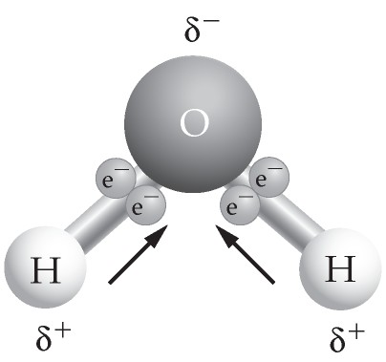

43) Use the figure above to answer the following question. If two or more of these molecules are in proximity to one another, how will they bond together?
A) hydrogen bonding, with two hydrogen atoms bonded together
B) covalent bonding, with two oxygen atoms bonded together
C) hydrogen bonding, with a hydrogen atom bonded to an oxygen atom
D) ionic bonding, with a hydrogen ion bonded to an oxygen atom
Answer: C
Diff: 2 Type: MC
Topic: 2.1
Skill: Applied

44) Which organelle is found in plant cells but not in animal cells?
A) chloroplast
B) endoplasmic reticulum
C) centriole
D) mitochondrion
E) nucleus
Answer: C
Diff: 2 Type: MC
Topic: 2.2
Skill: Factual

45) Which organelle performs photosynthesis?
A) chloroplast
B) Golgi apparatus
C) lysosome
D) mitochondrion
Answer: A
Diff: 1 Type: MC
Topic: 2.2
Skill: Factual
46) Which organelle performs cellular respiration?
A) chloroplast
B) endoplasmic reticulum
C) Golgi apparatus
D) lysosome
E) mitochondrion
Answer: E
Diff: 1 Type: MC
Topic: 2.2
Skill: Factual

47) Cells contain macromolecules that function as identification tags, marking cells as a particular type (liver cell, nerve cell, etc.). Where are these identification tags found?
A) Golgi apparatus
B) lysosome
C) mitochondrion
D) plasma membrane
E) ribosome
Answer: D
Diff: 2 Type: MC
Topic: 2.2
Skill: Conceptual

48) Which organelle is represented by a network of membranes involved in the production of proteins?
A) chloroplast
B) endoplasmic reticulum
C) lysosome
D) mitochondrion
E) nucleus
Answer: B
Diff: 1 Type: MC
Topic: 2.2
Skill: Factual

49) Which organelle is a stack of membranous sacs that are involved in sorting proteins to their proper cellular location?
A) centriole
B) endoplasmic reticulum
C) Golgi apparatus
D) lysosome
E) mitochondrion
Answer: C
Diff: 1 Type: MC
Topic: 2.2
Skill: Factual
50) Which part of the cell is composed of microtubules and helps move chromosomes around during cell division?
A) centriole
B) chromatin
C) microfilament
D) nucleolus
E) ribosome
Answer: A
Diff: 1 Type: MC
Topic: 2.2
Skill: Factual

51) Microtubules, microfilaments, and intermediate filaments compose what part of a cell?
A) centriole
B) cholesterol
C) chromatin
D) cytoskeletal elements
E) nucleolus
Answer: D
Diff: 1 Type: MC
Topic: 2.2
Skill: Factual

52) What kind of molecule forms a bilayer that is the basis for all cellular membranes?
A) carbohydrate
B) cholesterol
C) fat
D) phospholipid
E) protein
Answer: D
Diff: 1 Type: MC
Topic: 2.2
Skill: Factual

53) In what unit of a eukaryotic cell are ribosomes made?
A) central vacuole
B) endoplasmic reticulum
C) Golgi apparatus
D) lysosome
E) nucleolus
Answer: E
Diff: 1 Type: MC
Topic: 2.2
Skill: Factual
54) Which feature is found in both prokaryotic and eukaryotic cells?
A) mitochondria
B) Golgi body
C) DNA
D) centrioles
E) rough endoplasmic reticulum
Answer: C
Diff: 1 Type: MC
Topic: 2.2
Skill: Factual

55) According to the theory of evolution, which states that all life-forms on Earth arose from a common ancestor, all living organisms
A) share a common organic chemistry.
B) have DNA within their nucleus.
C) exhibit the same basic cell wall.
D) perform the same mode of reproduction.
Answer: A
Diff: 2 Type: MC
Topic: 2.2
Skill: Conceptual

56) The internal membrane-bound compartments found in eukaryotic cells are called ________.
Answer: organelles
Diff: 1 Type: SA
Topic: 2.2
Skill: Factual

57) The ________ defines the outer boundary of all cells, separating the cell's contents from its environment.
Answer: plasma membrane
Diff: 1 Type: SA
Topic: 2.2
Skill: Factual

58) Proteins in cells are assembled by structures called ________.
Answer: ribosomes
Diff: 1 Type: SA
Topic: 2.2
Skill: Factual

59) ________ are biological macromolecules that are composed mostly of hydrogen and carbon.
Answer: Lipids
Diff: 1 Type: SA
Topic: 2.2
Skill: Factual
60) The ________ is the compartment in a eukaryotic cell that stores DNA in the form of chromatin.
Answer: nucleus
Diff: 2 Type: SA
Topic: 2.2
Skill: Factual

61) Prokaryotes lack all the following EXCEPT a
A) nucleus.
B) endoplasmic reticulum.
C) Golgi apparatus.
D) cell wall.
E) mitochondrion.
Answer: D
Diff: 1 Type: MC
Topic: 2.2
Skill: Factual

62) The purported fossils in meteorite ALH84001 resemble modern prokaryotes called
A) nanobacteria.
B) amoebas.
C) fungi.
D) nucleoids.
E) zygobacteria.
Answer: A
Diff: 2 Type: MC
Topic: 2.2
Skill: Factual

63) Scientists believe that the first prokaryotes on Earth arose ________ years ago, and the first eukaryotes arose ________ years later.
A) 3.5 million; 1.7 million
B) 1.7 million; 3.5 million
C) 3.5 billion; 1.7 billion
D) 1.7 billion; 3.5 billion
Answer: C
Diff: 1 Type: MC
Topic: 2.2
Skill: Factual

64) Prokaryotic cells are generally ________ the size of eukaryotic cells.
A) twice
B) ten times
C) one-half
D) one-tenth
E) one-thousandth
Answer: D
Diff: 3 Type: MC
Topic: 2.2
Skill: Factual
65) The plasma membrane of a photosynthetic eukaryotic cell does all the following EXCEPT
A) convert carbon dioxide and water into sugars.
B) isolate the cell's contents from the external environment.
C) define the cell shape.
D) allow certain nutrients into the cell.
E) allow certain molecules out of the cell.
Answer: A
Diff: 2 Type: MC
Topic: 2.2
Skill: Conceptual

66) The reactions of cellular respiration occur in the
A) nucleolus of the nucleus.
B) ribosomes of the rough endoplasmic reticulum.
C) outer mitochondrial membranes.
D) matrix of the mitochondria.
E) hydrophobic core of the outermost cell plasma membrane.
Answer: D
Diff: 3 Type: MC
Topic: 2.2
Skill: Factual

67) The liquid interior of the chloroplast is called the
A) centriole.
B) chromatin.
C) Golgi apparatus.
D) stroma.
E) thylakoid.
Answer: D
Diff: 2 Type: MC
Topic: 2.2
Skill: Factual

68) The antibiotic streptomycin prevents protein synthesis in prokaryotes. Which cell component is the most likely target of this antibiotic?
A) ribosome
B) rough endoplasmic reticulum
C) Golgi apparatus
D) cell wall
Answer: A
Diff: 3 Type: MC
Topic: 2.2
Skill: Applied
69) Assume that a plant is suffering from drought and is beginning to wilt. Which cell component is most likely being affected, and what type of molecule is being lost from this structure?
A) cytoskeletal elements; protein
B) endoplasmic reticulum; protein
C) Golgi apparatus; water
D) lysosome; enzymes
E) vacuole; water
Answer: E
Diff: 1 Type: MC
Topic: 2.2
Skill: Conceptual

70) Cell membranes are ________, allowing certain molecules to pass while preventing other molecules from passing.
Answer: semipermeable
Diff: 1 Type: SA
Topic: 2.2
Skill: Factual

71) Mitochondria convert food energy into a high-energy molecule that is directly usable by the cell, called ________ (two words).
Answer: adenosine triphosphate (ATP)
Diff: 2 Type: SA
Topic: 2.2
Skill: Factual

72) Which organelle in a scavenging white blood cell would break down ingested bacteria and other materials that are consumed by the cell?
Answer: lysosome
Diff: 1 Type: SA
Topic: 2.2
Skill: Factual

73) A(n) ________ is the fundamental structural unit of life on Earth.
Answer: cell
Diff: 1 Type: SA
Topic: 2.2
Skill: Factual
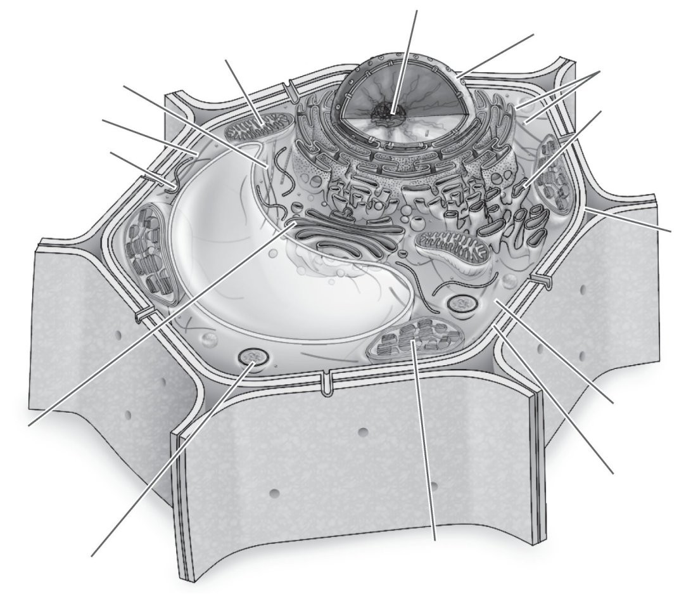
74) Which structure is present in this cell but lacking in an animal cell?
A) nucleolus
B) cell wall
C) smooth endoplasmic reticulum
D) mitochondrion
E) ribosome
Answer: B
Diff: 2 Type: MC
Topic: 2.2
Skill: Conceptual
75) Label the parts of the animal cell.

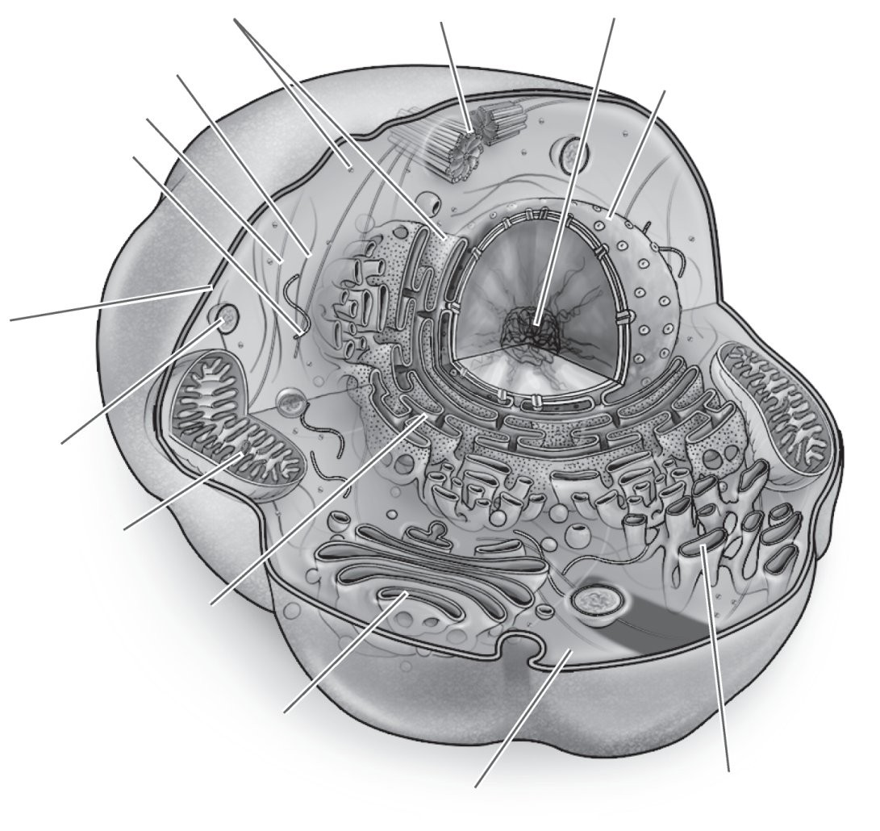

Answer:
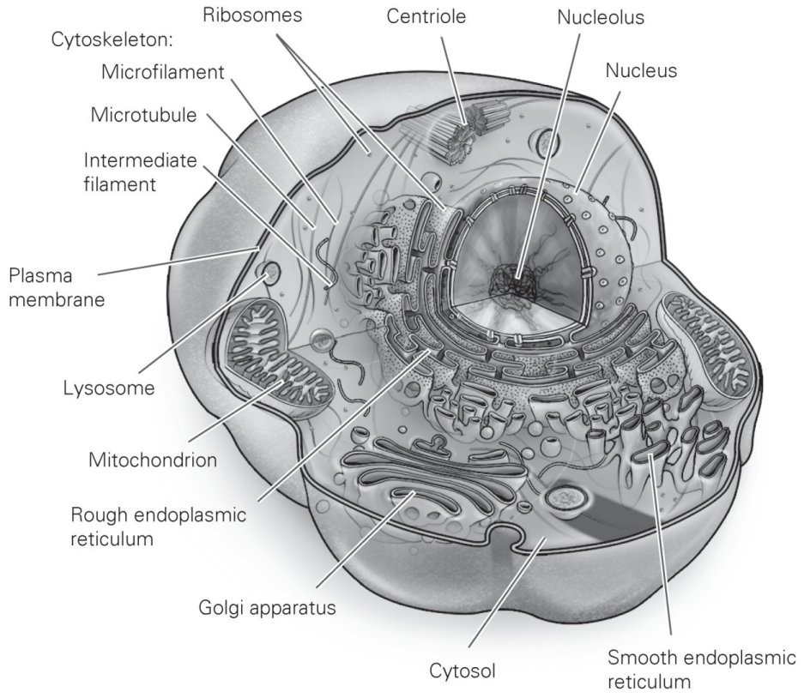
Diff: 2 Type: SA
Topic: 2.2
Skill: Factual
76) Label the parts of the plant cell.

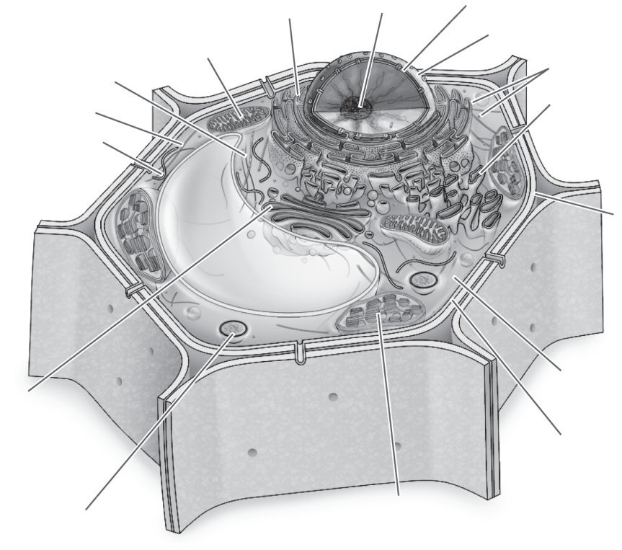
Answer:
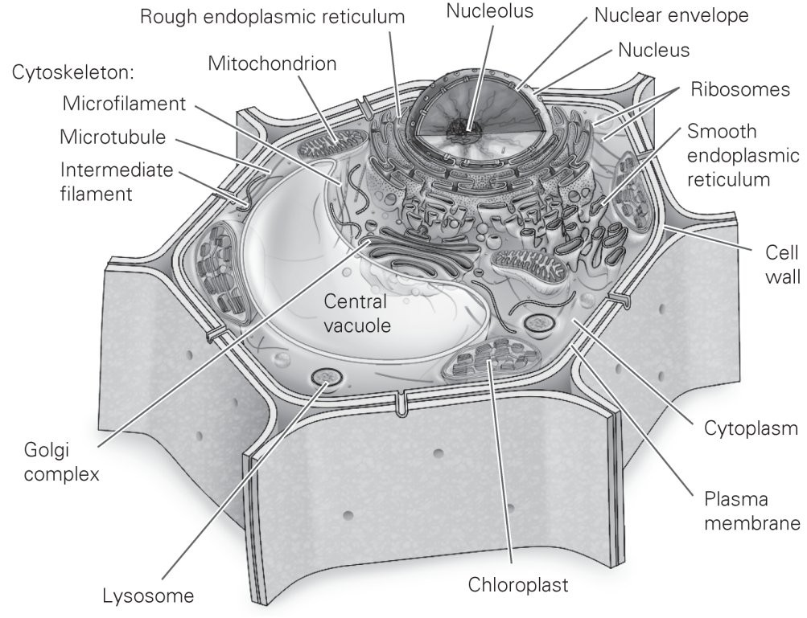

Diff: 2 Type: SA
Topic: 2.2
Skill: Factual

