College Accounting, 14ce (Slater/Good)
Chapter 1 Accounting Concepts and Procedures: An Introduction

1.1 Defining and listing the functions of accounting.

1) Which of the following professional accounting designations has been replaced by "CPA"?
A) CA
B) CMA
C) CGA
D) All of the above
Answer: D
Diff: 1 Type: MC
Objective: 1-1

2) The type of business organization that can continue indefinitely is known as a
A) sole proprietorship.
B) partnership.
C) corporation.
D) None of the above.
Answer: C
Diff: 1 Type: MC
Objective: 1-1

3) This type of business organization is subject to income tax.
A) sole proprietorship.
B) partnership.
C) corporation.
D) All of the above.
Answer: C
Diff: 1 Type: MC
Objective: 1-1

4) Putting the information into the accounting system would be called
A) analyzing.
B) recording.
C) classifying.
D) summarizing.
Answer: B
Diff: 2 Type: MC
Objective: 1-1

5) The purpose of the accounting process is to provide financial information about
A) sole proprietorships.
B) small businesses.
C) large corporations.
D) All of these answers are correct.
Answer: D
Diff: 2 Type: MC
Objective: 1-1

6) The advantages of a corporation do NOT include
A) limited personal risk.
B) can continue indefinitely.
C) business decisions made by career administrators.
D) easy to set up.
Answer: D
Diff: 1 Type: MC
Objective: 1-1

7) Accounting reports are least helpful in answering which of the following questions?
A) How much cash was available at the end of the last year?
B) How well were the employees treated by management?
C) Did the company make a profit for the previous year?
D) Can the company pay its debts on time?
Answer: B
Diff: 3 Type: MC
Objective: 1-1

8) Accounting provides information to
A) managers.
B) government.
C) investors.
D) All of these answers are correct
Answer: D
Diff: 2 Type: MC
Objective: 1-1

9) Which of the following is a characteristic of a sole proprietorship?
A) Business owned by more than one person
B) Easy to form
C) Each shareholder acts as an owner of the company
D) Can continue indefinitely
Answer: B
Diff: 1 Type: MC
Objective: 1-1

10) A partnership is a business which is
A) easy to form.
B) ends with the death of a partner.
C) owned by more than one person.
D) All of these answers are correct.
Answer: D
Diff: 1 Type: MC
Objective: 1-1

11) Which is an advantage of a sole proprietorship form of business?
A) There is limited personal risk.
B) The business can continue indefinitely.
C) The owner makes all the decisions.
D) All of these answers are correct.
Answer: C
Diff: 1 Type: MC
Objective: 1-1

12) Which of the following is NOT a type of business organization?
A) Corporation
B) Partnership
C) Sole proprietorship
D) Operation
Answer: D
Diff: 2 Type: MC
Objective: 1-1

13) A corporation
A) can continue indefinitely.
B) is owned by shareholders.
C) has limited risk to shareholders.
D) all of the above.
Answer: D
Diff: 2 Type: MC
Objective: 1-1

14) The Sarbanes-Oxley Act in the United States and National Policies in Canada were passed to
A) prevent fraud at public companies.
B) replace all of the old accounting procedures with new ones.
C) improve the accuracy of the company's financial reporting.
D) Both A and C are correct.
Answer: D
Diff: 2 Type: MC
Objective: 1-1

15) A legal firm would be considered a
A) merchandise company.
B) manufacturer.
C) service company.
D) None of the above are correct.
Answer: C
Diff: 1 Type: MC
Objective: 1-1

16) Not-for-profit organizations
A) aim to improve society in some way.
B) seek to maximize profits.
C) usually obtain funding from donations and government grants.
D) Both A and C are correct.
Answer: D
Diff: 1 Type: MC
Objective: 1-1

17) Generally Accepted Accounting Principles are the underlying concepts that make up acceptable accounting practices.
Answer: TRUE
Diff: 1 Type: TF
Objective: 1-1

18) Not-for-profit businesses are not permitted to earn any revenue.
Answer: FALSE
Diff: 2 Type: TF
Objective: 1-1

19) The primary objective of a not-for-profit business is to maximize revenue.
Answer: FALSE
Diff: 1 Type: TF
Objective: 1-1

20) The new accounting designation for Canada is CGA.
Answer: FALSE
Diff: 1 Type: TF
Objective: 1-1

21) A disadvantage of a corporation is that shareholders are held personally liable for the corporation's debts.
Answer: FALSE
Diff: 2 Type: TF
Objective: 1-1

22) The function of accounting includes analyzing, recording, classifying, summarizing, reporting, and interpreting financial information.
Answer: TRUE
Diff: 1 Type: TF
Objective: 1-1

23) A sole proprietorship ends with the death of the owner.
Answer: TRUE
Diff: 2 Type: TF
Objective: 1-1

24) Canada has not yet adopted the IFRS rules for accounting.
Answer: FALSE
Diff: 2 Type: TF
Objective: 1-1

25) The purpose of accounting is to provide decision-makers with useful, accurate information.
Answer: TRUE
Diff: 1 Type: TF
Objective: 1-1

26) List the 6 functions of accounting.
Answer:
1. Analyzing
2. Recording
3. Classifying
4. Summarizing
5. Reporting
6. Interpreting
Diff: 2 Type: ES
Objective: 1-1

27) Discuss the advantages and disadvantages of sole proprietorships, partnerships and corporations.
Answer: A sole proprietorship is a business that has one owner. The advantage of a sole proprietorship is that the owner makes all of the decisions for the business. Another advantage is ease of formation. A disadvantage is that if the business cannot pay its obligations, the business owner can be forced to pay them from personal assets. The business ends with the death of the owner or the closing of the business.

A partnership is a business owned by more than one person. Its advantage is ease of formation. The disadvantages are that partners could lose personal assets to meet obligations of the partnership and a partnership ends with death of a partner or exit of a partner. Also, disagreements among the partners are sometimes hard to deal with, and can result in strained relationships, and mental trauma.

A corporation is a business owned by shareholders. The advantages are that shareholders have limited personal risk which is limited to their investment in the company. Corporations also can have access to very large sums of money (if enough shares are issued). The corporation has unlimited life but the disadvantage is that a corporation is more difficult to form, and expenses to issue extra shares, especially to the general public, can be amazingly high.

In general, all forms of business profits are taxed, but only the corporation is itself a tax-paying entity. Proprietorships and partnerships are not taxed, but any profits are "assigned" to the owner(s) and taxed in their hands.
Diff: 2 Type: ES
Objective: 1-1

28) What is the difference between Financial and Managerial Accounting?
Answer: Financial accounting serves the needs of EXTERNAL users by providing financial statements to help make decisions. Day-to-day activities include statement preparation and analysis, auditing, regulatory issues, and planning. Managerial accounting serves the needs of INTERNAL users by providing special-purpose reports.
Diff: 2 Type: ES
Objective: 1-1

29) A book store would be considered a
A) merchandise company.
B) manufacturer.
C) service company.
D) None of the above are correct.
Answer: A
Diff: 1 Type: MC
Objective: 1-1

30) An accounting firm would be considered a
A) merchandise company.
B) manufacturer.
C) service company.
D) None of the above are correct.
Answer: C
Diff: 1 Type: MC
Objective: 1-1

31) A Toyota plant would be considered a
A) merchandise company.
B) manufacturer.
C) service company.
D) None of the above are correct.
Answer: B
Diff: 1 Type: MC
Objective: 1-1

32) A Hallmark store would be considered a
A) merchandise company.
B) manufacturer.
C) service company.
D) None of the above are correct.
Answer: A
Diff: 1 Type: MC
Objective: 1-1

33) All Canadian companies must follow the IFRS rules for accounting.
Answer: FALSE
Diff: 2 Type: TF
Objective: 1-1

34) Managerial accountants primarily provide special-purpose reports to serve the needs of external users.
Answer: FALSE
Diff: 2 Type: TF
Objective: 1-1

For each of the following financial statement users, identify if they would be considered an internal or an external stakeholder.

35) Manager of the Sales Department
Answer: Internal
Diff: 1 Type: SA
Objective: 1-1

36) The parliament member running for re-election
Answer: External
Diff: 1 Type: SA
Objective: 1-1

37) The bank who lends you money
Answer: External
Diff: 1 Type: SA
Objective: 1-1

38) Canada Revenue Agency
Answer: External
Diff: 1 Type: SA
Objective: 1-1

39) Your biggest customer
Answer: External
Diff: 1 Type: SA
Objective: 1-1

40) The President and CEO
Answer: Internal
Diff: 1 Type: SA
Objective: 1-1

41) Auditor hired by CRA
Answer: External
Diff: 1 Type: SA
Objective: 1-1

42) Day Shift Receptionist
Answer: Internal
Diff: 1 Type: SA
Objective: 1-1

43) President of the local Garden Club
Answer: External
Diff: 1 Type: SA
Objective: 1-1

44) Fred Jones, who purchased shares in our corporation
Answer: External
Diff: 1 Type: SA
Objective: 1-1

45) The Chief Financial Officer
Answer: Internal
Diff: 1 Type: SA
Objective: 1-1

46) Economical Life, the company that handles our employee benefit plan
Answer: External
Diff: 1 Type: SA
Objective: 1-1

1.2 Recording transactions in the basic accounting equation.

1) Which of the following is correct when speaking about a business's assets?
A) Assets are things of value owned.
B) Assets must always equal Liabilities.
C) Assets are shown at their resale value.
D) Assets are disclosed on the Income Statement.
Answer: A
Diff: 2 Type: MC
Objective: 1-2

2) A sample of a liability account is
A) Supplies.
B) Fees Earned.
C) Accounts Receivable.
D) Accounts Payable.
Answer: D
Diff: 2 Type: MC
Objective: 1-2

3) The basic accounting equation is: Assets = Liabilities.
Answer: FALSE
Diff: 1 Type: TF
Objective: 1-2

4) An obligation that is payable to creditors is
A) an asset.
B) a liability.
C) the owner's equity.
D) an expense.
Answer: B
Diff: 1 Type: MC
Objective: 1-2

5) Which of the following would have claims against the assets of the business?
A) Cash and liabilities
B) Cash and Equipment
C) Equipment and liabilities
D) Liabilities and owner's equity
Answer: D
Diff: 2 Type: MC
Objective: 1-2

6) The claims of creditors against the assets of a business are
A) expenses.
B) revenues.
C) liabilities.
D) assets.
Answer: C
Diff: 2 Type: MC
Objective: 1-2

7) The purchase of supplies for cash would affect which account category?
A) Assets
B) Liabilities
C) Capital
D) Expense
Answer: A
Diff: 2 Type: MC
Objective: 1-2

8) Items owned by the business such as land, supplies and equipment are
A) assets.
B) liabilities.
C) owner's equity.
D) revenue.
Answer: A
Diff: 1 Type: MC
Objective: 1-2

9) Which of the following is NOT an asset?
A) Cash
B) Accounts Receivable
C) Accounts Payable
D) Truck
Answer: C
Diff: 1 Type: MC
Objective: 1-2

10) Farrah's investment of cash and equipment in her existing business will
A) decrease assets and increase a liability.
B) increase assets and liabilities.
C) decrease assets and increase owner's equity.
D) increase assets and owner's equity.
Answer: D
Diff: 2 Type: MC
Objective: 1-2

11) Bob Allen's Company sells a machine it purchased last week for cash equivalent to the original cost of $15,000. This has the effect of
A) decreasing liabilities and increasing owner's equity.
B) decreasing assets and decreasing liabilities.
C) decreasing assets and increasing owner's equity.
D) no change to the overall accounting equation.
Answer: D
Diff: 3 Type: MC
Objective: 1-2

12) If total liabilities increased by $16,000 and the assets increased by $20,000 during the accounting period, what is the change in the owner's equity amount?
A) Increase of $4,000
B) Decrease of $4,000
C) Increase of $20,000
D) Decrease of $16,000
Answer: A
Diff: 3 Type: MC
Objective: 1-2

13) The claims of owners against the assets of a business are
A) expenses.
B) revenues.
C) liabilities.
D) owner's equity.
Answer: D
Diff: 1 Type: MC
Objective: 1-2

14) The Owner's Equity of Leyla's Company is equal to one-quarter of the total assets. Liabilities equal $30,000. What is the amount of Owner's Equity?
A) $40,000
B) $10,000
C) $30,000
D) None of these answers are correct.
Answer: B
Diff: 3 Type: MC
Objective: 1-2

15) Assets are equal to
A) liabilities + owner's equity.
B) liabilities - owner's equity.
C) liabilities - revenues.
D) revenues - expenses.
Answer: A
Diff: 1 Type: MC
Objective: 1-2

16) The basic accounting equation is
A) Assets = Revenues - Expenses.
B) Assets = Liabilities - Owner's Equity.
C) Assets = Owner's Equity - Liabilities.
D) Assets = Liabilities + Owner's Equity.
Answer: D
Diff: 1 Type: MC
Objective: 1-2

17) An acceptable variation of the accounting equation is
A) Assets - Liabilities = Owner's Equity.
B) Assets + Owner's Equity = Liabilities.
C) Assets = Liabilities - Owner's Equity.
D) All of these answers are correct.
Answer: A
Diff: 2 Type: MC
Objective: 1-2

18) If total liabilities are $22,000 and owner's equity is $17,000, the total assets must be
A) $39,000.
B) $5,000.
C) $20,000.
D) $17,000.
Answer: A
Diff: 3 Type: MC
Objective: 1-2

19) If total liabilities are $3,000 and total assets are $10,000, owner's equity must be
A) $7,000.
B) $3,000.
C) $10,000.
D) $13,000.
Answer: A
Diff: 2 Type: MC
Objective: 1-2

20) How does the purchase of equipment on account affect the accounting equation?
A) Assets increase; liabilities decrease.
B) Assets increase; owner's equity increases.
C) Assets increase; liabilities increase.
D) Liabilities increase; owner's equity decreases.
Answer: C
Diff: 2 Type: MC
Objective: 1-2

21) Sonya invested cash in her new business. What effect will this have?
A) Increase an asset and increase a liability.
B) Decrease an asset and increase a liability.
C) Increase an asset and increase owner's equity.
D) Increase an asset and decrease owner's equity.
Answer: C
Diff: 2 Type: MC
Objective: 1-2

22) A business paid $5,800 to a creditor in payment of an amount owed. The effect of the transaction on the accounting equation was to
A) increase one asset, decrease another asset.
B) increase an asset, increase a liability.
C) decrease an asset, decrease a liability.
D) increase an asset, increase owner's equity.
Answer: C
Diff: 2 Type: MC
Objective: 1-2

23) Stork Machining has total assets of $40,000. What are the total assets if new equipment is purchased for $10,000 cash?
A) $50,000
B) $40,000
C) $55,000
D) $60,000
Answer: B
Diff: 3 Type: MC
Objective: 1-2

24) Sunrise Company has total assets of $25,000. If $2,000 cash is used to purchase a new computer, the total assets would be
A) $25,000.
B) $23,000.
C) $27,000.
D) $22,000.
Answer: A
Diff: 3 Type: MC
Objective: 1-2

25) Kal's Vegan Restaurant, with total assets of $80,000, borrows $25,000 from the bank. Which of the following is a TRUE statement upon borrowing the money?
A) Total assets are now $105,000.
B) Total assets are now $80,000.
C) Total assets are now $25,000.
D) Total assets are now $55,000.
Answer: A
Diff: 3 Type: MC
Objective: 1-2

26) Liam's Sporting Goods buys $35,000 of equipment on credit. Which of the following is a TRUE statement?
A) Total assets increase.
B) Total assets are unchanged.
C) Total liabilities decrease.
D) Total liabilities are unchanged.
Answer: A
Diff: 2 Type: MC
Objective: 1-2

27) Bianca's Beverages purchases $2,500 worth of office equipment on account. This causes
A) Cash and Capital to decrease.
B) Office Equipment and Accounts Payable to increase.
C) Office Equipment to decrease and Accounts Payable to increase.
D) Accounts Payable to increase and Capital to decrease.
Answer: B
Diff: 2 Type: MC
Objective: 1-2

28) Eileen's Corner Shoppe purchases a new computer for cash. This causes
A) Cash and Capital to increase.
B) Computer Equipment and Cash to increase.
C) Computer Equipment to increase and Cash to decrease.
D) Accounts Payable to increase and Capital to increase.
Answer: C
Diff: 2 Type: MC
Objective: 1-2

29) Bob purchased a new computer for the company on account. The transaction will
A) increase Computer; increase Capital.
B) decrease Cash; increase Accounts Payable.
C) decrease Cash; increase Computer.
D) increase Computer; increase Accounts Payable.
Answer: D
Diff: 2 Type: MC
Objective: 1-2

30) Stephanie purchased $10,000 of new electronic equipment for her DJ Company on account. The effect on the basic accounting equation was to
A) decrease Cash $10,000 and increase Equipment $10,000.
B) increase Equipment $10,000 and increase Accounts Payable $10,000.
C) decrease Cash $10,000 and increase Accounts Payable $10,000.
D) increase Cash $10,000 and increase Equipment $10,000.
Answer: B
Diff: 3 Type: MC
Objective: 1-2

31) If total assets are $30,000 and total liabilities are $8,000, Capital must equal
A) $22,000.
B) $38,000.
C) $8,000.
D) $30,000.
Answer: A
Diff: 2 Type: MC
Objective: 1-2

32) The purchase of equipment with both cash and on account was recorded as only a credit purchase. Due to this error
A) assets would be understated.
B) liabilities would be overstated.
C) owner's equity would be overstated.
D) None of the above are correct.
Answer: B
Diff: 3 Type: MC
Objective: 1-2

33) If the beginning capital was $14,000 and in a fiscal period there was revenue of $8,000, withdrawals of $3,000, and expenses of $1,500 then the ending capital would be
A) $26,500.
B) $23,500.
C) $17,500.
D) $20,500.
Answer: C
Diff: 3 Type: MC
Objective: 1-2

34) The cash purchase of a truck was recorded as a purchase on credit. This error would mean
A) assets were overstated.
B) liabilities were overstated.
C) Answers A and B are correct.
D) None of the above are correct.
Answer: C
Diff: 3 Type: MC
Objective: 1-2

35) The payment of accounts payable would
A) increase both assets and liabilities.
B) increase assets and decrease liabilities.
C) decrease both assets and liabilities.
D) decrease assets and increase liabilities.
Answer: C
Diff: 2 Type: MC
Objective: 1-2

36) A purchase of a vehicle for cash would have what affect on the accounting equation?
A) Total asset amount remains the same.
B) Total liabilities are overstated.
C) Total owner's equity is overstated.
D) Both A and B are correct.
Answer: A
Diff: 3 Type: MC
Objective: 1-2

37) Which of the following transactions would cause one asset to increase and another asset to decrease?
A) The owner invested cash in the business.
B) The business paid a creditor.
C) The business bought inventory on credit.
D) The business bought supplies for cash.
Answer: D
Diff: 2 Type: MC
Objective: 1-2

38) Which of the following transactions would cause an asset to increase and the owner's equity to increase?
A) The owner invested cash in the business.
B) The business incurred an expense on credit.
C) The business bought supplies on account.
D) The owner withdrew cash from the business.
Answer: A
Diff: 2 Type: MC
Objective: 1-2

39) Which of the following would result if the owner invested cash in the business?
A) Cash would increase and Capital would decrease.
B) Cash would increase and Capital would increase.
C) Cash would decrease and Capital would increase.
D) An investment by the owner is not a business transaction.
Answer: B
Diff: 2 Type: MC
Objective: 1-2

40) Which of the following would result if the business purchased supplies on credit?
A) Supplies would increase and Cash would decrease.
B) Supplies would increase and Capital would increase.
C) Supplies would increase and Accounts Payable would increase.
D) The purchase of supplies is not a business transaction.
Answer: C
Diff: 2 Type: MC
Objective: 1-2

41) Which of the following would result if a business purchased Equipment paying a 50% down payment in cash?
A) Equipment would increase and Cash would decrease.
B) Accounts Payable would increase.
C) Since the equipment has not been paid in full, there is nothing to record.
D) Both A and B are correct.
Answer: D
Diff: 3 Type: MC
Objective: 1-2

42) The left side of the accounting equation shows what is owned by the business.
Answer: TRUE
Diff: 2 Type: TF
Objective: 1-2

43) Cash is the same thing as Capital.
Answer: FALSE
Diff: 2 Type: TF
Objective: 1-2

44) If the liabilities owed by a business total $150,000, then the assets must also total $150,000.
Answer: FALSE
Diff: 3 Type: TF
Objective: 1-2

45) The left side of the accounting equation must always equal the right side of the equation.
Answer: TRUE
Diff: 1 Type: TF
Objective: 1-2

46) If the assets owned by a business total $75,000, owner's equity must also total $75,000.
Answer: FALSE
Diff: 2 Type: TF
Objective: 1-2

47) In a shift of assets, the composition of the assets changes but total assets do not change.
Answer: TRUE
Diff: 2 Type: TF
Objective: 1-2

48) If the assets owned by a business total $50,000 and liabilities total $30,000, then owner's equity totals $80,000.
Answer: FALSE
Diff: 3 Type: TF
Objective: 1-2

49) Creditors' claims against assets are called owner's equity.
Answer: FALSE
Diff: 2 Type: TF
Objective: 1-2

50) The accounting equation states that total assets must always equal total liabilities plus owner's equity.
Answer: TRUE
Diff: 1 Type: TF
Objective: 1-2

51) The parties that have claims against the assets of the business are called creditors and owners.
Answer: TRUE
Diff: 1 Type: TF
Objective: 1-2

52) The accounting equation states that total assets must always equal owner's equity.
Answer: FALSE
Diff: 1 Type: TF
Objective: 1-2

53) A transaction can occur which will affect only the assets side of the accounting equation.
Answer: TRUE
Diff: 3 Type: TF
Objective: 1-2

54) If liabilities are $10,000 and assets are $15,000, owner's equity will be $5,000.
Answer: TRUE
Diff: 3 Type: TF
Objective: 1-2

55) Record the following transactions in the basic accounting equation:
a. Luke invests $25,000 cash to begin a financial planning service.
b. The company buys office furniture for cash, $1,200.
c. The company buys additional office furniture on account, $600.
d. The company makes a payment on the office furniture, $400.

Luke's Financial Planning
ASSETS = LIABILITIES + OWNER'S EQUITY
Cash + Office = Accounts + Luke's, Capital
Furniture Payable

a.
b.
c.
d.
Totals
Answer: Luke's Financial Planning
 | ASSETS |  | = | LIABILITIES | OWNER'S EQUITY
 | Cash + | Office Furniture | = | Accounts Payable | Luke's Capital
a. | +$25,000 |  | = |  | +$25,000
b. | - 1,200 | +$1,200 | =
c. |  | + 600 | = | +$600
d. | - 400 | _______ | = | - 400 | ________
T | +$23,400 | +$1,800 | = | +$200 | +$25,000

Diff: 2 Type: ES
Objective: 1-2

56) Given the following account balances, determine the total liabilities. Cash $350, Accounts Receivable $275, Equipment $500 and Capital $900.
Answer: $225 [$350 + $275 + $500 - $900]
Diff: 2 Type: ES
Objective: 1-2

57) Fred Pentell Company completes the following transactions
a. Mr. Pentell invests $5,500 cash in his company.
b. The company purchases equipment on account, $1600.
c. The company purchases additional equipment for cash, $600.
d. The company makes a payment on account for the equipment, $1,000.
Required: Record the above transactions in the basic accounting equation.

Fred Pentell Company

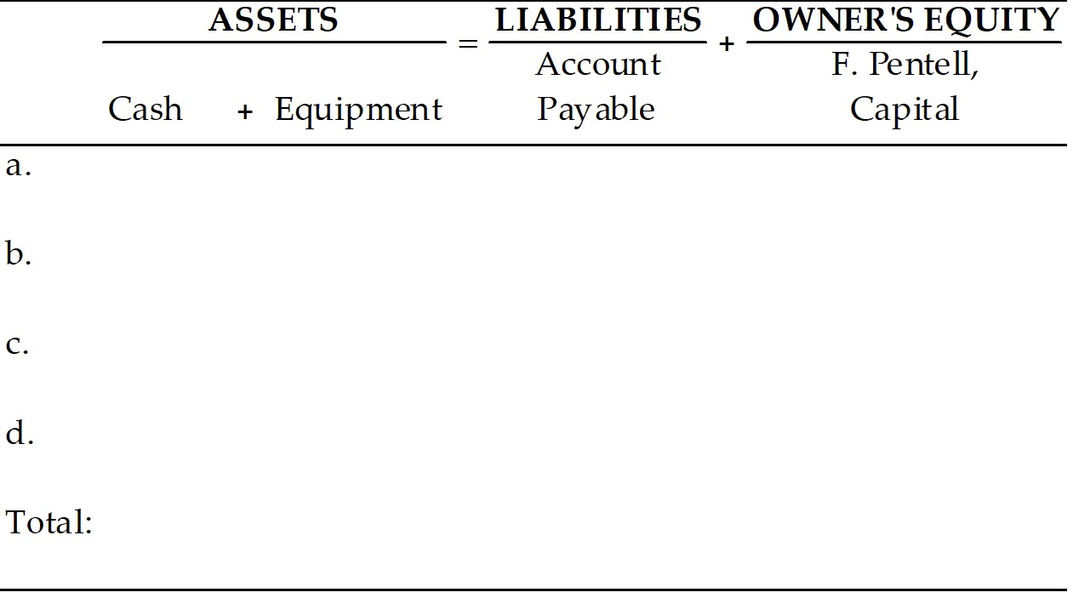

Answer: Fred Pentell Company

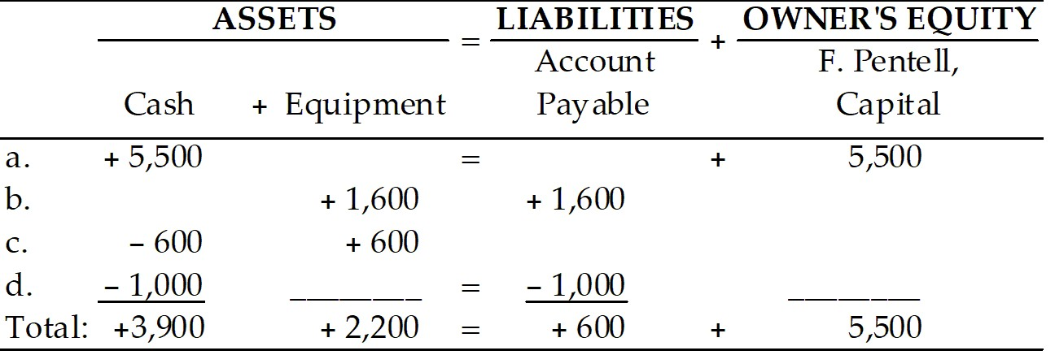

Diff: 1 Type: ES
Objective: 1-2

58) Tessa's Interior Design completes the following transactions:
a. Tessa invests $5,000 cash in her company.
b. The company purchases equipment on account, $250.
c. The company purchases additional equipment for cash, $100.
d. The company makes a payment on account for the equipment, $150.
Required: Record the above transactions in the basic accounting equation.

Tessa's Interior Design

ASSETS = LIABILITIES + OWNER'S EQUITY
Cash + Equipment = Accounts + Tessa's
Payable Capital
a. =
b. =
c. =
d. =
Totals =
Answer: Tessa's Interior Design

ASSETS = LIABILITIES + OWNER'S
EQUITY
Cash + Equipment = Accounts + Tessa's
Payable Capital
a. +$5,000 = +$5,000
b. +$250 = +$250
c. -100 +100 =
d. -150 ________ = -150 ________
T +$4,750 +$350 = +$100 +$5,000
Diff: 1 Type: ES
Objective: 1-2

59) If total liabilities increased by $20,000 and the assets increased by $25,000 during the accounting period, what is the change in the owner's equity amount?
A) Increase of $5,000
B) Decrease of $5,000
C) Increase of $25,000
D) Decrease of $20,000
Answer: A
Diff: 3 Type: MC
Objective: 1-2

60) If total liabilities increased by $10,000 and the assets increased by $4,000 during the accounting period, what is the change in the owner's equity amount?
A) Increase of $6,000
B) Decrease of $6,000
C) Increase of $4,000
D) Decrease of $10,000
Answer: B
Diff: 3 Type: MC
Objective: 1-2

61) If total liabilities are $15,000 and owner's equity is $7,000, the total assets must be
A) $22,000.
B) $15,000.
C) $7,000.
D) $8,000.
Answer: A
Diff: 3 Type: MC
Objective: 1-2

62) If total liabilities are $48,000 and assets are $52,000, the owner's equity must be
A) $100,000.
B) $52,000.
C) $48,000.
D) $4,000.
Answer: D
Diff: 3 Type: MC
Objective: 1-2

63) The purchase of a computer with on account was recorded as a cash purchase. Due to this error
A) assets would be understated.
B) liabilities would be overstated.
C) owner's equity would be overstated.
D) None of the above are correct.
Answer: A
Diff: 3 Type: MC
Objective: 1-2

64) A double line in a financial statement indicates at total and is called ________ a column.
A) footing.
B) heading.
C) adding.
D) tallying.
Answer: A
Diff: 1 Type: MC
Objective: 1-2

65) The parties that have claims against the assets of the business are called managers and customers.
Answer: FALSE
Diff: 1 Type: TF
Objective: 1-2

66) In a financial statement a double line indicates a total.
Answer: TRUE
Diff: 1 Type: TF
Objective: 1-2

67) The parties that have claims against the assets of the business are called managers and customers.
Answer: FALSE
Diff: 1 Type: TF
Objective: 1-2

68) Credit is the same thing as Liabilities.
Answer: TRUE
Diff: 2 Type: TF
Objective: 1-2

69) Record the following transactions in the basic accounting equation:
a. Larry invests $250,000 cash to begin a machine shop.
b. The company buys equipment for cash, $60,000.
c. The company buys another machine on account, $45,000.
d. The company makes a payment on the machine, $20,000.

Larry's Machine Shop
ASSETS = LIABILITIES + OWNER'S EQUITY
Cash + Equipment = Accounts + Larry's, Capital
Payable

a.
b.
c.
d.
Totals
Answer: Larry's Machine Shop
 | ASSETS |  | = | LIABILITIES | OWNER'S EQUITY
 | Cash + | Equipment | = | Accounts Payable | Larry's Capital
a. | +$250,000 |  | = |  | +$250,000
b. | - 60,000 | +$60,000 | =
c. |  | +45,000 | = | +$45,000
d. | - 20,000 | _______ | = | - 20,000 | ________
T | +$170,000 | +$105,000 | = | +$25,000 | +$250,000

Diff: 2 Type: ES
Objective: 1-2

1.3 Seeing how revenue, expenses, and withdrawals expand the basic accounting equation.

1) Which of the following will be recorded in the owner's equity column as an increase?
A) An exchange of assets
B) The purchase of an asset on credit
C) An investment by the owner
D) A withdrawal by the owner
Answer: C
Diff: 2 Type: MC
Objective: 1-3

2) Which of the following statements is TRUE?
A) Owner's withdrawals decrease net income.
B) Net income causes liabilities to decrease.
C) Net losses cause liabilities to increase.
D) Owner's withdrawals decrease owner's equity.
Answer: D
Diff: 3 Type: MC
Objective: 1-3

3) If a company's revenues are greater than its expenses, increasing its revenues and decreasing its expenses will
A) decrease net income.
B) increase net income.
C) decrease assets.
D) not affect owner's equity.
Answer: B
Diff: 2 Type: MC
Objective: 1-3

4) Owner's withdrawals
A) decrease assets.
B) increase expenses.
C) increase liabilities.
D) decrease withdrawals.
Answer: A
Diff: 3 Type: MC
Objective: 1-3

5) Go Blue Retail Store collected $12,000 of its accounts receivable. The expanded accounting equation changes include
A) Cash and Capital increase, $12,000.
B) Cash and Revenue increase $12,000.
C) Cash increases and Accounts Receivable decreases $12,000.
D) Accounts Receivable decreases and Capital increases $12,000.
Answer: C
Diff: 2 Type: MC
Objective: 1-3

6) If beginning capital was $100,000, ending capital is $85,000, and the owner's withdrawals were $10,000, the amount of net income or net loss was
A) net income of $5,000.
B) net income of $15,000.
C) net loss of $15,000.
D) net loss of $5,000.
Answer: D
Diff: 3 Type: MC
Objective: 1-3

7) Ryan withdrew cash from the business to pay his personal cell phone bill. The expanded accounting equation changes include
A) increase in both Cash and Withdrawal.
B) decrease in both Cash and Withdrawal.
C) decrease in Cash and increase in Withdrawal.
D) increase in Cash and decrease in Withdrawal.
Answer: C
Diff: 3 Type: MC
Objective: 1-3

8) Revenue, expenses, and withdrawals are subdivisions of
A) assets.
B) liabilities.
C) owner's equity.
D) All of these answers are correct.
Answer: C
Diff: 2 Type: MC
Objective: 1-3

9) Which of the following transactions has no effect on owner's equity?
A) Paying salaries expense
B) Equipment purchase
C) Billing for services rendered
D) A withdrawal
Answer: B
Diff: 3 Type: MC
Objective: 1-3

10) When services are rendered but payment is not made, which account would be increased?
A) Accounts Receivable
B) Accounts Payable
C) Cash
D) Withdrawal
Answer: A
Diff: 2 Type: MC
Objective: 1-3

11) When services are rendered but payment is not made, which account would be increased?
A) Revenue
B) Expense
C) Accounts Payable
D) Cash
Answer: A
Diff: 2 Type: MC
Objective: 1-3

12) If 'Ol Fashioned Toys' revenues are less than its expenses during the accounting period
A) owner's withdrawals decrease net income.
B) net income causes liabilities to decrease.
C) the business will incur a loss.
D) owner's withdrawals increase owner's equity.
Answer: C
Diff: 3 Type: MC
Objective: 1-3

13) If 'Ol Fashioned Toys' revenues are greater than its expenses during the accounting period
A) assets will increase more than liabilities.
B) liabilities will increase more than assets.
C) the business will incur a loss.
D) the business will earn a net income.
Answer: D
Diff: 2 Type: MC
Objective: 1-3

14) Carrie billed her legal clients $5,000 for legal work completed during the month. This transaction will
A) cause a $5,000 increase in revenues and liabilities.
B) cause a $5,000 increase in revenues and a decrease in liabilities.
C) cause a $5,000 increase in assets and revenues.
D) not be recorded until the cash is collected.
Answer: C
Diff: 2 Type: MC
Objective: 1-3

15) Boxes R' Us paid $2,000 in salaries and wages for February. This transaction will
A) increase expenses and decrease revenue.
B) increase expenses and increase liabilities.
C) decrease assets and increase expenses.
D) decrease assets and expenses.
Answer: C
Diff: 2 Type: MC
Objective: 1-3

16) Hazy Shades received and paid a utility bill for $725 for the month of March. This transaction will
A) increase Cash and increase Utility Expense.
B) decrease Cash and increase Utility Expense.
C) increase Cash and decrease Utility Expense.
D) increase Utility Expense and decrease Withdrawal.
Answer: B
Diff: 2 Type: MC
Objective: 1-3

17) If a company's revenues are higher than its expenses, it will cause
A) an increase in owner's equity.
B) a decrease in owner's equity.
C) an increase in assets.
D) no effect on owner's equity.
Answer: A
Diff: 1 Type: MC
Objective: 1-3

18) If a company's revenues are lower than its expenses, it will cause
A) an increase in owner's equity.
B) a decrease in owner's equity.
C) an increase in assets.
D) no effect on owner's equity.
Answer: B
Diff: 1 Type: MC
Objective: 1-3

19) Expenses
A) are costs the company incurs in carrying on operations.
B) are a subdivision of owner's equity.
C) record personal expenses not related to the business.
D) Both A and B are correct.
Answer: D
Diff: 1 Type: MC
Objective: 1-3

20) An expense should be recorded when
A) the bill is paid.
B) the expense is incurred.
C) a bill is received in the mail.
D) None of the above are correct.
Answer: B
Diff: 2 Type: MC
Objective: 1-3

21) A revenue should be recorded when
A) it is earned.
B) payment is received.
C) the invoice is sent to the customer.
D) None of the above are correct.
Answer: A
Diff: 2 Type: MC
Objective: 1-3

22) Legal services were provided to a credit customer. How would this affect the accounting equation?
A) Cash and Accounts Receivable increase.
B) Accounts Payable and Capital increase.
C) Accounts Receivable and Revenue increase.
D) None of the above are correct.
Answer: C
Diff: 2 Type: MC
Objective: 1-3

23) When the company pays salaries, which of the following is true?
A) Assets and Capital increase.
B) Liabilities and Capital increase.
C) Assets and Expenses increase.
D) None of the above are correct.
Answer: D
Diff: 2 Type: MC
Objective: 1-3

24) When the company buys supplies on account, which of the following is true?
A) Assets and Capital increase.
B) Liabilities and Capital increase.
C) Assets and Liabilities increase.
D) None of the above are correct.
Answer: C
Diff: 2 Type: MC
Objective: 1-3

25) When the company provides services to a cash customer, which of the following is true?
A) Assets and Capital increase.
B) Liabilities and Capital increase.
C) Assets and Revenue increase.
D) None of the above are correct.
Answer: C
Diff: 2 Type: MC
Objective: 1-3

26) When the owner withdraws cash from the business, which of the following is true?
A) Assets decrease and Withdrawals increase.
B) Liabilities and Capital increase.
C) Assets and Liabilities increase.
D) None of the above are correct.
Answer: A
Diff: 2 Type: MC
Objective: 1-3

27) Which of the following transactions would cause an asset to decrease and the owner's equity to decrease?
A) The business provided services to a cash customer.
B) The business bought supplies for cash.
C) The owner withdrew cash from the business.
D) The business bought supplies on account.
Answer: C
Diff: 3 Type: MC
Objective: 1-3

28) Tori's Shop collects $250 of its accounts receivable. The expanded accounting equation impact is
A) Cash and Capital increase $250.
B) Cash and Revenue increase $250.
C) Cash increases and Accounts Receivable decreases $250.
D) Accounts Receivable decreases and Capital increases $250.
Answer: C
Diff: 3 Type: MC
Objective: 1-3

29) Mark paid $500 cash to partially reduce the amount owed for equipment that was previously bought on account. This transaction would
A) increase both assets and liabilities.
B) increase assets and decrease liabilities.
C) decrease both assets and liabilities.
D) decrease assets and increase liabilities.
Answer: C
Diff: 2 Type: MC
Objective: 1-3

30) Victoria received $500 from customers in partial payment for accounting services performed previously. The recording of this transaction would
A) increase Cash and Victoria's Capital $500.
B) increase Cash and decrease Accounts Receivable $500.
C) increase Cash and increase Accounts Receivable $500.
D) decrease Accounts Receivable and increase Victoria's Capital $500.
Answer: B
Diff: 3 Type: MC
Objective: 1-3

31) The owner of a business paid personal rent with a company cheque. This payment reduces Cash as well as increases the expenses of the firm.
Answer: FALSE
Diff: 2 Type: TF
Objective: 1-3

32) Accounts Receivable results from earning revenue when cash is not yet received.
Answer: TRUE
Diff: 1 Type: TF
Objective: 1-3

33) Expenses are recorded as costs of doing business whether cash was paid or not.
Answer: TRUE
Diff: 2 Type: TF
Objective: 1-3

34) Withdrawals are considered an expense of doing business.
Answer: FALSE
Diff: 1 Type: TF
Objective: 1-3

35) When expenses are greater than revenue, net income is the result.
Answer: FALSE
Diff: 1 Type: TF
Objective: 1-3

36) The four parts of owner's equity include capital, withdrawals, revenue, and expenses.
Answer: TRUE
Diff: 2 Type: TF
Objective: 1-3

37) Cash withdrawals by the owner decrease both equity and assets.
Answer: TRUE
Diff: 3 Type: TF
Objective: 1-3

38) Cash investments by the owner increases both equity and assets.
Answer: TRUE
Diff: 3 Type: TF
Objective: 1-3

39) Revenue and cash will always be the same amount.
Answer: FALSE
Diff: 2 Type: TF
Objective: 1-3

40) Withdrawals are business expenses that are included on the balance sheet.
Answer: FALSE
Diff: 2 Type: TF
Objective: 1-3

41) Revenues generate an inflow of assets.
Answer: TRUE
Diff: 3 Type: TF
Objective: 1-3

42) Supplies are assets that have a longer life than equipment.
Answer: FALSE
Diff: 2 Type: TF
Objective: 1-3

43) Revenue is an asset.
Answer: FALSE
Diff: 1 Type: TF
Objective: 1-3

44) If expenses are more than revenue, a net loss is incurred.
Answer: TRUE
Diff: 1 Type: TF
Objective: 1-3

45) Indicate whether each of the following represents (1) Asset, (2) Liability, or (3) Owner's Equity:
1. ________ Merchandise Inventory
2. ________ Accounts Payable
3. ________ Capital
4. ________ Cash
5. ________ Withdrawal
6. ________ Land
7. ________ Accounts Receivable
8. ________ Expense
9. ________ Equipment
10. ________ Revenue
Answer:
1. Asset
2. Liability
3. Owner's Equity
4. Asset
5. Owner's Equity
6. Asset
7. Asset
8. Owner's Equity
9. Asset
10. Owner's Equity
Diff: 2 Type: ES
Objective: 1-3

46) Record the following transactions into the expanded accounting equation for the Mark's Accounting Firm. Note that all accounts have beginning balances. (You will need to determine the beginning capital balance.)
a. Provided accounting services for cash, $2,400
b. Billed customers for services rendered, $4,800
c. Received and paid the monthly utility bill, $600
d. Collected $1,200 on account from customers
e. Paid supplies expense, $500
f. Withdrew $600 cash for personal use

Mark's Accounting Firm
 |  | ASSETS | = | LIAB. | OWNER'S EQUITY
 | Cash + | Accts.Rec. | = | Accts Payable | Mark's Capital | +Rev. | -Exp | -Mark's Withdrawal
beg. | $1,800 | $200 | = | $600 | ??
a.
b.
c.
d.
e.
f.
T

Answer: Mark's Accounting Firm
 |  | ASSETS | = | LIAB. | OWNER'S EQUITY
 | Cash + | Accts.Rec. | = | Accts Payable | Mark's Capital | +Rev. | -Exp | -Mark's Withdrawal
beg. | $ 1,800 | $ 200 | = | $600 | $1,400
a. | +2,400 |  |  |  |  | +2,400
b. |  | +4,800 |  |  |  | +4,800
c. | -600 |  |  |  |  |  | +600
d. | +1,200 | -1200
e. | -500 |  |  |  |  |  | +500
f. | -600 |  |  |  |  |  |  | +600
T | $3,700 | $3,800 |  | $600 | $1,400 | $7,200 | $1,100 | $600

Diff: 3 Type: ES
Objective: 1-3

47) Record the following transactions into the expanded accounting equation for the Gorkas Lawn Service. Note that all accounts have beginning balances. (You will need to determine the beginning capital balance.)
a. Provided lawn services for cash, $800
b. Paid rent expense of $1,050 in cash
c. Received and paid the monthly telephone bill, $100
d. Collected $250 on account from customers
e. Billed customers for services rendered, $1,900
f. Withdrew $300 cash for personal use

Gorkas Lawn Service
 |  | ASSETS | = | LIAB. | OWNER'S EQUITY
 | Cash + | Accts.Rec. | = | Accts Payable | Gorkas Capital | +Rev. | -Exp | -Gorkas Withdrawal
beg. | $3,800 | $500 | = | $1,000 | ??
a.
b.
c.
d.
e.
f.
T

Answer: Gorkas Lawn Service
 |  | ASSETS | = | LIAB. | OWNER'S EQUITY
 | Cash + | Accts.Rec. | = | Accts Payable | Gorkas Capital | +Rev. | -Exp | -Gorkas Withdrawal
beg. | $ 3,800 | $ 500 | = | $1,000 | $3,300
a. | +800 |  |  |  |  | +800
b. | -1,050 |  |  |  |  |  | +1,050
c. | -100 |  |  |  |  |  | +100
d. | +250 | -250
e. |  | +1,900 |  |  |  | +1,900
f. | -300 |  |  |  |  |  |  | +300
T | $3,400 | $2,150 |  | $1,000 | $3,300 | $2,700 | $1,150 | $300

Diff: 3 Type: ES
Objective: 1-3

48) Katie's Wedding Planning Service completed the following transactions:
a. Billed clients for service, $1,250.
b. Completed work for clients who paid $500 cash.
c. Received a bill for utilities to be paid later, $120.
d. Collected cash on account from clients, $700.
e. Paid the amount due for utilities.
f. Withdrew $500 cash for personal use.
Required: Record the above transactions in the expanded accounting equation. Note that the items have beginning balances.
Katie's Wedding Planning Service
 |  | ASSETS | = | LIAB. | OWNER'S EQUITY
 | Cash + | Accts.Rec. | = | Accts Payable | Katie, Capital | +Rev. | -Exp. | -Katie, With.
beg. | $ 800 | $ 85 | = | $300 | $235 | $ 900 | $400 | $150
a.
b.
c.
d.
e.
f.
T

Answer: Katie's Wedding Planning Service
 |  | ASSETS | = | LIAB. | OWNER'S EQUITY
 | Cash + | Accts.Rec. | = | Accts Payable | Katie Capital | +Rev. | -Exp. | -Katie Withdr.
beg. | $ 800 | $ 85 | = | $300 | $235 | $ 900 | $400 | $150
a. |  | 1,250 | = |  |  | 1,250
b. | 500 |  | = |  |  | 500
c. |  |  | = | 120 |  |  | 120
d. | 700 | -700 | =
e. | -120 |  | = | -120
f. | -500 |  | = |  |  |  |  | 500
T | $1380 | $635 | = | $300 | $235 | $2650 | $520 | $650

Diff: 3 Type: ES
Objective: 1-3

49) Record the following transactions into the expanded accounting equation for the Jose Perez Company. Note that all accounts have beginning balances. (You will need to determine the beginning capital balance.)
a. Rendered services for cash, $40.
b. Billed customers for services rendered, $200.
c. Received the monthly utility bill to be paid later, $30.
d. Collected $60 on account from customers.
e. Paid the utility bill recorded in c.
f. Withdrew $30 cash for personal use.

Jose Perez Company
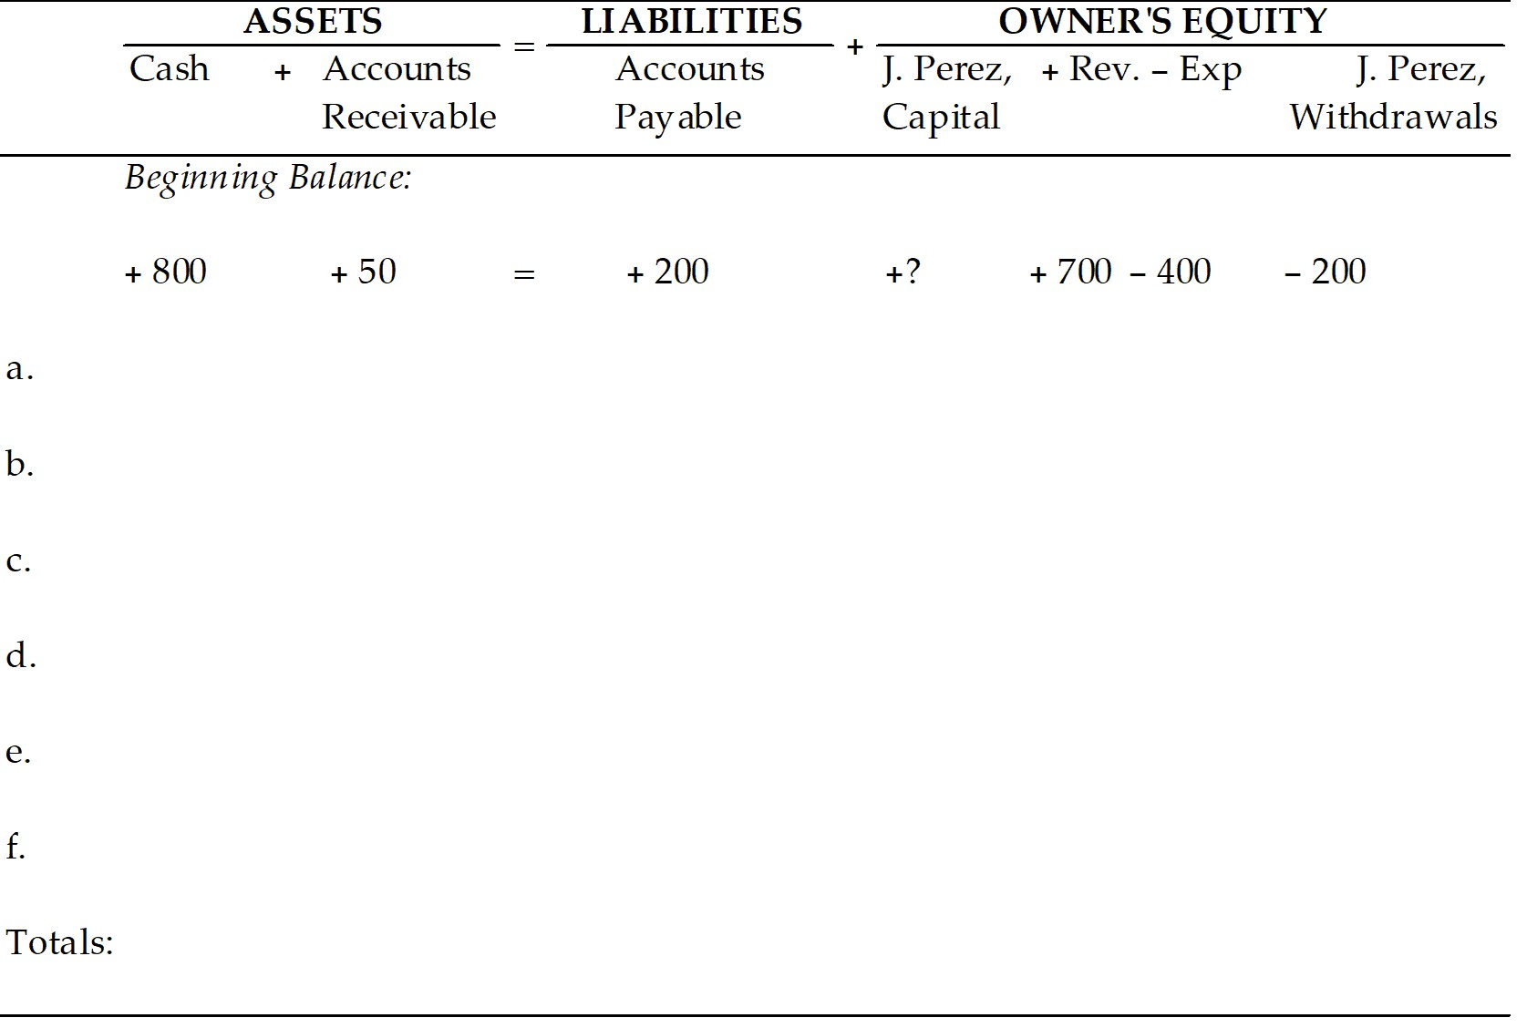

Answer: Jose Perez Company
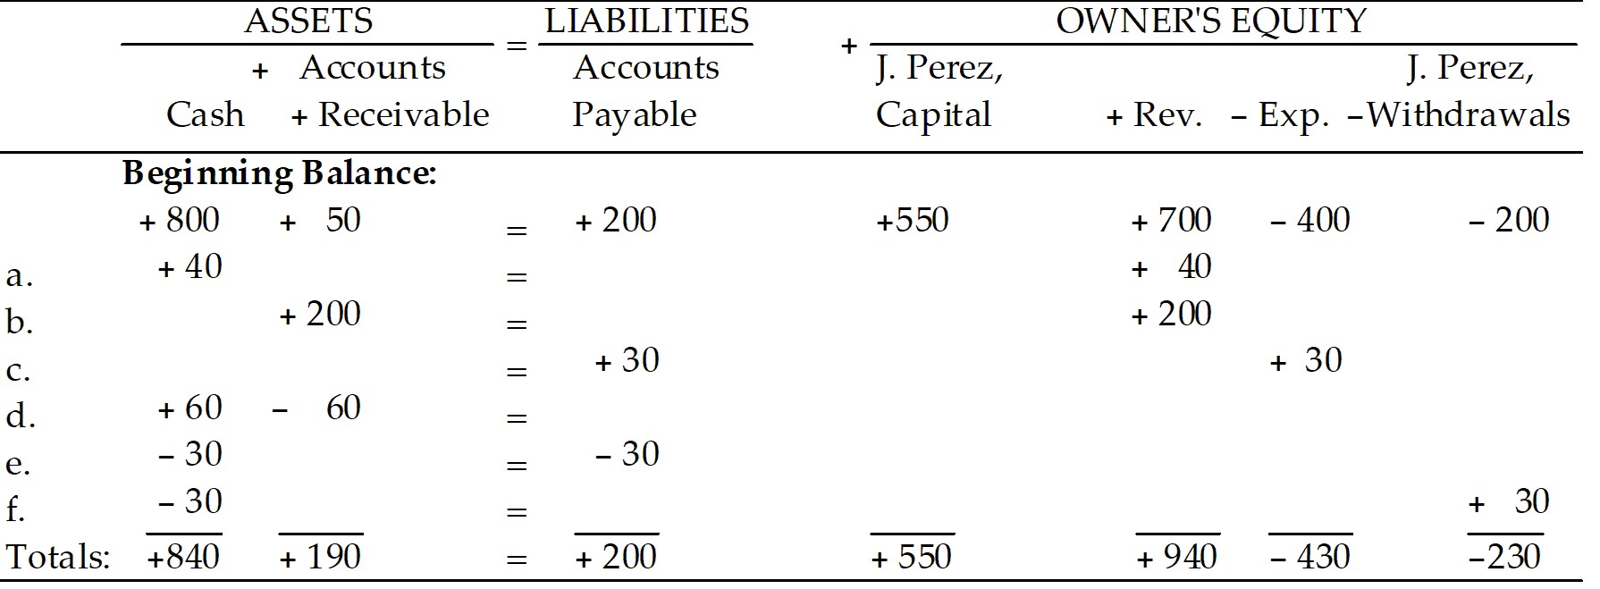
1,030 = 1,030
Diff: 2 Type: ES
Objective: 1-3

50) Record the following transactions into the expanded accounting equation for the Bob Cann Company. Note that all accounts have beginning balances. (You will need to determine the beginning capital balance.)
a. Rendered services for cash, $500.
b. Billed customers for services rendered, $1,000.
c. Received the monthly utility bill to be paid later, $250.
d. Collected $600 on account from customers.
e. Paid the utility bill recorded in c.
f. Withdrew $500 cash for personal use.

Cann Company

 |  | ASSETS | = | LIAB. | OWNER'S EQUITY
 | Cash + | Accts.Rec. | = | Accts Payable | B. Cann, Capital | +Rev. | -Exp. | -B. Cann, With.
beg. | $ 1,200 | $ 500 | = | $700 | ? | $ 1,500 | $800 | $300
a.
b.
c.
d.
e.
f.
T

Answer: Cann Company
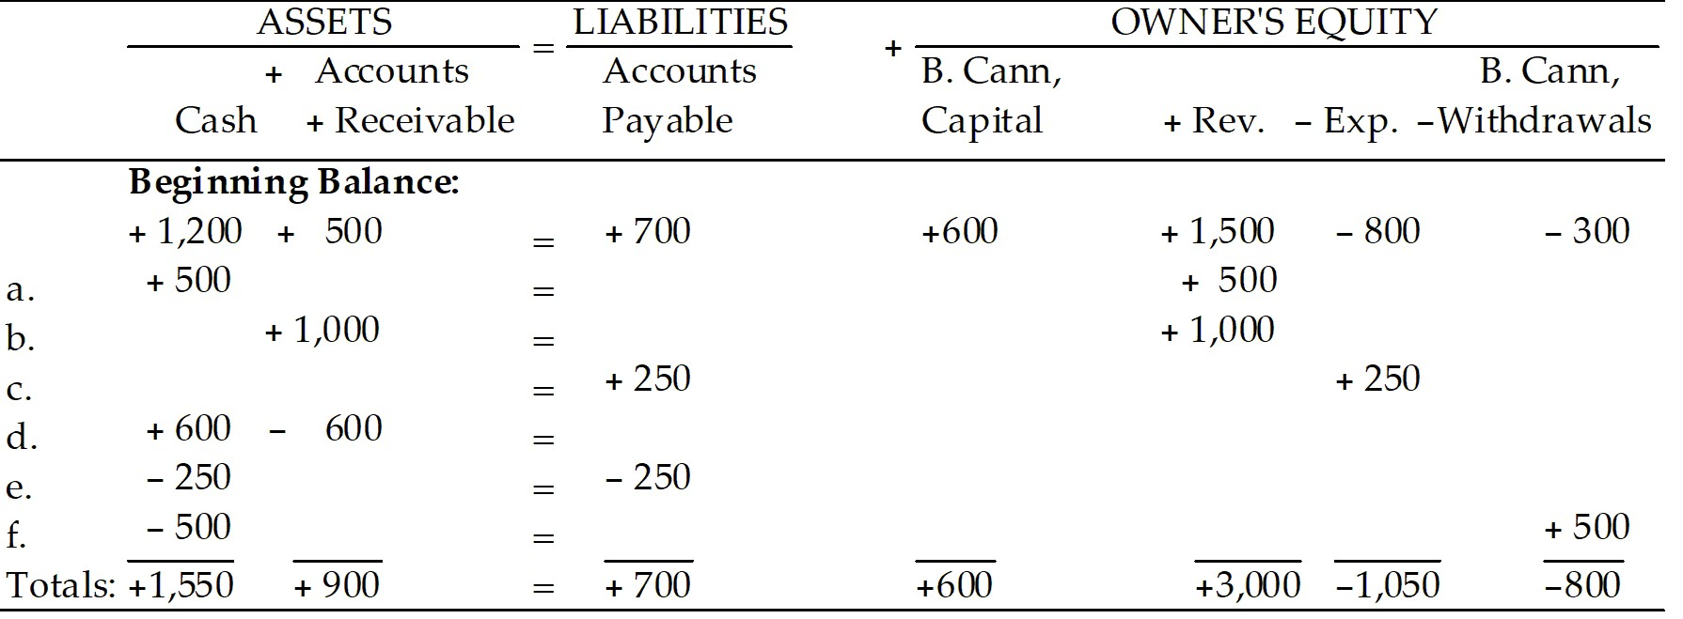
2,450 = 2,450
Diff: 2 Type: ES
Objective: 1-3

51) Which of the following will be recorded in the owner's equity column as a decrease?
A) An exchange of assets
B) The purchase of an asset on credit
C) An investment by the owner
D) A withdrawal by the owner
Answer: D
Diff: 2 Type: MC
Objective: 1-3

52) Record the following transactions into the expanded accounting equation for the Frita's Hair Salon. Note that all accounts have beginning balances. (You will need to determine the beginning capital balance.)
a. Provided hair cutting services for cash, $1,400
b. Billed customers for services rendered, $800
c. Received and paid the monthly rent, $1,600
d. Collected $200 on account from customers
e. Paid supplies expense, $200
f. Withdrew $500 cash for personal use

Frita's Hair Salon
 |  | ASSETS | = | LIAB. | OWNER'S EQUITY
 | Cash + | Accts.Rec. | = | Accts Payable | Frita's Capital | +Rev. | -Exp | -Frita's Withdrawal
beg. | $2,000 | $100 | = | $800 | ??
a.
b.
c.
d.
e.
f.
T

Answer: Frita's Hair Salon
 |  | ASSETS | = | LIAB. | OWNER'S EQUITY
 | Cash + | Accts.Rec. | = | Accts Payable | Frita's Capital | +Rev. | -Exp | -Frita's Withdrawal
beg. | $ 2,000 | $ 100 | = | $800 | $1,300
a. | +1,400 |  |  |  |  | +1,400
b. |  | +800 |  |  |  | +800
c. | -1,600 |  |  |  |  |  | +1,600
d. | +200 | -200
e. | -200 |  |  |  |  |  | +200
f. | -500 |  |  |  |  |  |  | +500
T | $1,300 | $700 |  | $800 | $1,300 | $2,200 | $1,800 | $500

Diff: 3 Type: ES
Objective: 1-3

53) Revenue and expenses will always be the same amount.
Answer: FALSE
Diff: 2 Type: TF
Objective: 1-3

54) Profit decreases equity.
Answer: FALSE
Diff: 2 Type: TF
Objective: 1-3

55) Profit increases drawings.
Answer: FALSE
Diff: 2 Type: TF
Objective: 1-3

56) Revenue and drawings will always be the same amount.
Answer: FALSE
Diff: 2 Type: TF
Objective: 1-3

1.4 Preparing an income statement, a statement of owner's equity, and a balance sheet.

1) The increase or decrease in the owner's equity is reported on the
A) income statement.
B) statement of owner's equity.
C) balance sheet.
D) All of these are correct.
Answer: B
Diff: 2 Type: MC
Objective: 1-4

2) The net income or net loss is calculated on the
A) balance sheet.
B) statement of owner's equity.
C) income statement.
D) none of these.
Answer: C
Diff: 1 Type: MC
Objective: 1-4

3) The income statement is for a particular date.
Answer: FALSE
Diff: 2 Type: TF
Objective: 1-4

4) The income statement is prepared first so the information can be used to prepare the statement of owner's equity.
Answer: TRUE
Diff: 2 Type: TF
Objective: 1-4

5) This statement shows the financial position of a business on a particular date.
A) Income Statement
B) Accounting Equation
C) Expanded Accounting Equation
D) Balance Sheet
Answer: D
Diff: 2 Type: MC
Objective: 1-4

6) The heading of a balance sheet (in correct order) would include
A) who, where, when.
B) who, what, why
C) why, what, where
D) who, what, when
Answer: D
Diff: 3 Type: MC
Objective: 1-4

7) The heading of an income statement (in correct order) would include
A) who, where, when.
B) who, what, why
C) why, what, where
D) who, what, when
Answer: D
Diff: 3 Type: MC
Objective: 1-4

8) The balance sheet contains
A) liabilities, expenses and capital.
B) assets, liabilities and revenues.
C) expenses, assets and cash.
D) assets, liabilities and owner's equity.
Answer: D
Diff: 1 Type: MC
Objective: 1-4

9) Which of the following items is NOT listed on the balance sheet?
A) Accounts Payable
B) Accounts Receivable
C) Revenue
D) Equipment
Answer: C
Diff: 1 Type: MC
Objective: 1-4

10) The balance sheet shows the company's financial position as of a particular date.
Answer: TRUE
Diff: 1 Type: TF
Objective: 1-4

11) Double-underlining is used for every sub-section on a Balance Sheet.
Answer: FALSE
Diff: 1 Type: TF
Objective: 1-4

12) To distinguish the total on a financial statement, use double underlines.
Answer: TRUE
Diff: 1 Type: TF
Objective: 1-4

13) The three elements that make up a balance sheet are assets, liabilities and expenses.
Answer: FALSE
Diff: 2 Type: TF
Objective: 1-4

14) The ending capital figure on the statement of owner's equity will be used on the balance sheet.
Answer: TRUE
Diff: 2 Type: TF
Objective: 1-4

15) The time period covered in a balance sheet is for a stated year.
Answer: FALSE
Diff: 2 Type: TF
Objective: 1-4

16) Which financial statement is prepared first?
A) Statement of Owner's Equity
B) Balance Sheet
C) Income Statement
D) None of the above
Answer: C
Diff: 1 Type: MC
Objective: 1-4

17) The financial statement that shows business results in terms of revenue and expenses is
A) an income statement.
B) a balance sheet.
C) a statement of owner's equity.
D) the expanded accounting equation.
Answer: A
Diff: 2 Type: MC
Objective: 1-4

18) An accounting report that shows the changes in capital during the accounting period is
A) a balance sheet.
B) an income statement.
C) a statement of owner's equity.
D) All of these answers are correct.
Answer: C
Diff: 2 Type: MC
Objective: 1-4

19) Which of the following items are on both the balance sheet and the statement of owner's equity?
A) Net loss
B) Capital
C) Additional owner's investments
D) Owner's withdrawals
Answer: B
Diff: 3 Type: MC
Objective: 1-4

20) Which of the following would be considered a subdivision of owner's equity?
A) Expenses
B) Cash
C) Assets
D) Liabilities
Answer: A
Diff: 1 Type: MC
Objective: 1-4

21) Which two financial statements show results for a period of time?
A) The Balance Sheet and the Statement of Owner's Equity
B) The Balance Sheet and the Income Statement
C) The Statement of Owner's Equity and the Income Statement
D) Only one statement shows results for a period of time
Answer: C
Diff: 3 Type: MC
Objective: 1-4

22) The financial statement that shows revenue and expenses for a period of time is the
A) balance sheet.
B) income statement.
C) statement of owner's equity.
D) statement of cash flows.
Answer: B
Diff: 2 Type: MC
Objective: 1-4

23) Cash is an asset that would appear on the balance sheet.
Answer: TRUE
Diff: 1 Type: TF
Objective: 1-4

24) What three elements make up a balance sheet?
A) Liabilities, expenses, and owner's equity
B) Assets, liabilities, and revenues
C) Debts, assets, and cash
D) Assets, liabilities, and owner's equity
Answer: D
Diff: 1 Type: MC
Objective: 1-4

25) The income statement is a financial statement showing business results in terms of revenues and expenses.
Answer: TRUE
Diff: 2 Type: TF
Objective: 1-4

26) A Statement of owner's equity shows the change in capital.
Answer: TRUE
Diff: 2 Type: TF
Objective: 1-4

27) On the Income Statement, the total of Expenses is always shown with a dollar sign ($).
Answer: FALSE
Diff: 1 Type: TF
Objective: 1-4

28) The statement of owner's equity shows assets, liabilities and capital.
Answer: FALSE
Diff: 2 Type: TF
Objective: 1-4

29) Total assets are included in the statement of owner's equity.
Answer: FALSE
Diff: 2 Type: TF
Objective: 1-4

30) On a Balance Sheet, both the total for Assets and the total of Liabilities plus Owner's Equity are shown with a dollar sign ($).
Answer: TRUE
Diff: 1 Type: TF
Objective: 1-4

31) The statement of owner's equity is the link between the income statement and balance sheet.
Answer: TRUE
Diff: 3 Type: TF
Objective: 1-4

32) The income statement is the first financial statement completed.
Answer: TRUE
Diff: 2 Type: TF
Objective: 1-4

33) Calculate the total Liabilities if the company has: Assets totaling $500 and Capital of $250.
Answer: $250 = $500 -$250
Diff: 1 Type: ES
Objective: 1-4

34) Calculate the total Assets if the company has: Cash $100, Accounts Receivable $300, Accounts Payable $500, Equipment $600.
Answer: $1,000 = $100 + 300 + 600
Diff: 2 Type: ES
Objective: 1-4

35) Use the following information to prepare 1) an income statement, 2) a statement of owner's equity for the month ended March 31, 2022, and 3) a balance sheet at March 31, 2022 for Bolthouse Company.

J. Bolthouse, Capital (beg.) $2,000
Revenue 900
Expenses 600
Withdrawals 150
Cash 3,000
Equipment 1,000
Accounts Receivable 150
Accounts Payable 2,000
Answer: Bolthouse Company
INCOME STATEMENT
For the Month ended March 31, 2022
Revenue $900
Expenses 600
Net Income $300

Bolthouse Company
STATEMENT OF OWNER'S EQUITY
For the Month ended March 31, 2022

J. Bolthouse, Capital, March 1 $2,000
Net Income $300
Less Withdrawals 150

Increase in Capital 150

J. Bolthouse Capital, March 31 $2,150

Bolthouse Company
BALANCE SHEET
March 31, 2022

Assets Liabilities and Owner's Equity
Liabilities
Cash $3,000 Accounts Payable $2,000
Accounts Receivable 150 Owner's Equity
Equipment 1,000 J. Bolthouse, Capital 2,150
Total Assets $4,150 Total Liabilities and Owner's Equity $4,150
Diff: 3 Type: ES
Objective: 1-4

36) Prepare the financial statements for H. Logan of Logan Motorcycles from the following account balances 1) an income statement, 2) a statement of owner's equity for the month ended October 31, 2023, and 3) a balance sheet at October 31, 2023. You will need to calculate the value of the Accounts Payable account (note: remember the basic accounting equation).

Cash $1,300
Accounts Receivable 500
Equipment 2,000
Accounts Payable ???
Travis, Capital 3,000
Revenue 1,000
Expenses 700
Travis, Withdrawal 100
Answer: Logan Motorcycles
INCOME STATEMENT
For the Month ended October 31, 2023

Revenue $1,000
Expenses 700
Net Income $300

Logan Motorcycles
STATEMENT OF OWNER'S EQUITY
For the Month ended October 31, 2023

H. Logan, Capital, Oct. 1 $3,000
Net Income $300
Less Withdrawals 100

Increase in Capital 200

H. Logan, Capital, Oct. 31 $3,200

Logan Motorcycles
BALANCE SHEET
October 31, 2023

Assets Liabilities and Owner's Equity
Liabilities
Cash $1,300 Accounts Payable $ 600
Accounts Receivable 500 Owner's Equity
Equipment 2,000 H. Logan, Capital 3,200
Total Assets $3,800 Total Liabilities & Owner's Equity $3,800
Diff: 3 Type: ES
Objective: 1-4

37) Prepare a balance sheet in proper form for Brampton Cleaners at December 31, 2022. Use the following information:
Accounts Payable $2,500
Accounts Receivable 800
Cash 2,200
Equipment 4,000
K. Carson, Capital?
Answer: BRAMPTON CLEANERS
BALANCE SHEET
December 31, 2022

Liabilities and Owner's Equity
Assets Liabilities
Cash $2,200 Accounts Payable $2,500
Accounts Receivable 800
Equipment 4,000
Owner's Equity
K. Carson, Capital 4,500
Total Assets $7,000 Total Liabilities & Owner's Equity $7,000
Diff: 2 Type: ES
Objective: 1-4

38) Prepare a balance sheet in proper form for Georgia Ironworks at December 31, 2022. Use the following information:
Accounts Payable $1,250
Accounts Receivable 1,600
Cash 3,400
Equipment 3,000
K. Creeper, Capital?
Answer: GEORGIA IRONWORKS
BALANCE SHEET
December 31, 2022

Liabilities and Owner's Equity
Assets Liabilities
Cash $3,400 Accounts Payable $1,250
Accounts Receivable 1,600
Equipment 3,000
Owner's Equity
K. Creeper, Capital 6,750
Total Assets $8,000 Total Liabilities & Owner's Equity $8,000
Diff: 2 Type: ES
Objective: 1-4

39) Determine the ending capital balance of a business which had a beginning capital balance of $1,970, additional investments of $530, withdrawals of $750, revenue of $3,790, and expenses of $2,600.
Answer: $2,940 [$1,970 + $530 - $750 + $3,790 - $2,600]
Diff: 2 Type: ES
Objective: 1-4

40) Determine the beginning capital balance of a business having an ending capital balance of $10,900, no additional investments, withdrawals of $2,500, and a net income of $4,100.
Answer: $9,300 [$10,900 - $4100 + $2500]
Diff: 3 Type: ES
Objective: 1-4

41) Explain the purpose of the following:
a. Income Statement
b. Statement of Owner's Equity
c. Balance Sheet
Answer: a. The income statement is an accounting report that shows business results in terms of revenue and expenses. If revenue is greater than expenses, the result is net income (or profit). If expenses are greater than revenue, the result is a net loss. An income statement can cover any period of time, but is most often one year. Many "public" companies disclose their earnings or losses every three months.

b. The statement of owner's equity shows for a certain time period the changes that occurred in the owner's equity. Increases are due to owner investments and net income, while decreases are due to owner withdrawals and net loss.

c. The balance sheet, or statement of financial position, presents information from the ending balances of the company's assets, liabilities and owner's equity. It summarizes the business' financial position on a given date. Some have said that a balance sheet is like a flash photograph of where a company stands at one point in time—and the analogy is a good one.
Diff: 2 Type: ES
Objective: 1-4

42) Assets and Liabilities are reported on the
A) balance sheet.
B) statement of owner's equity.
C) income statement.
D) none of these.
Answer: A
Diff: 1 Type: MC
Objective: 1-4

43) The balance sheet is prepared first so the information can be used to prepare the statement of owner's equity.
Answer: FALSE
Diff: 2 Type: TF
Objective: 1-4

44) Dollar signs must be used for every number on a Balance Sheet.
Answer: FALSE
Diff: 1 Type: TF
Objective: 1-4

45) The balance sheet is for a particular date.
Answer: TRUE
Diff: 2 Type: TF
Objective: 1-4

46) The statement of owners' equity is for a particular date.
Answer: FALSE
Diff: 2 Type: TF
Objective: 1-4

47) Indicate which Financial Report each the following would be reported on (1) Income Statement, (2) Statement of Owner's Equity, or (3) Balance Sheet:
1. ________ Merchandise Inventory
2. ________ Accounts Payable
3. ________ Additional Investments
4. ________ Cash
5. ________ Withdrawal
6. ________ Land
7. ________ Accounts Receivable
8. ________ Expense
9. ________ Equipment
10. ________ Revenue
Answer:
1. Balance Sheet
2. Balance Sheet
3. Statement of Owner's Equity
4. Balance Sheet
5. Statement of Owner's Equity
6. Balance Sheet
7. Balance Sheet
8. Income Statement
9. Balance Sheet
10. Income Statement
Diff: 2 Type: ES
Objective: 1-4

48) Indicate which Financial Report each the following would be reported on (1) Income Statement, (2) Statement of Owner's Equity, or (3) Balance Sheet:
1. ________ Sales Revenue
2. ________ Rent Expense
3. ________ Beginning Capital
4. ________ Salaries Expense
5. ________ Bank Loan
6. ________ Interest Receivable
7. ________ Interest Payable
8. ________ Interest Expense
9. ________ Office Equipment
10. ________ Net Income/Loss
Answer:
1. Income Statement
2. Income Statement
3. Statement of Owner's Equity
4. Income Statement
5. Balance Sheet
6. Balance Sheet
7. Balance Sheet
8. Income Statement
9. Balance Sheet
10. Income Statement
Diff: 2 Type: ES
Objective: 1-4

