# Chapter 1

## Introduction to Managerial Accounting

**Quick Check**

|  |  |  |  |
| --- | --- | --- | --- |
|  |  |  |  |

**Answers**

QC1-1. c

QC1-2. d

QC1-3. b

QC1-4. d

QC1-5. d

QC1-6. c

QC1-7. a

QC1-8. c

QC1-9. b

QC1-10. a

QC1-11. d

QC1-12. b

**Short Exercises**

(5–10 min.) S1-1

a. Planning

b. Controlling

c. Directing

d. Directing

e. Directing, Controlling

**(5–10 min.) S1-2**

a. Financial accounting

b. Financial accounting

c. Financial accounting

d. Managerial accounting

e. Managerial accounting

f. Managerial accounting

g. Financial accounting

h. Financial accounting

i. Managerial accounting

j. Managerial accounting

k. Financial accounting

l. Managerial accounting

m. Financial accounting

(5–10 min.) S1-3

a. Internal Auditing Department

b. Controller

c. Internal Auditing Department

d. Internal Auditing Department

e. Treasurer

f. Controller

g. Controller

h. Controller

i. Controller

j. Controller

k. Controller

l. Treasurer

m. Treasurer

(5–10 min.) S1-4

|  |  |  |
| --- | --- | --- |
|  | **Characteristic** | **Check (√) if related to internal auditing** |
| a. | Reports directly to the audit committee | **√** |
| b. | Reports to treasurer or controller |  |
| c. | Is part of the Accounting Department |  |
| d. | Helps to ensure that company’s internal controls are functioning properly | **√** |
| e. | Performs the same function as independent certified public accountants |  |
| f. | Usually reports to a senior executive (CFO or CEO) for administrative matters | **√** |
| g. | External audits can be performed by the internal auditing department |  |
| h. | Required by the New York Stock Exchange if company stock is publicly traded on the NYSE | **√** |
| i. | Ensures that the company achieves its profit goals |  |

(10 min.) S1-5

a. The CEO is hired by the *board of directors*.

b. A subcommittee of the board of directors is called the *audit committee*.

c. Raising capital and investing funds are the direct responsibilities of the *treasurer*.

d. The *CFO* and the *COO* report to the CEO.

e. Financial accounting, managerial accounting, and tax reporting are the direct responsibilities of the *controller*.

f. Management accountants often work on *cross-functional teams*.

g. The internal audit function reports to the CFO or the *CEO* and the *audit committee*.

h. The company’s operations are the direct responsibility of the *COO*.

(5 min.) S1-6

1. The Institute of Management Accountants (IMA) issues the Certified Management Accountant (CMA) certification.

2. The certification offered by IMA, focuses on accounting and finance topics.

3. The monthly professional magazine published by the Institute of Management Accountants is called *Strategic Finance*.

4. The certification launched in 2012 jointly by the Association of International Certified Professional Accountants (AICPA) and the Chartered Institute of Management Accountants (CIMA) is called the Chartered Global Management Accountant (CGMA).

5. To earn CMA certification, a candidate must have a(n) baccalaureate degree. The CMA exam can be taken, however, before finishing this degree.

(5 min.) S1-7

1. Failing to provide job description information to management because you fear it may be used to cut a position in your department violates the *credibility* standard.
2. Providing earnings information to your sister before it is publicly announced violates the *confidentiality* standard.
3. Failing to read the specifications of the software package before purchasing it violates the *competence* standard.
4. Stealing from your employer is a violation of the *integrity* standard.
5. Skipping continuing education sessions could violate the requirement to maintain professional *competence*. If your company paid for you to attend the conference, skipping the sessions also violates the *integrity* standard.

(5 min.) S1-8

a. Sustainability

b. Sarbanes-Oxley Act (SOX)

c. Enterprise resource planning (ERP) system

d. Data analytics

(5 min.) S1-9

|  |  |  |
| --- | --- | --- |
| **Letter** | **Scenario** | **Standard violated** |
| a. | Aidan, an accountant for a smartphone manufacturer, told his friends about a new model of smartphone being released by the company in the following quarter. For competitive reasons, the company keeps its models shrouded in secrecy until release date. | Confidentiality |
| b. | The CFO directed that certain expenses be reclassified as assets, so that target profit could be achieved. The CFO rationalized that jobs would be saved by reaching the targeted income figures. | Integrity |
| c. | Even though Meagan's company is adopting a new ERP system that impacts the accounting system, Meagan (a management accountant) has not completed the required ERP training from the vendor. | Competence |
| d. | Mateo provides an analysis of the profitability of a company-owned store that is managed by Mateo’s best friend, Akeno. Mateo neglects to include allocated fixed costs in Akeno’s report. If Mateo includes those allocated fixed costs, the store will show a loss and Akeno’s job could be in danger. | Credibility |
| e. | Yimeng, a purchasing agent for their company, received two tickets from a supplier to the upcoming Ohio State versus University of Michigan football game. These tickets sell for over $500 each. | Integrity |

(10 min.) S1-10

1. Financial accounting system
2. Critical thinking
3. IMA
4. Treasurer
5. Economic, environmental, and social
6. Controller
7. Internal audit
8. Sarbanes-Oxley Act of 2002
9. Triple Bottom Line
10. Controlling
11. Directing
12. ERP
13. Sustainability
14. CEO
15. Planning
16. CFO

(5 min.) S1-11

Data analytics adds more fact-based information to the decision-making process. Data analytics allows organizations to make quicker decisions. Data analytics can also increase the efficiency of internal operations. Data analytics can help companies better adapt and respond to customer’s individual preferences by more specifically tailoring marketing efforts. Finally, data analytics can drive company innovation and have a disruptive effect on existing industries.

(10 min.) S1-12

|  |  |  |
| --- | --- | --- |
| Item | Task | Screen shot letter |
| 1. | Format as accounting number | K |
| 2. | Insert new workbook | I |
| 3. | Insert function | D |
| 4. | Worksheet name | H |
| 5. | Decrease decimal | J |
| 6. | Active cell | E |
| 7. | Ribbon | A |
| 8. | Name of workbook (file name) | G |
| 9. | Cell reference | C |
| 10. | Formula bar | F |
| 11. | Name box | B |

(10 min.) S1-13

|  |  |
| --- | --- |
| Task | Description of how to do the task in Excel (Windows) |
| 1. Change the order of the worksheets in the workbook | c. Drag and drop worksheet to desired location. |
| 2. Copy and paste the contents of one cell to another cell | j. In the first cell, hold down Ctrl + C, then navigate to the desired cell and hold down Ctrl + V. |
| 3. Copy the contents of a cell to a range of cell | a. Drag the fill handle down the column or across the row. |
| 4. Go to the end of the data set in a worksheet | g. Hold down the Ctrl and End keys simultaneously. |
| 5. Move between worksheets | i. Click on a worksheet tab. |
| 6. Refer to a cell as an absolute reference | d. Put dollar signs in front of both the column and row reference in the formula. |
| 7. Rename worksheet | h. Right click worksheet tab and select option to give the worksheet a new name. |
| 8. Select a range of cells | b. Click on the first cell in a range and drag your cursor to the final cell you are selecting. |
| 9. Select all data in a worksheet | e. Hold down the Ctrl and A keys simultaneously. |
| 10. Select one cell | f. Click on a cell. |

(10 min.) S1-14

1. =B2*C2
2. Drag the cell handle in the lower right corner of Cell D2 down to Cell D5.
3. =SUM(B2:B5)
4. =SUM(D2:D5)
5. =B2+B4
6. =D2+D4
7. =B10/B9
8. =B3-B5
9. =D3-D5

(10 min.) S1-15

1. To quickly navigate to the end of the data in a worksheet when using Excel in a Windows environment, use the Ctrl + End keystrokes.
2. The top bar in an Excel workbook that contains File, Home, Insert, and other tabs is called the ribbon.
3. File, Home, Insert, Page Layout, Formulas, and Data are examples of tabs.
4. The formula bar displays how the content of the active cell was generated.
5. To select all data in a worksheet when using Excel in a Windows environment, use the Ctrl + A keystrokes.
6. The worksheet tab is right clicked to rename it.
7. The active cell will have a colored border around it and the cell reference will appear in the name box.
8. A unique address for each cell in an Excel worksheet is called a cell reference.
9. The cell reference for the active cell will appear in the name box.
10. To quickly navigate to the first column of a row in Excel when using Excel in a Windows environment, use the Ctrl + arrow left keystrokes.
11. There are separate tabs for each worksheet in a workbook.

Exercises (Group A)

(10 min.) E1-16A

a. Information on a company’s past performance is provided to external parties by financial accounting*.*

b. Managerial accounting systems are chosen by comparing the costs versus the benefits of the system and are not restricted by GAAP (or International Financial Reporting Standards, IFRS, in the case of companies headquartered in many countries outside of the United States).

c. Managerial accounting systems report on various segments or business units of the company.

d. Financial accounting develops reports for external parties such as creditors and shareholders.

e. When managers evaluate the company’s performance compared to the plan, they are performing the controlling role of management.

f. CPAs audit the financial accounting statements of public companies.

g. Companies must follow GAAP (or International Financial Reporting Standards, IFRS, in the case of companies headquartered in many countries outside of the Unites States) in their financial accounting systems.

h. Choosing goals and the means to achieve them is the planning function of management.

i. Decision makers inside a company are the managers.

**(10 min.) E1-17A**

1. Technical
2. Nontechnical
3. Technical
4. Nontechnical
5. Nontechnical
6. Nontechnical
7. Technical
8. Technical
9. Technical
10. Technical
11. Nontechnical
12. Nontechnical
13. Technical
14. Nontechnical
15. Technical
16. Technical
17. Nontechnical
18. Nontechnical
19. Technical
20. Nontechnical

**(10 min.) E1-18A**

1. Financial accounting information

2. Managerial accounting information

3. Financial accounting information

4. Financial accounting information

5. Managerial accounting information

6. Financial accounting information

7. Both

8. Financial accounting information

9. Financial accounting information

10. Financial accounting information

11. Both

12. Both

13. Financial accounting information

14. Financial accounting information

(10 min.) E1-19A

1. Confidentiality

2. Credibility

3. Credibility

4. Credibility

5. Confidentiality

6. Confidentiality

7. Integrity

8. Competence

9. Competence

10. Competence

11. Integrity

12. Integrity

13. Competence

(10 min.) E1-20A

Expected benefit (cost savings)

Wages (20 workers x 40 hrs. x $15/hr.) $12,000

Payroll taxes ($12,000 x 7.65%) 918

Total expected cost savings $12,918

Expected costs

Lettuce Bot cost (machine cost) $8,000

Lettuce Bot delivery cost 500

Cost of operating the lettuce bot 1,500

Total expected costs $10,000

Net expected benefit in first year $2,918

(10 min.) E1-21A

1. Economic
2. Social
3. Environmental
4. Social
5. Environmental
6. Social
7. Economic
8. Environmental
9. Environmental
10. Social
11. Social
12. Social
13. Social
14. Environmental

**(20 min.) E1-22A**

**Excel file should show:**

**(continued) E1-22A**

**Formulas in each cell should be:**

**(10 min.) E1-23A**

1. 985
2. MD-Disability
3. 389
4. 3
5. 49926
6. See below
   1. $636.10
   2. 12
   3. $7,633.20
7. 80840
8. Click in the cell in the upper left corner of the worksheet (the intersection of the row and column headers)

**(10 min.) E1-24A**

**Excel file should show:**

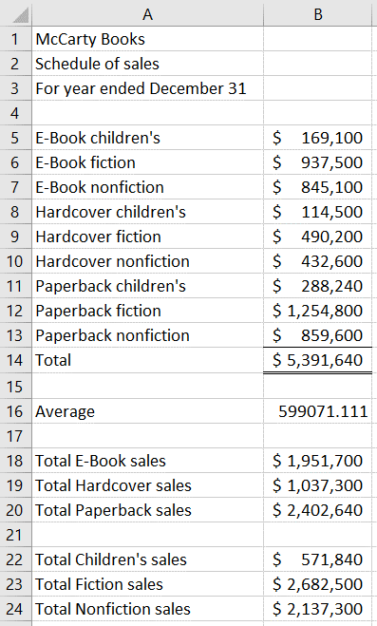

**(continued) E1-24A**

**Formulas in each cell should be:**

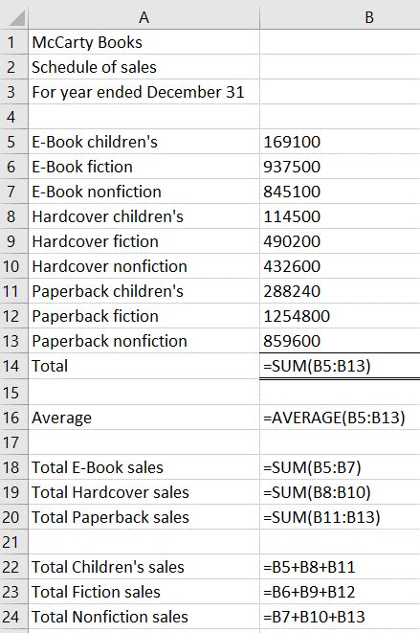**Exercises (Group B)**

(5 min.) E1-25B

a. U.S. companies must follow GAAP (or International Financial Reporting Standards, IFRS, in the case of companies headquartered in many countries outside of the United States) in their financial accounting systems.

b. Financial accounting develops reports for external parties, such as creditors and shareholders.

c. When managers evaluate the company’s performance compared to the plan, they are performing the controlling role of management.

d. Managers are decision makers inside a company.

e. Financial accounting provides information on a company’s past performance to external parties.

f. Managerial accounting systems are not restricted by GAAP (or International Financial Reporting Standards, IFRS, in the case of companies headquartered in many countries outside of the United States) but are chosen by comparing the costs versus the benefits of the system.

g. Choosing goals and the means to achieve them is the planning function of management.

h. Managerial accounting systems report on various segments or business units of the company.

i. Financial accounting statements of public companies are audited annually by CPAs.

(5–10 min.) E1-26B

1. Nontechnical
2. Nontechnical
3. Nontechnical
4. Technical
5. Nontechnical
6. Technical
7. Technical
8. Technical
9. Nontechnical
10. Technical
11. Nontechnical
12. Technical
13. Nontechnical
14. Technical
15. Technical
16. Technical
17. Technical
18. Nontechnical
19. Nontechnical
20. Nontechnical

(5–10 min.) E1-27B

1. Both

2. Financial accounting information

3. Financial accounting information

4. Managerial accounting information

5. Financial accounting information

6. Managerial accounting information

7. Financial accounting information

8. Financial accounting information

9. Financial accounting information

10. Financial accounting information

11. Both

12. Both

13. Financial accounting information

14. Financial accounting information

(10 min.) E1-28B

1. Credibility

2. Competence

3. Integrity

4. Competence

5. Integrity

6. Credibility

7. Confidentiality

8. Competence

9. Integrity

10. Confidentiality

11. Credibility

12. Confidentiality

13. Competence

(10 min.) E1-29B

Expected benefit (cost savings)

Wages (25 workers x 50 hrs. x $15/hr.) $18,750

Payroll taxes ($18,750 x 7.65%) 1,434

Total expected cost savings $20,184

Expected costs

Lettuce bot cost (machine cost) $ 9,500

Lettuce bot delivery cost 1,000

Cost of operating the lettuce bot 2,500

Total expected costs $13,000

Net expected benefit in first year $7,184

(10 min.) E1-30B

1. Social
2. Environmental
3. Environmental
4. Economic
5. Environmental
6. Social
7. Environmental
8. Social
9. Environmental
10. Social
11. Economic
12. Social
13. Environmental
14. Social

**(20 min.) E1-31B**

**Excel file should show:**

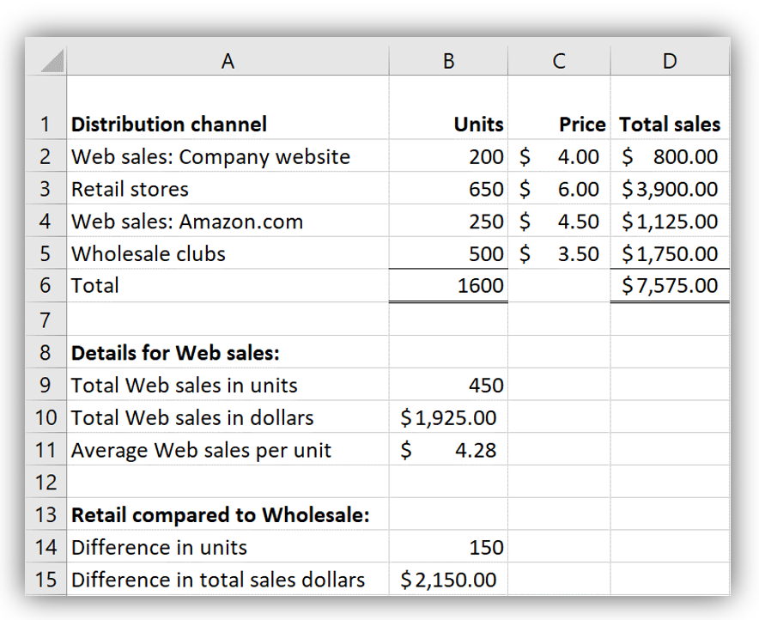

**Formulas in each cell should be:**

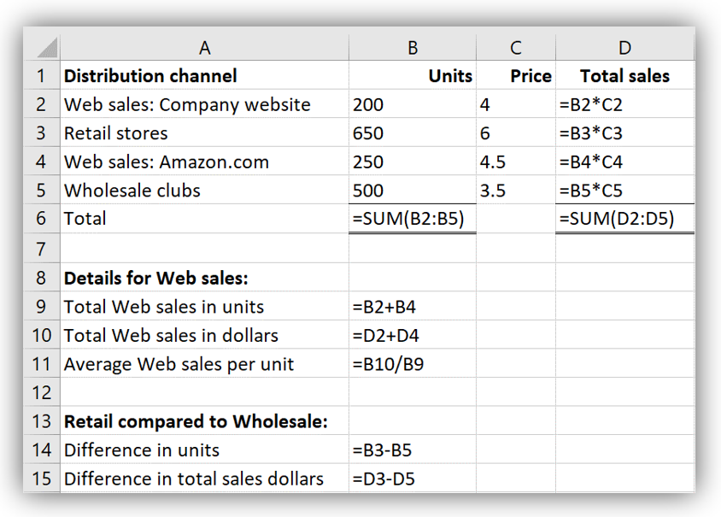

**(10 min.) E1-32B**

1. 386
2. NJ-Disability
3. 693
4. 9
5. 57516
6. See below
   1. $679.55
   2. 12
   3. $8,154.59
7. 56243
8. Click in the cell in the upper left corner of the worksheet (the intersection of the row and column headers)

**(10 min.) E1-33B**

**Excel file should show:**

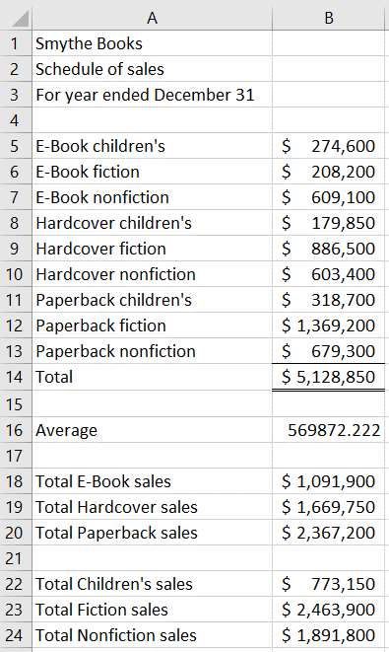

**(continued) E1-33B**

**Formulas in each cell should be:**

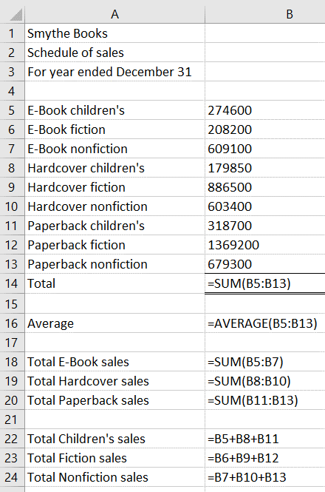

**Problems (Group A)**

(45–60 min.) P1-34A

*Req. 1*

|  |  |  |  |
| --- | --- | --- | --- |
|  | **Planning** | **Directing** | **Controlling** |
| Sales | Increase sales | Setting competitive prices.  Examine sales reports. | Monitor sales numbers and prices from different products and locations over time. Investigate variances. |
| Repairs | Increase volume of repairs | Streamline process to save time. Set competitive prices; generate reports showing time used for each type of repair. | Track total number of repairs and see if more repairs are being made and if time is utilized efficiently. |
| Lessons | Increase number of lessons given | Find out what customers want and need. Observe competitors for prices and lessons offered. Improve teacher qualifications. | Examine number of lessons given per instrument. |
| Web development | Increase Web traffic | Improve design of website. Offer more products online. Make shopping easier and more intuitive. Increase marketing efforts. | Monitor Web traffic by having an online counting device. Look at sales numbers to see if people are just surfing or actually buying merchandise. |
| Accounting | Implement ERP system to monitor department activities and record finances | Train employees on new system. Find potential flaws in the system and fix before implementation. | Track employee work schedules to stay on time. Double-check entries to ensure system is working properly. |
| Human resources | Decrease employee turnover | Hire employees who are “a good fit” for the company.  Raise employee morale; set clear job descriptions. Give feedback to employees. | Monitor both involuntary and voluntary turnover. Interview employees to determine potential problems with the workplace. |

(continued) P1-34A

*Req. 2*

|  |  |  |  |
| --- | --- | --- | --- |
|  | **Planning** | **Directing** | **Controlling** |
| Sales | A sales budget for the entire company and each individual product at each location is needed. | Analyze sales reports to monitor type and amount of sales made. Prices would be analyzed using these reports and market analysis of competitors. | Compare budgets with actual sales numbers. Investigate variances to take corrective actions if needed. Change prices if deemed appropriate. |
| Repairs | Labor budgets would be needed to determine the time taken to repair instruments and if hiring more repair staff would be feasible. | Employee training programs would be used. Monitor time taken per repair for each member of repair staff. | Compare budgets with actual results. Investigate variances and take corrective action if needed. |
| Lessons | Budgets for types of lessons offered, time needed per lesson taught, and market analysis to determine which lessons potential customers want. | Ensure customer satisfaction by hiring qualified staff. Analyze market analysis to determine market needs and proper pricing schemes. | Compare budgets with actual results. Use customer feedback to improve lessons. Make changes if needed. |
| Web development | An expense budget is needed to ensure money is spent efficiently. A budget would also be needed to set Web traffic goals. | Monitor department expenses and website visits using online counting program. | Compare budgeted expenses with actual and compare expected Web traffic with actual. Investigate variances and make changes as needed. |
| Accounting | Time budgets as well as expense budgets are needed. | Train employees on new system to keep within time budget. Monitor expenses closely. | Compare budget with actual numbers. Investigate variances and make changes if needed. |
| Human resources | Employee satisfaction surveys and feedback reports. | Active relationship between management and employees. Management would record needs and suggestions made by employees in feedback system. | Consider employee suggestions and enact changes if needed. |

*Note:* All the information needed in the table above would be generated almost entirely by the managerial accounting system. Managerial accounting systems provide much of the information needed for internal decision making, while financial accounting systems are geared towards external financial reporting.

(15–20 min.) P1-35A

1. If the goods have been received, postponing recording of the purchases understates liabilities. This is unethical and inconsistent with the IMA standards even if the supplier agrees to delay billing.
2. The software has not been sold. Therefore, it would be inconsistent with the IMA standards to record it as sales.
3. Delaying year-end closing incorrectly records next year’s sales as this year’s sales. This is clearly wrong and unethical, and it is inconsistent with the IMA standards.
4. The appropriate allowance for bad debts is a difficult judgment. The decision should not be driven by the desire to meet a profit goal. It should be based on the likelihood that the company will collect. We cannot determine this without more information. However, because the company emphasizes earnings growth, which can lead to sales to customers with weaker credit records, reducing the allowance seems questionable. This strategy is likely inconsistent with the IMA standards.
5. If the maintenance is postponed, there is no transaction to record. This strategy is beyond the responsibility of the controller, so it does not violate IMA standards.

Strategies a, b, and c are clearly unethical and inconsistent with the IMA standards of integrity, credibility, and perhaps competence. Strategy d is likely unethical, but we cannot be certain without more information. The controller should resist attempts to implement a, b, and c, and she should gather more information about d. If the president ignores the controller’s concerns and still insists that these strategies be implemented, then the controller should probably resign rather than continuing to work for a company that engages in unethical behavior.

(15–20 min.) P1-36A

*Req. 1*

Benefits if the project is successful:

|  |  |
| --- | --- |
| Savings from more efficient order processing………………………… | $105,000 |
| Savings from streamlining the manufacturing process……………… | 125,000 |
| Savings from inventory reduction……………………………………….. | 225,000 |
| Profits from increased sales...........…………………………………….... | 155,000 |
| Total benefits if the project is successful……………………………… | $610,000 |

*Req. 2*

Costs of implementing the project:

|  |  |
| --- | --- |
| Software costs…………………………………………………………………. | $435,000 |
| Customizing ERP and loading data……………………...………………… | 95,000 |
| Employee training…………………………………………………………….. | 105,000 |
| Total costs…………………………………..………………………………….. | $635,000 |

Now compare the value of benefits to the costs:

|  |  |
| --- | --- |
| Expected benefits………….................................................. | $610,000 |
| Expected costs...…………………………….......................... | (635,000) |
| Net benefits (costs)…………..…...…………………………... | $ (25,000) |

Because the expected value of the benefits is less than the total costs, the company should not undertake the project.

*Req. 3*

The CEO formed a team to evaluate the feasibility of installing an ERP system for two reasons. First, the project was probably too big for one person. Second, representatives of the different functional business areas have different knowledge and information to contribute.

|  |  |  |
| --- | --- | --- |
| a. | Estimating software costs | systems specialist |
| b. | Estimating cost of loading data into the new ERP system | management accountant  systems specialist |
| c. | Customize the ERP software | management accountant  systems specialist |
| d. | Estimate customization costs | all team members |
| e. | Estimate training costs | human resource director |
| f. | Savings from more efficient order processing | systems specialist  management accountant |
| g. | Savings from streamlining the manufacturing process | plant engineer  plant foreman |
| h. | Evaluate the effects of integrating purchasing, production, marketing, and distribution into a single system | plant foreman |
| i. | Estimate increase in sales from higher customer satisfaction | marketing director |
| j. | Estimate benefits and costs | all team members |

Student answers may vary. The main point is that different team members contribute different knowledge.

(10–15 min.) P1-37A

|  |  |
| --- | --- |
| Costs: |  |
| Financial assistance to dealers...............………….. | $ 760,000 |
| Computer hardware upgrade………………….......... | 160,000 |
| Software and consulting fees……………………….. | 220,000 |
| Total costs...........................………………………............ | $1,140,000 |
|  |  |
|  |  |
| Value of benefits (lower labor costs)………….……….. | $1,340,000 |
| Total costs...............................………………………….… | (1,140,000) |
| Excess of benefits over costs…………………………… | $ 200,000 |

Because the benefits exceed the costs, a cost-benefit analysis suggests that the company should proceed with the online ordering system.

(20–25 min.) P1-38A

*Req. 1*

The expected value of the benefits is the labor cost savings of $935,000. This is a downward revision from what was originally estimated in P1-37A.

*Req. 2*

|  |  |
| --- | --- |
| Expected value of benefits……….……………............ | $935,000 |
| Total costs (from P1-37A)………………...……………. | (1,140,000) |
| Net cost..........................………………………………… | $ (205,000) |

The revised estimates mean the expected costs are greater than the expected benefits. The quantitative analysis suggests that the company should not undertake the project. Before deciding, the company should carefully consider other factors like those listed in *Req. 3*.

*Req. 3*

Other factors management should consider before making a final decision include the following:

* The difficulty and costs of laying off employees may reduce the expected benefits.
* Employee layoffs may hurt morale and efficiency in other areas of the company, thus increasing costs.
* Electronic order processing should reduce human errors, thereby reducing costs.
* Providing dealers with current availability, price information, and timely order processing will help the company manage and reduce its inventories.

Student answers to *Req. 3* may vary.

Problems (Group B)

(45–60 min.) P1-39B

*Req. 1*

|  |  |  |  |
| --- | --- | --- | --- |
|  | **Planning** | **Directing** | **Controlling** |
| Sales | Increase sales | Setting competitive prices.  Examine sales reports. | Monitor sales numbers and prices from different products and locations over time. Investigate variances. |
| Repairs | Increase volume of repairs | Streamline process to save time. Set competitive prices; generate reports showing time used for each type of repair. | Track total number of repairs and see if more repairs are being made and if time is utilized efficiently. |
| Customization | Increase number of custom systems built | Find out what customers want and need. Observe competitors for prices and options offered. Improve employee certification and offer higher-quality parts. | Examine number of computer systems built per type (multimedia, gaming, etc.). |
| Web development | Increase Web traffic | Improve design of website. Offer more products online. Make shopping easier and more intuitive. Increase marketing efforts. | Monitor Web traffic by having an online counting device. Look at sales numbers to see if people are just surfing or actually buying merchandise. |
| Accounting | Implement ERP system to monitor department activities and record finances | Train employees on new system. Find potential flaws in the system and fix before implementation. | Track employee work schedules to stay on time. Double check entries to ensure system is working properly. |
| Human resources | Decrease employee turnover | Hire employees who are “a good fit” for the company.  Raise employee morale; set clear job descriptions. Give feedback to employees. | Monitor both involuntary and voluntary turnover. Interview employees to determine potential problems with the workplace. |

(continued) P1-39B

*Req. 2*

|  |  |  |  |
| --- | --- | --- | --- |
|  | **Planning** | **Directing** | **Controlling** |
| Sales | Haas would need a sales budget for the entire company and each individual product at each location. | Analyze sales reports to monitor type and amount of sales made. Prices would be analyzed using these reports and market analysis of competitors. | Compare budgets with actual sales numbers. Investigate variances to take corrective actions if needed. Change prices if deemed appropriate. |
| Customization | Budgets for types of computers offered, time needed per job, and market analysis to determine which computers potential customers want. | Ensure customer satisfaction by hiring qualified staff. Research quality of available parts. Analyze market analysis to determine market needs and proper pricing schemes. | Compare budgets with actual results. Use customer feedback to improve custom builds. Make changes if needed. |
| Repairs | Labor budgets would be needed to determine the time taken to repair instruments and if hiring more repair staff would be feasible. | Employee training programs would be used. Monitor time taken per repair for each member of repair staff. | Compare budgets with actual results. Investigate variances and take corrective action if needed. |
| Web development | Haas would need an expense budget to ensure money is spent efficiently. A budget would also be needed to set Web traffic goals. | Monitor department expenses and website visits using online counting program. | Compare budgeted expenses with actual and compare expected Web traffic with actual. Investigate variances and make changes as needed. |
| Accounting | Haas would need time budgets as well as expense budgets. | Train employees on new system to keep within time budget. Monitor expenses closely. | Compare budget with actual numbers. Investigate variances and make changes if needed. |
| Human resources | Employee satisfaction surveys and feedback reports. | Active relationship between management and employees. Management would record needs and suggestions made by employees in feedback system. | Consider employee suggestions and enact changes if needed. |

*Note:* All the information needed in the table above would be generated almost entirely by the managerial accounting system. Managerial accounting systems provide much of the information needed for internal decision making, while financial accounting systems are geared toward external financial reporting.

(15–20 min.) P1-40B

1. If advertising is postponed, there is no transaction to record. This strategy is beyond the responsibility of the controller, so it does not violate IMA standards.
2. The value of each individual sales return may not be material. However, even if each is small on an individual basis, in aggregate, they may amount to a material level. Failing to record sales returns and allowances will falsely inflate this year’s sales, so it is inconsistent with the IMA standards.
3. If customers actually place orders in December and those orders are filled, then a transaction has occurred that can legitimately be recorded. This strategy does not violate IMA standards.
4. The appropriate allowance for bad debts is a difficult judgment. The allowance for bad debts should not be driven by the desire to meet a profit goal. It should be based on the collectability of the accounts receivable. Without more information on the collectability of accounts receivable, it is not clear whether this strategy would violate IMA standards.
5. The goods in the public warehouses have not yet been sold and therefore should not be recorded as sales. This strategy is inconsistent with the IMA standards.

Strategies b and e are clearly unethical and violate the IMA standards of integrity, credibility, and perhaps competence. Without more information, it is not clear whether strategy d violates the IMA standards. The controller should resist attempts to implement b and e and should gather more information about d. If the president ignores the controller’s concerns, then the controller should probably resign rather than continuing to work for a company that engages in unethical behavior.

(15–20 min.) P1-41B

*Req. 1*

Benefits if the project is successful:

|  |  |
| --- | --- |
| Savings from more efficient order processing……………………………. | $185,000 |
| Savings from streamlining the manufacturing process…………………. | 255,000 |
| Savings from inventory reduction…………………………………………… | 215,000 |
| Profits from increased sales...........………………………………………….. | 150,000 |
| Total benefits if the project is successful………………………………….. | $805,000 |

*Req. 2*

Costs of implementing the project:

|  |  |
| --- | --- |
| Software costs……………………………………………………….. | $390,000 |
| Customizing ERP and loading data……………………...………. | 85,000 |
| Employee training…………………………………………………… | 112,000 |
| Total costs…………………………………..………………………... | $587,000 |

Now compare the value of benefits to the costs:

|  |  |
| --- | --- |
| Expected benefits…………................................................. | $805,000 |
| Costs ………………………………………….......................... | (587,000) |
| Excess of benefits over costs…...…………………………. | $218,000 |

Because the expected value of the benefits is greater than the total costs, the company should undertake the project.

(continued) P1-41B

*Req. 3*

A team was formed to evaluate the feasibility of installing an ERP system for two reasons. First, the project was probably too big for one person. Second, the representatives of the different functional business areas have different knowledge and information to contribute.

|  |  |  |
| --- | --- | --- |
| a. | Estimating software costs | systems specialist |
| b. | Estimating cost of loading data into the new ERP system | management accountant  systems specialist |
| c. | Customize the ERP software | management accountant  systems specialist |
| d. | Estimate customization costs | all team members |
| e. | Estimate training costs | human resource director |
| f. | Savings from more efficient order processing | systems specialist  management accountant |
| g. | Savings from streamlining the manufacturing process | plant engineer  plant foreman |
| h. | Evaluate the effects of integrating purchasing, production, marketing, and distribution into a single system | plant foreman |
| i. | Estimate increase in sales from higher customer satisfaction | marketing director |
| j. | Estimate benefits and costs | all team members |

Student responses may vary. The main point is that different team members contribute different knowledge.

(10–15 min.) P1-42B

|  |  |
| --- | --- |
| Costs: |  |
| Financial assistance to dealers...............………………………. | $ 765,000 |
| Computer hardware upgrade…………………........................... | 150,000 |
| Software and consulting fees……………………………………. | 240,000 |
| Total costs...........................………………………............................. | $1,155,000 |
|  |  |
|  |  |
| Value of benefits (lower labor costs)………….……………………. | $1,370,000 |
| Total costs...............................………………………………………… | (1,155,000) |
| Excess of benefits over costs……………………………………….. | $ 215,000 |

Because the benefits exceed the costs, a cost-benefit analysis suggests that the company should proceed with the online ordering system.

(20–25 min.) P1-43B

*Req. 1*

The expected value of the benefits is the labor cost savings of $936,000. This is a downward revision from what was originally estimated in P1-42B.

*Req. 2*

|  |  |
| --- | --- |
| Expected value of benefits……….……………................................ | $936,000 |
| Total costs (from P1-42B)………………...………………………….. | (1,155,000) |
| Net cost..........................……………………………………………….. | $ (219,000) |

The revised estimates mean the expected costs are greater than the expected benefits. The quantitative analysis suggests the company should not undertake the project. Before deciding, the company should carefully consider other factors like those listed in *Req. 3*.

*Req. 3*

Other factors the company should consider before making a final decision include the following:

* The difficulty and costs of laying off employees may reduce the expected benefits.
* Employee layoffs may hurt morale and efficiency in other areas of the company, thus increasing costs.
* Electronic order processing should reduce human errors, thereby reducing costs.
* Providing dealers with current availability, price information, and timely order processing will help the company manage and reduce its inventories.

Student answers to *Req. 3* may vary.

Serial Case

C1-44

Burburr’s managers use accounting information for much more than preparing annual financial statements. They use managerial accounting information to guide their actions and decisions. These decisions might include opening a new hotel tower and nightclub, renovating old hotel rooms and restaurants, or sourcing required materials from different suppliers. Management accounting information helps Burburr’s management decide whether any or all of these actions will help accomplish the company’s ultimate goals.

Burburr’s management is continually making decisions while it plans, directs, and controls operations. Burburr Resorts & Hotels must decide where to open new hotels, which restaurants to refurnish, what prices to set for rooms and meals, what items to offer on its menu, and so forth. Managerial accounting gathers, summarizes, and reports on the financial impact of each of these decisions.

Student answers will vary

Discussion & Analysis

A1-45

1. What are the three main areas of management’s responsibility? How are these three areas interrelated? How does managerial accounting support each of the responsibility areas of managers?

The three main areas of management’s responsibility are planning, directing, and controlling. Planning involves setting goals, directing means overseeing the day-to-day operations that support those goals, and controlling means evaluating the results of those operations. Budgets, variance analysis, and cost-volume-profit analysis are some of the ways managerial accounting supports the responsibility areas of management.

2. What is the Sarbanes-Oxley Act of 2002 (SOX)? How does SOX affect financial accounting? How does SOX impact managerial accounting? Is there any overlap between financial and managerial accounting in terms of the SOX impact? If so, what are the areas of overlap?

The Sarbanes-Oxley Act of 2002 is a congressional act that enhances internal control and financial reporting requirements and establishes new regulatory requirements for publicly traded companies and their independent auditors. SOX requires company CEOs and CFOs to assume responsibility for the financial statements and disclosures. In addition, they assume responsibility for establishing an adequate and internal control structure and procedures for financial reporting. Managerial accounting is affected by SOX because internal control affects the entire company and managerial accounting systems provide information that is published in the company’s financial reporting.

3. Why is managerial accounting more suitable for internal reporting than financial accounting?

Managerial accounting is more suitable than financial accounting for internal reporting because management needs timely information that will assist them in planning, analyzing, and making decisions. They cannot wait for the historical information that is provided by financial accounting. Managerial accounting information is future-oriented.

4. How can what is taught in managerial accounting help you in careers other than accounting?

All professions require decision making. Techniques taught in managerial accounting can help in all careers.

5. A company currently has all its managerial accountants reporting to the controller. What might be inefficient about this organizational structure? How might the company restructure? What benefits would be offered by the restructuring?

Having all managerial accountants report to the controller is the traditional way of structuring companies in the past when management accountants were viewed as recorders of historical transactions. Now the company should consider how management accountants make a better fit in cross-functional teams, which consist of employees representing various functions of the company. This would allow the management accountants to use their consultant and advisor roles more effectively for the company.

6. What skills are required of a management accountant? In what college courses are these skills taught or developed? What skills would be further developed in the workplace?

Today’s management accountants need the following skills: (1) technical competencies such as computer skills and decision analysis, (2) nontechnical competencies such as communication skills and leadership, (3) critical thinking, and (4) accounting knowledge.

These skills are taught and developed in a variety of college courses: accounting, management, communication, computer science, finance, and any courses that require students to work in teams and practice their communication skills. All skills would be further developed in the workplace especially as each company has its own needs and requirements based on its industry and culture.

7. What is the Institute of Management Accountants (IMA)? What is the Association of International Certified Professional Accountants (AICPA)? How could being a member of a professional organization help a person’s career?

The IMA is the professional association for management accountants. The Association of International Certified Professional Accountants is the world’s largest association representing the accounting profession. Being a member of a professional organization can help a person’s career because the association often provides certification programs, practice development, education, and networking.

8. How might a Certified Management Accountant (CMA) certification benefit a person in his or her career? What skills are assessed on the CMA exam?

Most employers do not require the CMA certification, but it tends to command a higher salary and higher level positions for those who hold the certification. The CMA exam focuses on managerial accounting topics as well as economics and business finance.

9. What are the four ethical standards in the Institute of Management Accountants’ Statement of Ethical Professional Practice? Describe the meaning of each of the four standards. How does each of these standards impact planning, directing, and controlling?

The four ethical standards are competence, confidentiality, integrity, and credibility.

Competence includes the following:

* Maintain an appropriate level of professional expertise by continually developing knowledge and skills.
* Perform professional duties in accordance with relevant laws, regulations, and technical standards.
* Provide decision support information and recommendations that are accurate, clear, concise, and timely.
* Recognize and communicate professional limitations or other constraints that would preclude responsible judgment or successful performance of an activity.

Confidentiality includes the following:

* Keep information confidential except when disclosure is authorized or legally required.
* Inform all relevant parties regarding appropriate use of confidential information.
* Monitor subordinates’ activities to ensure compliance.
* Refrain from using confidential information for unethical or illegal advantage.

Integrity includes the following:

* Mitigate actual conflicts of interest. Regularly communicate with business associates to avoid apparent conflicts of interest. Advise all parties of any potential conflicts.
* Refrain from engaging in any conduct that would prejudice carrying out duties ethically.
* Abstain from engaging in or supporting any activity that might discredit the profession.

Credibility includes the following:

* Communicate information fairly and objectively.
* Disclose all relevant information that could reasonably be expected to influence an intended user’s understanding of the reports, analyses, or recommendations.
* Disclose delays or deficiencies in information, timeliness, processing, or internal controls in conformance with organization policy and/or applicable law.

Each of the standards affects all three of managers’ responsibilities.

10. What business trends are influencing managerial accounting today? How do these trends impact management accountants’ roles in the organization?

Some business trends, such as the shifting economy, have required managers to become knowledgeable in services as well as products. Global competition also has required managers to become skilled in e-commerce. Lean thinking and Six Sigma require management accountants to analyze new quality costs and develop costs and benefits for quality improvement initiatives. Sustainability, social responsibility reporting, and the triple bottom line have increased the types and amount of information the management accountant must obtain. The abundance of data from the Internet and other technology has resulted in the management accountant honing data analytic skills.

11. The effect of sustainability on the planet (environment) is probably the most visible component of the triple bottom line. For a company with which you are familiar, list two examples of its sustainability efforts related to the planet.

Student responses will vary.

12. One controversial area regarding sustainability is whether organizations should use their sustainability progress and activities in their advertising. Do you think a company should publicize their sustainability efforts? Why or why not?

Student responses will vary.

Application & Analysis *Mini Cases*

A1-46

Basic Discussion Questions

1. When you think of an accountant, whom do you picture? Do you personally know anyone (family member, friend, relative) whose chosen career is accounting? If so, does the person “fit” your description of an accountant or not?

Student answers will vary.

2. Before reading this chapter, what did you picture accountants doing, day-in and day-out, at their jobs? From where did this mental picture come (e.g., movies, first accounting class, speaking with accountants, etc.)?

Student answers will vary.

3. What skills do employers value highly? What does that tell you about “what accountants do” at their companies?

The skills required by employers are (1) technical competencies such as computer skills and decision analysis, (2) nontechnical competencies such as communication skills and leadership, (3) critical thinking, and (4) accounting knowledge. Today, management accountants are business advisors and analysts.

Management accountants must ensure that the company’s financial records adequately capture economic events. They help design the information systems that capture and record transactions and make sure that the information system generates accurate data. They use professional judgment to record nonroutine transactions and adjust the financial records as needed. Because management accountants have been freed, due to technology, from the routine mechanical work, they spend more time planning, analyzing, and interpreting accounting data and providing decision support.

4. Many accounting majors start their careers in public accounting. Do you think most of them stay in public accounting? Discuss what you consider to be a typical career track for accounting majors.

According to the IMA, about 85% of all accountants work in organizations, so it appears that most accounting majors do not stay in public accounting.

Student answers will vary concerning the typical career track for accounting majors because there are many. It would start with the decision to enter public, corporate, governmental, or independent accounting.

5. If you are not an accounting major, how do the salaries of accountants compare with your chosen field? How do the opportunities compare (i.e., demand for accountants)?

Student answers will vary depending on their chosen field.

A1-47

Ethics at Enron

Basic Discussion Questions

1. Do you think such behavior is common at other companies, or do you think this was a fairly isolated event?

2. How important is the “tone at the top” (the tone set by company leadership)?

3. Do you think you could be tempted to follow along if the leadership at your company had the same mentality as the leadership at Enron, or do you think you would have the courage to “just say no” or even be a “whistle-blower”?

4. Why do you think some people can so easily justify (at least to themselves) their unethical behavior?

5. In general, do you think people stop to think about how their actions will affect other people (e.g., the elderly in California who suffered due to electricity blackouts) or do they just “do their job”?

6. What was your reaction to the psychology experiment shown in the movie? Studies have shown that unlike the traders at Enron (who received large bonuses), most employees really have very little to gain from following a superior’s directive to act unethically. Why then do some people do it?

7. Do you think people weigh the potential costs of acting unethically with the potential benefits?

8. You are a business student and will someday work for a company or own a business. How will watching this movie impact the way you intend to conduct yourself as an employee or owner?

9. The reporter from *Fortune* magazine asked the question, “How does Enron make its money?” Why should every employee and manager (at every company) know the answer to this question?

10. Considering the “mark-to-market” accounting that enabled Enron to basically record any profit it wished to record, can you understand why some of the cornerstones of financial accounting are “conservatism” and “recording transactions at historical cost”?

11. How did employees of Enron (and employees of the utilities company in Oregon) end up losing billions in retirement funds?

Student answers will vary.

Decision Case

A1-48

Sustainability

This is an open-ended project, without definite solutions. However, the following observations may be helpful.

This project works best with groups of four or five students.

The person interviewed could be identified through a connection of one of the students, a connection made by the instructor, or a connection through the school.

Requiring students to answer the first four questions before the interview will help ensure that they are prepared for the interview. It is important that students be prepared so they can make a favorable impression on the interviewee (for the school and future employment!) and so they do not waste the interviewee’s time. If the company is of any reasonable size, they should be able to gather information from the library or the Internet.

1. What is the company’s primary product or service?
2. Does your company have a stated policy on sustainability? What is this policy?
3. How would this manager define “sustainability”? Is the manager’s definition similar to the definition of “sustainability” in the chapter?
4. Regardless of whether the company has a sustainability policy or not, what sustainability efforts does the company make with respect to the environment? For example, does the company recycle its waste? What specific types of waste are recycled? Does the company purchase recycled-content products?
5. Is the amount (or percentage) of waste that is recycled tracked in a reporting system? Who gets reports on the organization’s recycling efforts?
6. How does the company measure its impact on the environment (if it does)? (For example, does it measure its carbon footprint in total? Does it measure the carbon footprint of individual projects?)
7. Does the company do any external reporting on sustainability? If so, how long has the company been reporting on its sustainability efforts? If the company does not do any sustainability reporting at the current time, does it anticipate starting to report on its sustainability efforts in the near future?
8. In the manager’s opinion, is sustainability important within that organization’s industry? Why or why not?

Student responses to the preceding questions will vary by student and organization.

A1-49

Ethics

1. The ethical issue involves providing access to financial and other information about the company where Sancha works to other individuals, in this case her boyfriend. Sancha has made the company’s financial information available through conversations, phone conversations, and emails obtained through a cell phone passcode.
2. Sancha has a responsibility to keep the company’s information confidential. Each IMA member has a responsibility to keep information confidential except when disclosure is authorized or legally required. She also has a responsibility to safeguard the company’s information from others who could profit from inside information. She has made the company’s information available to a third party who could profit from the information.
3. The ethical standard that Sancha may have violated is confidentiality. She had a responsibility to keep her work details confidential. Jaya, on the other hand, has committed illegal acts (insider trading at a minimum).

If Sancha discovers what Jaya has been doing, she may have a responsibility to report his actions. If they get married before she discovers his wrongdoings, then that muddies the waters further.

Student answers will vary.

*Note from author: This case was based loosely on a real-life legal case. For additional information, please see SEC Sues 26-Year Old On Charges He Made $200,000 Insider Trading Off Ex-Girlfriend's Work Project* [*http://www.businessinsider.com/toby-scammell-insider-trading-girlfriend-bain-capital-marvell-disney-2011-8*](http://www.businessinsider.com/toby-scammell-insider-trading-girlfriend-bain-capital-marvell-disney-2011-8)

A1-50

1. Types of financial accounting information that may be generated or recorded include
   1. Ticket sales revenue
   2. Operating costs including salaries, utilities, cost of props, etc.
2. Information needed by *Hamilton* producers to calculate return of original investment and to keep show open
   1. Financial accounting system
      1. Original investment costs
      2. Ticket revenues to date
      3. Operating costs to date
   2. Managerial accounting system
      1. Projected ticket revenues
      2. Projected operating costs
3. Information needed by *Mamma Mia!* producers to decide to move to a different theater
   1. Financial accounting system
      1. Ticket revenues to date
      2. Operating costs to date
   2. Managerial accounting system
      1. Projected rental costs of new theater for upcoming year
      2. Projected rental costs of current theater for upcoming year
      3. Projected operating costs of new theater
      4. Projected operating costs of current theater
      5. Projected ticket revenues in new theater
      6. Projected ticket revenues in current theater
      7. Moving cost
4. Information needed by *Beetlejuice* producers to close the show early and by a different producer to reopen the show in another theater
   1. Financial accounting system
      1. Ticket revenues to date
      2. Operating expenses to date
   2. Managerial accounting system
      1. Projected ticket revenues
      2. Projected operating costs
      3. Costs of reopening (moving, redesign, etc.) in new theater
      4. Projected ticket revenues in new theater
      5. Projected operating costs of new theater

Student answers will vary.