Homework Solutions Chapter 1
1.1 Using the information in Table 1.4, calculate the percentage of engineers that are:
a. civil engineers
b. environmental engineers
Summing all to get the total, the percentages are:

Civil engineers/total engineers x 100% = 256,000/1,510,400 x 100% = 14% (largest field of engineering)
Environmental engineers = 54,000/1,510,400 x 100% = 4% (eighth largest field of engineering)

1.2 Recreate Figure 1.2 to show the percent of people living in urban areas on the y axis.
Values are estimated from graph:
Date | Urban population | Rural population | Total population | % urban
 | millions | millions | millions
1950 | 10 | 200 | 210 | 5
1960 | 20 | 220 | 240 | 8
1970 | 40 | 260 | 300 | 13
1980 | 60 | 350 | 410 | 15
1990 | 120 | 400 | 520 | 23
2000 | 180 | 510 | 690 | 26
2010 | 250 | 600 | 850 | 29
2020 | 370 | 700 | 1070 | 35
2030 | 550 | 750 | 1300 | 42
2040 | 750 | 770 | 1520 | 49
2050 | 950 | 760 | 1710 | 56
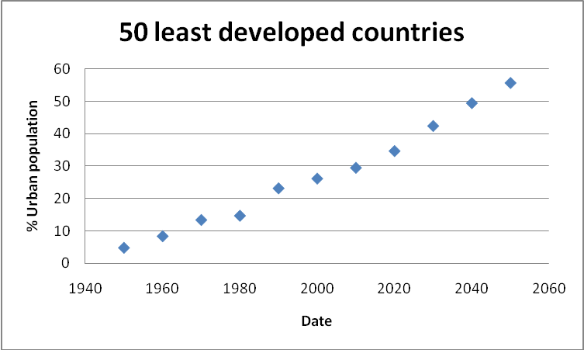

1.3 What is per capita GDP and why is it potentially a more meaningful value than the GDP of a nation?

The gross domestic product (GDP) is the sum value of goods and services produced. It is thus a function of the population and the average amount produced per person. A very large population may have a relatively low production per person, but a relatively high GDP. Conversely, a small population may be very productive and have a relatively low GDP.

For example, using data from Nationmaster.com, accessed in 2011:

Ireland
GDP= $172,300,000,000 Population= 4,156,119 GDP per capita= $41,400

India
GDP= $4,046,000,000,000 Population= 1,147,995,904 GDP per capita= $ 3,500

Per capita GDP is the nation’s sum value of production divided by the population, giving an “average” GDP per person and thus is a measure of the productivity (and an approximation of the wealth) of individuals.

1.4 In your own words, summarize ASCE’s Vision for Civil Engineering in 2025.

Answers will vary.

1.5 Why is the United States experiencing an ‘‘infrastructure crisis’’?

Answers will vary. ASCE “Infrastructure Crisis” highlights:

- The percentage of total spending for infrastructure has declined from approx. 6% to approx. 2% over the last 40 years.
- Much of our infrastructure is taken for granted and is not properly maintained.
- Much of our infrastructure is aging and in need of repair or replacement.
- Funding of infrastructure has largely shifted from the national to local level, and many local governments do not have, or do not prioritize, funds for infrastructure.
- The public and elected officials often lack long-term vision and commitment.
- Increasing population places increasing demands on infrastructure.
- The increased demand by other rapidly developing countries leads to rapidly escalating costs for materials (concrete, steel, etc.).

1.6 List the advantages and disadvantages of pursuing a master’s degree in civil and/or environmental engineering.

Answers will vary.

Advantages: higher starting salary, more challenging projects, greater job security, more education (both broad and specific), for some positions a graduate degree is required

Disadvantages: delayed start of career, cost of graduate school (if not covered by an assistantship)

1.7 Does ASCE’s Vision for Civil Engineering in 2025 apply to the field of environmental engineering? Discuss.

Answers will vary. To a large degree the Vision does apply to environmental engineering, since there is substantial overlap between civil and environmental engineering.

1.8 Describe how the responsibilities of entry-level engineers have changed.

From the text: “A generation ago, newly hired engineers were typically restricted to design and analysis functions. Today as a young engineer, you can expect to take on many additional tasks such as meeting with clients, presenting at public meetings, writing proposals, and managing construction projects.”

1.9 Why hasn’t the ‘‘infrastructure crisis’’ been resolved?

Answers will vary.

- There are increasing demands for funds (e.g. Medicare, military, etc.).
- Short term needs (non-infrastructure) often trump long-term needs such as infrastructure.
- Many infrastructure problems are regional and complex, difficult to gain public understanding and support.
1.10 Which area of emphasis within civil and environmental engineering appeals to you most? Why?

Answers will vary.

1.11 Which area of emphasis within civil and environmental engineering appeals to you least? Why?

Answers will vary.

1.12 Do you think that a master’s degree should be required to practice as a professional engineer? Why or why not?

Answers will vary.
1.13 Identify the student chapters of professional civil and environmental engineering societies/organizations at your campus. How would membership in one or more of these organizations benefit students?

Answers will vary.
1.14 Read the ‘‘Findings’’ section of the NTSB Accident Report for the I-35W bridge collapse, (available at www.wiley.com/college/penn). Was the failure of the bridge due to the factors that had caused the bridge to be classified as ‘‘structurally deficient?’’

The failure of the bridge was NOT due to the factors that had caused the bridge to be classified as ‘‘structurally deficient.” From the conclusion of the report, “Although the I-35W bridge had been rated under the National Bridge Inspection Standards as Structurally Deficient for 16 years before the accident, the conditions responsible for that rating did not cause or contribute to the collapse of the bridge.”
The primary reason was a design flaw.

1.15 Read the ‘‘Findings’’ section of the NTSB Accident Report for the I-35W bridge collapse (available at www.wiley.com/college/penn). What are some lessons that young engineers can learn from the findings?

Answers will vary.

- Large bridges are complex structures.
- Designs must be properly reviewed for correctness and completeness.
- Existing review process requirements may not be adequate to identify design errors.
- Improper designs may result in catastrophic events.
- Construction activities on existing bridges must be evaluated based on loads resulting from materials and equipment.
- Visual inspections alone may not identify problems.

1.16 Explore a subdiscipline area of civil and environmental engineering. Answer these questions:
a. What are some typical careers in this area?
b. How essential is a master’s degree in this area? Note
that in some subdisciplines, a master’s degree is more
important than in others.
c. What is the outlook for jobs in this subdiscipline area?
d. What are some specializations within this subdiscipline?
e. What are some potential future projects in this area that
you find exciting?
f. What are some non-infrastructure aspects of this subdiscipline?

Answers will vary.

1.17 Choose a professional journal from ASCE (a list is available at www.wiley.com/college/penn) in an area of interest and prepare a one-page summary of an article published in the last 2 years.

Answers will vary.

1.18 Research a labor strike associated with some sector of the infrastructure, and summarize the effect on society. The example you choose is not to be one of the strikes mentioned in this chapter.

Answers will vary.

