Multiple Choice Questions

1) Which of the following represents the breaking of a noncovalent interaction?

A) hydrolysis of an ester
B) dissolving of salt crystals
C) ionization of water
D) decomposition of hydrogen peroxide
E) none of the above

Answer: B

Difficulty: 1 Topic: The Nature of Noncovalent Interactions

2) Which of the following is the most likely noncovalent interaction observed between a carboxylic acid and an alcohol?

A) charge-charge interaction
B) charge-dipole interaction
C) dipole-dipole interaction
D) dipole-induced dipole interaction
E) formation of an ester bond

Answer: B

Difficulty: 1 Topic: The Nature of Noncovalent Interactions

3) Which of the following atoms could interact through a hydrogen bond?

A) the oxygen of a ketone and the hydrogen of an aldehyde
B) the oxygen of methanol and a hydrogen on the methyl carbon of methanol
C) the hydrogen of an amine and the oxygen of an alcohol
D) the hydrogen on an aromatic ring and the oxygen of carbon dioxide
E) none of the above

Answer: C

Difficulty: 2 Topic: The Nature of Noncovalent Interactions

4) Which of the following would likely form micelles in an aqueous solution?

A) hexane
B) glucose
C) glutamic acid
D) dodecanoic acid
E) none of the above

Answer: D

Difficulty: 2 Topic: The Role of Water in Biological Processes

5) Which of the following best explains the hydrogen bonding that occurs in water?

A) the average number of H-bonds formed by one water molecule is the same in liquid and solid water, the only difference is the duration of the H-bond
B) the number of H-bonds formed by one water molecule is greater in liquid water than in solid water
C) the structure of liquid water is best described as flickering clusters of H-bonds due to the relative short duration of individual H-bonds
D) each water molecule is capable of forming 8 H-bonds: 2 from each lone pair of electrons and 2 from each hydrogen
E) none of the above

Answer: C

Difficulty: 2 Topic: The Role of Water in Biological Processes

6) Given the structure of a glucose molecule, which of the following explains the hydrogen bonding between glucose and water?
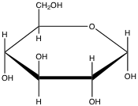
A) H-bonds will form with glucose always being the H-bond donor
B) H-bonds will form with water always being the H-bond donor
C) each glucose molecule could H-bond with as many as 17 water molecules
D) due to the cyclic structure of glucose, H-bonding with water does not occur
E) none of the above

Answer: C

Difficulty: 2 Topic: The Role of Water in Biological Processes

7) Which of the following acids or bases is least likely to be encountered in a biochemical setting?

A) nitric acid
B) acetic acid
C) ammonia
D) citric acid
E) phosphoric acid

Answer: A

Difficulty: 1 Topic: Ionic Equilibria

8) What pH range is generally considered to be the physiological pH range?

A) 1.5-3.0
B) 4.5-7.0
C) 5.5-9.0
D) 6.5-8.0
E) 7.5-10.0

Answer: D

Difficulty: 1 Topic: Ionic Equilibria

9) Since pK_{a} = -log K_{a}, which of the following is a correct statement?

A) acetic acid (pK_{a} = 4.7) is stronger than lactic acid, (pK_{a} = 3.9)
B) lactic acid, (pK_{a} = 3.9) is weaker than all forms of phosphoric acid, (pK_{a} = 2.1, 6.9 and 12.4)
C) since the pK_{a} for conversion of the ammonium ion to ammonia is 9.25, ammonia is a weaker base then the acetate ion
D) for carbonic acid with pK_{a} values of 6.3 and 10.3, the bicarbonate ion is a stronger base than the carbonate ion
E) none of the above

Answer: E

Difficulty: 2 Topic: Ionic Equilibria

10) If gastric juice has a pH of about 1.5, which of the following would be predominantly deprotonated in the stomach?

A) phenol (pK_{a} = 9.9)
B) acetic acid (pK_{a} = 4.7)
C) lactic acid, (pK_{a} = 3.9)
D) phosphoric acid (pK_{a} = 2.1)
E) hydrochloric acid (pK_{a} = -6)

Answer: E

Difficulty: 2 Topic: Ionic Equilibria

11) Given the pK_{a} values for phosphoric acid of 2.14, 6.86 and 12.4, what is the ratio of HPO₄²⁻/H₂PO₄⁻ in a typical muscle cell where the pH is 7.2?

A) 0.46
B) 2.2
C) 6.3 × 10⁻⁶
D) 1.1 × 10⁵
E) none of the above

Answer: B

Difficulty: 2 Topic: Ionic Equilibria

12) You have been asked to determine the pK_{a} of an unknown acid. In a solution at pH 7.0, you find that 24% of the acid is in its deprotonated form. What is the pK_{a} of the acid?

A) 7.9
B) 7.5
C) 6.5
D) 5.6
E) none of the above

Answer: B

Difficulty: 2 Topic: Ionic Equilibria

13) Citric acid is a triprotic acid with three carboxylic acid groups having pK_{a} values of 3.1, 4.8, and 6.4. If a solution of citric acid has a pH of 5.5, what can be said about the predominant protonation state of the citric acid?

A) 1 carboxylic acid group is deprotonated, 2 are protonated
B) 2 carboxylic acid groups are deprotonated, 1 is protonated
C) all 3 carboxylic acid groups are deprotonated
D) all 3 carboxylic acid groups are protonated
E) the protonation state cannot be determined

Answer: B

Difficulty: 2 Topic: Ionic Equilibria

14) Which of the following is the conjugate acid of hydrogen phosphate, HPO₄²⁻?

A) H₂PO₃⁻
B) H₂PO₄⁻
C) H₃PO₄
D) H₂PO₄²⁻
E) none of the above

Answer: B

Difficulty: 1 Topic: Ionic Equilibria

15) Formic acid is the active agent in an ant bite. What is the ratio of base/acid for formic acid (pK_{a} 3.9) in the blood stream at pH 7.4?

A) 3.16 × 10⁻⁴
B) 3.16 × 10³
C) 3.5
D) 0.54
E) 1.90

Answer: B

Difficulty: 1 Topic: Ionic Equilibria

16) If a buffer is made with the pH below the pK_{a} of the weak acid, the ratio of [base]/[acid] will be:

A) less than 1
B) greater than 1
C) equal to 1
D) equal to 0
E) cannot be determined

Answer: A

Difficulty: 1 Topic: Ionic Equilibria

17) A typical amino acid has a carboxylic acid and an amine with pK_{a} values of 2.3 and 9.6, respectively. In a solution of pH 4.5, which of the following best describes the protonation and charge state of the amino acid?

A) carboxylic acid: protonated and neutral; amine: deprotonated and negative
B) carboxylic acid: protonated and neutral; amine: protonated and neutral
C) carboxylic acid: deprotonated and negative; amine: protonated and neutral
D) carboxylic acid: deprotonated and negative; amine: protonated and positive
E) carboxylic acid: deprotonated and negative; amine: deprotonated and neutral

Answer: D

Difficulty: 2 Topic: Ionic Equilibria

18) Glutamic acid contains two carboxylic acid groups (pK_{a} values of 2.2 and 4.2) and an amine group (pK_{a} 9.7). What is the pI for glutamic acid?

A) 3.2
B) 6.0
C) 6.5
D) 7.0
E) none of the above

Answer: A

Difficulty: 2 Topic: Ionic Equilibria

19) Lysine contains two amine groups (pK_{a} values of 9.0 and 10.0) and a carboxylic acid group (pK_{a} 2.2). In a solution of pH 9.5, which of the following would best describe the protonation and charge state of lysine?

A) carboxylic acid: deprotonated and neutral; both amines: protonated and positive
B) carboxylic acid: deprotonated and negative; both amines: deprotonated and neutral
C) carboxylic acid: deprotonated and negative; amine (pK_{a} 9.0): deprotonated and neutral; amine (pK_{a} 10.0): protonated and positive
D) carboxylic acid: deprotonated and negative; amine (pK_{a} 9.0): protonated and positive; amine (pK_{a} 10.0): deprotonated and neutral
E) carboxylic acid: deprotonated and neutral; amine (pK_{a} 9.0): deprotonated and neutral; amine (pK_{a} 10.0): protonated and positive

Answer: C

Difficulty: 3 Topic: Ionic Equilibria

20) In the following titration curve, what does the inflection point represent?
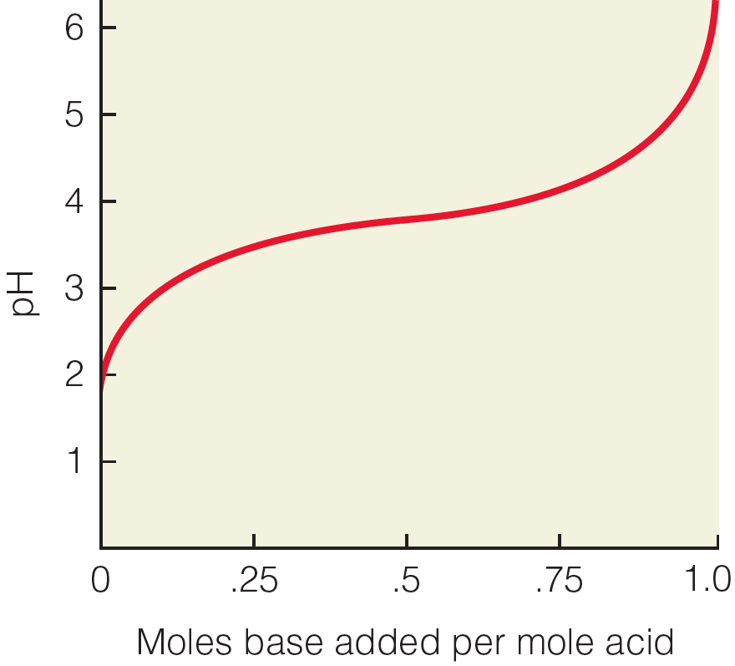
A) pH of solution equals pK_{a} of weak acid
B) concentration of weak acid and conjugate base are equal
C) the pH where the solution would function most effectively as a buffer
D) the weak acid is 50% protonated, 50% deprotonated
E) all of the above

Answer: E

Difficulty: 2 Topic: Ionic Equilibria

21) What happens to DNA when placed into an aqueous solution at physiological pH?

A) individual DNA molecules attract each other due to presence of positive and negative charges
B) individual DNA molecules repel each other due to presence of negative charges
C) individual DNA molecules repel each other due to presence of positive charges
D) DNA molecules bind to negatively charged proteins
E) none of the above

Answer: B

Difficulty: 2 Topic: Interactions Between Macroions in Solution

22) What solution conditions are required for a protein to be a positively charged macroion?

A) pH of solution is greater than the protein’s pI
B) pH of solution is less than the protein’s pI
C) pH of solution is greater than the protein’s pI and ionic strength is low
D) pH of solution is less than the protein’s pI and ionic strength is low
E) none of the above

Answer: B

Difficulty: 2 Topic: Interactions Between Macroions in Solution

Short Answer Questions

1) Lactic acid is a common product of actively working muscle. It is transported via the bloodstream to the liver. What percent of lactic acid is ionized in the bloodstream if the pH is 7.40 and the pK_{a} is 3.86?

Answer: 99.97% (100% using correct SF)

$$\begin{aligned}\text{pH}=\text{pKa}+\text{log}\frac{[\text{lactate}]}{[\text{lactic acid}]} \\ \frac{[\text{lactate}]}{[\text{lactic acid}]}=\text{3467 or }[\text{lactate}]\text{ = 3467 }´[\text{lactic acid}] \\ [\text{lactate}]+[\text{lactic acid}]=\text{100}\text{\%} \\ \text{lactate}=\text{99}\text{.}\text{97}\text{\%}\end{aligned}$$

Difficulty: 2 Topic: Ionic Equilibria

2) Imidazole is a commonly used buffer in biochemistry labs. With a pK_{a} of 7.0, what would be the ratio of base to acid at pH 7.4?

Answer: 2.5

$$\begin{aligned}\text{pH}=\text{pKa}+\text{log}\frac{[\text{base}]}{[\text{acid}]} \\ \frac{[\text{base}]}{[\text{acid}]}={\text{10}}^{(7\text{.}4−7\text{.}0)}=2\text{.}5\end{aligned}$$

Difficulty: 1 Topic: Ionic Equilibria

3) Use the equilibrium equation of the blood buffer to predict what would happen to blood pH if respiration were to slow significantly.

Answer: CO₂ + H₂O H₂CO₃ H⁺ + HCO₃⁻

Slowing of respiration would cause a decrease in pH since more carbon dioxide would be present in the blood, forcing the equilibrium to the right, thus creating more H⁺.

Difficulty: 2 Topic: Ionic Equilibria

